I, Stacy and the youth would like to thank all of you who brought food for the food drive.

As you can see in the picture below, WE collected over 500 non-perishable food items for the patients and families of Hospice of Greensboro.
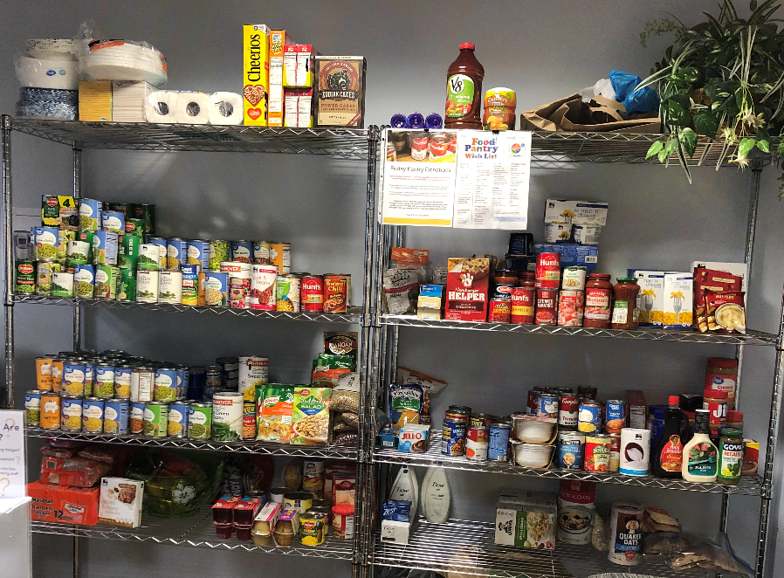
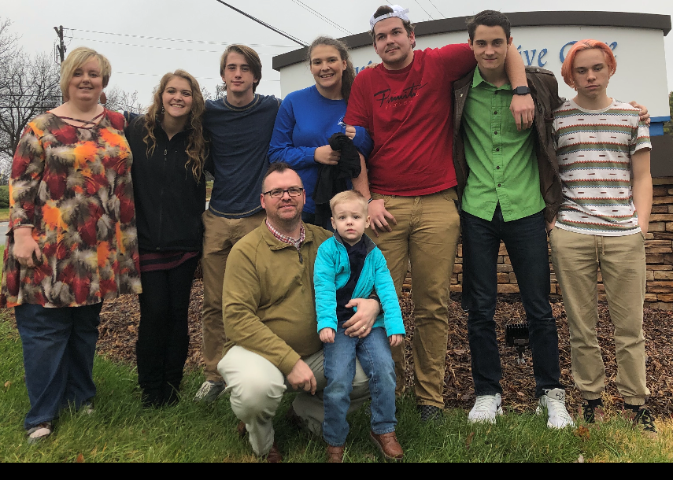

We love you all!
Andy and Stacy

Baptist Men’s Day will be celebrated on Sunday, January 26th. In observance of this event we invite EVERYONE to attend a breakfast, provided by our Baptist Men, on Sunday morning the 26th at 9am – 9:45am. Also our men will lead us in the morning worship service. Baptist Men meet each month on the first Wednesday evening at 7pm after the monthly Family Night Supper. For more info contact John Church.



January Birthdays

1/1  1/6  1/9  1/10  1/12  1/13  1/18  1/19  1/20  1/20  1/24  1/29  1/30 |  |  | Crista Church  Sara VonCannon  Danny Wilson  Frances Prevette  Judy Daniels  Steve Hurley  Beverly Weavil  Paul East  S Susan Cheek, Stoney Longworth  Kathy Mills, Terri Turner  Ernest George  Amy Clodfelter  Brenda Grose, Kathy Horton

Union Cross

Baptist News
Vol. 42 January 1, 2020 No. 1

Happy New Year!

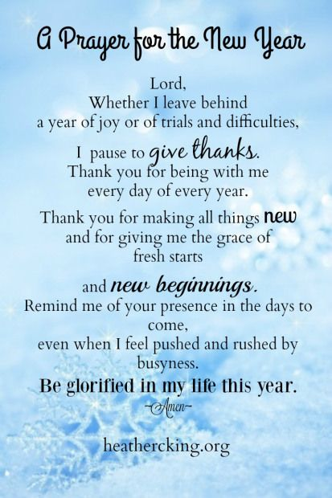


HAPPY NEW YEAR 2020!

Words to Live By

As I enter 2020 I want to put more effort into the most important things in life. I think this is so important that I want to encourage all of us to do that, let go of some things that don’t mean so much and invest more of our life into the things that are the most valuable. Beginning Sunday, January 5th our new sermon series is designed to put our focus on some of the most important things in life for 2020, we’re calling it Words to Live By. Some of our “Words” that highlight the important pieces of life in 2020 are: Ready (Be Ready for Christ’s Return), Serving (Blessings that come from Serving), Friendship (Friendship Starts with Me), Sin (What Do I do about My Sin), Family, Bible, and other important words. Do you need a little encouragement about some of the most important priorities of life in 2020? Come out each Sunday and let’s learn to simplify, prioritize, and put our effort into the most important things in life in the new year.

Happy New Year,
Kent

Senior Moments Highlights
The Seniors will be having their luncheon at 11am on January 16th at the church. So bring a dish, and join them for fun and fellowship.

Bad Weather Policy

The Bad Weather Committee in coordination with the Pastor will make the determination to cancel services and/or activities. We no longer follow the Winston-Salem Forsyth County School closings.
- You may watch WFMY-TV 2 (cable channel 9), WGHP FOX8 TV (cable channel 10), or WXII-TV 12 (cable channel 11) for cancellation information.
- If you have not heard any news within a reasonable time, you may contact your Deacon.

Nursery Schedule
January 5, 2020 (Sun) | Stacy Bowlin AM
January 8, (Wed) | Stacy Bowlin PM
January 12, (Sun) | Carlene Compton & Susan Hilton AM
January 15, (Wed) | Stacy Bowlin PM
January 19, (Sun) | Marianne & CC Casas AM
January 22, (Wed) | Stacy Bowlin PM
January 26, (Sun) | Kathy Idol & Alice Striplin AM
January 29, (Wed) | Stacy Bowlin PM

Children’s Church & Wee Church Schedule

January 5, (Children’s) | Megan Coleman & Brittney Lewallen
January 5, (Wee) | Julie Striplin
January 12, (Children’s) | Melissa Little & Carole Blakley
January 12, (Wee) | Emma & Chris Lawrence
January 19, (Children’s) | Cindy Clark
January 19, (Wee) | Krisi Kern
January 26, (Children’s) | Susan Kramer & Daughters
January 26, (Wee) | Robin French


Thank you for your donations to our missions offering. As of Sunday, December 15th we have raised $1,148.00 for Lottie Moon,$134.00 for Global Missions, and $494.65 for the W-S Rescue Mission.


December WOM ACTIVITIES:
- Deliveries to both Hospice Homes were made in December and the next Hospice Ministry emphasis Sunday is scheduled for January 12th.
- Our WOM International Supper on December 4th was a success. In addition to a time of fellowship and sharing each other’s food dishes, we humbly paid tribute to missionaries and learned exactly who is and what a Christian does.
- Once again compassion and generosity of you at UCBC prevailed!!! We delivered a 68 fleece blankets, 204 hygiene items, 73 gifts, 159 stocking stuffers, 170 clothing items (gloves, hats/toboggans & cozy slipper booties/socks), 36 stockings, 29 gift bags, 2 very large packs of tissue paper and 125 name tags = all totaling 866 items to the Eastern Forsyth Baptist Toy Store on Friday, December 6th. There were 90 local families with 268 children scheduled to receive the gifts. Please continue to pray for those families not only during this Christmas season but always.
- There were 7 WOM ladies (Ann, Beverly, Carole, Jane, Jean, Jill and Kathy I) volunteering in various capacities at the Toy Store and we were each blessed by our work.
- Unfortunately the weather prediction prevented our “day at the red kettle” for Salvation Army as planned and we were unable to secure a date to wrap gifts at the Ronald McDonald House.
This poem will explain the work of WOM and how UNION CROSS REACHES OUT TO SHOW HIS LOVE:
HAPPY NEW YEAR
A new year is about to unfold
With new opportunities to explore
Doors will open for new experiences,
New adventures for the Lord
Remember not the former things,
The things of this past year,
The Lord will do new things in us,
Much more than we are aware.
- M.S. Lowndes -

