



Prayer Concerns: Margaret Baker, Barbara Dortch, Joan Honeycutt, Sylvia Phillips, Larry Snyder, Bob & Bettie Spencer, Nancy Vanhoy, & Tim VonCannon.



Thank you for your donations to our missions offering. As of Sunday, December 27th we have raised $1,530.00 for Lottie Moon, $200.00 for Global Missions, and $640.50 for the W-S Rescue Mission.



January Birthdays

1/1  1/6  1/9  1/10  1/12  1/13  1/18  1/19  1/20  1/20  1/24  1/29  1/30 |  |  | Crista Church  Sara VonCannon  Danny Wilson  Hutcherson Lawrence, Frances Prevette  Judy Daniels  Steve Hurley  Beverly Weavil  Paul East  S Susan Cheek, Stoney Longworth  Kathy Mills, Terri Turner  Ernest George  Amy Clodfelter  Brenda Grose, Kathy Horton

Union Cross

Baptist News
Vol. 43 January 1, 2021 No. 1

Happy New Year!

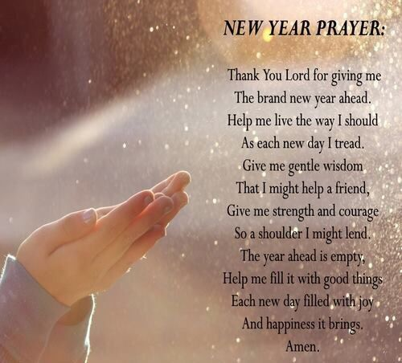

2021 What Does This Year Hold For You?

I love December and the whole Christmas Season! Now comes the excitement of a new year and the mystery of what the next 12 months hold for us. There certainly have been a lot of surprises in 2020, we better keep our seatbelt on as we enter 2021 in case of more turbulence. Here are a few quotes to get us looking forward to 2021:
- “Our hope is not in the new year…but in the One who makes all things new.”
- “Look not back on yesterday. So full of failure and regret; look ahead and seek God’s way…All sin confessed you must forget.”
- “May you shine the light of Christ in the New Year.”
- “Enter the coming year with renewed hope in the power of God to do through you what you cannot.” John MacArthur
- “Let’s make one resolution this year: to anchor ourselves to God’s grace.” Chuck Swindoll
- “Glory to God in highest heaven, who unto man His Son hath given; while angels sing with tender mirth, a glad new year to all the earth.”
Martin Luther
Sounds like we should not only look ahead to what the New Year holds but look up to the One who holds us, guides us, loves us and has a plan for us in 2021.
Look up each day, breath a prayer and walk with God in 2021.
Happy New Year!
Peace, kent

Bad Weather Policy

The Bad Weather Committee in coordination with the Pastor will make the determination to cancel services.
- You may watch WFMY-TV 2 (cable channel 9), WGHP FOX8 TV (cable channel 10), or WXII-TV 12 (cable channel 11) for cancellation information.
- If you have not heard any news within a reasonable time, you may contact your Deacon.

Women on Mission ladies continue to meet monthly by email with our regular meeting held on December 4 and special email meetings on December 7 and again on Sunday, December 20.

First let me again say thank you to all those who support WOM and the many projects we have undertaken in 2020 especially during this time when our worlds were turned upside down due to Covid and its many restrictions. The monetary contributions have been so generous and without each of you, we would never have been able to be successful with meeting the needs of our “neighbors” in the name of Jesus Christ through UCBC. BLESS YOU ALL!
DECEMBER WOM ACTIVITIES:
- Hospice Ministry Note: Ann continues to be grateful for your donations which also enable this to be an active ministry of our church.
- $496.74 WOM funds were spent for the following purchases for the Eastern Forsyth Baptist Toy Store: 39 children’s gifts, 11 stocking stuffers and 40 batteries for the toys….Overall (WOM and individual donations) UCES contributed 161 children’s gifts, 81 stocking stuffers, 108 pairs of cozy slippers/socks, 82 winter wear--(toboggans, gloves and hats), 83 fleece blankets and 50 stockings. Let me assure you for the size of church we are the above totals shows how much UCBC cares for those less fortunate.
- With WOM funds, we supported a local family with 100 gallons of fuel oil using $252.41 along with a $100 Food Lion gift card.
- We purchased an electric heater for a Toy Store family who had no heat. That cost was $53.34.
- While volunteering at the Toy Store, another need came to my attention. There was a mother who reluctantly confided in us that she needed a winter coat and shoes. When Beverly and I met the lady at Walmart to shop, we found she had other clothing needs as well like PJ’s, robe, underwear, socks, jeans and sweat pants. We also purchased a doll for her 6 year old and she chose a children’s bedtime Bible storybook. The total WOM funds spent for this family was $269.85.
I want to share a very sacrificial blessing. There was a young girl from NCLA celebrating her 9th birthday in late November this year. She requested no gifts for herself -- only gifts for needy children and I picked up 3 huge baskets of toys that were being donated to our Toy Store at this child’s request. What more can I say—this child has the gift of love for others at such a young age. May we all embrace this lovely spirit in 2021.
In year-end closing, I feel so very blessed that we as Women on Mission have continued to find opportunities and ways to serve the community and our fellowmen as UNION CROSS REACHES OUT TO SHOW HIS LOVE.

BEST WISHES FOR THE NEW YEAR!

