Hello UCBC Family,

The end of the school year and the beginning of the summer are busy times! I’m all geared up for all the awesome opportunities we have for this summer! We have four youth going to Gospel Light Camp July 1-5 and four youth going to Passport Camp July 15-20. Please pray for these teens as they go off to camp.

There are many factors that make youth going to a Christian camp a positive and valuable experience. One factor, in most Christian camps, there is an extensive exposure to the Word of God. Hebrews 4:12 tells us that the Bible is living and powerful. A typical day in a Christian camp will have some form of personal or group devotions, an evening chapel service, and a Scripture memorization program. Another factor is that there is the opportunity to observe and learn from godly mentors (counselors, staff, and speakers). Many campers come from broken homes or grow up with less-than-ideal role models because one or both parents are unsaved or weak and immature in their faith. As Paul encouraged others to follow his example as he emulated Christ (1 Corinthians 11:1), these godly mentors are able to model loving discipline and the freedom it offers. They are also able to show
unconditional love, model how a godly man or woman behaves, and display God-centered living before the campers.

Thank you so much for your prayers and we love you all.

Andy & the Youth



July Birthdays

7/1  7/8  7/9  7/11  7/14  7/15  7/18  7/20  7/21  7/22  7/23  7/28  7/28 |  |  | Gary Hilton, Barbara Snyder  Kyle Wilson  Jordan Shields  Jean Foster  Margaret Baker  Rick Slaydon  Ryan Evans, Chris Lawrence  Tim Weavil  Bill Grose  Faye Eller  Jim Dunlap, Christian Sexton  Peggy Beaver, Kenny Johnson  Jane Sutphin

Union Cross

Baptist News

Vol. 41 July 1, 2019 No. 7

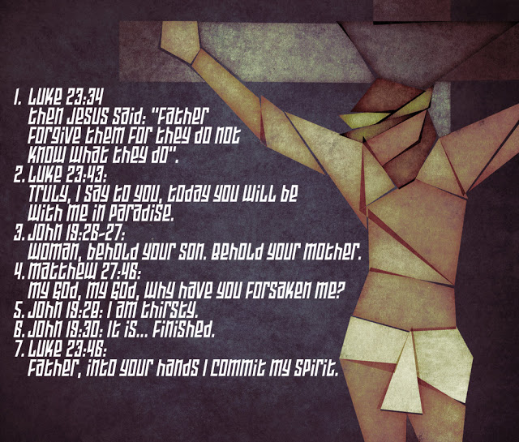

FINAL WORDS FROM THE CROSS
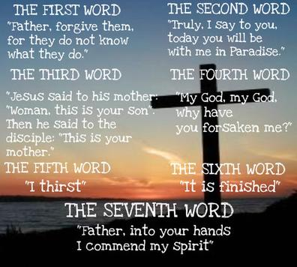
Did you know that Jesus spoke seven times while nailed to the cross? Each time was a window into His heart, it revealed to us what was important in His last moments of life. First He sought forgiveness for those who punished him and mistreated Him. Secondly, He promised eternal life to the repentant criminal on the cross next to Him. Thirdly, He made sure His mother would be taken care of by His best friend John. As the full punishment for sin was upon Him and He was separated from His Father, His fourth words were to crying out to reveal His forsakenness. Just as He was about to give His victory cry that salvation was accomplished by Him he needed to wet His dry throat and His fifth statement was “I thirst”. With parched throat quenched Jesus sixth statement was yelling out His victory cry “It is finished” and then seventh He verbally committed Himself back into the presence of the Father. After the seventh statement His body hung lifeless, so it was removed and placed in a borrowed tomb and then He rose again on the third day. Come to church each Sunday in July and August and hear the details about each of these incredible seven statements Jesus spoke from the cross during our summer series.
Peace,
Kent

The Senior Moments Group will be not be having their luncheon on July 18th. We will resume in August .

Nursery Schedule
July 3, (Wed) | No Evening Activities PM
July 7, (Sun) | Robin French & Stacy Bowlin AM
July 10, (Wed) | Alice Striplin PM
July 14, (Sun) | Ann & Lisa Canada AM
July 17, (Wed) | Julie Striplin PM
July 21, (Sun) | Tina & Crista Church AM
July 24, (Wed) | Nancy Clodfelter PM
July 28, (Sun) | Marianne & CC Casas AM
July 31, (Wed) | Brenda Grose AM

Children’s Church & Wee Church Schedule
July 7, (Children’s) | Megan Coleman & Brittney Lewallen
July 7, (Wee) | Emma & Chris Lawrence
July 14, (Children’s) | Carole Blakley & Melissa Little
July 14, (Wee) | Julie Striplin & Need Volunteer
July 21, (Children’s) | Susan Kramer & Daughters
July 21, (Wee) | Jane & Jill Sutphin
July 28, (Children’s) | Stacy & Morgan Bowlin
July 28, (Wee) | Krisi Kern & Need Volunteer


JUNE ACTIVITIES:
- Deliveries to both Hospice Homes were made and the next Hospice Ministry emphasis Sunday is scheduled for July 7th. During the visit to deliver to the Hospice Home in WS, God gave Jane a chance to share a hug and a word of comfort to a lady who just had at that very minute lost her loved one. God does put us in special places at special times—be on guard for those special opportunities and do not let them pass by!
- Unfortunately our June 9th Food Drive for Crisis Control by the WOM was cancelled due to expected rain. We do hope to schedule another time, possibly a weekday afternoon to make up for the one cancelled.
- A few Inward Meals were prepared for those dealing with medical issues.
- Nancy C. has been busy making walker carriers for members and friends.
- On June 1st seven went to volunteer for the H. O. P. E organization where we made bagged lunches and filled fresh produce bags to be delivered to folks in need in downtown WS. Then on June 22nd, thirteen of our ladies had the opportunity to do this mission project as well. Everyone who went found the volunteer time very rewarding.
JULY PLANS:
Important-- The date and location of the July WOM meeting has been moved to 6:30pm Tuesday, July 9th at the Olympic Restaurant on West Mountain St. in Kernersville. The Baptist Men are invited to join us.
At that meeting we will be discussing several upcoming mission opportunities and voting on some important issues. God made us in His own image so let us all demonstrate that as UNION CROSS REACHES OUT TO SHOW HIS LOVE.

