
Dad, You Win!

Psalm 127:3-5 (Good News Translation) “Children are a gift from the Lord; they are a real blessing. The sons a man has when he is young are like arrows in a soldier's hand. Happy is the man who has many such arrows.”

On a brutally hot day a man walked past a miniature golf course and saw a dad following three small children from hole to hole. “Who’s winning?” he shouted. “I am,” said one kid. “Me,” said another. “No, me,” yelled the third. With sweat dripping down the frustrated father’s face, he responded, “Their mother is.”

I think the dad was the winner. It may have been swelteringly hot, dad may not like miniature golf, and the children may hit the ball like they were “driving” and not “putting” but some good things happened that made dad the big winner.
- He got to spend time with his children
- He got to make a memory, maybe have a good laugh with little guys
- He got to show interest in their interest
- He got to invest into their relationship
Psalm 103:13 “As a father has compassion on his children, so the LORD has compassion on those who fear him”

Happy Father’s Day!

Peace, Kent



June Birthdays

6/4  6/5  6/10  6/16  6/23  6/25  6/28  6/29 |  |  | Smith Parnell  Iley Baker  Mike Sexton  Lauren Horton  Megan Coleman, Ruth Osborne  Luke Gann  Carole Blakley, Sarah Horton  Sherri Wilson

Cookbook update! The Kitchen Angel Committee is planning on putting together a cookbook if we get enough recipes. As of now we don’t have enough turned in. So share your favorite recipes. Please give them to Jerry Sexton.


Union Cross

Baptist News

Vol. 41 June 1, 2019 No. 6

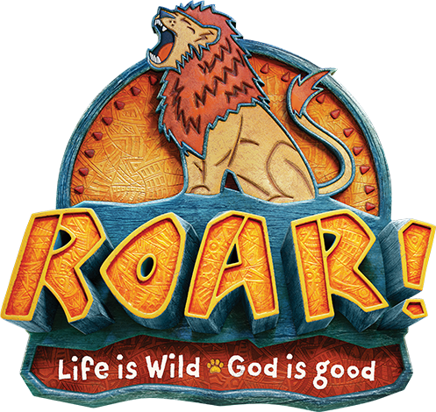

Vacation Bible School
June 24th – June 28th
9:30 AM – 12:00 PM daily
Monday through Thursday
Ages: 4 – 11 years old

Hello UCBC Family,
High school graduation is a rite of passage unlike any other. You move from being treated like a child (legally) to being counted an adult, both in society and in any academic setting you might enter. Colleges aren’t even allowed to discuss your grades with your parents apart from your consent. Childhood is over. Adulthood beckons. How should you respond to the blessing and challenge?
1. Own Your Faith.
If you come from a Christian home, you have benefited tremendously from a host of supportive circumstances (household rules, numerous protections, church life). Testing awaits as you enter the world. It won’t be enough to ride the coat tails of your parents’ faith. If you’re not sure about Christianity, now is the time to settle the matter (Ecclesiastes 12:1). Christianity is a faith unlike any other because it’s based on historical events that were verifiable to thousands of people in Christ’s day (1 Corinthians 15:3-6, 12-14) — some of whom died for what they would have known to be false, had it been false. If you have doubts, ask away. The existence of God, the reliability of the Bible, the resurrection of Jesus, Jesus being the only way to God — there is a wealth of material which addresses these and other questions.
2. Own Your Relationships.
At college, the easiest friendships aren’t always the best. To become wise, you need to walk (or do life) with the wise (Proverbs 13:20). Look for others who share your commitment to the things of God and faithfully invest in them.
3. Own Your Decisions.
Panicked that you’ll miss God’s will? God wants us to follow him more than we do. His moral will is revealed in the Bible. His sovereign will is revealed as we live it. So make the best decisions you can based on sound judgment, accept the consequences, learn from any missteps, and trust God to shower you with mercy and goodness (Psalm 23:6). With God no path is without difficulty and no path is without blessing.

Congratulations on your graduation and always seek God in all of your endeavors.

Blessings, Andy



Morgan Bowlin, Jordan Dunlap, Cheyenne Hurley, Kaleb Kern, Kyle Kern, Aaron Sexton, and Katie Weavil
Nursery Schedule
June 2, (Sun) | Kathy Idol & Alice Striplin AM
June 5, (Wed) | Brenda Grose PM
June 9, (Sun) | Ann & Lisa Canada AM
June 12, (Wed) | Julie Striplin PM
June 16, (Sun) | Tina & Crista Church AM
June 19, (Wed) | Nancy Clodfelter PM
June 23, (Sun) | Mariann & CC Casas AM
June 26, (Wed) | Alice Striplin PM
June 30, (Sun) | Carlene Compton & Susan Hilton AM

Children’s Church & Wee Church Schedule
June 2, (Children’s) | Megan Coleman & Brittney Lewallen
June 2, (Wee) | Robin French & Need Volunteer
June 9, (Children’s) | No Children’s Church – Graduation Service
June 9, (Wee) | Emma & Chris Lawrence
June 16, (Children’s) | Melissa Little & Carole Blakley
June 16, (Wee) | Julie Striplin & Need Volunteer
June 23, (Children’s) | Julie Striplin
June 23, (Wee) | Jane & Jill Sutphin
June 30, (Children’s) | Stacy & Morgan Bowlin
June 30, (Wee) | Krisi Kern & Need Volunteer

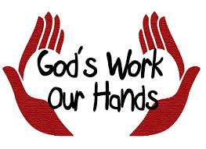

MAY ACTIVITIES:
- Deliveries to both Hospice Homes were made with the next Hospice Ministry emphasis Sunday scheduled for June 9th. Also, just need to express to Dorcas Weavil our sincere appreciation for her donation of 4 cases of Girl Scout cookies for this ministry and to the others who donate on a regular basis.
- A total of 1200 items were delivered to the Thomasville Baptist Children’s Home. What an exciting way to express our love for these youngsters!
- We had 45 attending the Ladies Fellowship Tea sponsored by WOM with a total of 753 items and $30 donated to the Pivot Ministry along with a $100 check from WOM funds to purchase the books they require in the program. As in the past, NO WOM funds were used for the tea expenses—it was funded by a private donation.
- On Sat. May 25th, 8 of our ladies went to WS to make bagged lunches for the H.O.P.E. (Help our People Eat) organization & 2 other days are scheduled to assist this organization.
Our next WOM meeting will be June 5th when we will be planning other projects to help our fellow brothers and sisters in the name of Christ as UNION CROSS REACHES OUT TO SHOW HIS LOVE.
Vacation Bible School



Get ready to ROAR with us this summer! ROAR VBS is Monday, June 24th – Thursday, June 27th from 9:30am-12pm. Children must be at least 4 years old - 11 years old to register. There will not be an adult class. Registration is completely online at https://vbspro.events/p/events/ucbaptist. We are in need of volunteers to help with all areas of VBS. Our greatest needs will be for Class leaders to take children to each station, and station leaders for Crafts & Games. Please contact Andy Bowlin, Emma Lawrence or Lindsey Parnell if you are willing to serve. Help us make this a great outreach to children and families of the Union Cross community!

