God At Work!

I read a devotional that was entitled “Four Signs God Is at Work in the Chaos of COVID-19”. It began by saying COVID-19 caught the world by surprise but not God and mentioned four ways we see God at work in the chaos of COVID-19. Here are some encouraging thoughts from that devotional.

- Greater Openness to the Gospel
People are searching for hope in the midst of chaos, churches are closed, but many people are more open to hear about Jesus now that they are engulfed by such uncertainty and fear.
- Community Is Stronger Than Ever
God is at work drawing people together during this time of crisis. People have discovered an innate need to stay in community and long to stay connected, especially the Church.
- Forced Rest
The world has slowed down in a way we’ve never seen before. The mandate to shelter-in-place is forcing people to pause and rest. It’s not a pace of life our society is used to living and it’s not one that comes easy. But God modeled rest for us, “And on the seventh day God finished his work that he had done, and he rested on the seventh day from all his work that he had done” (Genesis 2:7). The call to rest is a call to trust God and see the goodness of rest in our lives.
- Your Faith Is Growing
It’s in times like these, when your faith is challenged, that you are more likely to mature in your faith. James (James 1:3-4) said it this way, “you know that the testing of your faith produces perseverance. Let perseverance finish its work so that you may be mature and complete, not lacking anything.”

We are living in difficult times but God has not stopped working. He is not silent or passive. He is on the move. He is working in the hearts and faith of his people. It may be difficult to see the hand of God during this time. But rest assured that God is at work during the COVID-19 crisis. He is working all things for his glory and for the good of those who love him.

Peace,
Kent



June Birthdays

6/4  6/5  6/10  6/16  6/23  6/25  6/28  6/29 |  |  | Smith Parnell  Iley Baker  Mike Sexton  Lauren Horton  Megan Coleman, Ruth Osborne  Luke Gann  Carole Blakley, Sarah Horton  Sherri Wilson

Union Cross

Baptist News

Vol. 42 June 1, 2020 No. 6

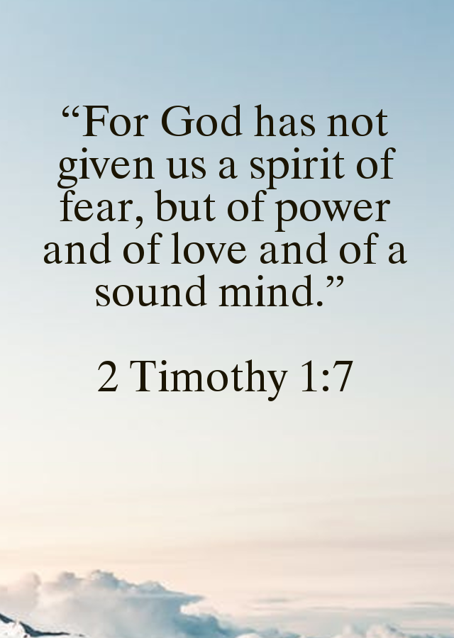

To our graduates from Andy:
"For I know the plans I have for you," declares the Lord, "plans to prosper you and not to harm you, plans to give you hope and a future." Jeremiah 29:11

This year has brought with it so much uncertainty. As I was preparing this article, I found myself at a loss for words. Then, I read this prayer which truly expresses my prayers each day for you:

Dear God,
We pray for our graduates today and lift them before you. We thank you so much for these we love and for the work you are continuing to do in their lives. They are a gift to us and to many others. And during this season of new beginnings, we ask that you would make their way clear. We ask that you would keep their footsteps firm and remind them that you are with them, always. May they sense the freshness of your Spirit over their lives in amazing ways, may they be strengthened, instilled with hope, for the new roads you have in store.
And today, again, we release our children straight into your tender care. Because we know that’s the best place they could ever be. We thank you in advance for all you have in store, for this day, for this year, for their lives.
We pray for protection, for your covering, that you would surround their lives as with a shield. Protect their coming and going. We ask that you would help them to live aware in a dark world and keep harm or evil intent far away. We ask that you would hide them in the safety of your powerful presence.
Our world is currently anxious, fearful and uncertain. We pray our graduates are filled with your courage and strength, that they may be a light to their friends and neighbors in this uncertain time.
We ask for your wisdom and clear direction over their lives, that you would give them understanding beyond their years. Thank you that your timing is perfect. We pray that you would direct their steps, that your plans for them would prosper; that every place you have determined for them to walk would be paved clear. We ask for you to open doors that need to be opened and close every one that should be shut tight. Allow every gift and treasure you have placed inside their lives to grow, develop, and flourish, to bring you glory.
We ask that you would remind them every day how very much you love them, that they would find security and confidence fully in you, knowing that you are trustworthy and true.
We ask that you would teach them your ways and fill them with an unquenchable desire to learn your Word. Give them a compassionate spirit, and the wisdom to look beyond outward appearances to the heart within. We pray that you would surround them with friends and leaders who would challenge them to press closer to you.
We ask for your peace to cover them. We ask for laughter and joy to fill their days. We pray that you would give them boldness and courage to face challenges set before them, with the confidence and peace that can only come from your spirit.
We ask that you would raise up greatness in their lives, greatness in this generation, willing to stand strong and true, passionate for you, believing that you have designed them for purpose and good works, which you have planned and prepared in advance for them to do.
Be a lamp for their feet, and a light to their path. Shine over them. Fill them with your spirit. Bless them with your favor and peace.

In Jesus’ Name,
Amen


Crista Church, Logan Deweese, Meg Gibbs, and Christian Sexton!



As services in the building are on hold until further notice, we invite you to attend church online instead! We have three ways you can watch Kent’s weekly sermons. We send out weekly emails with the link to the site; you can join our facebook page; go to YouTube and type in Union Cross Baptist Church Kernersville NC and select the sermon. Hope you can join us weekly for updates and worship!



Prayer Concerns: Bobby & Edna Bond in the hospital with Covid-19 and pneumonia, Ralph & Ruth Hedgecock, Bob & Bettie Spencer, Nancy Vanhoy, and Tim VonCannon.

Update from Building & Grounds Committee
The floors in the Fellowship Hall have been refinished. They are shiny and look great! A big thank you goes out to those who helped with moving furniture, etc.!



Once again Women on Mission held their meeting by email on May 6th.

MAY WOM ACTIVITIES:
- Hospice Ministry Note: Since the Hospice Home in WS could not accept our snacks and cookies donations during May, Ann Canada, our Hospice Ministry Coordinator, elected to send Trellis in WS a $100 check from the Hospice Ministry Fund to purchase snacks for the patients’ families. With this action we hope no family was overlooked. Please note both WS and HP will once again begin to accept donations in June, and you are encouraged to drop off your items at church in the Hospice Ministry room located in the Fellowship Building or make a cash donation to this ministry.
- Update on the Parsons Ministry donations: There were around 300 items donated!!!
- WOM ladies voted to send a box of snacks to Korey Kern and upon the advice of Jerry Sexton, we voted to send a gift card to Aaron Sexton so he could purchase his own favorite goodies due to lack of space in his barracks. Please continue to lift up these two young servicemen in your prayers.
- When we learned that the Baptist Children’s Home was dealing with extra expenses due to no school for their residents and the fact BCH daycare had been chosen as an Emergency Daycare for Essential Workers, and also based on the postponement of their Annual Food Roundup, we voted to send them $200 from WOM funds to assist with additional expenses.
- It was also brought to our attention that a co-worker (a single mom) of Melissa Fulp had lost everything in a house fire and the WOM ladies also voted to send her a check for $500 to help with immediate needs.
- Nancy C. made two very small bereavement covers for Newborns in Need and both Nancy, Jean & Jane (and probably other members) have been making some masks to help keep others safe.
JUNE ANNOUNCEMENTS:
- WOM ladies will have another “meeting” by email on June 3.
- June 6 – H.O.P.E. bagged lunch event was cancelled by H.O.P.E.
- June 13 Food Drive event when WOM ladies are supposed to assist has not yet been determined if it is still a “go”.
- As you have read above, WOM is STILL doing missions during this time of no “regular” church. Unfortunately our WOM funds are running quite low at this time and if you feel led to assist with this ministry, please mark your offering envelope ‘WOM Fund’ so our mission projects may be continued.
Stay well, keep praying for one another and as we so often hear we are in this together and we truly are…and we must continue to demonstrate how UNION CROSS REACHES OUT TO SHOW HIS LOVE.

