
Exciting news, Sunday School is starting again on March 6th at 9:45 am. Adults will meet in the Fellowship Hall and Children’s classes and Nursery will available. Coffee and doughnuts will be served. Come on back!

Senior Moments Highlights: On Tuesday, March 8th we will be going to Hamrick’s for a fun day of shopping. We will leave the church by 9 am. Please contact Ann Canada if you will be attending.
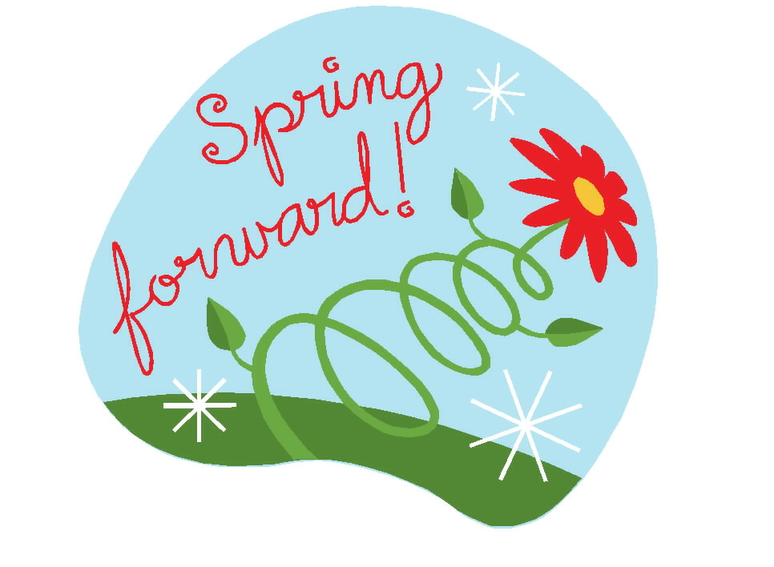
Remember: Set your clocks ahead 1 hour before going to bed on Saturday, March 12th!

Children’s Church - Ages 3 to 10
March 13th | Lisa Canada & Kathy Horton
March 27th | Robin French & Susan Hilton+


Hospice Ministry Emphasis Sunday will be March 6th. If you would like to help with this ministry you can bring snack donations or contribute monetarily.

Food Drive will be held Saturday, March 12th, 10 am –
2 pm at the Union Cross Food Lion Parking Lot. March’s food of the month is pancake mix and syrup.

We will be having our quarterly Church Conference on Wednesday, March 16th at 7 pm. Please make plans to attend.

March Birthdays



3/2  3/6  3/12  3/13  3/19  3/22  3/24 |  |  | Jason Horton  Julie Striplin, Sierra Hurley  Ron Mills  Ruth Hedgecock, Joan Honeycutt  Mattie McCann  Tony Phillips  Emma Lawrence

Union Cross

Baptist News

Vol. 44 March 1, 2022 No. 3



Just before release of this newsletter Teresa asked if I could write something again especially since we were celebrating Baptist Women’s Day during March……Some of us may remember the adult VBS classes we had at UCBC. One year each class member was given the assignment of writing another Psalm and coincidentally about two weeks prior to Teresa’s request I had run across what I scribbled down in 1993, but I believe the content may still be applicable for today:

Lord, hear my prayer!
I stand amidst those suffering from drug addiction,
Alcoholism and abuse. Weariness and despair seem
To abound from every being.

I am surrounded by those longing for a deep peace—
Rest never comes.
Bread of life and the sweet contentment of salvation
Is foreign knowledge to so many.

Lord, hear my prayer!
I know the joys you have bestowed upon me
The never ending guide when temptation surrounds me.
By your grace I have found the way!
From your word and promises I see a light
At the end of dark tunnels of life.

Lord, hear my prayer!
Help me, oh God to be an instrument to share my faith
To the lost and troubled souls.
Let this world accept you Lord and their riches
Will surpass all expectations.

-Jane

Baptist Women’s Day will be held on Sunday, March 13th. Please try and attend this service as ladies of the church will be lifting up their voices in praise, meditation and reflection.

Prayer Concerns: Margaret Baker, Durham Clodfelter, Judy Daniels, Charles & Gail Davis (Susan Hilton’s brother and his wife), Rev. Wayne Eller (friend of Rick Slaydon), Robin French, Steve Grose, Ruth Hedgecock, Rick & Penny Hilton (Gary Hilton’s brother and sister in law), Cathy Honeycutt, Jeff & Joan Honeycutt, Richard Moody (Iley & Mary Anne’s son in law), Pastor Search Committee, Robin Scott, Jon Shoe, Larry Snyder, Bob & Bettie Spencer, Bridgett Taylor (Melissa Little’s mother), Gene Vanhoy, and Lisa Young’s family (Stephanie Burnette-sister, Carl Burnette-Uncle, Barbara Loveless-Aunt, Jackie Mitchum-Aunt).


March Pulpit Supply

March 13th Baptist Women’s Day
March 20th Delbert Lauten, Jr.
March 27th Nathan Moore


Women on Mission ladies had their February email meeting on February 2nd .
FEBRUARY WOM ACTIVITIES:
- Hospice Ministry Note: Deliveries to both WS & HP Hospice Homes continued in February. Also, when Ann delivered the Valentine cards and gifts to the HP Hospice Home, she was asked to become one of their volunteers and she gladly accepted. Congratulations to Ann.
- Under the leadership of Nancy we continue to provide Inward Meals for members of our church who could benefit from them.
- We voted to support Leslie’s House in High Point with a check for $400. This is a safe place in High Point for homeless women. Shelter, hot meals, clothing, case management, life skills and most importantly hope is provided at that facility.
- With all the recent local tragedies like apartment fires where the American Red Cross always steps in and helps, we elected to also provide them with a donation of $400.
- As a special tribute to the memory of Michelle Lakey Liddle, we agreed to send $150 to the Glenn High School Booster Club for the scholarship fund established to assist another young student.
- Valentine cards from WOM were mailed to shut-ins and those dealing with serious illnesses.
- On February 12th a couple of WOM ladies assisted in preparation and serving a meal to about 40 ladies of the General Federation of Woman’s Clubs District Arts Festival. In addition to reimbursement for our expenses, we received a $150 donation to our church for WOM.
February is typically known as the “love” month. However, WOM tries to express Christian compassion every month as “UNION CROSS REACHES OUT TO SHOW HIS LOVE.”
Jane Sutphin - WOM President

