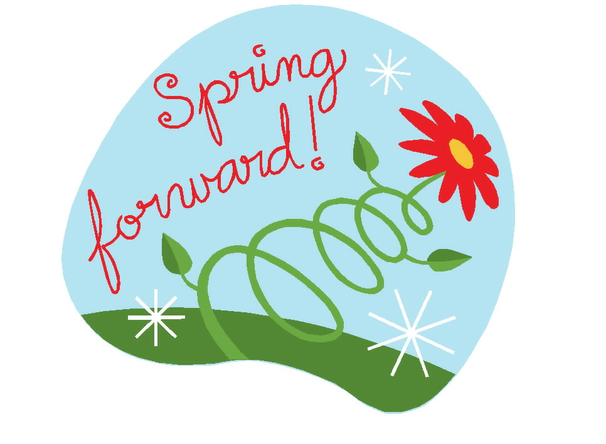

Remember: Set your clocks ahead 1 hour before going to bed on Saturday, March 14th!

We need your help to locate a missing flower arrangement. The valentine flower arrangement was purchased by Ethel Stafford to be used by the church. The arrangement’s vase had cherubs on it. If you have borrowed this arrangement please return it to the church office or if you know where we may find it please call the church office. Thank you so much for your help!

Dear UCBC, I am writing to express our gratitude to your church body. Thank you for the time you take to organize, order and provide the prepackaged food to our families who visit their loved ones at Trellis Supportive Care-Kate B. Reynolds Hospice Home. Your generosity has not gone unnoticed. Covid may have stopped a lot in our lives but one thing is for sure it did not stop people like you in our community. Yours Faithfully, Jan Matthews, Volunteer Services Coordinator

March Birthdays



3/2  3/6  3/12  3/13  3/17  3/19  3/22  3/24  3/25 |  |  | Jason Horton  Julie Striplin, Sierra Hurley  Ron Mills  Ruth Hedgecock, Joan Honeycutt  Hannah Wilson  Mattie McCann  Tony Phillips  Emma Lawrence  Riah Wilson

Union Cross

Baptist News

Vol. 43 March 1, 2021 No. 3



RIP
Normal Life
Birth – March 2020
March 2021, the One Year Anniversary since our “normal lives” ended and got twisted into a very different life by the effects of a pandemic. We went from a routine normal life to schools and universities closed, all education online, restaurants/companies closed, board meetings moved to Zoom calls, no concerts/live sporting events, wearing a mask everywhere, water parks/vacation spots closed, social distancing, churches closed, airports nearly vacant, waiting in your car for doctor’s appointments, unable to visit loved ones in the hospital, cancellation of funerals, weddings, family reunions, anniversaries and birthday parties – I could go on but that’s enough to say our “normal life” no longer feels very normal. In addition to this depression is on the rise, drug abuse is on the rise and many businesses closing permanently causing financial struggles everywhere. Did anything good happen in the last year? One thing the “crash of normal life and rise of difficulties” does is change the affection of our hearts from this world and this life to the world that is far better and perfect, just waiting for us when God calls us home. The “collapse of the comfortable normal life” has reminded us we are just strangers in the world passing through and we “look for a city which has foundations, whose architect and builder is God” (Hebrews 11:10). When everything is comfortable we could easily spend our energy accumulating more temporary stuff, 2020 reminds us; “Do not store up for yourselves treasures on earth, where moths and vermin destroy, and where thieves break in and steal. But store up for yourselves treasures in heaven, where moths and vermin do not destroy, and where thieves do not break in and steal. For where your treasure is, there your heart will be” (Matthew 6:19-21). What should we do in 2021? Keep looking up, trust God one day at a time, invest in eternity to store up treasures in heaven and not on Earth, pray for an opportunity to point someone else to Christ, everyone wonders if peace is found in this confused world and we know it is, in Jesus Christ. Remember in the Father’s House, life will be better than “normal” it will be “perfect”.
Peace,
kent


Prayer Concerns: Margaret Baker, Joan Honeycutt, Larry Snyder, Bob & Bettie Spencer, Nancy Vanhoy, Tim VonCannon & Tracy Ward.


Women on Mission ladies continue to meet monthly by email with our regular meeting held on February 3.
FEBRUARY WOM ACTIVITIES:
- Hospice Ministry Note: Both Hospice Homes staff and patient family members are grateful of the support from UCBC. We do make a difference sometimes in such small ways.
- In recognition of our Faith Partnership with the Brenner Pediatric Intensive Care Unit following Addison’s lengthy stay there, we decided to support them once again. Although we used to take home baked goodies and other treats for both the staff and the patient family members, we voted to send a $300 check from WOM funds to WFMC to be designated for this same purpose for the PICU and this was done in memory of Addison Simmons. On the cover letter to them, I included this picture of our sweet Addison.
In loving memory 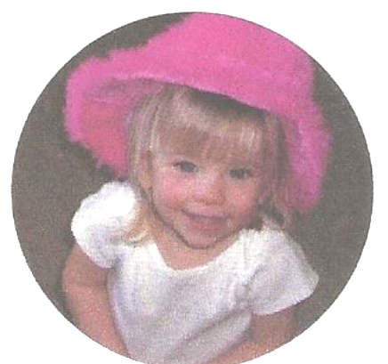
- We mailed 34 Valentine cards to our seniors who are now secluded somewhat due to age, illness, fear of Covid or sometimes just living alone.
- We voted to send a check for $200 using WOM funds to the Ronald McDonald House to provide a hot take-out meal for the resident family members. In the past we have been able to go there and cook, but with things so different now, we decided to still provide a meal to show our concern.
- In looking over the wish list for the Ronald McDonald House, we zeroed in on a couple of items and voted to spend $150 of WOM funds to assist with this mission project. Preemie and newborn diapers and clothing, paper products, and single serve food items were purchased. A couple of our WOM ladies made purchases themselves—we just cannot resist those tiny baby clothes for those precious little ones.
- Ronald McDonald House also asked for notes of encouragement for the resident families and I know that at least 20 cards with appropriate notes were written.
- Inward Meals were delivered to at least two households during February. Please keep in mind with Covid and other medical issues hitting households of people you know, you should call Nancy Clodfelter, our Inward Meal Coordinator, whenever a meal would be beneficial.
May I say thank you again for all the support WOM is receiving. You provide the funds and through prayer, God leads us in the right direction as UNION CROSS REACHES OUT TO SHOW HIS LOVE.

