Hello UCBC family!
On February 15, I had the privilege of taking five teens to Winter Jam.
Winter Jam is an incredible evening of live concerts by the top artists in Christian music, plus worship and ministry, to encourage believers and share the good news with those who have yet to trust Christ.
When you attend a Winter Jam event, you can count on ministry being the main focus. God used this event in the life of one of our teens and he gave his life to Jesus that night. I rejoice with him and thank God for His faithfulness.

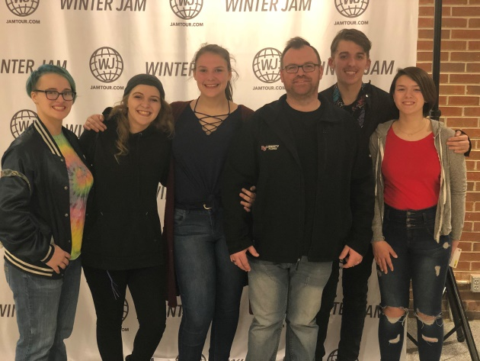


Remember: Set your clocks ahead 1 hour before going to bed on Saturday, March 7th!

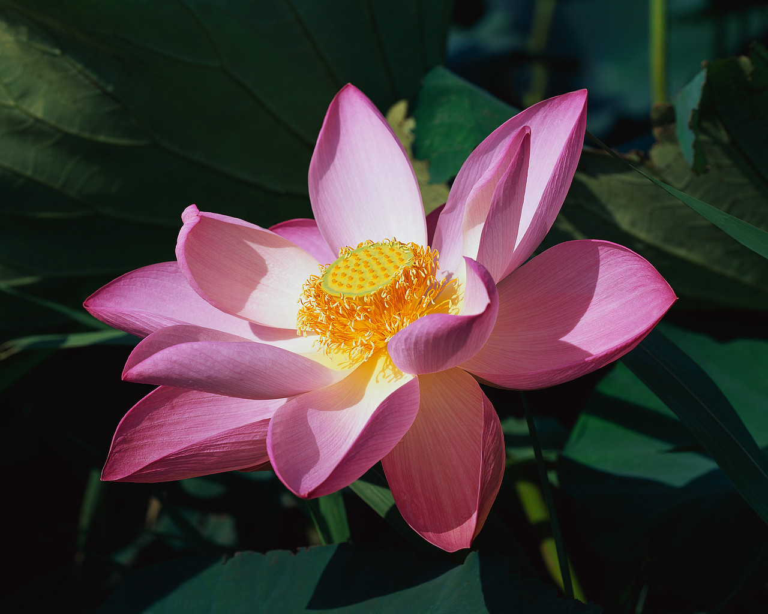

3/2  3/6  3/12  3/13  3/17  3/19  3/22  3/24  3/25   |  |  | Jason Horton  Julie Striplin, Sierra Hurley  Ron Mills  Ruth Hedgecock, Joan Honeycutt  Hannah Wilson  Mattie McCann  Tony Phillips  Emma Lawrence  Riah Wilson  March Birthdays

Union Cross

Baptist News

Vol. 42 March 1, 2020 No. 3



Baptist Women’s Day
March 8th, 11:00 am

Food Drive
March 14th, 10:00 am

Church Conference
March 18th, 7:00 pm

Senior Moments Luncheon
March 19th, 11:00 am

God Bless You!
Numbers 6:24 The Lord Bless You and Keep You.
A rich man bought an Italian sports car, a Lamborghini to be precise. He phoned the local priest and asked him if he would bless the new vehicle because it was such a huge investment. The priest stammered a bit then asked, “Just what is a Lamborghini?” The man said “Well, if you don’t know what one is, I don’t think your blessing would amount to much,” and hung up. Then man with the new sports car proceeded to call the local protestant church and asked the minister if he would bless the sports car. The minister immediately responded: “A Lamborghini? Wow! That’s great. Zero to 60 in 5.3 seconds. Best engineered sports car in the world.” Then he hesitated and said, “You want me to bless it? What’s a blessing?”

What is a blessing - the kind that God gives? A blessing is a gift from God, it’s been described as “the touch of His hand upon your life, the breath of His presence in such a way that you are enriched, strengthened, helped, and enabled.” The blessings of God comes to us in many different ways; peace in a difficult time, hope for the hard time, financial relief, a warm bed to rest at night, the food on our table, the ability to see and hear and walk and read, an open door such as the job you have been praying for, a closed door to show you that’s not the way, and even sometimes a difficulty that ends up changing and enriching our life. God’s blessing are many and fill our lives every day. I pray God’s blessings will abundantly fill each of your lives. Next time someone says “God bless you” you can reply, “I am blessed”.

Peace, Kent
Baptist Women’s Day will be celebrated Sunday, March 8th with all women leading the service. Two of our ladies will be sharing their Christian journey with us and we know you will be blessed by this service. There will be no Wee & Children Church that day.

Senior Moments Highlights: For our monthly luncheon on Thursday the 19th we will be having a Pizza Party. So be sure and make plans to join in on the fun!

Nursery Schedule
March 1, (Sun) | Kathy Idol & Alice Striplin AM
March 4, (Wed) | Stacy Bowlin PM
March 8, (Sun) | Stacy Bowlin AM
March 11, (Wed) | Stacy Bowlin PM
March 15, (Sun) | Marianne & CC Casas AM
March 18, (Wed) | Stacy Bowlin PM
March 22, (Sun) | Tina & Crista Church AM
March 25, (Wed) | Stacy Bowlin PM
March 29, (Sun) | Carlene Compton & Susan Hilton AM

Children’s Church & Wee Church Schedule

March 1, (Children’s) | Cindy Clark
March 1, (Wee) | Julie Striplin
March 8, (Children’s) | Baptist Women’s Day – Children’s Church
March 8, (Wee) | Baptist Women’s Day – Wee Church
March 15, (Children’s) | Susan Kramer & Daughters
March 15, (Wee) | Jane & Jill Sutphin
March 22, (Children’s) | Stacy & Andy Bowlin
March 22, (Wee) | Krisi Kern
March 29, (Children’s) | Carole Blakley & Melissa Little
March 29, (Wee) | Megan Coleman


FEBRUARY WOM ACTIVITIES:
- Deliveries to both Hospice Homes were made in January and the next Hospice Ministry emphasis Sunday is scheduled for March 8th. (Just a note to tell you again how much it means to families staying at the Hospice Home—recently a family dear to our hearts expressed how very appreciative they were of the snacks and cookies that were provided at the Hospice Home while they sat and waited the pending death of their loved one.)
- Inward meals were delivered on two occasions during February.
- Twelve Valentine cards were mailed to some of members confined primarily to their homes.
- 2,044 dessert bars were delivered to H.O.P.E. of WS for their weekend meals. On Jan. 25th thirteen of our ladies met at the church to do blitz baking for this organization and we made 1,042 on that day, but a couple of ladies continued to bake in their homes so we were able to deliver another 1,002 and they were gratefully received.
- Thanks to the Mission Committee for securing David and Kathy Parsons from the NC Missions Center now serving in WS to speak at our Feb. meeting. A total of 5 containers of concentrated lemonade, 138 coloring books, 63 boxes of crayons, and 193 pair of children’s socks all totaling 357 items were donated by WOM and other church members for this ministry. Of this total WOM ladies approved spending $150 of WOM funds for this ministry and we were able to purchase 164 pair of children’s socks, 29 coloring books and 23 pks of crayons with appropriated monies with the expenditure of $156.88.
- There were 9 from our church scheduled to attend the Baptist Missions Rally at Oaklawn Baptist on February 20th.
UPCOMING EVENTS:
- Baptist Women’s Day will be March 8th.
- Annual WMU salad supper is scheduled for March 21st at Clemmons FBC.
- Next meeting will be March 4th and we will be discussing and planning other mission projects.
February is sometimes referred to as the love month because of Valentine Day, but with WOM every month is a love month because throughout the entire year UNION CROSS REACHES OUT TO SHOW HIS LOVE.

