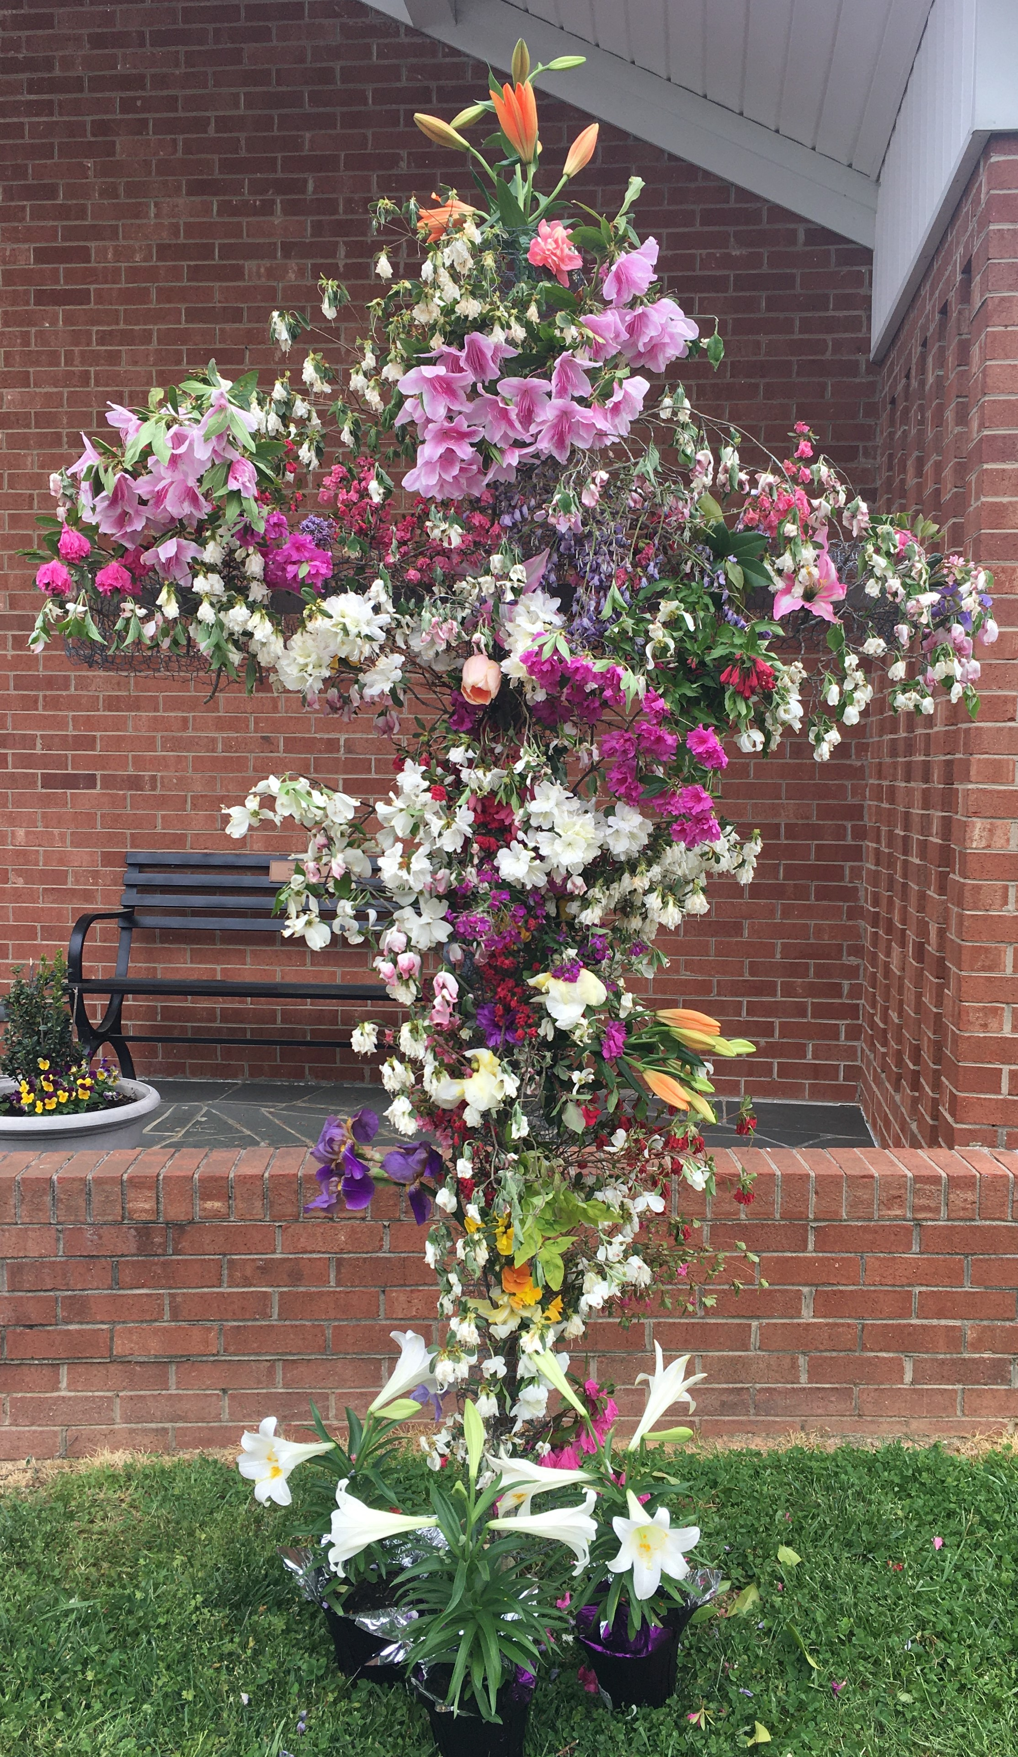
Was it because we couldn’t be at church on Easter morning and that we had not worshipped together for weeks that the Easter Flower Cross was so awe inspiring? I don’t really know but I purposely waited until 11am on Easter morning to add my flowers. As I approached the crest of the driveway, I was struck by how beautiful the cross was this year. In addition there were wreaths placed around the lights at the front door and a white mailbox for prayer requests.
I wanted to take a moment to thank all of those involved in continuing this Easter tradition. I am sure it spoke volumes to our community as it did to me. Even though we weren’t there together to worship this year, as I stood there I felt the love of each member of our church. Stay safe and well.
God Bless, Beverly Weavil

Prayer Concerns: Tim VonCannon, Aubree Phillips has a fractured elbow, Ralph Hedgecock has extreme back pain, Ruth Hedgecock is in Novant Rehabilitation Center, Room 122, Hillcrest Center Circle, W-S, NC 27103, her phone number is 336-754-3722. Nancy Vanhoy fell over the weekend and was hospitalized. She is now home recuperating.


May Birthdays

5/1  5/3  5/4  5/7  5/9  5/10  5/11  5/13  5/20  5/27  5/29  5/30  5/31 |  |  | Pam Hester  Beth Clodfelter  Nancy Vanhoy  Grady Weavil  Grace Jarrett  Russel Yokeley  Tracy Ward  Carlene Compton  Cheyenne Hurley  Sylvia Phillips  Aubree Phillips  Bobby Bond, Jennifer Brantley  Debbie Slaydon, Gene Vanhoy

Union Cross

Baptist News

Vol. 42 May 1, 2020 No. 5

When this is over,
I am never taking for granted
a coffee with a friend, playing with children at the park,
going to social events,
church services, full shelves
at the grocery store,
restaurants to dine in or a simple hand shake to say hello.
I know when this is over, the world will be different. I hope that it is a kinder, more
thankful world closer to God.

Gods 411
Well, WOM did things differently for our April meeting on April 1st. We had an email meeting and although it was not what we would have wanted we were still able to have our “meeting”.
APRIL WOM ACTIVITIES:
- Since the Hospice Home in WS wasn’t accepting donations, Ann also took WS’s to HP Hospice—great thinking Ann.
- Thank you to each one who brought their donations to church for the Parsons ministry. I could certainly tell I was not the only one cleaning out drawers and closets during this time of home confinement. These collections will be packed up and delivered at a later date. The Wednesday meal for this ministry that we were supposed to provide in April was also cancelled.
- WOM sent 26 Easter card greetings to many of our senior adults and our two service men as a way to let them know we were thinking of them.
- WOM ladies voted to send donations from the WOM fund to the following organizations since there is a great need now for providing food to so many people in our area and it is hard for us to get out personally and make purchases: $150 to H.O.P.E of WS, $150 to Second Harvest Food Bank, $150 to Salvation Army of Kernersville and $100 (this was doubled to $200 during their match campaign) to Crisis Control in Kernersville.
MAY ANNOUNCEMENTS:
- Our Annual Ladies Fellowship Tea scheduled for May 17th has been cancelled. Please pass this information along to those visitors that generally attend.
- The Baptist Children’s Home Annual Food Roundup was postponed until the fall of 2020 by BCH. I had indicated in the April newsletter it would be held in June or July of this year with combined efforts with our Youth, but unfortunately that date had to be moved until fall.
- To be determined events: June 6th – H.O.P.E. bagged lunch event and the June 13th Food Drive when WOM ladies were supposed to assist.
- WOM ladies will have another “meeting” by email on Wednesday, May 6th and we will be planning/discussing other ways to continue mission projects during this time.
It sure seems like our lives are turned upside down and every aspect seems to be put on hold, but just as I relayed to my Wee Church kids this past Sunday with a written lesson, God still loves and cares for us especially during these times. How fortunate we are that amidst this entire worldwide pandemic involving each and every one of us, we can still call upon our God for comfort and He HEARS us. UCBC WOM ladies will still find ways to do missions and to be that beacon on the hill by contacting and sharing with others so that we can continue to say that UNION CROSS REACHES OUT TO SHOW HIS LOVE.

Scholarship

Attention seniors who are planning to enroll in college or community college this fall! If you are a member or a child of a member, you are eligible to apply for our church’s scholarship. You will need to fill out an application form, write a personal letter of request, and a copy of your acceptance letter. Please call the church office to request the application form and submission instructions. Deadline is June 1st.

God is faithful!
If He brings you to it, He’ll bring you through it!

For everything there is a season, and a time for every matter under heaven (Ecclesiastes 3:1). I read this verse and I thought “A season and time for every matter under heaven - and God determines the time. I was so certain the time to return to church was Easter (but I was wrong), then I was certain the time would be the beginning of May (but I was wrong again), then I heard the big news, Phase One of reopening is coming, that must be the time (but I was wrong yet again– no gatherings over ten people). But we know this, God has a plan and God has a time and we have begun the reopening process so we are on our way to seeing our church doors open again (I don’t know the exact time, but it will be in God’s timing). When we get back together I’m sure some things will have to be different but we’ve learned to adjust. And when we get back together we will be different, we’ve changed through this process, we’ve learned by experience God is faithful and if He brings you to it, He’ll bring you through it! Get ready to celebrate, the time to get back to Sunday Worship is coming – God has set the time – just be ready.

Peace,

Kent

Dear UCBC Family,

First, let me say that I greatly miss each and every one of you. UCBC is a special place in my life and in the life of my family. I look forward to the day when we can all be together fellowshipping with one another and worshipping our Lord—together!

This unprecedented virus and unprecedented time in our lives has caused much trepidation. I have had to explain to my children why we no longer go to the shopping center or go into a restaurant to eat. I have also had to explain why the parks no longer have basketball hoops and why the playgrounds are roped off. On the other hand, with all of the fear and anxiety, there has also been good will and comfort.

During this time of social distancing, people have risen up to help others who cannot help themselves and by finding ways to bond with each other in light of the ban on social gatherings. I have seen news stories of elderly people having groceries dropped off at their homes by concerned family members and neighbors; police and firemen in their cars and trucks making laps around hospitals thanking medical staff for working around the clock to fight the virus; and entire communities rehanging their Christmas lights to spread cheer in this season of gloom. These social displays of solidarity are encouraging and go a long way to bring home the fact that we are all in this together.

At home, however, you may be struggling to keep inner peace. You may be feeling a range of emotions. Maybe you are mildly uneasy, or simply annoyed with all of the social restrictions. You may be resentful that you have to be quarantined despite feeling healthy. Still yet, you may be panicked that your or your loved one’s cough and fever may result in a dreaded diagnosis. Whatever you may be feeling, the Bible tells us that God is a warrior who becomes our strength and our defense when we are under attack, shattering our enemies with His mighty hand (Exodus 15:1-6). “Raise a Hallelujah” by Bethel Music has lyrics that can also give you peace: “I’m gonna sing in the middle of the storm; Louder and louder, you’re gonna hear my praises roar; Up from the ashes, hope will arise; Death is defeated, the King is alive!; I raise a Hallelujah; With everything inside of me; I raise a Hallelujah; I will watch the darkness flee; I raise a Hallelujah; In the middle of the mystery; I raise a Hallelujah; Fear, you lost your hold on me!”

We will get through this together! God is in control. I love all of you.

Pastor Andy

