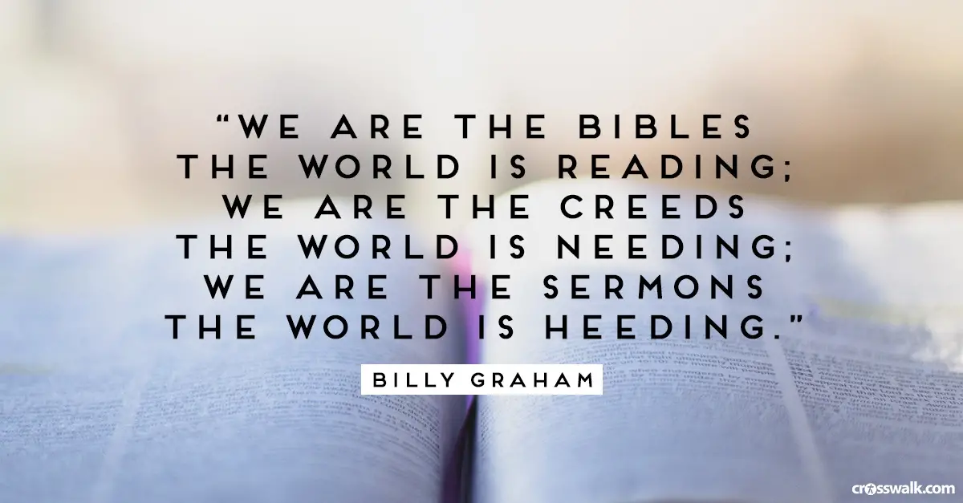
Children & Youth Upcoming Events:
- October 16 - Hayride at Clodbuster Farms - Leave UCBC at 6pm.
- October 23 - Trunk-or-Treat – Meet 6pm in the Sanctuary.
Car trunks be in the parking lot by 5:45pm. Thanks.

Homecoming
Join us on Sunday, October 20th, for our 63rd annual Homecoming celebration. Our guest speaker this year is Rev. Dr. Noel Schoonmaker. He served as the Minister of Youth here at UCBC in 2002 – 2004. He is currently Senior Pastor of Second Baptist Church, Richmond, Virginia. A native of Travelers Rest, South Carolina, he was ordained to the gospel ministry at Churchland Baptist Church, Lexington, North Carolina, where he served as Senior Minister. He also served as Senior Pastor of First Baptist Church, Valdese, North Carolina and First Baptist Church, Murfreesboro, Tennessee. Noel is married to Dayna, whom he met at Wake Forest, and they have two daughters, Maggie (12) and Nora (9). We’ll have lunch in the Fellowship Hall following our worship service. Bring your covered dishes and be ready for a good time. Clean-up day to prepare for homecoming is Saturday, October 12th beginning at 8am. Rain date will be Saturday, October 19th. We ask that the Building & Grounds Committee and anyone who would like to volunteer, please come help set up the Fellowship Hall on Friday, October 18th at 7pm.



October Birthdays

10/1  10/2  10/4  10/5  10/7  10/8  10/11  10/12  10/13  10/25  10/26  10/27  10/28 |  |  | Aaron Kramer, Alana Whitaker  Trevor Ward, Josh Wilson  Teresa Riggs  Amy Turner, Tina Church  Dennis Hester, Tyler Johnson  Michael Buckner, Madyson Daniels  Charlie Hall  Jake Weavil  Barbara Dortch, Kathy Idol  Ralph Hedgecock  Ann Canada  Durham Clodfelter  Angie Weavil

Union Cross

Baptist News

Vol. 41 October 1, 2019 No. 10



Seniors to the Fair
Tuesday, October 8th

Men’s Class Sponsoring
Food Drive
Saturday, October 12th

Homecoming
Sunday, October 20th

Senior Moments Luncheon
October 17th @ 11am

Trunk or Treat
October 23th @ 6pm

It’s a beautiful day!
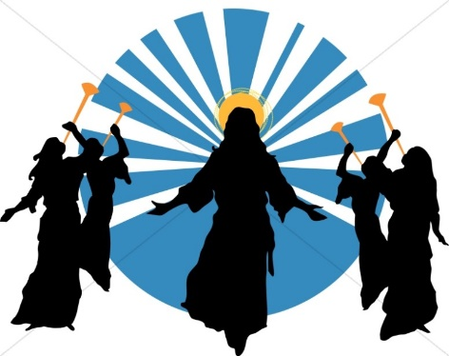
Today has been another of the many days recently when I have found myself saying “It is a beautiful day!” Then it struck me, what if I said “It is a beautiful day, maybe Jesus will come today!” Will I do anything differently if I think more often that this sunny warm day may be the one when Jesus returns? Here are some thoughts from God’s Word to help us think about Jesus’ return.
There is an exciting day coming to look forward to that is described like this; (1 Thessalonians 4:16-18 Living Bible) ^{16…}the Lord Himself will come down from heaven with a mighty shout and with the soul-stirring cry of the archangel and the great trumpet-call of God. And the believers who are dead will be the first to rise to meet the Lord. ¹⁷ Then we who are still alive and remain on the earth will be caught up with them in the clouds to meet the Lord in the air and remain with him forever. ¹⁸ So comfort and encourage each other with this news.
While we wait we are to (Luke 21:28) ^{28…}stand up and lift up your heads, because your redemption is drawing near."
We are to look forward to Christ’s return so as not to be caught unprepared (1 Thessalonians 5:2-5) ^{2…}know very well that the day of the LORD will come like a thief in the night. ³While people are saying, "Peace and safety," destruction will come on them suddenly, as labor pains on a pregnant woman, and they will not escape. ⁴But you, brothers and sisters, are not in darkness so that this day should surprise you like a thief.
Some of Jesus last words in the last chapter of the Bible to us are (Revelation 22:12) ¹²"Look, I am coming soon! My reward is with me, and I will give to each person according to what they have done.
Let’s try something, next time we walk out and greet a beautiful day don’t just say “It is a beautiful day!” let’s try and say “It is a beautiful day, maybe Jesus will come today!”
Peace, Kent

The Senior Moments Group will be going to the fair on Tuesday, October 8th, leaving the church at 9am. Their monthly luncheon will be on Thursday, October 17th at 11am. So bring a covered dish and join the fun.

Nursery Schedule
October 2, (Wed) | Alice Striplin PM
October 6, (Sun) | Kathy Idol & Alice Striplin AM
October 9, (Wed) | Julie Striplin PM
October 13, (Sun) | Susan Hilton & Carlene Compton AM
October 16, (Wed) | Nancy Clodfelter PM
October 20, (Sun) | Marianne & CC Casas AM
October 23, (Wed) | Brenda Grose PM
October 27, (Sun) | Tina & Crista Church AM

Children’s Church & Wee Church Schedule
October 6, (Children’s) | Megan Coleman & Brittney Lewallen
October 6, (Wee) | Emma & Chris Lawrence
October 13, (Children’s) | Carole Blakley & Melissa Little
October 13, (Wee) | Julie Striplin & Need Volunteer
October 20, (Children’s) | Stacy & Morgan Bowlin
October 20, (Wee) | Jane & Jill Sutphin
October 27 (Children’s) | Susan Kramer & Daughters
October 27, (Wee) | Krisi Kern & Need Volunteer

New Deacon Officers for the 2019/2020 church year are: David Beekman - Chair, Beverly Weavil - Vice Chair, Nancy Clodfelter -Secretary, and Robin French - Assistant Secretary.



SEPTEMBER ACTIVITIES:
- Deliveries to both Hospice Homes were made in September and the next Hospice Ministry emphasis Sunday is scheduled for October 6th.
- At our September meeting, we separated and counted the back to school items and we were overwhelmed with the total count – 1,444 items!!!. Wow, that is amazing and I wish to thank each of you for your donations—bless you all!!. We were able to not only assist Union Cross and Glenn High schools as planned, but also Hall-Woodward Elementary, Smith Farm Elementary and the Community Involvement Program whom we found out were very much in need of donations as well. During delivery, the Social Worker for these latter 3 schools told us of a great need for earbuds and headphones to be used in reading labs so Beverly and I personally donated 45 pr. of earbuds and 10 headphones for those youngsters whose families could not afford them. Let us continue to pray for all children to have a successful school year.
- As approved by WOM ladies attending the September meeting, we sent a $500 check from WOM funds to a local family with connections to our church for upcoming travel expenses needed for one of the family members to receive medical treatment at an out of town hospital.
- 40 hygiene bags, 48 bottles of water, 48 peanut butter crackers, 48 bags of Cheez-Its, 48 Pecan Twirls and 1 blanket were delivered to Clemmons FBC for the upcoming Fair Ministry.
- 14 ladies from our church loaded up on September 21st to go to the H.O.P.E facility to bag fresh vegetables and prepare bagged lunches for inter-city economically deprived families.
- A total of 37 new blankets have been purchased to be given to families that receive toys at the December Community Baptist Toy Store in Kernersville sponsored by local Baptist churches.
All ladies are invited to attend our next WOM meeting on Wednesday, October 2nd. Doing what we can, when we can, and where we can for others is our way of demonstrating how UNION CROSS REACHES OUT TO SHOW HIS LOVE.

