Homecoming
Join us on Sunday, October 16th, for our Homecoming celebration. Pastor Benn will have a brief message, then we will hear the gospel through song from the Unity Quartet. They are a Southern Gospel Quartet from Pembrock, NC that has performed all over the US allowing them to share Gods word in churches, theme parks, auditoriums, cruise ships and radio. Come expecting a blessing, invite everyone you know and be a part of some good ole singin! Our homecoming offering will go to the Kernersville Crisis Control. Lunch will follow the service in the fellowship hall. Bring your covered dishes and be ready for a good time. Clean-up day to prepare for homecoming is Saturday, October 8th beginning at 8am. Rain date will be Saturday, October 15th. We ask that the Building & Grounds Committee and anyone who would like to volunteer, please come help set up the FH on Friday, October 14th at 6pm.

Sisters in Christ
October 8th come out for breakfast at the Olympic restaurant
in k-ville at 8:00 am. Then off to Tanglewood for the Southern Charm at the Farm. You will need to purchase your $6 ticket online before Oct. 7th. October 21st at 7:00 pm in the FH join the ladies for great fellowship and play Bunco. There is a sign-up sheet on the bulletin board in the sanctuary foyer. All ladies 20 and over are invited.

Children’s Church - Ages 3 to 10
October 9th | Kathy Horton
October 16th | Robin French



October Birthdays

10/2  10/4  10/5  10/7  10/8  10/12  10/13  10/25  10/26  10/27  10/28 |  |  | Trevor Ward, Josh Wilson  Teresa Riggs  Amy Turner, Tina Church  Dennis Hester  Michael Buckner, Madyson Daniels  Jake Weavil  Kathy Idol  Thomas Lawrence  Ann Canada  Durham Clodfelter  Angie Weavil

Union Cross

Baptist News

Vol. 44 October 1, 2022 No. 10

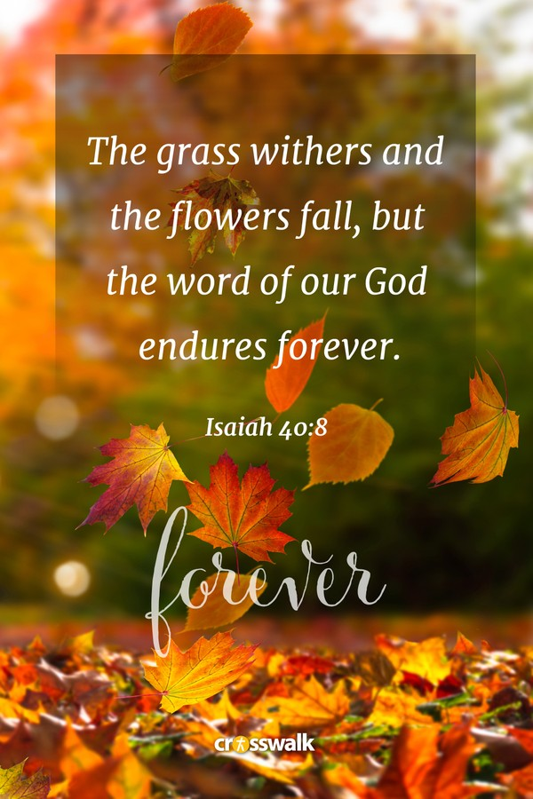

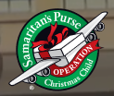
GOOD NEWS. GREAT JOY. Operation Christmas Child shoebox gifts are not just gifts but where Samaritan’s Purse’s local partners deliver the message of the Gospel of Jesus Christ & multiplies believers & churches worldwide. I cannot believe
a year has passed. Women on Missions is already getting ready for the Operation Christmas Child season. I volunteered to be the Project Leader again this year because it is so near and dear to my heart. Last year, despite the continued pandemic, we were able to fill 83 shoeboxes! I hope we can fill just as many if not more this year, so I am setting the goal to 90 shoeboxes. On Sunday, Oct. 2nd, empty boxes & brochures will be available in the sanctuary foyer & other buildings. Our collection this year will run till Oct. 31st. There will also be empty, decorated boxes in all buildings to place items if you don’t want to fill a whole box or you can give me money in an envelope to go shopping for items. Get your Sunday School Class, friends, & family involved & start thinking now about what you want to put in your shoebox(es). Look for more information via church bulletins as we kick off OPERATION CHRISTMAS CHILD! -Jill Sutphin, UCBC WOM OCC Coordinator

“Go therefore and make disciples of all the nations.” - Matthew 28:19

The Senior Moments Group will be having a pizza party on Tuesday, October 25th at 11:00 am. So come join them for a fun time of fellowship.

New Deacon Officers for the 2022/2023 church year is: Robin French - Chair, Beverly Weavil - Vice Chair, Jane Sutphin -Secretary, and Brenda Grose - Assistant Secretary.

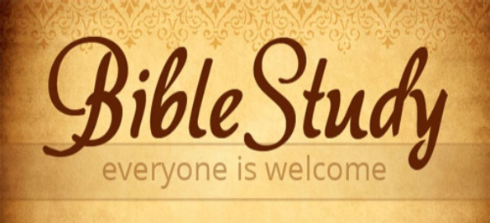

Come join us EVERY Wednesday morning for bible study at 10:00 am in the Fellowship Hall. Pastor Benn will be teaching on the Holy Spirit.

Keeping in Touch
Ruth would welcome visits and cards.
Medical masks are required.
Westchester Manor
Ruth Hedgecock Room #213
1795 Westchester Drive, High Point, NC 27262


Women on Mission ladies had their September email meeting on August 4th.
SEPTEMBER WOM ACTIVITIES:
- Hospice Ministry Note: Generous snack donations were sent to both Hospice Homes.
- Inward Meals continues.
- A big thank you to Lisa Young for bringing in 4 huge boxes of school supplies for our various projects. They will be used wisely!
- Vote taken & approval given to sending a $150 check to Joyce Love for the Carolina Classic Fair Ministry to assist with canteen items & meals for the Fair Workers.
- Hygiene items for our troops are still being donated.
- Appalachian Coalfields Backpacks Ministry
- We voted to using $500 of WOM funds to purchase Bibles, backpacks, hygiene items & candy for the Appalachian Backpack Kids Christmas Ministry, all of which are required in each backpack we send. With much research, we found exceptionally good prices online & purchased backpacks & Bibles in bulk while one of my “Sherlock’s” aka Jean Foster found a great markdown on backpacks at Walmart for $1 each! Other WOM ladies are always looking for the very best prices to enable us to help more people by being good stewards with our funds. (The bargain hunting applies to all our projects.)
- It was decided that we ask the congregation to assist us with donations of the other required items; i.e., scarf, toboggan, socks, toys, flashlights, jewelry, canned food with pop tops, etc. and wow did you come through!!! The collection baskets were so overflowing that some of the donations were moved to our storage room. Also, for your information, each filled backpack will have a flyer called “The Christmas Story” which explains the true meaning of Christmas as we know it.
- Additionally, we made the decision to use excess toy donations for the Christmas Shoe Boxes with any excess food donated to Crisis Control.
- Thank you to Mark Reavis who shared with the congregation first hand insight regarding all the poverty in the area where our backpacks will be delivered.
For Information Purposes:
Jill Sutphin has agreed to be our Operation Christmas Child Shoe Box Coordinator, Nancy Clodfelter has agreed to continue to be our Inward Meals Coordinator & Jean Foster will continue as the WOM Missions Committee Representative. Beverly Weavil & Jane Sutphin have already met with the Baptist Toy Store Leader to begin planning the Christmas toy store. Time is truly flying by, but we must all remember God gave us purpose in life & it is up to us to choose how we use it, so as we plan our mission projects, it is our prayer that others in need can really feel how “UNION CROSS REACHES OUT TO SHOW HIS LOVE.”
Jane Sutphin - WOM President

