
Prayer Concerns: Roger Burnett (Lisa Young’s father), Ellen Cook, Bobby & Irene Cheek, Jr. Clodfelter, Marty & Judy Daniels, Larry Davis (Susie Hilton’s nephew), Melvin Duncan, Brian Grose, Ann Huth, Ritchie & Stoney Longworth, Juan & Lidia Mendoza (neighbors of Hal & Melissa Little), Ron Mills, Jerry & Pam Napier, Ron & Doris Pinyan, Alice Striplin, Davis Tucker (Felix & Gayle’s friend), Sara VonCannon, Dean & Tracy Ward, John Young (Lisa’s husband), and unspoken prayers.

Church Yard Sale
Please continue bringing your clean, gently used, and saleable items for our Yard Sale, which will be held on September 12th from 8am – 2pm. Donation Drop-Off Location: Youth Room in the Fellowship Hall. All proceeds from the yard sale will benefit the Drive-Thru Awning Project. The last drop-off date is September 5th. In addition to the yard sale, we will have a bake sale. Anyone wishing to donate frozen Items (i.e., chicken pies, etc.), Canned goods (i.e., pickles, relish, etc.) or baked goods, please have them to the church no later than 3pm on September 11th. If you have any questions, please see Susie Hilton or Robin French.

Children’s Church - Ages 3 to 10
September 7th | Marianne Casas
September 14th | Cindy Clark
September 21st | Julie Striplin
September 28th | Kathy Horton

September Birthdays


9/4  9/7  9/9  9/13  9/20  9/22  9/25  9/26  9/30 |  |  | Hal Little  Luke Weavil  Hugo & Cassidy Casas  Madison Weavil  Rae Hurley, Dale Lakey, Becky Lauten  Jeff Honeycutt  Matthew Nibert  Marianne Casas  John Church

Non-Profit Organization
U.S. Postage PAID
Greensboro, NC
Permit 5043

Pastor
Music Director
Minister of Education
Organist
Pianist
Office Administrator

Union Cross Baptist Church
4350 High Point Rd.
Kernersville, NC 27284
(336)769-2862 Phone
www.unioncrossbaptistchurch.org ucbaptist@bellsouth.net

Dr. Adam Woods
Mrs. Gayle Smith
Rev. Marty Daniels
Mrs. Angie Weavil
Mrs. Sara VonCannon
Mrs. Teresa Tucker
Return Service Requested



Union Cross

Baptist News

Vol. 48 September 1, 2026 No. 9

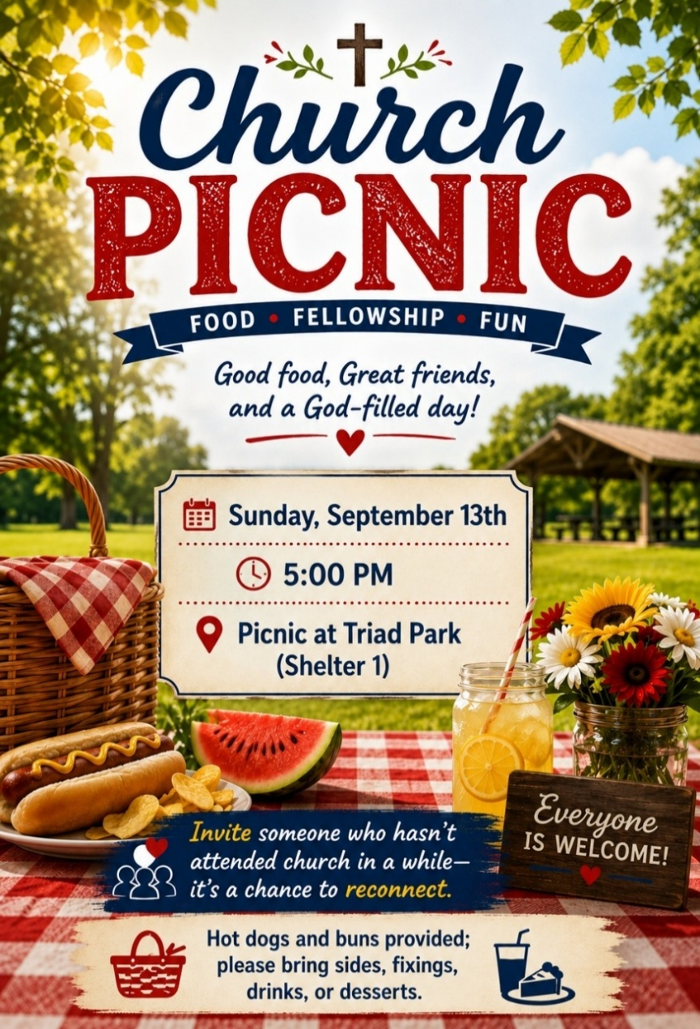
A Word from the Pastor

Thomas Carlyle said, "Our main business is not to see what lies dimly at a distance, but to do what lies clearly at hand." Vision is essential to leadership, as is seeing the big picture—no doubt about it. But great leaders also have the ability to see and do what is necessary today.

It's the principle of first things first. Solomon said it as simply as it can be said: Develop your business first before building your house. (Proverbs 24:27) This is what great leaders do. Whereas many flounder from week to week, effective leaders make sure that first, before anything else, business gets done each day.

What's your business? I mean your real business? What matters most to you? Is there anything on your agenda today that reflects this priority? Long-term vision is great, but we also need to make a habit of taking care of today's business today. See if you can complete these two sentences:

1. My real business is __________.

2. I will develop it today by doing this: _______________.

If your real business is following Jesus, then do something today that makes you more like him. Give. Love. Serve. Forgive. Show mercy. Develop your business (your real business) first, before doing anything else.

Grace and Peace
Adam

Help us help others! NC Baptists on Mission & our WOM ladies seek your help with providing canned food in the Appalachian Backpacks that we send each year to poverty-stricken youngsters in the Appalachian Coalfield areas. Our goal this year is to fill 48 backpacks. Each backpack must have 3-4 pop-top metal cans of food such as beef stew, ravioli, tuna, vegetables, fruit, etc. If you can help us with this project, there will be collection baskets in all 3 buildings beginning Sept. 1st & ending September 30th. (Any excess donations of the estimated 168 cans needed will be donated to either Hospice or to Crisis Control Ministry.) PLEASE KEEP IN MIND THESE SPECIFIC REQUIREMENTS – NO PLASTIC OR MICROWAVABLE CONTAINERS & MUST BE POP-TOP!!! Contact Jane Sutphin with questions.
Financial Summary

August 2, 2026
Undesignated Gifts $ 2,880.00
Designated Gifts $ 550.00
Total Offering $ 3,430.00

August 9, 2026
Undesignated Gifts $ 1,009.00
Designated Gifts $ 653.00
Total Offering $ 1,662.00

August 16, 2026
Undesignated Gifts $ 2,411.00
Designated Gifts $ 1,462.00
Total Offering $ 3,873.00

August 23, 2026
Undesignated Gifts $ 2,075.00
Designated Gifts $ 288.00
Total Offering $ 2,363.00

General Fund
July General Fund | $17,740.00
July General Fund Expenses | -$13,117.47
July General Fund Net | $ 4,622.53
July General Fund Balance | $122,524.69


AUGUST 2026 WOM ACTIVITIES:
Hospice Ministry Note: Did you know the snacks that are delivered to the Hospice Homes are a form of outreach? Each one of the snacks has a small label indicating it is from our church & the recipients usually are very appreciative.
Inward Meals: There were some meals delivered during August.
August Mission Projects & Outreach—Members voted & approved the following:
- $67 for candy as required for the 48 Appalachian Backpacks we will be assembling.
- $133 for 150 Operation Christmas Child shoeboxes.
- $200 to Crisis Control Ministry for their pharmacy needs during the special matching challenge.
- To request participation from the congregation for the canned food needed for the backpacks. (see separate announcement).
FYI:
- On Sunday August 16th, 48 ladies attended our Ladies Fellowship Event (Tea) & 16 of those were visitors from within our community. Monetary donations totaling $597 were received for the Family Room Foster Care Resource Room along with 69 clothing items & 7 packs of baby wipes. Our WOM on Mission group also donated a toddler bed, a car seat, and $150 to be applied to their new building fund. A special thank you to every lady who helped make this a successful & enjoyable event!! Also, just as a reminder, general expenses for this fellowship tea were covered by an anonymous donor.
- For the Upcoming Church Year: Jane will remain as President of WOM, Beverly as Vice-President,
Nancy as our Inward Meals Coordinator & Jill as Operation Christmas Child Shoebox Coordinator.
- From January thru June, $5,945.52 of WOM funds were used for our WOM projects & each member was provided a detailed accounting of our contributions & expenses which concurred with those of our church administrator.
UPDATES:
- August 29th @ 9am WOM members will meet to make crafts for OCC shoeboxes & Appalachian Backpacks.
At our Ladies Fellowship Tea, we learned of the many ways to express Hospitality & some of those are shown every month as we plan our monthly projects that extends to many beyond our church walls which also expresses how UNION CROSS REACHES OUT TO SHOW HIS LOVE. --Jane Sutphin

Homecoming
Our Homecoming Celebration will be on Sunday, October 18th. Mike Lauten will be joining us as our guest speaker. Join us for this unique and special time of worship. Lunch will follow the service in the Fellowship Hall.

Crisis Control Food Drive
This month’s food drive will be held at the church on September 12th, the same day as our Yard Sale. Please bring your non-perishable food items and/or this month’s featured food items: Instant Grits & Oatmeal. Monetary donations are always welcome!

