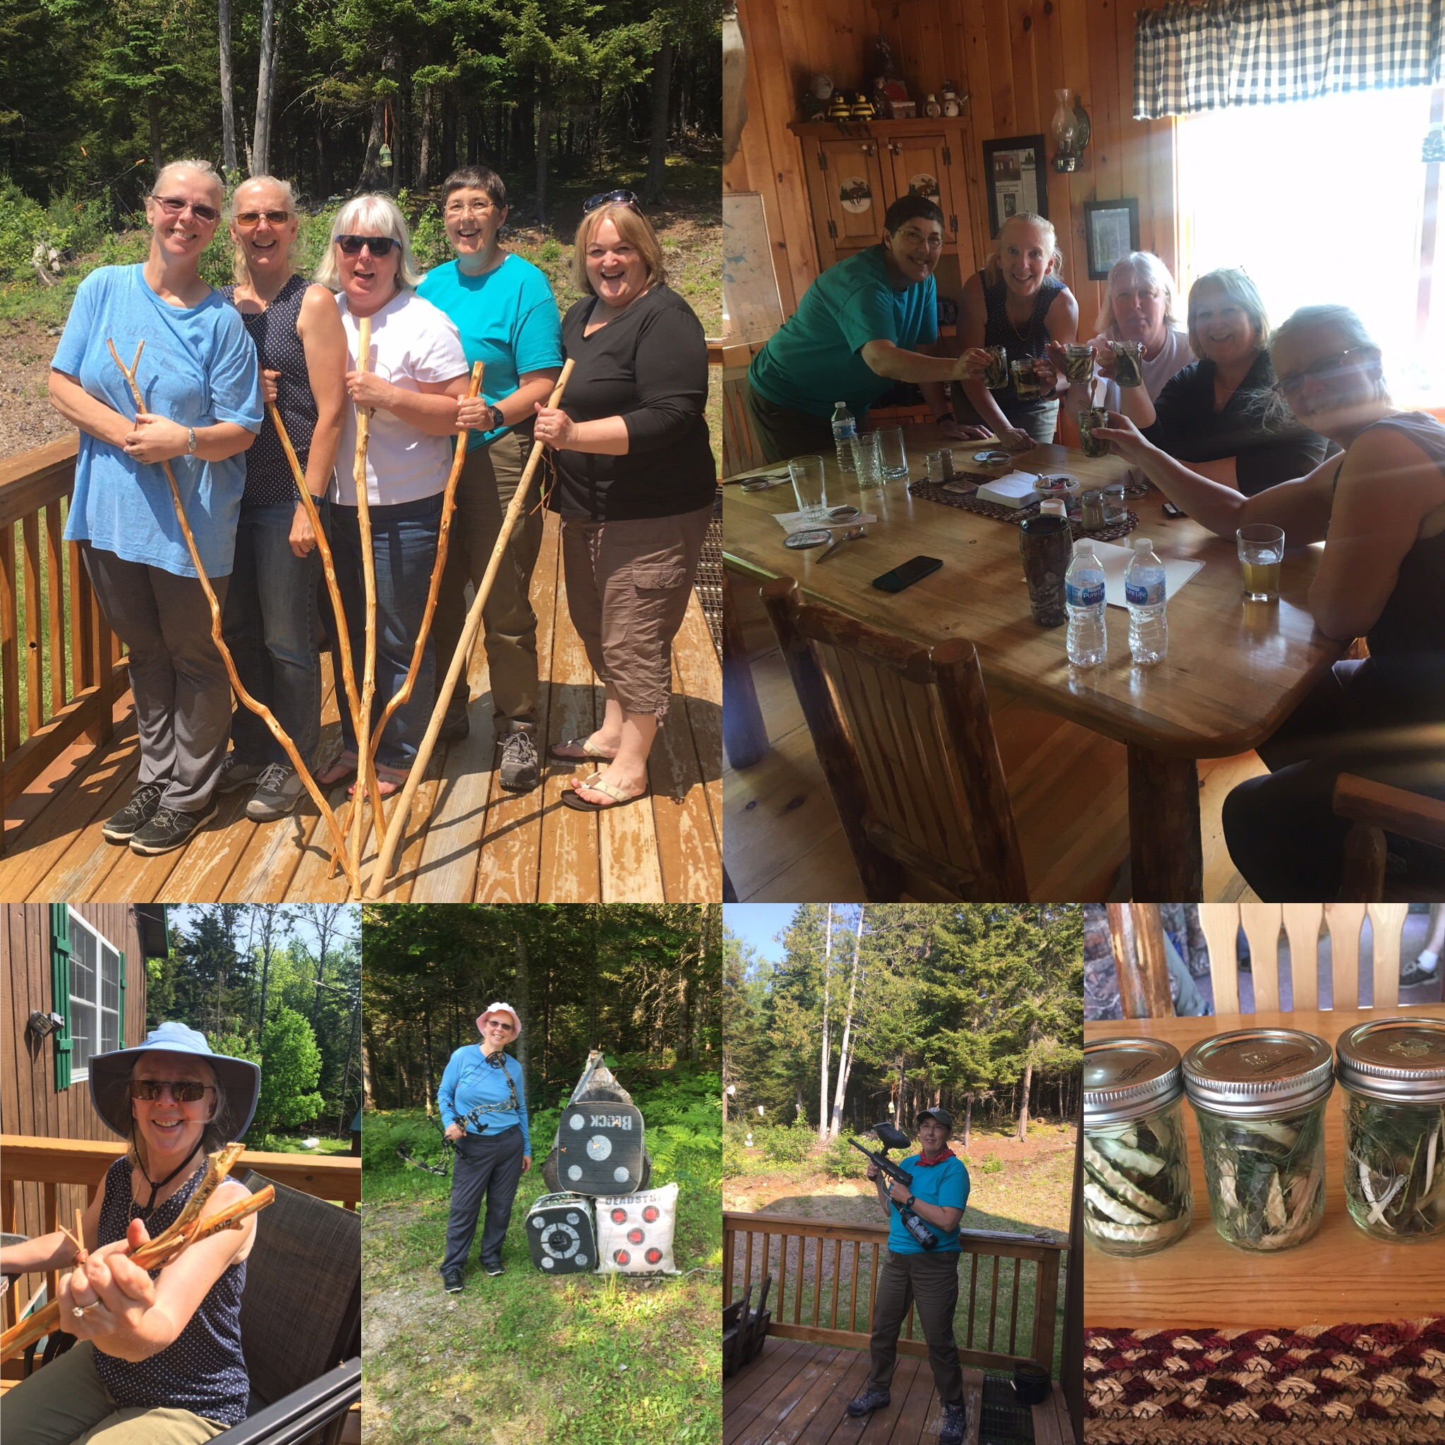
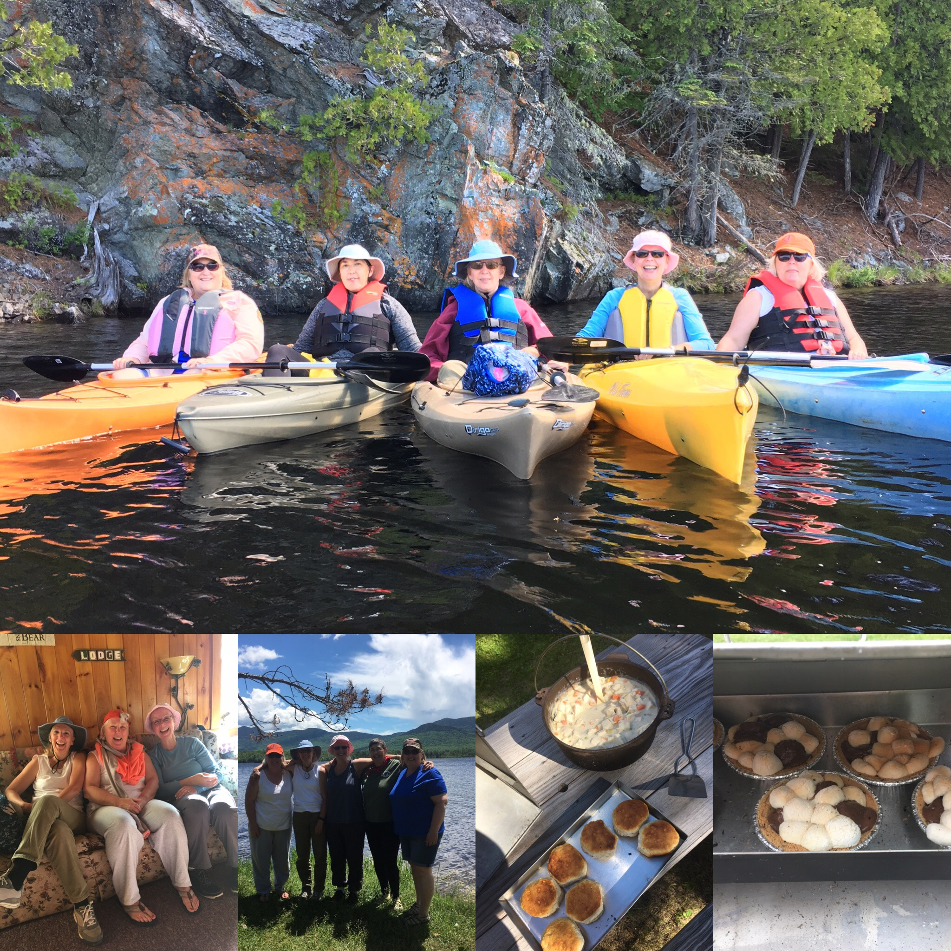
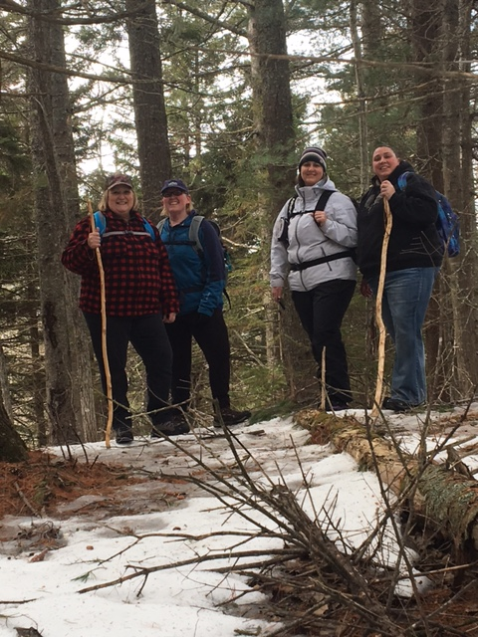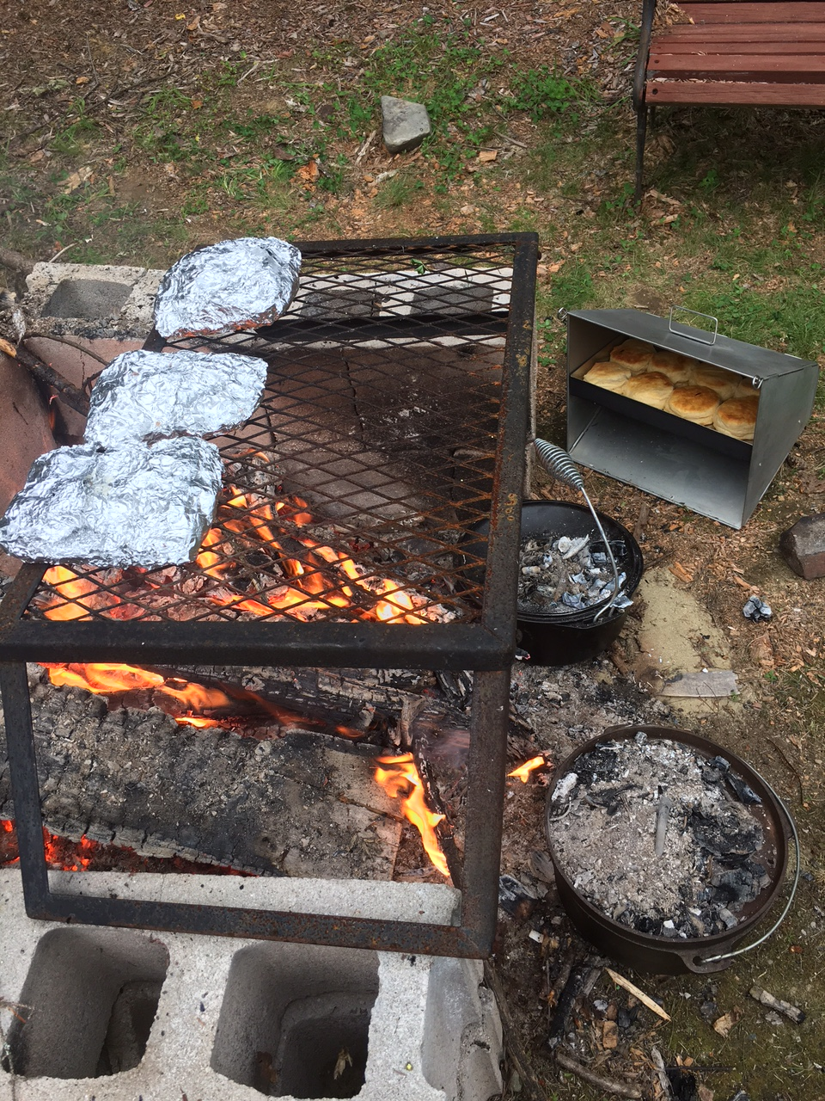
Women’s Weekend Getaway
Langtown Outfitters & Guide Service, LLC
34 Rabbit Hollow Road, Lang Township
Located between Rangeley & Stratton, Maine
Mert & Carol Buzzell, Registered Maine Guides
(207) 402-8824 (207) 576-4536

You and your friends (up to 10) can enjoy a weekend away from the hustle bustle of everyday life.
Time to trade in your to-do list and play in the outdoors.

Custom build your fun adventure retreat; choose from the following classes and workshops……

__Nature Walk & Wildlife Tracking __Campfire Cooking
__Hiking Stick Woodcraft __Wild Game Cooking
__Bird House Woodcraft __Kayaking (flat water)
__Backyards Gone Wild __Nature Crafts
__Forest Walking __Wildlife Safari- Moose Cruisin’
__Turkey Talk, Tales & Tools __Mountain Views Tour - Fall Foliage
__Wilderness Survival Skills __Archery 101
__Field Dressing Big Game __Paintball Target Shooting
__Shed Hunting __Brook fishing & Fly fishing
__Winter Outdoor Survival __Deer Hunting 101

Nature walk & wildlife tracking- A casual walk along the back trails, we’ll explore the forest and look for wildlife signs. Deer, rabbit, fox, coyote, raccoon and moose are frequent visitors to our backyard. We may even catch a glimpse of one of these forest creatures in its own habitat. This nature walk is great for a beginner. Wear comfortable shoes or hiking boots.
Hiking Stick Woodcraft - Whittle your own hiking stick (walking staff). Learn safe knife handling and sharpening skills. Bring your own knife (a lock back-folding knife or sheath knife). You can personalize your new creation with pyrography (wood burning). This is a fun hands-on class.

Bird House Woodcraft - Learn why, when, where and how to attract birds to your backyard. Build your own bird house using common household tools. You can even woodburn a design on it if you choose.

Backyard's Gone Wild - Learn how to create wildlife habitat right in your backyard; – from small mammal habitat to bird habitat. Learn what components are needed for the wildlife you’re trying to attract and what not to plant. Great fun for those that love watching wildlife close to home.

Forest Walking – Connect to nature as we slowly meander along the forest path while listening to the birds, looking at the different greens of the trees, smelling the fragrance of the forest air, dipping your toes in a stream while we drink in the flavour of the forest as we connect to nature through our senses.
Turkey Talk, Tales & Tools -learn about wild turkey habitat and behavior, hunting gear, calling, hunting safety and ethics plus how to clean your turkey. You’ll even make your own turkey box call to take home.
Wilderness Survival Skills- Learn how to stay safe in the outdoors. Participants will learn what to do if lost, how to build a shelter, make a fire, signal for help, find water, find food, and recognize hypothermia. People prepared to survive are least likely to end up in a life-threatening situation. A fun hands-on class. Feel more comfortable in your ability to cope with the unexpected!
Field Dressing Big Game - Proper care of game in the field is a very important part of hunting ethics. This is often a very difficult thing to learn on your own. This class will review the procedure for field dressing a white-tailed deer. Be prepared for a hands-on opportunity.

Shed Hunting – How exciting it is to find your very first antler shed! We’ll discuss some tips and tricks to finding them. What time of year, where and how to look for them. A little luck is very helpful too! Then we'll go for a short hike to see what we can find.

Winter Outdoor Survival_- Shake away your fears of being outdoors in the winter! You will learn how to dress properly, stay warm, navigate and use basic survival techniques. The afternoon will be spent outside building survival shelters, rescue fires, and navigating through the woods. In addition, learn basic winter first aid techniques.
Campfire Cooking -Cooking outdoors over an open fire is challenging and fun – you'll learn to build a fire, cook directly over the hot coals using a Dutch oven, pie iron, foil packs and reflector oven. You will be able to try several different ways of cooking over a campfire. Recipes will be shared and everyone will get a chance to prepare and sample a variety of dishes – even desserts! This is a delicious hands-on class.

Wild Game Cooking- In this workshop you’ll learn to prepare and cook several different game such as deer, moose, bear, partridge, salmon & game fish. More and more people are relying on hunting and fishing to supply themselves and their family with healthy food. Lots of recipes will be shared. You’ll prepare and sample a variety of scrumptious dishes.
Kayak -Learn basic kayaking skills and then practice on the flat waters of an area lake or pond. Learn safety tips and what equipment is needed to enjoy a peaceful adventure. Dress to get wet. We’ll venture out onto either Flagstaff Lake or another picturesque pond and glide along the waters edge, enjoying the peacefullness and tranquility of nature around us. All equipment provided but feel free to bring your own kayak and PFD (life jacket) if you have one. Canoe also available if needed.
Nature crafts – Learn to make a walking stick, survival bracelet, Nature shadow box with pebbles, duck nesting box, bird house, fairy house, brew some Pine Bark Tea or one of many other nature crafts.
Wildlife Safari – Moose Cruisin’- For many folks, catching a glimpse of a Maine moose is a once-in-a-lifetime experience. They are fun to watch, and it’s always exciting to capture one on your camera. You’ll have the opportunity to safely and comfortably view these magnificent creatures and other wildlife as we travel along the old backwoods roads. You’ll also learn about moose habits and habitat from a knowledgeable Maine Guide. We are not guaranteed to find a moose but we’ll do our best and have fun trying.
Mountain Views Tour - Fall Foliage – We’ll take you to some of the most beautiful awe inspiring places in Maine where you’ll feel hugged by the mountains. We’ll travel to a mountain top and have a 360 degree panoramic view for miles and miles, as far as you can see of the most brilliant Autumn colors. This tour is spectacular and awe-inspiring at any time of the year.
Archery 101 – Have you ever wanted to try to shoot a bow? This class will teach you the basics of a bow and how to be successful at shooting the bulls eye. We’ll explore which bow is specifically best for you, safe shooting techniques and tips on accurately hitting your target. Whether you just want to target shoot or learn to archery hunt big or small game, this class is very informative.
Paintball Target Shooting- Let’s splatter some paintballs! This is a fun and exciting ‘free time’ event. You’ll try your hand at shooting several different targets, including a moving target with a paintball gun.
Brook Fishing & Fly Fishing– Let’s build a memory of ‘the one that got away”. Several brooks, streams and lakes in the area are great little fishing holes to cast a few. Bring your own gear and we’ll have some fun. We can even cook up your catch of the day.

Deer Hunting 101- Are you new to hunting or just want to feel more confident in the woods then this class is for you. You’ll learn the steps to take to prepare for a hunt, clothing & gear, deer behavior, where and how to put up hunting stands and blinds, how to choose the proper firearm, shot placement and field dressing.

~~~~~~~~~~~~~~~~~~~~~~~~~~~~~~~~~~~~~~~~~~~

Arrive Friday evening, unpack and unwind. A chance to connect to life's simple pleasures while catching up with friends. Perhaps roast s'mores over the campfire and enjoy the tranquility of the forest around us. Feel free to bring your favorite beverage or spirits to enjoy.

Saturday wake up to a delicious breakfast and head out for the day doing the next adventure. We'll coordinate all the details with lunch included. Return to camp for a hearty dinner. In the evening we’ll have plenty of time to relax and star gaze or go moose cruisin’.
Sunday breakfast is prepared then off for another adventure. After lunch it's time to pack up and begin your journey home re-energized, invigorated, with new skills learned and lots of great memories.

Cost is only $145 per person
(includes lodging, all meals, materials, equipment use and Maine Guide instructions)

So call your friends, choose a date and sign up today

www.LangtownOutfitters.com
For more information contact Carol at (207)576-4536

