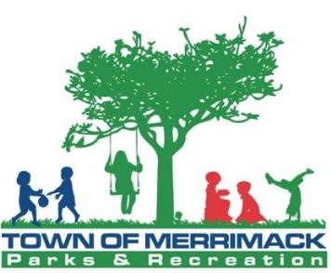
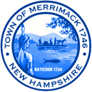
Town of Merrimack
Parks & Recreation
Weekend Park Attendant

The Town of Merrimack, Parks & Recreation Department is currently seeking applicants for the part time position of weekend Park Attendant at Wasserman Park for the Summer 2019 Season.

This position is responsible for staffing the Wasserman Park Beach on weekends from Mid June – Late August. Person in this position will be responsible for enforcing park rules and cleaning up the grounds near the waterfront on a daily basis. Candidates should have good character, integrity, be punctual and be able to effectively and diplomatically deal with park users.
MINIMUM QUALIFICATIONS:
- Must be 18 years of age or older.
- Must be certified in Standard First Aid or willing to become certified prior to employment
- Desire and ability to work outdoors.
- Good character, integrity, punctual and adaptability.
- Independent judgment & initiative
HOURS:
Hours for this position are Saturdays & Sundays from 10:00 am - 6:00 pm

HOW TO APPLY

Interested candidates should complete a Town of Merrimack Application which is available on our website at: www.merrimacknh.gov/positionopenings.

Complete descriptions of all open positions are available on our website. Completed applications should be sent to: Town of Merrimack Human Resources, 6 Baboosic Lake Rd, Merrimack, NH 03054.

Applications can also be obtained by calling the Parks & Recreation Department at 882-1046 or by emailing the Parks & Recreation Department at mcasparius@merrimacknh.gov.

Position open until filled. EOE.

