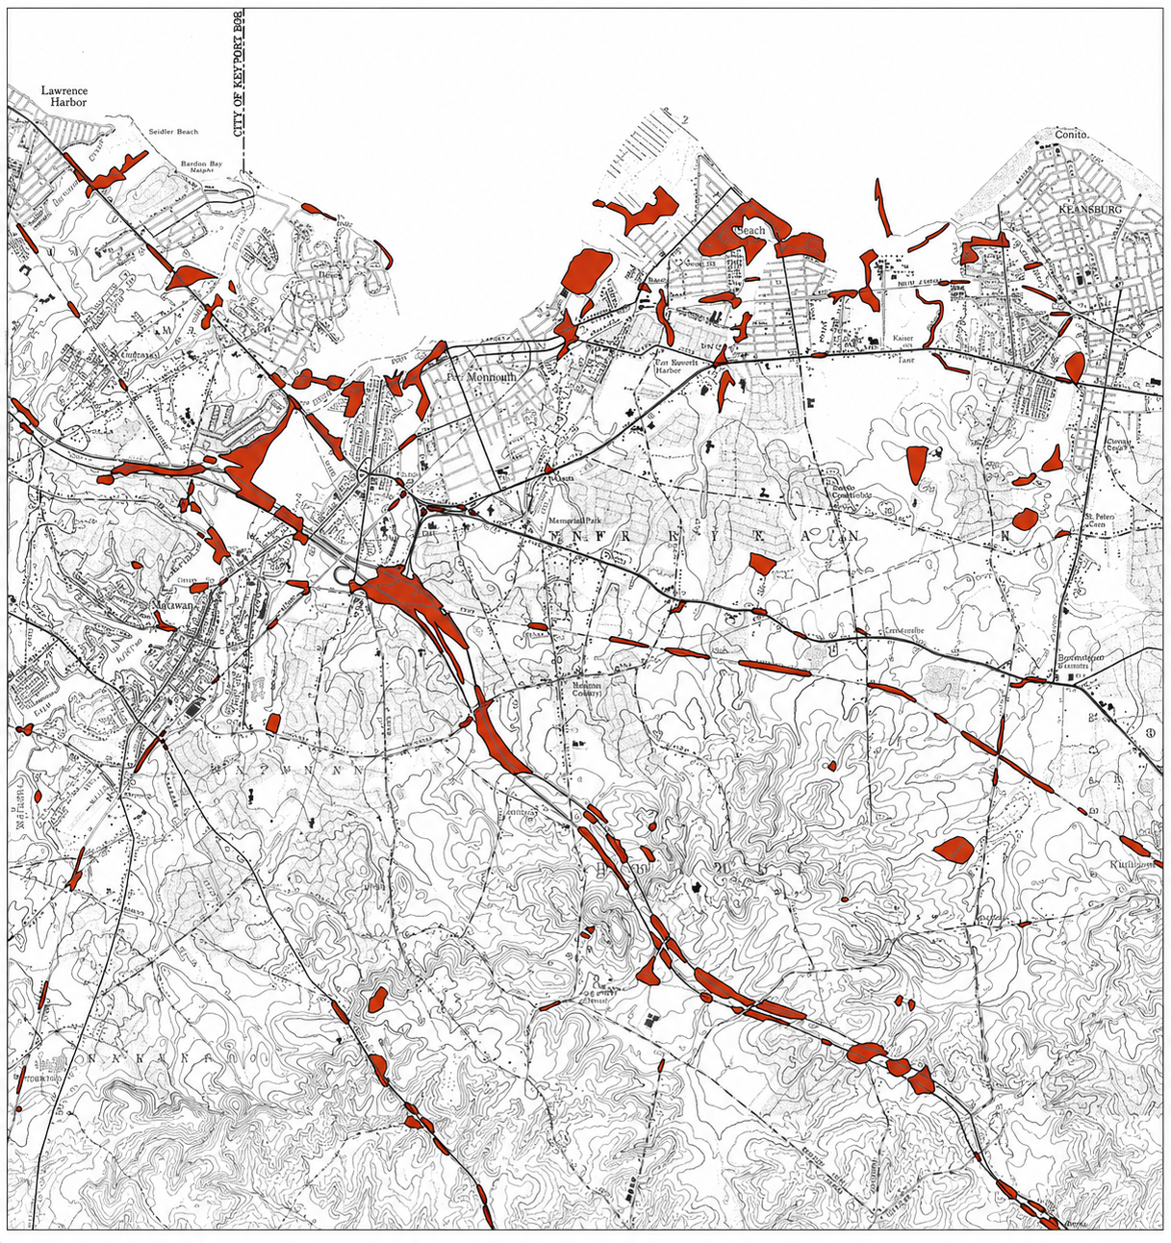
WHAT THIS MAP SHOWS
This map was created by the New Jersey Department of Environmental Protection (NJDEP). It highlights areas in and around Keyport where “historic fill” has been identified. It was very difficult to reproduce the map so that the correct names and labels could be clearly seen, but the shaded areas are more important. They show places where the natural land was filled in by people in the past—sometimes to raise land, build roads, expand waterfronts, or dispose of materials.

WHAT LOOKS LIKE TRUE LANDFILL / DUMPING AREAS
The top portion of the map (below) was enlarged and sharpened, but may not be as precisely accurate as the larger map of the full area shown on the previous page. Some streets are identified in another color. Looking closely at both maps, here are the strongest candidates for actual landfill-type sites in and around Keyport / Union Beach / Cliffwood Beach:
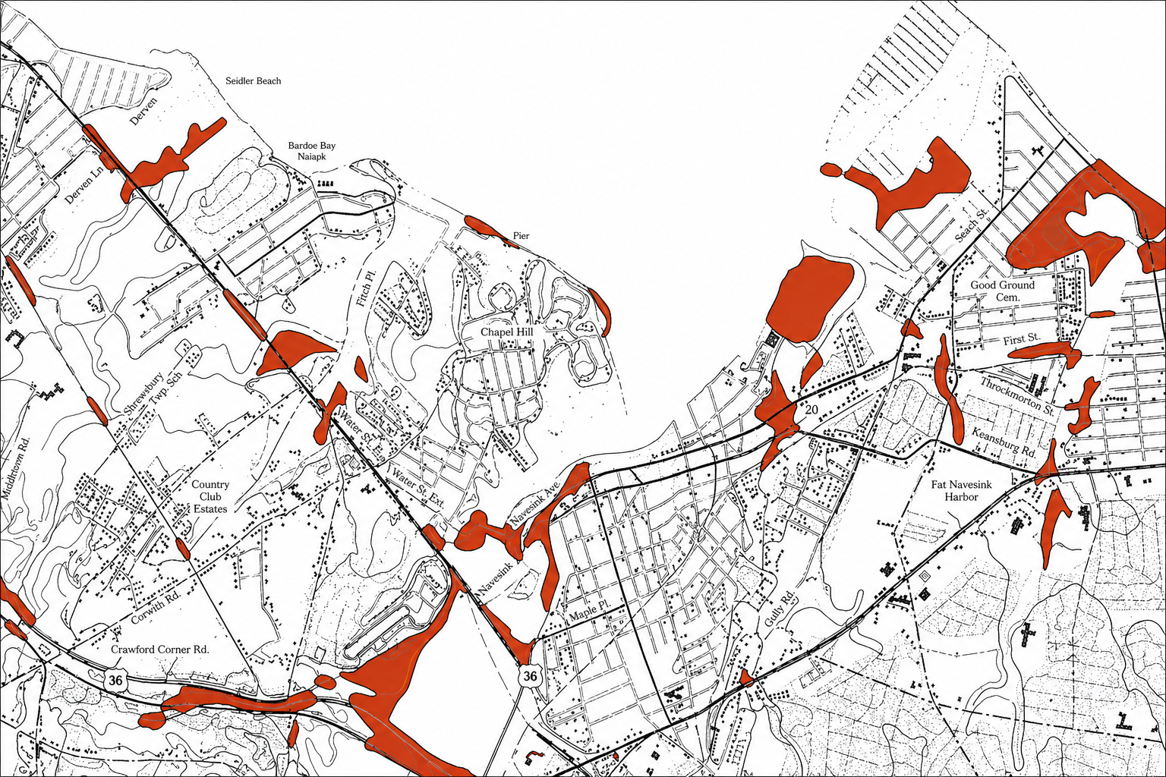
AEROMARINE
1. Aeromarine Site (Keyport Industrial Area)
This is the big one.
- Located near the waterfront along Chingarora Creek / Raritan Bay
- Large, concentrated red area
- Historically documented as:
  - Industrial site (seaplane manufacturing)
  - Later used as a landfill (1960s–1970s)
This is widely considered the primary historic landfill in Keyport

2. Waterfront Fill Areas (Keyport & Union Beach shoreline)
Along the bay, you’ll see long stretches of red:
- These are areas where land was extended into the water
- Often filled with:
  - Dredge spoils
  - Construction debris
  - Unknown materials
Some sections may include dumping, but many are bulkhead/shoreline fill, not formal landfills

3. Creek and Marsh Areas (Luppatatong Creek & surrounding wetlands)
You’ll notice red patches along:
- Luppatatong Creek
- Smaller tributaries and lowlands
These areas were often:
- Soft marshland filled in
- Sometimes used for informal dumping
These are “suspect zones”—not confirmed landfills, but historically vulnerable to dumping

4. Route Corridors and Linear Fill (roadbeds / rail lines)
Long thin red lines—especially inland—are typically:
- Old railroad beds
- Early road construction fill
These are NOT landfills, just engineered fill

5. Scattered Inland Pockets
There are smaller, isolated red patches inland:
- Could be:
  - Old dump sites
  - Construction fill areas
  - Former industrial backfill
These require site-by-site investigation—they’re not automatically landfills
WHAT “HISTORIC FILL” REALLY MEANS
In simple terms, “historic fill” means:
- The land is not completely natural
- Materials were brought in and dumped or placed there
- This could have happened decades ago, often before modern environmental laws existed
What was used as fill could include:
- Dirt and sand
- Construction debris (brick, concrete, ash)
- Industrial waste
- Household or municipal garbage
- Unknown materials (this is important)

WHAT THIS MAP DOES NOT SAY
This is critical to understand:
- The map does NOT prove contamination
- It does NOT tell you what is in the ground
- It does NOT confirm health risks by itself
It simply tells us: “These are areas where the ground has been altered and may need closer attention.”

WHY THIS MATTERS
Areas with historic fill are important because:
- Older fill practices were often unregulated
- Some materials used in the past are now known to be harmful
- These areas may be more likely to contain:
  - Heavy metals (like lead)
  - Petroleum products
  - Industrial chemicals
Because of that, these locations are often:
- Studied more closely
- Monitored
- Tested if development or concerns arise
WHAT WE’RE SEEING IN KEYPORT AND SURROUNDING AREAS
On this map, you’ll notice:
- Many red areas along the waterfront
- Filled sections near creeks, bays, and marshes
- Patches inland where development or dumping occurred
This reflects how towns like Keyport grew over time—by:
- Expanding land into wetlands
- Building over low-lying areas
- Using available materials to reshape the landscape

WHY IT’S IMPORTANT FOR TODAY
Understanding where historic fill exists helps:
- Guide environmental studies
- Inform public health investigations
- Support smarter decisions about land use
- Ask better questions about long-term exposure

Prepared by John R. Schneider (4-28-2026)

