To install the SAC Runway 33/15 landing scenarios into your Orbiter 2010 (orbiter100830) system:

1. Download the Student Astronaut Challenge landing scenarios from the StudentAstronautChallenge.com website to your PC. The download location will be needed in step 7. The scenario files are located in the Challenges > Flight Simulation Challenge > [Documentation for the Student Space Flight Simulation Challenge can be found here.](https://studentastronautchallenge.net/simulation-challenge)
2. Locate your orbiter100830 folder. This houses your version of Orbiter 2010.
   1. Right-click on the **orbiter** startup shortcut.

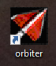

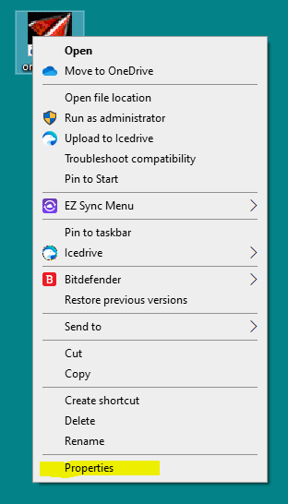

* 1. Select the **Properties** entry. The **Start in:** field displays the file path to the orbiter100830 folder.

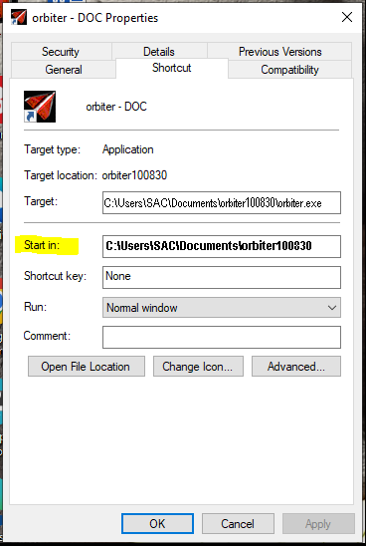

1. Open the orbiter100830 folder following the path shown in step 1b.
2. Open the Scenarios folder. This displays all the folders and files containing Orbiter 2010 flight scenarios (.SCN suffix).
3. Create a new folder named Astronaut Challenge in the Scenarios folder.
4. Open the Astronaut Challenge folder.
5. Copy the two SAC flight scenarios (downloaded in step 1) into the new Astronaut Challenge folder.
6. Exit the orbiter100830 folder.
7. Start Orbiter 2010.
8. The Astronaut Challenge folder should appear in the list of simulation scenarios in the Orbiter Launchpad window.

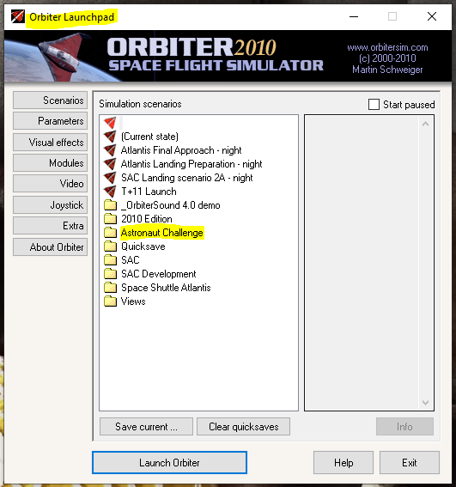

1. Double-click the Astronaut Challenge folder to display the scenarios it contains.

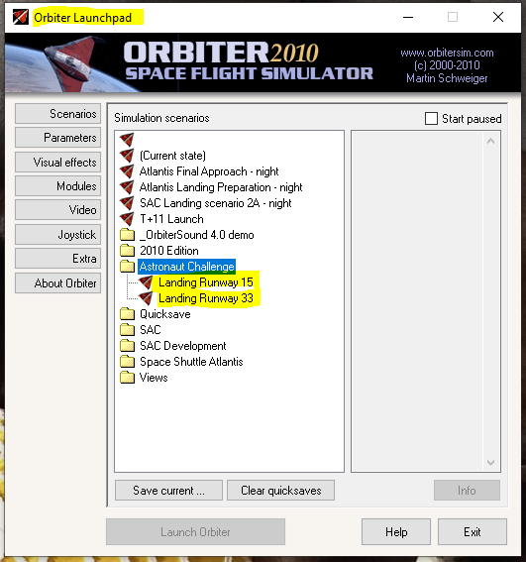

1. Double-click on the scenario you want to run.
2. Have fun and good luck!