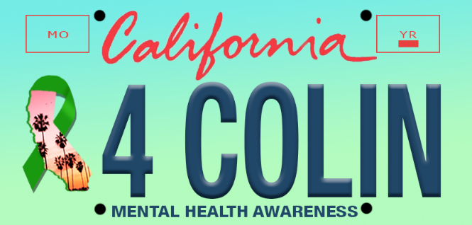
February 14, 2021

Superintendent Tony Thurmond

Attn: Bryan Sapp, Legislative Representative
California Department of Education
1430 N Street
Sacramento CA 95814-5901
EMAIL: bsapp@cde.ca.gov
CC: info@beingwellca.org

SUBJECT: Requesting signature on Mental Health Awareness License Plate Senate Bill, (SB21 Glazer)

Dear Superintendent Thurmond,

On behalf of (ORGANIZATION OR PERSON), I respectfully submit this letter of support for Senator Glazer’s bill that creates a Mental Health Awareness License Plate (SB21) This bill authorizes the DMV to issue a specialty license plate. Funds raised by this plate will go the California Department of Education to support on Campus Wellness Centers for student mental health. This legislation has the ability to raise tens of millions of dollars and equitably fund school mental health support for decades to come.

Even before the current COVID-19 pandemic, anxiety, depression and suicide rates among students and educators had been increasing drastically. Now, this mental health crisis has grown significantly under the weight of isolation and uncertainty. California Healthy Kids Survey or CalSCHLS Survey is given every other year to 7th, 9th & 11th graders. The results show a marked increase in the rates of anxiety, depression and suicide ideation in our students. In some districts, the responses by female Juniors indicate that 51% have experienced clinical depression that year, with some school results reporting a 24% suicide ideation rate.

As a State we can be proud of how our leadership has addressed the physical aspects of the pandemic. The need to bring mental health to the forefront is CRITICAL. National Crisis Call Centers are reporting an increase of 886% in call volume AND the calls are more severe in nature. We are just seeing the tip of the iceberg as we all adjust to a post pandemic California. Mental health will be the next crisis as students return to campus after ten months isolation and disruption.

For the reasons outlined, I urge you to continue to support the Mental Health Awareness License Plate Bill (SB21 Glazer) for it to be signed into law this year.

Sincerely,

{SIGNED}

