JANUARY 2025

ANNUAL REPORT 2024

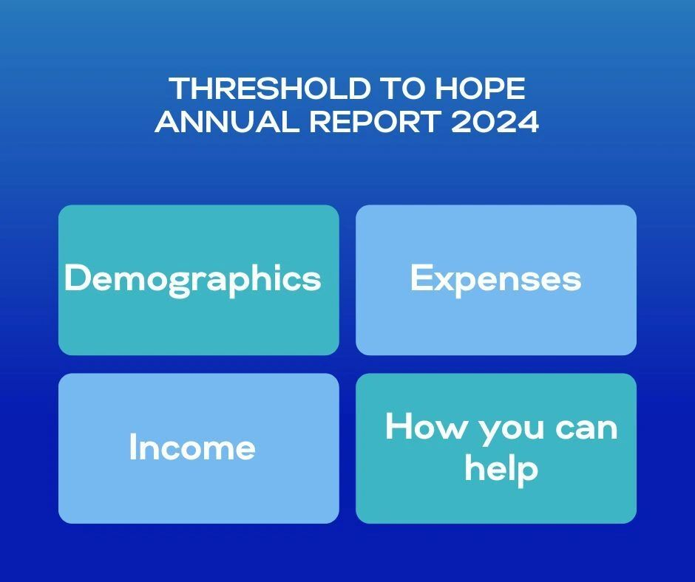
Vision statement: To offer hope and healing through the power of art to those who are experiencing barriers to creativity. Classes are offered on a “pay what you can” basis, regardless of their ability to pay.

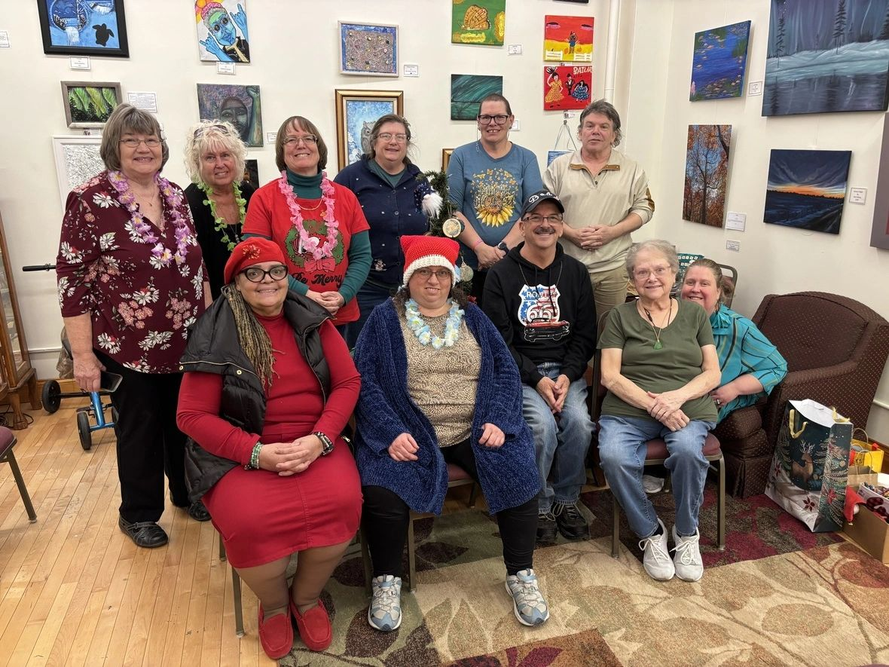
In the year 2024, Threshold to Hope, Inc. celebrated its first full year in its downtown location in the Fox and Hound Building. In this new location, we had plenty of space to allow artists to create while encouraging an atmosphere of community. The ability to do art is extremely important to our artists who expressed that doing art reduced their stress and brought them much joy.
Here is what some of our artists have to say about Threshold to Hope, Inc.:
"It helps me relax and create, lets tension and stress out."
"I love the kindness, love, patience and understanding shown and shared here."
"Threshold is a life changer."
"While painting my mind is in a peaceful place."
"A better experience I have not found in 75 years. Good friends, good fun, good learning new things. Good coffee."
"Takes my mind off day-to-day problems and gives peace of mind doing something I enjoy and give sense of accomplishment."
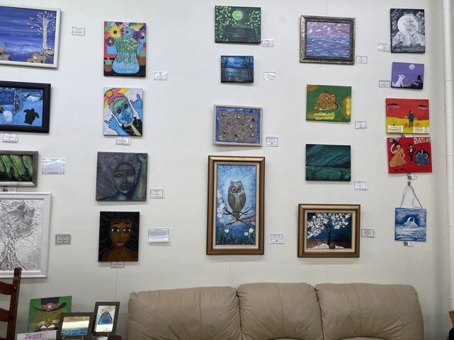
"I feel calm, peaceful and want to create more."
One of our goals was to provide artists a place to show and sell their art. This location gives us a gallery space to display our artists' creations. The art is sold on commission with 60% going to the artist, 30% to TTH and 10% to a nonprofit of the artist's choice. We had over $5700 in sales including fundraising items that benefited TTH 100%!

STATISTICS FOR 2024
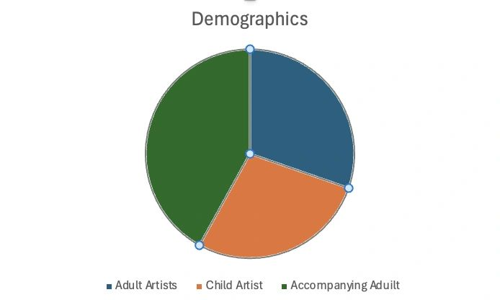
During 2024 we served 232 adult artists (181 New), 212 child artists and 321 accompanying adults. Attendance for 2024 was over twice the amount of 2023 in all areas. This was likely due to the increased visibility of our new location in downtown Bloomington. Many of these individuals came on a regular basis to one or more of the four weekly classes or open sessions. With the increase visibility, we also have increased expenses. Expenses for 2024 were up by 25%.

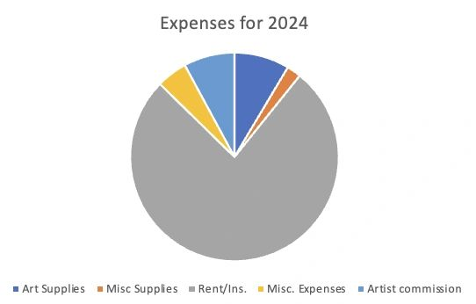
They say a picture is worth a thousand words. This picture shows where most of our money goes—to rent and insurance. We do not have paid staff. Everyone involved with Threshold to Hope as a volunteer does it because they have a passion for people and for art.
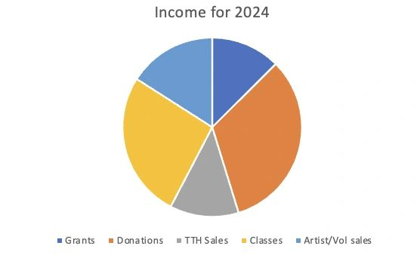
We are so grateful for the donors who support us, the grants from organization that believe in us, our customers and those who chose to take paid classes or have a party with us. You all have kept our doors open and brought joy and support to so many emerging artists. A special thanks to our grant awarders: This program was supported by a grant from the Illinois Arts Council Agency, an agency of the State of Illinois, the McLean County Arts Center, and the National Endowment for the Arts along with Illinois Prairie Community Foundation.
We also wish to thank every single person who donated funds or supplies, or bought a piece of art. It all made a difference in the lives of our artists!

HOW YOU CAN HELP:
- Volunteer—lead or assist with classes, man our front desk, or assist with daily needs at TTH.
- Become a supporter—Give a monthly or one-time gift.
- Buy art for the cause.

Current Hours of services:
Tuesdays and Thursdays from 11-4pm Wednesdays from 6-8pm Open every First Friday from 5-8pm Saturdays from 10-2pm (Children's drop in art classes) Fundraising Classes as scheduled.

Board Members: David Zaring, Chairman of the Board; Nora Zaring, Secretary/Treasurer and Executive Director; Mary Darling, Lead artist for Children's Program; Althea Bellamy; John Beck; Connie Pinkston
A BIG Thank You from all of us at TTH!

See more of our artwork on our Facebook page: https://www.facebook.com/thresholdtohope
For more about our nonprofit visit our webpage at: https://thresholdtohope.org/
Donations may be made through the Facebook page, the website, sent to our mailing address: 200 W. Monroe, Bloomington, IL 61701 We are a 501c3 so your donation is tax deductible.

Our organization earned a 2024 Platinum Seal of Transparency from Guidestar! Now, everyone can see our strategy, metrics, and achievements. Check out our updated #NonprofitProfile on Candid: https://www.guidestar.org/profile/82-195279 200 W. Monroe, Suite 104, Bloomington, IL 61701

