

**200 W. Monroe, Suite 104**

**Bloomington, IL. 61701**

**200 W. Monroe, Suite 104**

**Bloomington, IL. 61701**

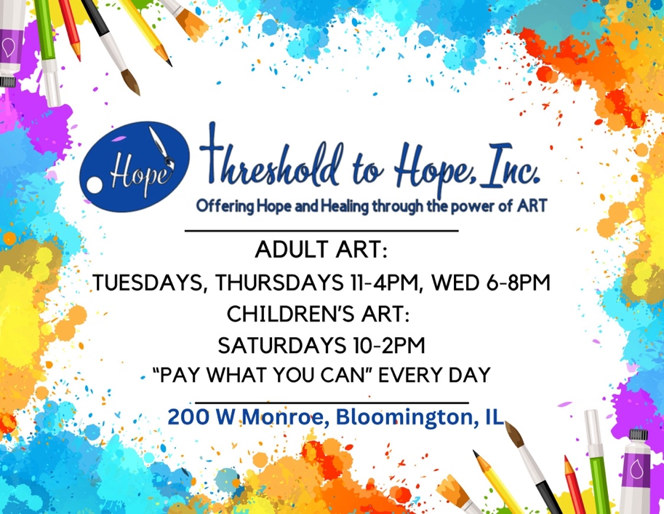

What we offer:

* Open Art Studio (for a donation)

“Pay what you can” Supplies provided

* Classes
* Private parties (classes)
* Art Gallery & Boutique



What we offer:

* Open Art Studio (for a donation)

“Pay what you can” Supplies provided

* Classes
* Private parties (classes)
* Art Gallery & Boutique