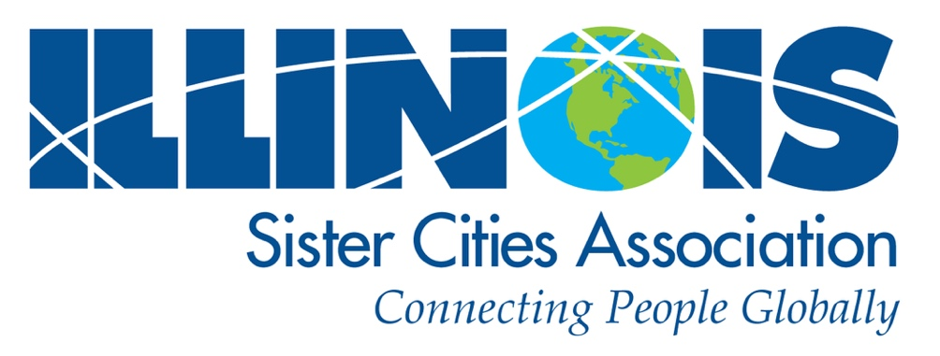

2026 ISCA Awards

Application Forms

*March 29, 2026*

***The Board of Directors of the Illinois Sister Cities Association invites all ISCA member organizations to consider applying for our two state-wide annual awards:***

Illinois Sister City of the Year **and/or**Champion of Youth**.**

Covering events held in **2025** (Youth Award may include events held during the 2024-2025 regular school calendar year).

This is a great way to **generate program recognition** among volunteers and elected officials. Awards will be *announced* at **ISCA’s Annual Meeting,** in_TBD_, Illinois on Saturday, _TBD_, 2026 and *officially* *presented* at the **Illinois Municipal League Annual Conference/Hyatt Regency Chicago**, on September _TBD_, 2026. **No program is too small to be considered for this honor**.

When completing the application, be as informative as possible, and submit any supporting materials that illustrate the quality of your program.

Reminder:

A program that won an award in 2025 must wait one year before tendering another application.

Applicant must be current paid ISCA member

Applications will be available on the ISCA website: <https://www.iscatoday.org>   
 or by contacting: Award Committee Chairman Jim Brown: [capabilitybrown@hotmail.com](mailto:capabilitybrown@hotmail.com)

Application Deadline: 5:00 p.m. Saturday, March 29, 2026

Illinois Sister Cities Association – 2026 Awards – https://www.iscatoday.org

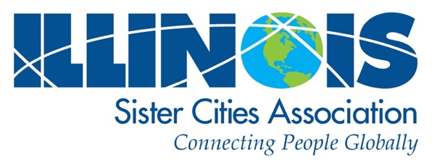

Applicant Instructions

______________________________________________________

All applications will be submitted digitally.

A completed and signed General Application is required from each award applicant:

(pages 3– 5)

1.) If you apply for Sister City of the Year, please **also** complete pages 6 – 7.   
  
 3.) If you apply for the Champion of Youthaward**,** please **also** complete pages 8 –9.

Supporting Materials:

Supporting materials may be submitted as pdf files:

a. Photos of your program / events

b. Newspaper articles, press releases  
 c. The URL of your association’s website if you have one

d. Organization newsletter relating to your application if you have one

e. Any other supporting materials

Submit forms to the awards chair Jim Brown: [capabilitybrown@hotmail.com](mailto:capabilitybrown@hotmail.com)

Reminder:

A program that won an award in 2025 must wait one year before tendering another application.

Applicant must be current paid ISCA member

Illinois Sister Cities Association – 2026 Awards – https://www.iscatoday.org

Illinois Sister Cities Association / **General Application** Form / **p. 2**

*Deadline is March 29, 2026*

Illinois Sister Cities Association / **General Application** Form / **p. 3**

*Deadline is Friday, March 29, 2026*

**GENERAL APPLICATION FORM (All Applicants)   
2026 ISCA Awards**

Questions? contact Jim Brown: [capabilitybrown@hotmail.com](mailto:capabilitybrown@hotmail.com)

_________________________________________________________________________________________  
  
Provide Information covering your activities between **January 1, 2025** and **December 31, 2025**

**________________________________________________________________________________________________________________________________________________**

**Applicant Information**

|  |
| --- |
| On behalf of the City of: |
| Name of City Mayor or Administrator: |
| Community population: |

|  |  |  |  |
| --- | --- | --- | --- |
| Sister City Organization making application: | | | |
| Name of Organization’s President: | | | |
| Organization’s contact address: | | | |
| City: | | State: IL | Zip Code: |
| Phone contact: | Cell Phone | | |
| E-mail contact: | | | |

**How long have you been a Sister Cities organization?** ___________

**Sister Cities Partnerships**

|  |  |
| --- | --- |
| Please tell us the names and location of each partnership (attach additional partnerships on separate paper) | |
| 1.| Sister City Partner: | |
| Province /Country: | Year founded: |
|  | |
| 2.| Sister City Partner: | |
| Province /Country: | Year founded: |
|  | |
| 3.| Sister City Partner: | |
| Province /Country: | Year founded: |
|  | |
| 4.| Sister City Partner: | |
| Province /Country: | Year founded: |

Illinois Sister Cities Association – 2026 Awards – https://www.iscatoday.org

Illinois Sister Cities Association /**General Application** Form / **p. 4**

*Deadline is Friday, March 29, 2026*

**General Application Form** *(cont.)*   
 Questions? contact Jim Brown: [capabilitybrown@hotmail.com](mailto:capabilitybrown@hotmail.com)

**Tell Us About Your Sister City Organization**

|  |
| --- |
| Are you an independent 501(c)3? ______ Yes ______ No |
| Are you part of the City’s administration? ______ Yes ______ No |
| Does an elected official and/or paid staff person serve on the committee? ______ Yes ______ No  If “YES,” what is their name and title? ___________________________________________________________________ |

**Budget**

|  |  |
| --- | --- |
| What is your annual budget? | |
| Does your city provide funding? ______ Yes ______ No | **If so,** what % of your budget? |
| Other sources of your funding? | |

**Membership**

|  |  |
| --- | --- |
| How many members do you have? | Does your membership pay dues? ______ Yes ______ No |

**Communications and Outreach**

|  |  |
| --- | --- |
| Do you publish a brochure? ______ Yes ____ No | A newsletter? _______ Yes ______ No |
| Do you maintain a web site? ______ Yes ______ No  What is the URL? Website - ________________________________ Facebook-______________________________________ | |
| Do you use other types of Social Media or advertising? | |
| Other information you wish to share:  ­­­­­ | |

Illinois Sister Cities Association – 2026 Awards – https://www.iscatoday.org

Illinois Sister Cities Association /**General Application** Form / **p. 5**

*Deadline is Friday, March 29, 2026*

**General Application Form** *(cont.)*    
 Questions? contact Jim Brown: [capabilitybrown@hotmail.com](mailto:capabilitybrown@hotmail.com)

__________________________________________________________________________________________

**IMPORTANT:** If selected to receive this award, a plaque will be presented to your city. Please provide the following information, which ISCA will use to prepare the award plaque.

The ISCA Board expects to be able to make the presentation at the 2026 Illinois Municipal League (IML) Annual Meeting. (Errors or incorrect information at submission will be corrected at cost to the award recipient, including shipping – so please fill in your information with care.)

**Plaque Information**

|  |
| --- |
| Name of City: |
| Name of your Sister City organization: |
| Name and title of Mayor or City leader |

-- -- -- -- -- -- -- -- -- -- -- -- -- -- -- -- -- -- -- -- -- -- -- -- -- -- -- -- -- -- -- -- -- -- -- -- -- -- -- -- -- -- -- -- -- -- -- -- -- -- -- -- -- -- **General Application Form Completion**

**Signature of Applicant:** _________________________________________________

**Officer’s Signature:** ____________________________________________________

**Officer’s Title:** ________________________________________________________

**Date Submitted:**  ______________________________________________________

Reminder:

A program that won an award in 2025 must wait one year before tendering another application.

Applicant must be current paid ISCA member

Illinois Sister Cities Association – 2026 Awards – https://www.iscatoday.org

Illinois Sister Cities Association / Sister City of the Year **Application** Form / **p. 6**

*Deadline is Friday, March 29, 2026*

**APPLICATION FORM: 6**2026 Sister City of the Year    
For activities between **January 1, 2025** and **December 31, 2025**

Questions? call contact Jim Brown: [capabilitybrown@hotmail.com](mailto:capabilitybrown@hotmail.com)

__________________________________________________________________________________________  
For consideration to be chosen Illinois Sister City Association’s **“Sister City of the Year,”** please answer the following Questions and submit them along with the completed General Application Form.

A **“Sister City of the Year”** shows an outstanding level of energy, commitment, and success which makes it an excellent example of the goals and mission of the Sister Cities International program. It may exhibit a high profile within the community and exhibit active participation at the municipal, academic, humanitarian, or community service level.

**Arts, Cultural, Recreational, or Other Activities Conducted by Your Organization This Past Year**

|  |  |
| --- | --- |
| Event: | Date: |
| Number attending: |
| Comments: | |

|  |  |
| --- | --- |
| Event: | Date: |
| Number attending: |
| Comments: | |

|  |  |
| --- | --- |
| Event: | Date: |
| Number attending: |
| Comments: | |

|  |  |
| --- | --- |
| Event: | Date: |
| Number attending: |
| Comments: | |

Illinois Sister Cities Association – 2026 Awards – https://www.iscatoday.org

Illinois Sister Cities Association / Sister City of the Year **Application** Form / **p. 7**  
 *Deadline is Friday, March 29, 2026*

|  |  |
| --- | --- |
| Event: | Date: |
| Number attending: |
| Comments: | |

**Remote Events if applicable**

(Events conducted through Zoom or other social media platforms.)

|  |  |
| --- | --- |
| Event: | Date: |
| Number attending: |
| Comments: | |

|  |  |
| --- | --- |
| Event: | Date: |
| Number attending: |
| Comments: | |

|  |
| --- |
| Additional Comments |

**How do you publicize your Sister Cities and their cultures to your community?**

|  |
| --- |
|  |

*We greatly appreciate your time in completing and submitting your application!*

*Thank You!*

Illinois Sister Cities Association – 2026 Awards – https://www.iscatoday.org

Illinois Sister Cities Association / Champion of Youth **Application** Form / **p. 8**  
 *Deadline is Friday, March 29, 2026*

**APPLICATION FORM:**2026 Champion of YouthFor activities between **January 1, 2025** -**December 31, 2025** (or for the **2024-2025** school year).   
   
 Questions? contact Jim Brown: [capabilitybrown@hotmail.com](mailto:capabilitybrown@hotmail.com)

__________________________________________________________________________________________

For consideration to become Illinois Sister City Association’s **“Champion of Youth,”** please answer the following questions and submit them along with the General Application Form.

A **“Champion of Youth”** award winner initiates, coordinates and otherwise supports a program for youth that   
may include exchanges between Sister Cities partner cities, schools, or family-to-family. It may also support exchanges that are media based via Zoom, Skype, FaceTime, Facebook, Snapchat, E-mail or letter writing.

The Sister Cities program supports youth through Citizen Diplomacy in other ways as well, such as through high schools, churches, and family-to-family activities, or working with other community groups with similar goals. Support is broadly defined and may include fund-raising, providing housing for exchange students, events, etc.

**Exchanges and Events**

For activities between **January 1, 2025** to **December 31, 2025** (or thepast school calendar year)

|  |  |  |  |
| --- | --- | --- | --- |
|  | **Exchange Events & Exchange Partners** | **Dates** | **No. of Participants** |
| 1. |  |  |  |
| 2. |  |  |  |
| 3. |  |  |  |
| 4. |  |  |  |
| 5. |  |  |  |

*We greatly appreciate your time in completing and submitting your application!*

*Thank You!*

***The Board of Directors of Illinois Sister Cities Association***

***is proud to represent and support so many remarkable programs   
across the state.***

***We applaud your efforts to promote peace, create opportunities,  
 build friendships, and make a positive difference in the world.***

***We look forward to receiving your application.***

Illinois Sister Cities Association – 2026 Awards – https://www.iscatoday.org

Illinois Sister Cities Association / Champion of Youth **Application** Form / **p. 9**  
 *Deadline is Friday, March 29, 2026*