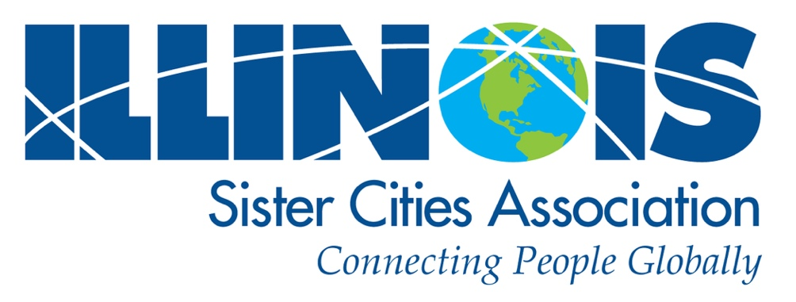

2022 ISCA Awards
Application Forms

The Board of Directors of the Illinois Sister Cities Association invites all ISCA member organizations to consider applying for our two state-wide annual awards:
Illinois Sister City of the Year or Champion of Youth
for events held between January 1, 2021 and December 31, 2021
Applications will be available on the ISCA website: https://www.iscatoday.org
or from:
Award Committee Chairman–Dennis Roberts: awardschair@iscatoday.org
(217) 344-0069

This is a great way to generate recognition for volunteers and elected officials. Awards will be announced at ISCA’s annual meeting in April, 2022, and generally presented at the Illinois Municipal League Annual Conference in Chicago, September 2022.

Application Deadline: Tuesday March 15, 2022

Illinois Sister Cities Association – 2022 Awards – https://www.iscatoday.org
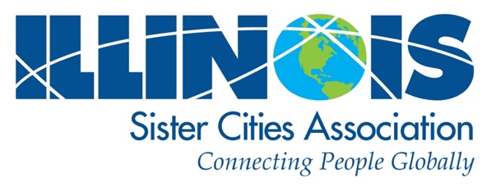

General Instructions
______________________________________________________
All applications will be submitted digitally this year. We will need from each award applicant:

1.) A completed and signed 3-page General Application (pages 1– 3)

2.) Sister City of the Year applicants – shall also complete pages 4 – 5 of the form
3.) Champion of Youth applicants – shall also complete pages 6 –7 of the form

4.) Supporting Materials:
Supporting materials may be submitted digitally as pdf files:

a. Photos of your program / events

b. Newspaper articles, press releases
c. The URL of your association’s website
d. Any other supporting materials

5.) Send completed application(s) in by the deadline for consideration

6.) Submit forms to: awardschair@iscatoday.org

REMEMBER:
Application Deadline is: MARCH 15, 2022

Award winners will be announced during the ISCA Annual Meeting April 22, 2022
and Award Certificates issued. We encourage you to register for the ISCA Conference
April 22-23, 2022 at https://www.iscatoday.org. The ISCA Board expects to be able to
make the formal presentation to each winner at the Illinois Municipal League 2022
Annual Meeting.

Illinois Sister Cities Association – 2022 Awards – https://www.iscatoday.org

Illinois Sister Cities Association / General Application Form / p. 1.
GENERAL APPLICATION FORM (All Applicants)
2022 ISCA Awards
Questions? call Dennis Roberts: 217 344-006 / Email: awardschair@iscatoday.org
__________________________________________________________________________________________
Provide Information covering your activities between January 1, 2021 and December 31, 2021
________________________________________________________________________________________________________________________________________________

Applicant Information
On behalf of City:
Name of City Mayor or Administrator:
Community population:

Sister City Organization making application:
Name of Organization’s President:
Organization’s contact address:
City: |  | State: | Zip Code:
Phone contact: | Cell Phone:
E-mail contact:

Tell us about your Community

Sister Cities Partnerships
Please tell us the names and location of each partnership (attach additional partnerships on separate paper)
1.| Sister City Partner:
Province /Country: | Year founded:
2.| Sister City Partner:
Province /Country: | Year founded:
3.| Sister City Partner:
Province /Country: | Year founded:
4.| Sister City Partner:
Province /Country: | Year founded:

Illinois Sister Cities Association /General Application Form / p. 2.
General Application Form (cont.)
Questions? call Dennis Roberts: 217 344-006 / Email: awardschair@iscatoday.org
__________________________________________________________________________________________
Tell Us About Your Sister City Organization
Are you an independent 501(c)3 ? ______ Yes ______ No
OR Are you part of the City’s administration? ______ Yes ______ No
Does an elected official and/or paid staff serve on the committee? ______ Yes ______ No
If “YES ,” what is their name and title? __________________________________________________________________________

Budget
What is your annual budget ? ______________
Does your city provide funding? ______ Yes ______ No | If so, what % of your budget? _____________
Other sources of your funding?

Membership
How many members do you have? _________ | Does your membership pay dues? ______ Yes ______ No

Communications and Outreach
Do you publish a brochure? ______ Yes ______ No | A newsletter? ______ Yes ______ No
Do you maintain a web site? ______ Yes ______ No
What is the URL? __________________________________________________________________________________________

What other types of Social Media or advertising do you use? _______________________________________________________
_________________________________________________________________________________________________________
_________________________________________________________________________________________________________
How have you remained active during the Covid-19 pandemic restrictions?
_________________________________________________________________________________________________________
_________________________________________________________________________________________________________
_________________________________________________________________________________________________________
Other information you wish to share:
_________________________________________________________________________________________________________
_________________________________________________________________________________________________________
_________________________________________________________________________________________________________

Illinois Sister Cities Association /General Application Form / p. 3.
General Application Form (cont.)
Questions? call Dennis Roberts: 217 344-006 / Email: awardschair@iscatoday.org
__________________________________________________________________________________________

IMPORTANT: If selected to receive this award, a plaque will be presented to your city. Please provide the following information, which ISCA will use to prepare the award plaque.
The ISCA Board expects to be able to make the presentation at the 2022 Illinois Municipal League (IML) Annual Meeting. (Errors or incorrect information at submission will be corrected at cost to the award recipient, including shipping – so please fill in your information with care.)

Plaque Information

Name of City:
Name of your Sister City organization:
Name and title of Mayor or City leader (Mayor, Village President, Trustee, etc.):
Name and Title of other individual (President of your Sister Cities Organization):

-- -- -- -- -- -- -- -- -- -- -- -- -- -- -- -- -- -- -- -- -- -- -- -- -- -- -- -- -- -- -- -- -- -- -- -- -- -- -- -- -- -- -- -- -- -- -- -- -- -- -- -- -- --
General Application Form Completion

Signature of Applicant: ______________________________________________________________________

Officer’s Signature: _________________________________________________________________________

Officer’s Title: _____________________________________________________________________________
Date Submitted: _______________________________________

Illinois Sister Cities Association / Sister City of the Year /Application Form / p. 4.
APPLICATION FORM:
2022 Sister City of the Year
(For activities between January 1, 2021 and December 31, 2021)
Questions? call Dennis Roberts: 217 344-006 / Email: awardschair@iscatoday.org
__________________________________________________________________________________________
For consideration to be chosen Illinois Sister City Association’s “Sister City of the Year,” please answer the following Questions and submit them along with the appropriate application form (below).

A “Sister City of the Year” shows an outstanding level of energy, commitment, and success which makes it an excellent example of the goals and mission of the Sister Cities International program. It may exhibit a high profile within the community and exhibit active participation at the municipal, academic, humanitarian, or community service level.
Arts, Cultural, Recreational, or Other Activities Conducted by Your Organization This Past Year
(attach additional events on separate paper)

Event: | Date:
 | Number attending:
Comments:

Event: | Date:
 | Number attending:
Comments:

Event: | Date:
 | Number attending:
Comments:

Covid-Era Remote Events
Events conducted through Zoom or other social media

Have you conducted virtual exchanges through Zoom or other social media? | Yes: | No:

Event: | Date:
 | Number attending:
Comments:

Event: | Date:
 | Number attending:
Comments:

Illinois Sister Cities Association / Sister City of the Year /Application Form / p. 5.

Event: | Date:
 | Number attending:
Comments:

Event: | Date:
 | Number attending:
Comments:

Event: | Date:
 | Number attending:
Comments:

Event: | Date:
 | Number attending:
Comments:

Event: | Date:
 | Number attending:
Comments:

Event: | Date:
 | Number attending:
Comments:

How do you publicize your Sister Cities and their cultures to your community?

Other comments or information here:

END

Application Deadline is March 15, 2022
Illinois Sister Cities Association / Champion of Youth / Application Form / p. 6.
APPLICATION FORM:
2022 Champion of Youth
(For activities between January 1, 2021 and December 31, 2021)
Questions? call Dennis Roberts: 217 344-006 / Email: awardschair@iscatoday.org
__________________________________________________________________________________________
For consideration to become Illinois Sister City Association’s “Champion of Youth,” please answer the following questions and submit them along with the appropriate application form (below).

A “Champion of Youth” award winner initiates, coordinates and otherwise supports a program for youth that
may include exchanges between Sister Cities partner cities, schools, or family-to-family. It may also support exchanges that are media based via Zoom, Skype, FaceTime, Facebook, Twitter, E-mail or letter writing.
The Sister Cities program supports youth through Citizen Diplomacy in other ways as well, such as through high schools, churches, and family-to-family activities, or working with other community groups with similar goals. Support is broadly defined and may include fund-raising, providing housing for exchange students, events, etc.

General Information – Youth Programs

How long have you conducted a youth program?
How do you attract young members to your Sister Cities program?
What are the future plans for your youth activities for the coming year and beyond?

Youth-Specific Events (workshops, recreation, educational, arts, etc.)
(attach additional events on separate paper)

Dates: ________________ | Number of participants: _____________
Briefly describe the program:

Dates: ________________ | Number of participants: _____________
Briefly describe the program:

Illinois Sister Cities Association / Champion of Youth / Application Form / p. 7.

Covid-Era Remote Events

Have you conducted Virtual Exchanges through Zoom or other social media? | Yes: | No:
Comment on your experience conducting these programs:

Dates: ________________ | Number of participants: _____________
Briefly describe the program:

Dates: ________________ | Number of participants: _____________
Briefly describe the program:

Dates: ________________ | Number of participants: _____________
Briefly describe the program:

Dates: ________________ | Number of participants: _____________
Briefly describe the program:

Application Deadline is MARCH 15, 2022 Illinois Sister Cities Association / Champion of Youth / Application Form / p. 8 .
Optional Addendum (Use if you need additional space)
2022 Champion of Youth
Exchanges and Events – Addendum
(For activities between January 1, 2021 and December 31, 2021)
 | Exchange & Exchange Partners | Dates | No. of Participants
1.
2.
3.
4.
5.
6.

Application Deadline is MARCH 15, 2022

