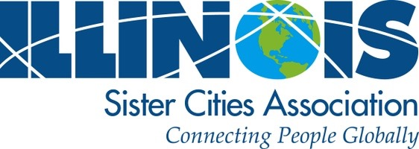

**Conference Attendee Registration Form**

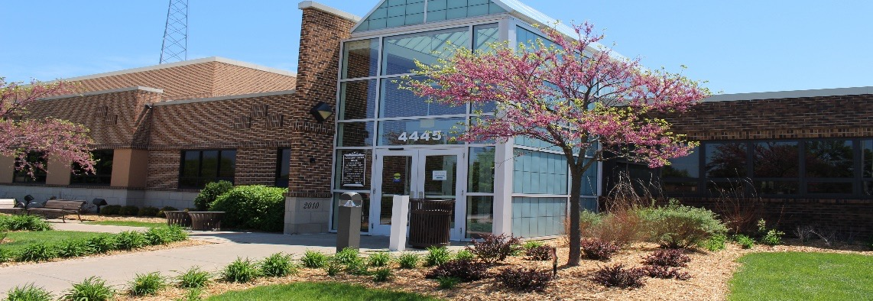

**Conference Registration Form:**

First_______________________ Last________________________________

Title: __________________________________________________________

Sister City Organization Name: _____________________________________________________

Organization Address: ____________________________________________________________

City: ________________________ State: _____ Zip: __________ Phone: ________________________

Email for confirmation: ___________________________________________________ (Required)

**Saturday-One Day**

**$40**

(Includes all Saturday Conference sessions, Annual Meeting & Lunch)

**Hosted By: Richton Park Sister Cities Committee**

**Illinois Sister Cities Association’s**

**Annual Conference**

**“Cities Helping Cities”**

**Friday April 22 2022 – Saturday April 23 2022**

Hotel reservation link: <https://www.wyndhamhotels.com/groups/hr/sister-cities> (until 3/16/18)

|  |  |  |  |  |
| --- | --- | --- | --- | --- |
| **Total Conference Package**  **$100 Per Person**  **(Includes Friday Evening Banquet with Dinner/Entertainment**  **& Saturday Morning Breakfast with Choice of Workshops and Lunch)**  Fri. April 22 to Sat April 23 2022 | **Friday- One Day**  **$65.00 Per Person**  **(Includes Friday Banquet Dinner)**  6:00pm-10:00pm  Tinley Park Convention Center  18451 Convention Center Dr. Tinley Park, IL. 60477 | **Saturday- One Day**  **$45.00 Per Person**  **(Includes All Saturday Conference Sessions, Breakfast & Lunch)**  8:00am-1:00pm  Richton Park Community Center  4445 Sauk Trail Richton Park IL. 60471 | **Conference Event Attendance Days And Activities Are Optional.**  **Please Add Your Days Attendance with Sheet.**  **Registration Deadline is Fri.**  **April 15 2022** | **Events Days Attending**  **(Yes or No Below)**  **Friday & Saturday___________**  **Friday Event_____________**  **Saturday Event____________** |

**Conference Registration Fee Payment: Total Amount Due: $_______**

**Questions please contact Kenneth Jones at 708-481-8950 Ext. 120 or via email at** [kljones@richtonpark.org](mailto:kljones@richtonpark.org)

**Illinois Sister Cities Association’s Annual Conference**

**Hosted By: Richton Park Sister Cities Committee**

**“Cities Helping Cities”**

**Friday, April 22, 2022 – Saturday, April 23, 2022**

**Conference Payment Options:**

Registration deadline is Friday 4/15/22

**Conference Registration Options:**

1. **Payments Accepted In Person or Mail At: Village of Richton Park, 4455 Sauk Trail, Richton Park, IL. 60471 or via our Village Drop Box -West of Village Hall**
2. **If paying by check: Make checks payable to Village of Richton Park (Reference: ISCA Conference)**
3. **Online Payment Directions: From Home Page- https://www.richtonpark.org**

**Online Registration & Payment Link:** <https://bit.ly/SisterCityCon22>

* **Enter Your Payment Information Referencing (ISCA Conference)**

**Attendees at our conference will be required to conform to any COVID protocols in place for Cook County, Illinois. Everyone registered will receive specific information prior to our conference.**

**After registration participants will receive additional Conference Information**

**Hotel Accommodations:**

**Room block at the Even Hotel Chicago- Tinley Park Convention Center**

**Location: 18501 Convention Center Dr. Tinley Park, IL. 60477**

**Room Rate: $149.00 per night**

**Guests can book one of the following ways:**

* **By calling the front desk at 708-444-1100 and referencing the Village of Richton Park block, or group code VRP**
* **By going on our website [http://www.evenhotels.com/chitinleypark](https://urldefense.proofpoint.com/v2/url?u=http-3A__www.evenhotels.com_chitinleypark&d=DwMFAg&c=euGZstcaTDllvimEN8b7jXrwqOf-v5A_CdpgnVfiiMM&r=43ERcXvrX12Sqqqa0ERvRD4MC-oXeeZjW8UyweU-nVk&m=odm7GGLBRfN0K9V7i_H8fVg2zzC0PA-zajXMMdZFnZU&s=7GrVTACG4fDd7kB2jTpRzOlt2v2jC6cmeUBsQYIt2kE&e=) , enter your stay dates & group code VRP**