**CHRIS AND ROY’S CATERING MENU**

**WWW.CHRISANDROYSLLC.COM**

**203-589-7676**

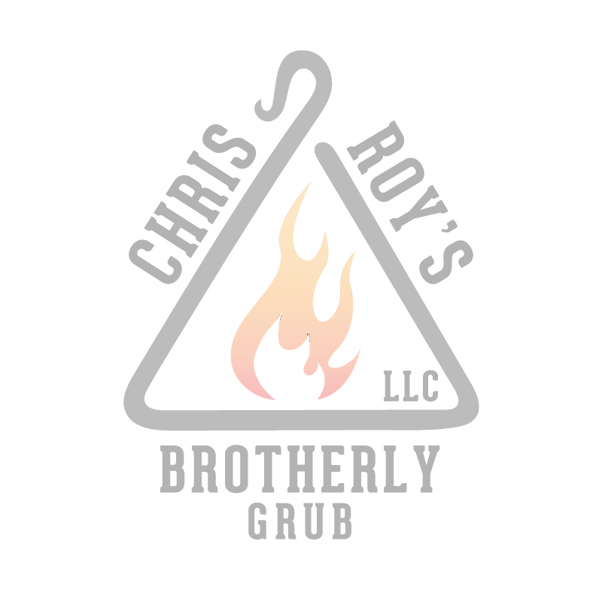

|  |  |  |  |  |
| --- | --- | --- | --- | --- |
| **APPETIZERS** |  |  |  |  |
| RUEBEN EGGROLLS | $24/DOZ - 2 DOZ MIN |  | CHEESE STEAK EGGROLLS | $24/DOZ - 2 DOZ MIN |
| MOZZERELLA STICKS | $15/DOZ - 2 DOZ MIN |  | CHICKEN WINGS | $1.25ea – 3 DOZ MIN |
| FRIED CHICKEN | $20pc - $35.00 |  | FRESH CUT FRENCH FRIES | $20 SM - $40 LG |
| FRIED PIEROGIES | $45 – 5lbs |  | FRIED WONTONS | $45 ½ PAN $80 FULL |
| FRIED ZITI BALLS | $50 ½ PAN $95 FULL |  | ZUCCHINI STICKS | $35 ½ PAN $70 FULL |
| WHOLE BAKED CLAMS | $30/DOZ 2 DOZ MIN |  | CHOPPED BAKED CLAMS | $30/DOZ 2 DOZ MIN |
| CHRIS AND ROYS OVERSTUFFED CLAMS | $3ea 2 DOZ MIN |  | STEAMED CLAMS | $75/100 count |
| SHRIMP COCKTAIL | $95 FULL TRAY |  | LUMP MINI CRAB CAKES | $25/DOZ 2 DOZ MIN |
| COCONUT SHRIMP | $135 FULL TRAY |  | BACON WRAPPED SCALLOPS | $135 FULL TRAY |
| STUFFED BREADS | $20 each |  | GRILLED CHICKEN STICKS | $24/DOZ 2 DOZ MIN |
| POTATO PANCAKES | $24/DOZ 2 DOZ MIN |  | STUFFED SHROOMS | $24/DOZ 2 DOZ MIN |
| GRILLED BEEF STICKS | $30/DOZ 2 DOZ MIN |  | COWBOY BAKED BEANS | $35 ½ PAN |
| GRILLED OR STEAMED VEGGIE MEDLY | M/P |  | TWICE BAKED POTATO | $24/DOZ |
|  |  |  |  |  |
| **PORK SELECTIONS:** |  |  |  |  |
| FRIED PORK CUTLETS | $55 ½ PAN $95 FULL |  | BRATWURST | $55 ½ PAN $95 FULL |
| RIBS | $30/RK 2 RK MIN |  | CRIB | $30/RK 2 RK MIN |
| PORK LOIN ROAST | $95 |  | SAUSAGE AND PEPPERS | $55 ½ PAN $95 FULL |
| PULLED PORK | $65 ½ PAN $110 FULL |  |  |  |
|  |  |  |  |  |
| **CHICKEN SELECTIONS:** |  |  |  |  |
| BREADED CHICKEN CUTLETS | $65 ½ PAN $95 FULL |  | PANKO BREADED CHICKEN CUTLETS | $65 ½ PAN $95 FULL |
| CHICKEN CUTLET PARMESAN | $55 ½ PAN $95 FULL |  | CHICKEN MARSALA | $65 ½ PAN $95 FULL |
| CHICKEN FRANCHESE | $55 ½ PAN $95 FULL |  | HAWAIIAN CHICKEN | $65 ½ PAN $95 FULL |
| CHICKEN SCAMPI | $55 ½ PAN $95 FULL |  | GRILLED CHICKEN BREASTS | $50 ½ PAN $85 FULL |
| DRUNK CHICKEN | $70 ½ PAN $125 FULL |  | GRILLED CHICKEN THIGHS | $65 ½ PAN $95 FULL |
| CHICKEN CACCIATORE | $55 ½ PAN $95 FULL |  |  |  |
|  |  |  |  |  |
| **PASTA SELECTIONS:** |  |  |  |  |
| BAKED ZITI WITH MEAT | $65 ½ PAN $95 FULL |  | BAKED ZITI NO MEAT | $55 ½ PAN $85 FULL |
| MANICOTTI | $65 ½ PAN $110 FULL |  | PASTA ALA VODKA | $65 ½ PAN $110 FULL |
| PASTA MEAT SAUCE | $55 ½ PAN $85 FULL |  | PASTA WITH SAUSAGE AND BROC. RABE | $60 ½ PAN $100 FULL |
| PLAIN PASTA OR EGG NOODLES | $35 ½ PAN $60 FULL |  | STUFFED SHELLS | $65 ½ PAN $110 FULL |
| RICE WHITE OR WILD | $35 |  | PASTA MARINARA | $40 ½ PAN $75 FULL |
|  |  |  |  |  |
| **SEAFOOD SELECTIONS:** |  |  |  |  |
| FRIED SHRIMP | $100/PAN |  | SHRIMP SCAMPI | $110/PAN |
| SHRIMP FRANCHESE | $110/PAN |  | STUFFED WHITE FISH | $5 ea 2 DOZ MIN |
| BAKED OR BROILED SALMON | M/P |  | RED/WHITE CLAM SAUCE OVER PASTA | $60 ½ PAN $95 FULL |
| SHRIMP PARMESAN | $110/PAN |  | RED/WHITE MUSSELS SAUCE OVER PASTA | $60 ½ PAN $95 F |
| BROILED FILLET OF FISH | $60 ½ PAN 110 FULL |  |  |  |

**CHRIS AND ROY’S CATERING MENU**

**WWW.CHRISANDROYSLLC.COM**

**203-589-7676**



|  |  |  |  |  |
| --- | --- | --- | --- | --- |
| **VEGETABLE SELECTIONS**: |  |  |  |  |
| GRILLED OR STEAMED VEGETABLES | M/P |  | EGGPLANT PARMESAN | $55 ½ PAN $85 FULL |
| SAUTED’ STRING BEANS | $55 ½ PAN $85 FULL |  | SAUTED’ ASPARAGUS | M/P |
| EGGPLANT ROLATINI | $55 ½ PAN $90 FULL |  | STUFFED PEPPERS | $55 ½ PAN $95 FULL |
| CORN ON THE COB | $45 ½ PAN $80 FULL |  | BAKED POTATO’S | $40 ½ PAN $70 FULL |
| STUFFED CABBAGE | $55 ½ PAN $95 FULL |  | ROASTED POTATO’S | $55 ½ PAN $85 FULL |
| SAUTED’ BROCCOLI RABE | $55 ½ PAN $85 FULL |  | SAUTED’ BRUSSEL SPROUTS | $55 ½ PAN $85 FULL |
|  |  |  |  |  |
| **SALAD SELECTIONS:** |  |  |  |  |
| MACARONI SALAD | $45/ 5LBS |  | GARDEN SALAD | $40 ½ PAN $65 FULL |
| GERMAN POTATO SALAD | $45/ 5LBS |  | AUNTIE SUE’S AWESOME TACO SALAD | $50 ½ PAN $75 FULL |
| COLESLAW | $45/ 5LBS |  | CEASAR SALAD | $40 ½ PAN $65 FULL |
| PENN DUTCH POTATO SALAD | $45/ 5LBS |  | GREEN BEAN SALAD | $50 ½ PAN $75 FULL |
| POTATO SALAD | $45/ 5LBS |  | TORTELLINI SALAD | $65 ½ PAN $105 FULL |
| SPINACH SALAD | $40 ½ PAN $65 FULL |  |  |  |
|  |  |  |  |  |
| **SPECIALTY SELECTIONS:** |  |  |  |  |
| LASAGNA WITH MEAT | $55 ½ PAN $100 FULL |  | LASAGNA NO MEAT | $50 ½ PAN $100 FULL |
| PROSCIUTTO ASPARAGUS MANICOTTI | $60 ½ PAN $105 FULL |  | SPETZLE | $45 ½ PAN $80 FULL |
| SEAFOOD MANICOTTI | $60 ½ PAN $105 FULL |  | CHICKEN CORDON BLEU | $50/DOZ 2 DOZ MIN |
| LOBSTER MAC AND CHEESE | $125/TRAY |  | UNCLE JOE’S VEAL | $60 ½ PAN $110 FULL |
| STUFFED CHICKEN THIGHS | $50/DOZ 2 DOZ MIN |  | TACO BAR | $150 |
| VEAL SALTAMBUCCA | $50/DOZ 2 DOZ MIN |  | MAMA’S STUFFED CALAMARI | $65 ½ PAN $110 FULL |
| ORANGE BEEF | $55 ½ PAN $95 FULL |  | FRIED CALAMARI W/CHERRY PEPPERS | M/P |
| SEARED SCALLOPS WITH BACON | M/P |  | VEAL PARMESAN | $50/DOZ 2 DOZ MIN |
| CRAB LEGS | M/P |  | BEEF SHORT RIBS | M/P |
| BAKED TURKY BREAST | $65 |  | GYRO BAR | $150 |
| FRUIT PLATTER | $65 |  | LOBSTER | M/P |
| CHEESE PLATTER | $75 |  | BAKED HAM | $75 |
| AMERICAN COLD CUT PLATTER | $80 |  | HERO BY THE FOOD  3’ AND UP | ASK FOR DETAILS |
| PIG ROAST | $1600.00 |  |  |  |

**Check us out on social media!**

