Patient Drive Contract

This is a Patient Drive Service Contract Between Bill’s Bud Connection Dr Referral Service:

110 East Beck Drive, Pawnee Oklahoma 74058

Phone :918-521-9349

Email: [billsbudconnection@provalue.net](mailto:billsbudconnection@provalue.net)

Website: [www.billsbudconnection.com](http://www.billsbudconnection.com)

and (Dispensary Name) ___________________________________________________________________

Dispensary Location: _____________________________________________________________________

Dispensary Phone number: ________________________________________________________________

email address: __________________________________________________________________________

Dispensary Contact Person Name: ___________________________________________________________

Position At Dispensary: ____________________________________________________________________

**Dispensary Patient Drive Details:**

Date of Patient Drive: ______________________________________________________________________

Time of Patient Drive: __________ PM to ___________ PM

Location of Patient Drive: ___________________________________________________________________

________________________________________________________________________________________

The Dispensary will Provide:

Electricity (This is Needed for Our Computers)

White Wall Area to take the Client’s Picture

Chairs for Client’s Waiting Area

Table

**The Dispensary Contact Person has the Authority to: Choose the Type of Drive that will be Held, Make the Patient Drive Dates/Times and Pay Bill’s Bud Connection the Same Day the Patient Drive is Held.**

**The Dispensary has Chosen the Following Service:**

**Guarantee 10**

Check One Box:

**Bronze Oklahoma:** Guarantees 10 Clients will Get/Renew their MedCard During the Patient Drive.

* If the G10 is not meet – the Dispensary will Pay the Difference.
* Payment is Due Immediately at the End of the Patient Drive.
* If the Dispensary has Several Locations and Dates Set up the Guarantee 10 is Per Location and Date.

**Bronze Missouri:** Guarantees 10 Clients will Get/Renew their MedCard During the Patient Drive.

* If the G10 is not meet – the Dispensary will Pay the Difference.
* Payment is Due Immediately at the End of the Patient Drive.
* If the Dispensary has Several Locations and Dates Set up the Guarantee 10 is Per Location and Date.

**Sponsorship**

**Dispensary Sponsors Unlimited Dr Recommendations & Client Pays the Upload Assistance Fee and Their State Fee!**

**Oklahoma Silver:** $1000.00 Paid by the Dispensary and Clients are responsible to pay the Discount Upload Assistance Fee.

* Dispensary Pays $1000.00 to Bill’s Bud Connection at the Beginning/end of the Event. (Choose beginning or end—choice must be marked)
* This sponsors Unlimited Dr Recommendations for the Day of the Patient Drive.
* Clients are responsible to pay the Discounted $25.00 Upload Assistance. (Reg. Upload Fee is $40)

**Missouri Gold:** $ 1500.00 Paid by the Dispensary and Clients are responsible to pay the Discount Upload Assistance Fee.

* Dispensary Pays $1000.00 to Bill’s Bud Connection at the Beginning/end of the Event. (Choose beginning or end—choice must be marked)
* This sponsors Unlimited Dr Recommendations for the Day of the Patient Drive.
* Clients are responsible to pay the Discounted $25.00 Upload Assistance. (Reg. Upload Fee is $40)

**Iowa Platinum:** $2000.00 Paid by the Dispensary and Clients are responsible to pay the Discounted Upload Assistance Fee.

* Dispensary Pays $1000.00 to Bill’s Bud Connection at the Beginning/end of the Event. (Choose beginning or end—choice must be marked)
* This sponsors Unlimited Dr Recommendations for the Day of the Patient Drive.
* Clients are responsible to pay the Discounted $25.00 Upload Assistance. (Reg. Upload Fee is $40)

**Virginia Titanium**: Is Virtual Only for Now...Call 918-521-9349 for Details

**If the Dispensary is wanting to have several Patient Drives or there is more than 1 location to have a Patient Drive– a New Patient Drive Service Contract Between Must be filled out!**

**Advertising:**

* Bill’s Bud Connection Will Make the Flyer for the Event and e-mal it to the Dispensary.
* Flyer of Event Will Be Posted in All Social Media and Groups that Bill’s Bud Connection is affiliated with.
* The Dispensary Will Also Post the Event Flyer to:

1. Their Social Media and groups they are affiliated with

2. Post the Flyer in The Dispensary

3. Other Advertising, they fill is Needed.

* The Dispensary Can Also Send out a Mass Email to All their Current Patients to let them know about the event.

**Cancelation:**

* If a Guaranteed 10 Patient Drive Needs to Be Cancelled by the Dispensary:

Name ____________________________________Phone # ______________________

email address_______________________________________________________ is Required to let us know

**5 days BEFORE THE PATIENT DRIVE** or a Cancelation Fee of $100.00 will be sent to the Dispensary and is required to be paid upon receipt of the invoice. This Fee Covers the Loss of the Advertisement Fees incurred by Bill’s Bud Connection for the Event!

* If the Guaranteed 10 Patient Drive is Canceled due to Natural Disasters, then there will be NO Cancelation Fee.

If Bill’s Bud Connection needs to Cancel the Patient Drive due to Unforeseen Reasons, we will call ____________________ at ___________________ As soon as possible to advise of the Cancelation and Why.

During this Call the Dispensary can advise:

* If the Dispensary would like to Reschedule the Guaranteed 10 Patient Drive and Modify this Contract or Write a new One.
* Have Bill’s Bud Connection turn the Event into a Virtual Patient Drive… If the Event is turned into A virtual Patient drive Bill’s Bud Connection will:

* Bill’s Bud Connection Will Send a new flyer with the Virtual QR Code – so the clients/patients can make an appointment and we will call them back at their appointment time and complete their process by phone.

* With the Virtual Patient Drive the Dispensary IS NOT required to have a Guaranteed 10 for the event.

* If the Patient Drive was a Sponsorship: Event Is Required to be Rescheduled.

Date:_____________________ Date:___________________________

_________________________ _______________________________

Billy Murphy Or Carolyn Murphy _______________________________

Signature Required _______________________________

Owners of Bill’s Bud Connection _______________________________

918-521-9349 Authorized Dispensary Personnel Signature

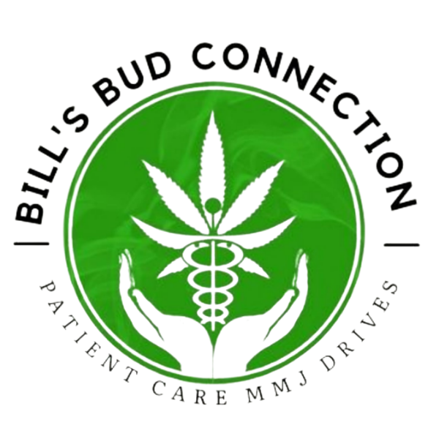

110 East Beck Drive, Pawnee Oklahoma 74058

Email: [billsbudconnection@provalue.net](mailto:billsbudconnection@provalue.net)

Phone: 918-521-9349

Website: [www.billsbudconnection.com](http://www.billsbudconnection.com)

Dispensary Paid $ ________________________ to Bill’s Bud Connection on __________________ for the

(Type of Service)____________________________________________________________________

Number of Clients Seen at Dispensary During the Event: _____________

Names of Clients will not be released to the Dispensary Per HIPPA unless The Client has Signed a HIPPA Form Release allowing Bill’s Bud Connection to release their name!