September 2025

Dear Partners,

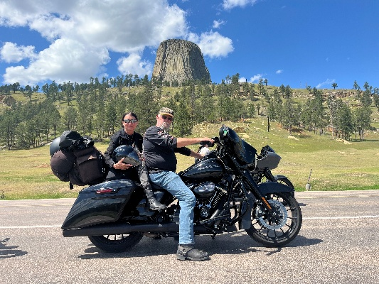
Thank you so much for standing with us. We can only do this because of your faithfulness in giving to Reaching the World. Matthew 25:35 “for I was hungry, and you gave me food; I was thirsty, and you gave me drink; I was a stranger, and you took me in.”

In August Mary and I had a motorcycle holiday and visited our son and family in Colorado. It was a special time to see some of our beautiful country. We are back and have a busy schedule ahead of us.

Myanmar Report
Children’s Home: The children are all doing well at school and their teachers always give them praise. This month we provided funds for them to hook up to the government water supply. They now have a continual supply of water.

Prayer need: The second floor of the Children’s Home has rotted out and needs to be replaced. Plans are to use steel beams to replace the rotten and bug-eaten wood. We need to raise $3000 for this project.

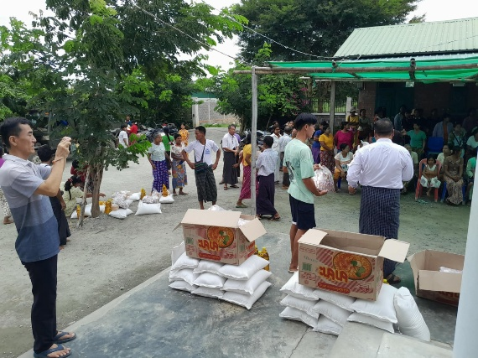
Mandalay Relief Work: This continues to be an ongoing project to help recover from the earthquake. We are providing food and helping to rebuild homes while sharing the love of God.

Reaching the World Bible College: The students have now taken their midterm exams.

My schedule for the next 3 months is to be in Pennsylvania, Missouri, North Carolina, England and Scotland. We are still working on a visa for Myanmar.

We thank you for your prayers and partnership.

In His Service,

Roger and Mary King

