**MYANMAR UPDATE**

We are starting to get reports from our ministry teams in Myanmar. As you have heard, a major earthquake has hit the country near to Mandalay with major damage and loss of lives.

First let me tell you all the children in Yangon area and ministry team members are all safe. The director’s home has a crack in the wall but otherwise everything is good.

In Mandalay the church compound in the area has been damaged and the building’s inner ceiling has fallen in and the walls around the compound damaged. The pastor’s home walls have cracks in them, which has made it unsafe for them to sleep in their home. We are thankful they were not hurt. Some of the members of the church have been injured and we are waiting for reports of their condition.

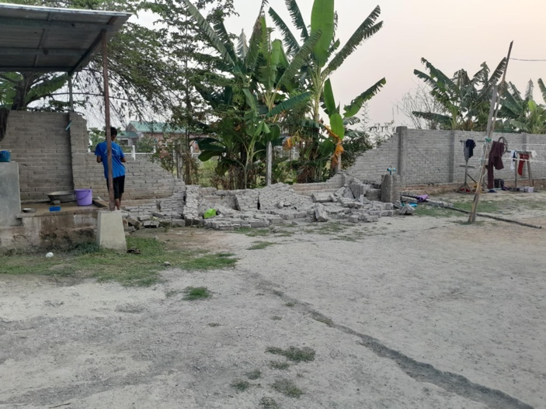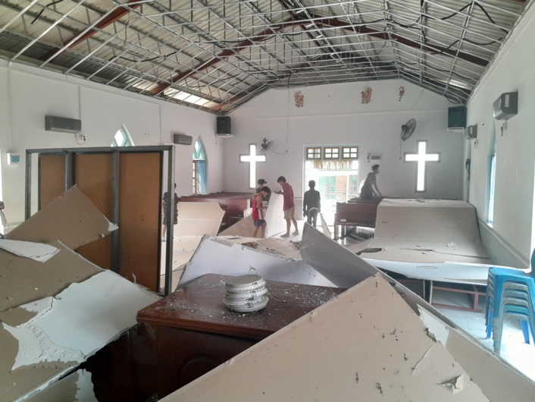

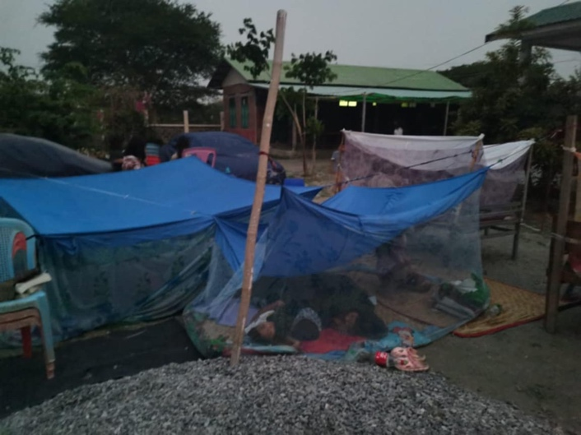

The Internet is down, and communication systems are not working in much of the country.

I am traveling and ministering so it is difficult to do reports, but I will keep everyone posted as we get more information.

Thank you for your prayers.

Roger and Mary King