March 2025

Dear Partners,

Greetings in the wonderful name of Jesus.

Acts 2:17 “And it shall come to pass in the last days, says God, that I will pour out of My Spirit on all fresh…”

As Mary and I have been ministering across the United States we are seeing a stirring of the Spirit of God among people and in the church, and a sense of expectation. We want to encourage you to keep pressing into His presence.

MYANMAR
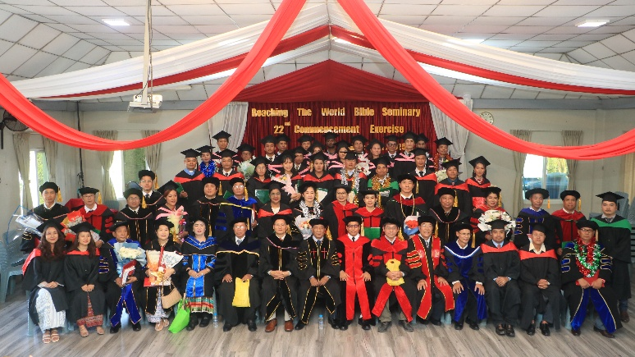
The Bible School held their graduation service in Yangon. Over Twenty students could not return home because of the fighting in their areas. It is too dangerous where they live. The last report that we received is that the Military Junta now only controls 21% of the country. They are still taking young people to fight for them. Our children and young people are safe because of God and your prayers. Please continue to pray for them.

A little over a year ago we held a seminar in this building.
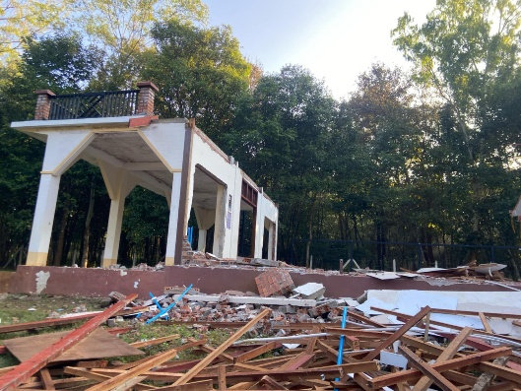
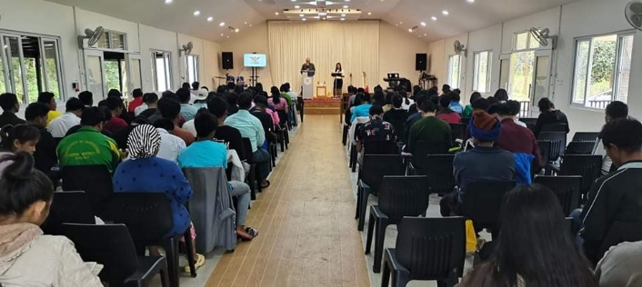
This is the building today destroyed by the military.
Thank you for your prayers. We appreciate everyone standing with us.

In His Service,

Roger and Mary King

