February 2025

Dear Partners,

We pray Apostle Paul’s prayer in Colossians 1:9- “That you may be filled with the knowledge of His will in all wisdom and spiritual understanding.”

2 Corinthians 9:10 “That He will multiply the seed you have sown and increase the fruits of your righteousness.”

The beginning of every year, because the climate in Myanmar is so hot and humid with no air conditioning, the children need new bedding, matts, blankets and mosquito nets. Once again, we were able to provide this for them. Thank you!
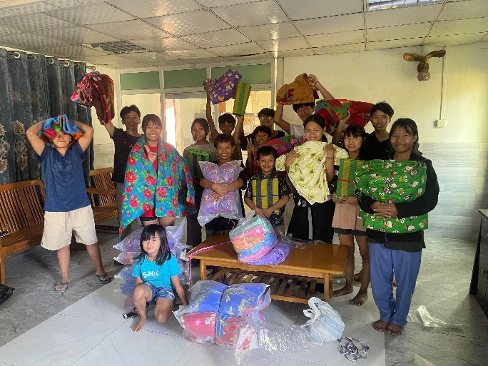
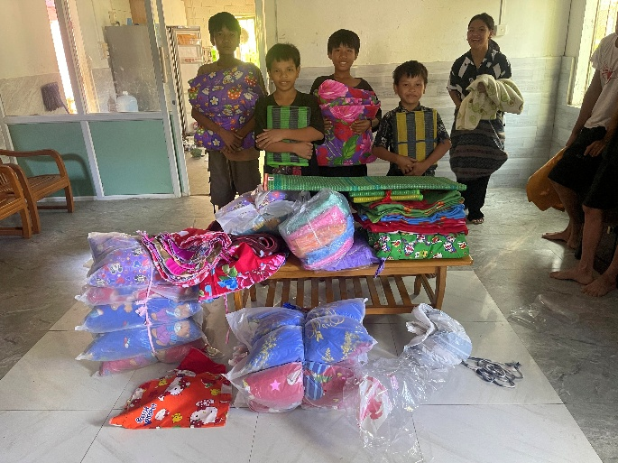
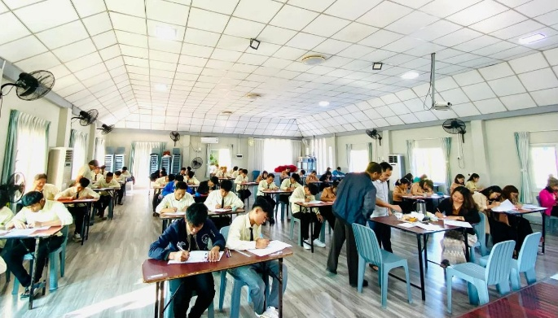
At Reaching the World Bible College the students finished their year and took their final exams. The school runs from June to January because of the seasons.

Prayer Requests
Continue to pray for Myanmar and our young people that they have divine protection around them.

Our plans are to be in Germany, Switzerland and the UK this spring ministering. Pray for doors of opportunity for us that we may speak the Word boldly.

Thank you for partnering with us.

Roger and Mary King

