July 2025

Dear ,

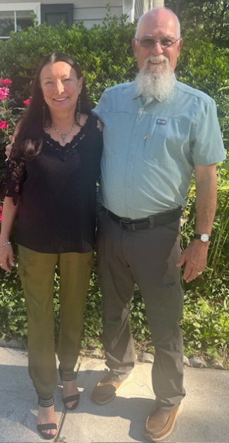
It has been a very interesting month with world events. Paul writes in 1 Timothy 2:1-4 “...praying for all men…those in authority that we may lead a quiet and peaceable life in all godliness and reverence…who desires all men to be saved…”

In June Mary and I celebrated our 50th Anniversary. We reflected on the goodness of God to us as we endeavored to follow him. God has always been faithful even in times when we did not know how we could make it.
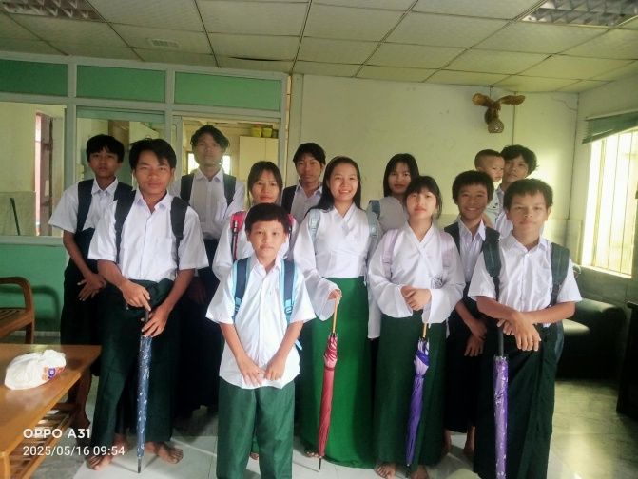
Myanmar news, the children have returned to a new school year, which means new uniforms and basic school supplies. Thank you, because of you they have what they need.
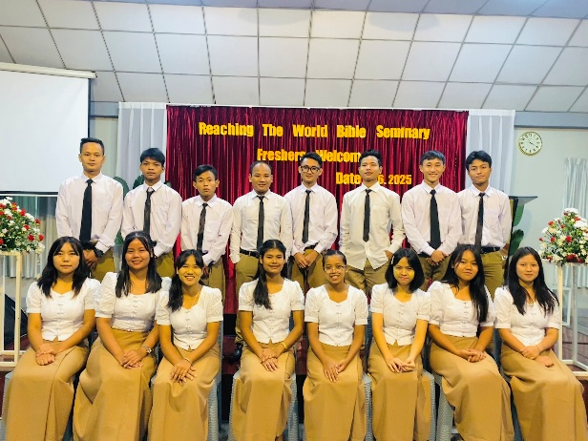
The Bible College has also started a new year, and we have 70 students attending. This is a photo of the new students.
Prayer items: The relief work continues. We are helping to rebuild homes and some churches. We will share more about this next month.
We are making plans to return to Myanmar. We need a visa from the government.
Pray for wisdom concerning our bank in the UK. They are becoming very difficult to work with, especially for Christian charities.
Thank you for all your prayers and support.

Roger and Mary King

