November 2023

Dear Partners and Friends,

“Pray for the peace of Jerusalem; they shall prosper that love thee.”
Psalms 122:6

If there has ever been a time we need to pray, it is now! Read Luke 21:25-28

I am currently in Myanmar. I have been here for a couple of weeks and just returned from the Mandalay area where I held two different seminars. I also ministered in the local church that our graduates from our Bible College have started. It is refreshing to see the hunger people have for the Word of God. They are living in a country full of unrest and must trust God daily for safety and their personal needs.

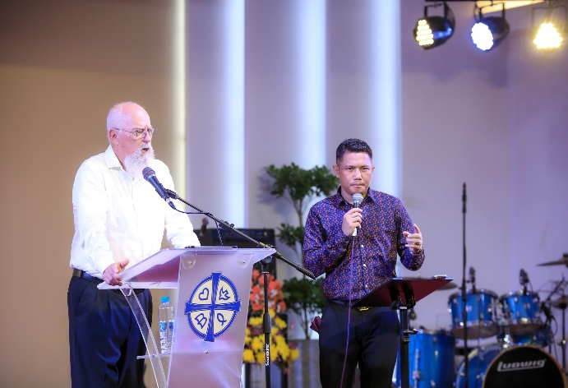
Right now, I am teaching at Reaching the World Bible College. We have over 60 students enrolled. Many of our graduates are working full time in the ministry going into areas where there is very little Christian exposure. Next week I will be teaching at Gospel for Asia Bible School before heading to Thailand to minister.

I really appreciate your prayers. I still have a month to go before heading home. It is not always easy to be away from family and to travel alone. Thank God for emails and FaceTime. I can remember when we did not have any of this technology.

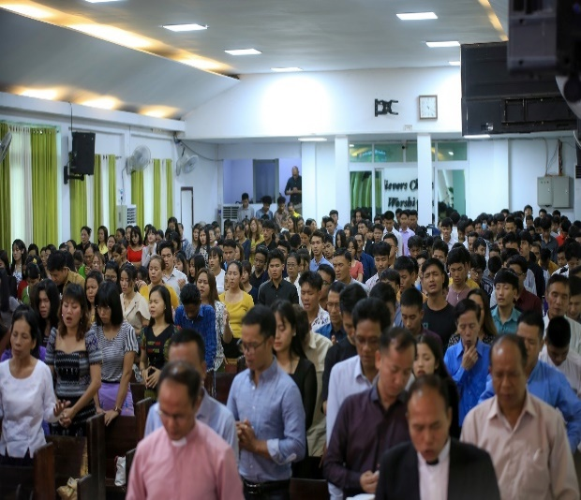
John 9:4-” I must work …while it is day; the night comes when no man can work.”
We do not know how much time we have. Thank you for standing and helping us fulfill the call that God has put on our lives.

We want to remind our partners and child sponsors that this time of year we are asking for donations for the Children’s Home Christmas gifts. This is an exciting time for them for outreach and celebration.

In His service,
Roger and Mary

