June 2025

Dear Partners,

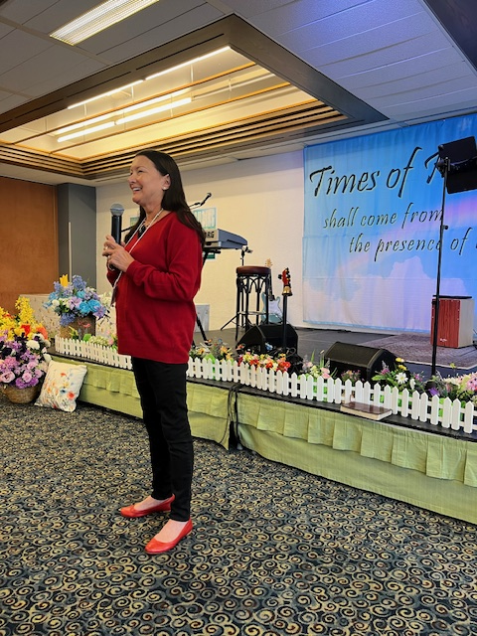
Proverbs 24:27- “Prepare your outside work, make it fit for yourself in the field; And afterward build your house.”
1 Mary speaking at TOR Switzerland

We stand and believe that as you have sown into the mission field (outside work) every need shall be met in your life. Philippians 4:19 “And my god shall supply all your need according to his riches in glory by Christ Jesus”

It has been a busy month since our last update letter. We have ministered in Germany, England and Switzerland. In Switzerland we were part of ‘The Time of Refreshing’, which ministers and blesses missionaries working across Europe. This year there were over sixty people working in 10 different nations. It is a joy to sow into so many missionaries.

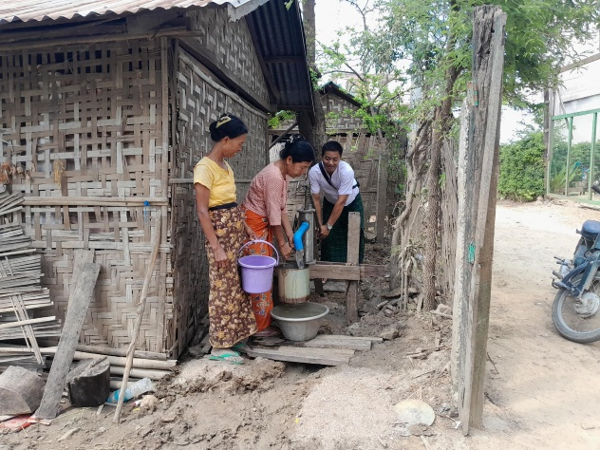
The relief work in Myanmar due to the earthquakes has continued. We have been able to help so many people with the natural needs and at the same time sharing the gospel of Good News.

We have provided a generator for the church in Mandalay so that they can use their well to get water out. We have also put two new wells into two villages for the people. This is due to your generous giving to the earthquake relief. Thank you so much for touching their lives.

The water source is so bad because of the earthquake that we have purchased a water filtering system. This will allow our workers to provide water to many people, as well as providing individual water filters for some homes. We are continuing to give out food and help meet daily needs. We have also helped with the medical expenses of some who have been hurt.

Thank you for being a part of this work and outreach. You are a great blessing! May God bless you abundantly!

In His service,
Roger and Mary King

MYANMAR REPORT

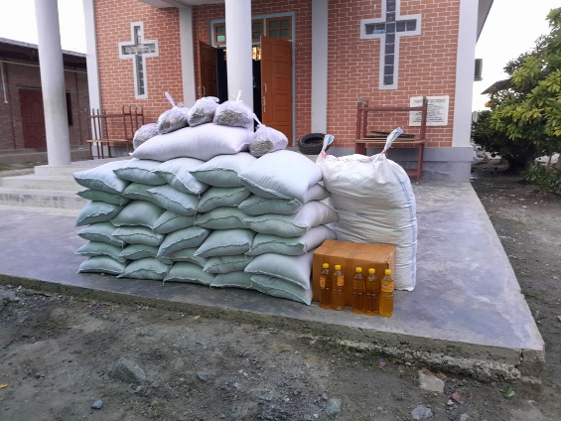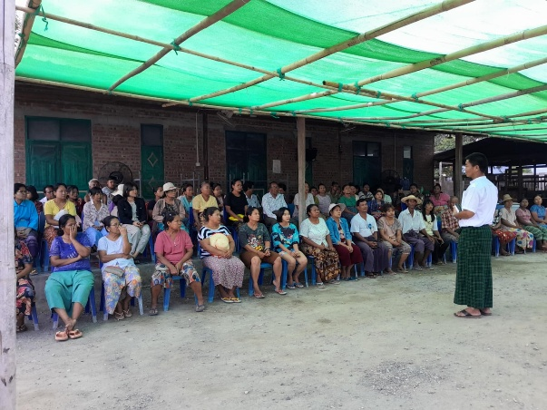
Rice to be given away. Gospel being shared.

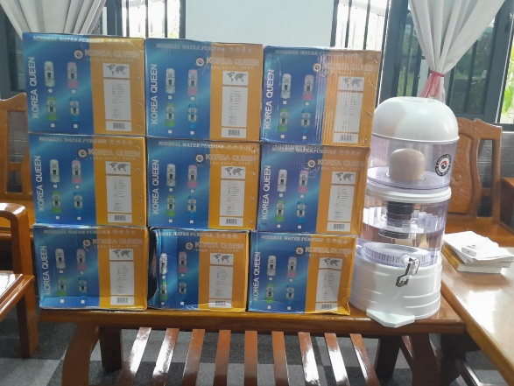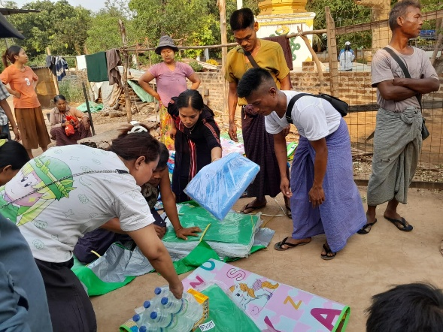
Individual water filters Giving aid.
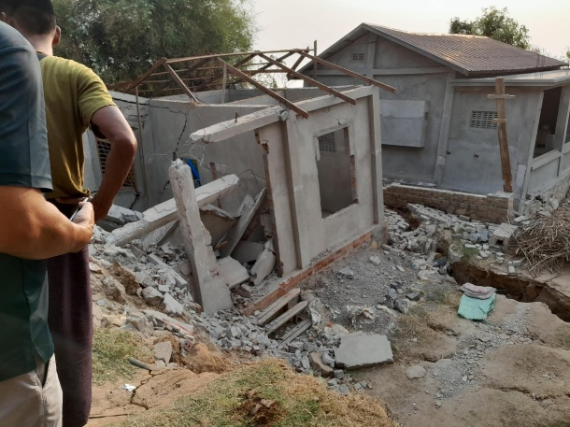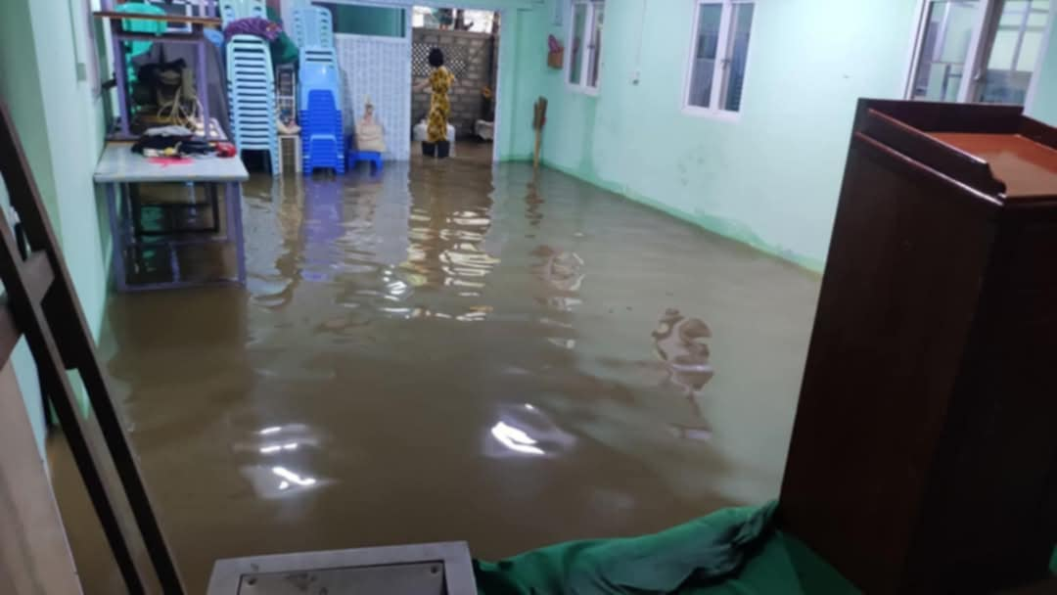
Houses destroyed and others flooded by the new rainy season.

