April / May 2025

Dear Partners,

We are so grateful for your prayers and support. We speak 2 Corinthians 9:8 over your lives. “God is able to make all grace abound toward you, that you, always have all sufficiency in all things, may have an abundance for every good work.”

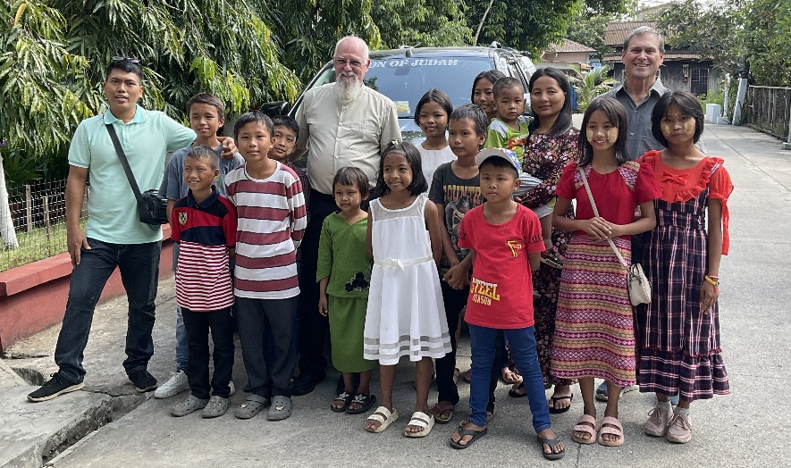
This letter is for both April and May because Mary and I will be traveling out of the country so the office will be closed. We will be in the UK, Germany and Switzerland ministering. In Switzerland we will be part of the team for TOR (Times of Refreshing). TOR was started in the 1980’s by Bill Kaiser Ministries. They invite American missionaries working anywhere in Europe to come to Switzerland for three nights, the rooms and meals are all paid for. It is a special time of letting the Holy Spirit minister and refresh the missionaries. We want to bless and encourage them in the Lord. There are no offerings taken and no organizations or ministries are promoted, just the Lord. Mary and I were for many years on the receiving side, and it is now a blessing to be on the giving side.

Myanmar news
It’s been 4 years since the military seized control of the government. The Bible School is on summer break, but 0ver 20 students could not go home because of the conflict. We are helping to provide for them at the Bible School. Please pray for these students.

Praise report. The photo is of Joshua and his children from the Children’s home he has started. Joshua was one of our first children. He grew up and went to the Reaching the World Bible College. He now is in the ministry and has a Children’s Home. Joshua says, “He wants to give back as he was blessed.” We help him sometimes as we are able. We see the fruit going forward to the next generation. This is part of your reward now and in Heaven.

Thank you for your prayers and support that make this ministry fruitful.

In His service,

Roger and Mary King

