October 2025

Dear Partners,

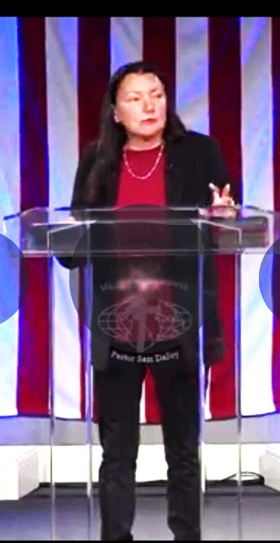
Acts 2:17- “And it shall come to pass in the last days, says God, That I will pour out My spirit on all flesh…”

This month we have been busy ministering at several churches, and we are seeing good things happening. God is moving among the young people, which is exciting.

In 1979 Mary and I held a Bible study for about a year at a dairy farm. We were obedient to what God wanted us to do. Today it is a vibrant church, touching their whole community. Sometimes we do not understand how our small seeds sowed end up as big accomplishments. (Matthew 13:31-32)

The picture is Mary ministering at one of our support churches.

Myanmar Report
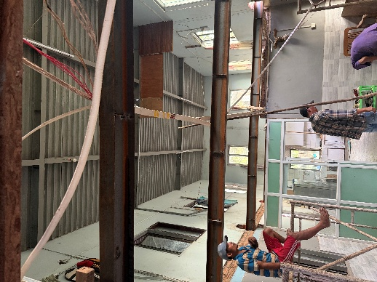
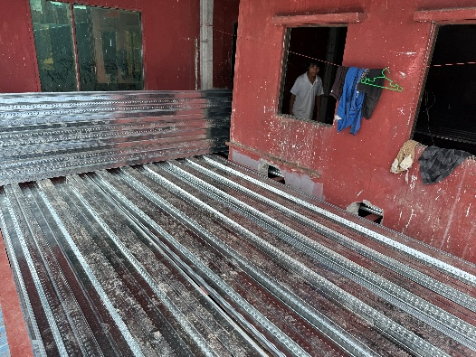
The new floor is being installed at the Children’s home. If you have ever been involved in a construction project, you will know that the cost seems to always go beyond the estimate. This is the case here, but we believe every need is met. Thank you to those who have contributed to this project.

This month I will be ministering in North Carolina before heading to England and Scotland for the month of November.

We are still praying about how to obtain a visa for Myanmar for future trips.

Thank you for standing in prayer with us. We stand with you that all your needs are met in Christ Jesus!

In His Service,

Roger and Mary King

