CUSTOMIZED LOCAL
DISCOUNT CARD’S
300 Cards Sold = $3,000.00 Profit For You
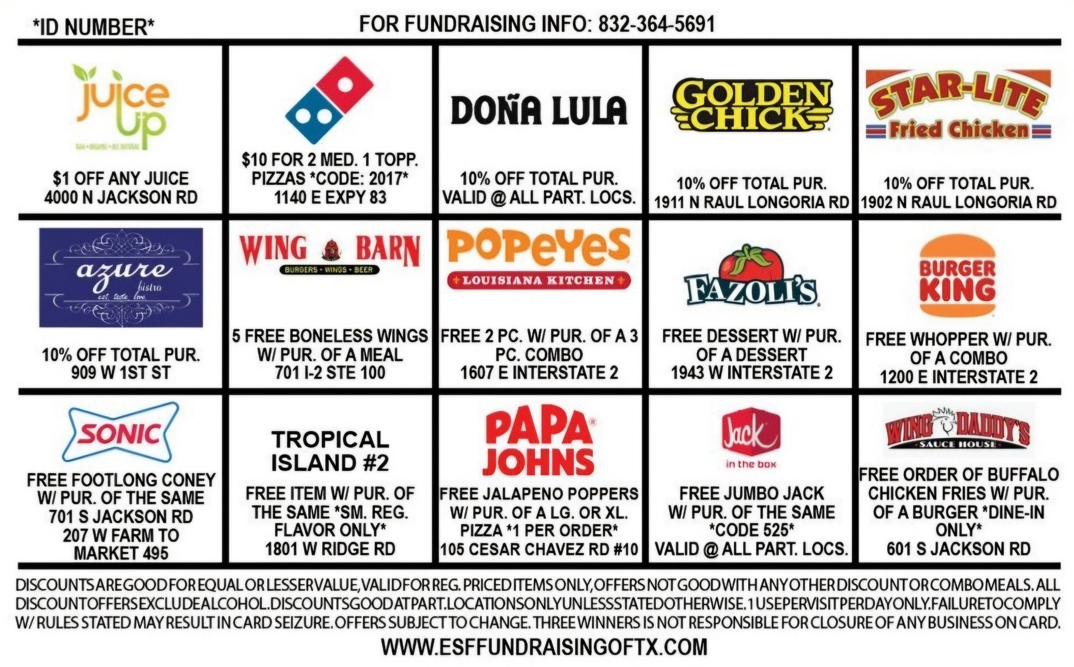
- 30 Days To Pay
- 40% to 60% Split
- No Up-Front Money
- Free Rewards Program

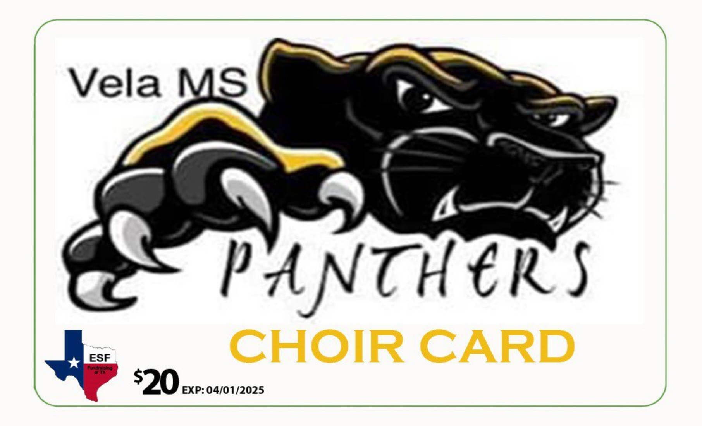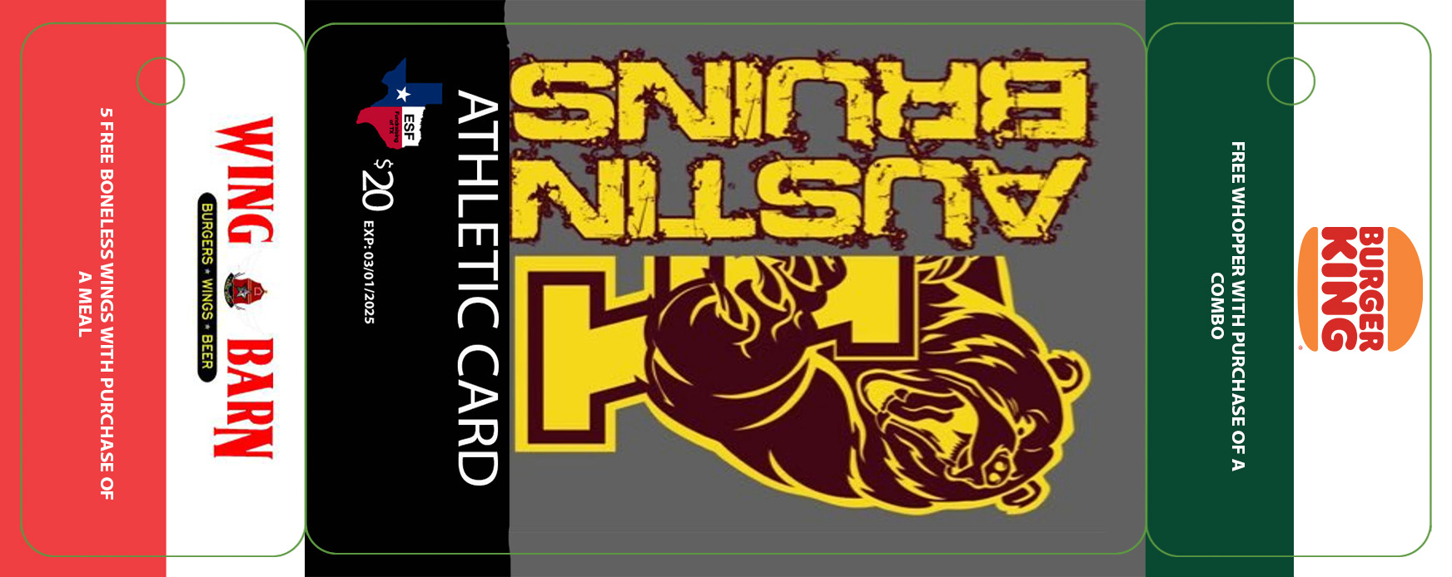
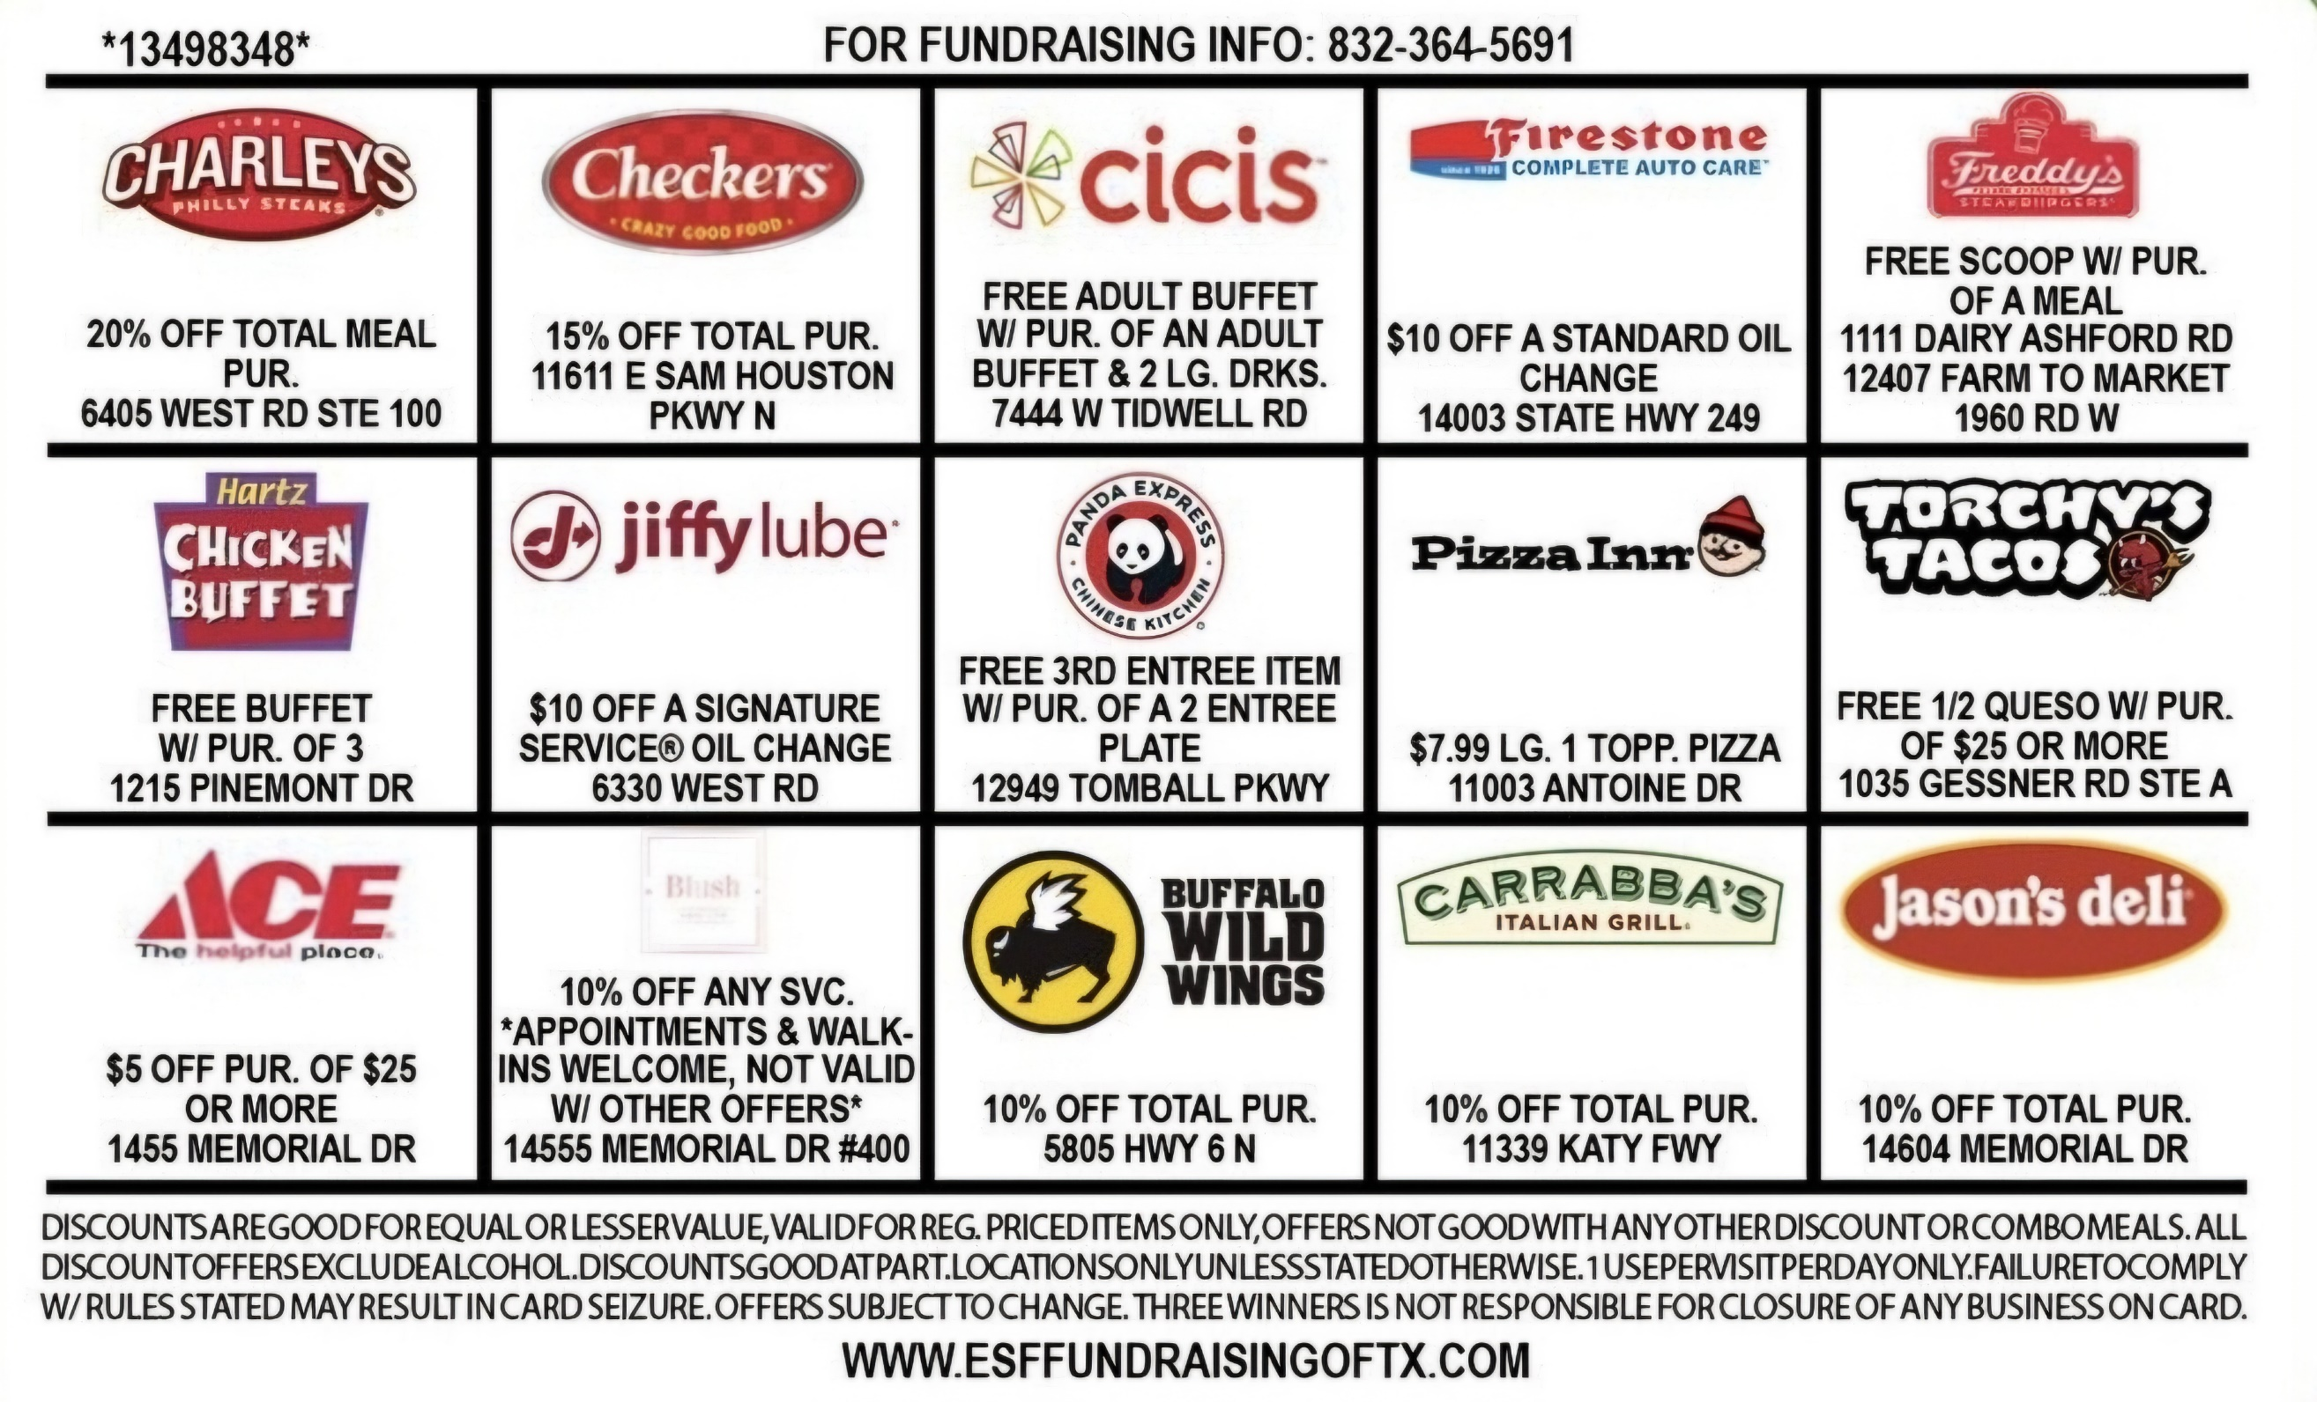

- All the Discounts on the Card are UNLIMITED USE FOR 1yr
- We go out and GET LOCAL BUSINESS
- You Get The Final Say On All The Business On Your Card
- You Only Pay For The Cards You Sell/Don’t Return To Me
ESF FUNDRAISING OF TX
920.246.6198 – Cell / bob@esffundraisingoftx.com / www.esffundraisingoftx.com

