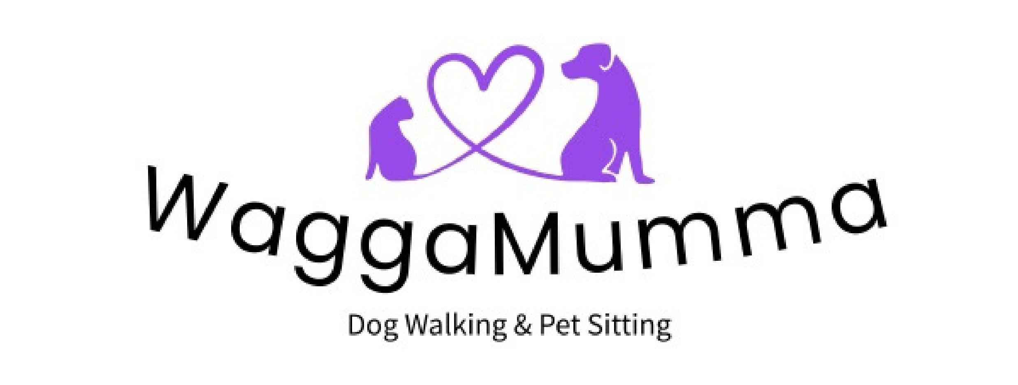Terms of Business for WaggaMumma – Pet sitting and dog walking service

1. The Client is solely responsible for any harm or damage caused by their dog while it is under the care of WaggaMumma staff and agrees to indemnify WaggaMumma in full against any liability arising from such harm or damage to third parties.
2. The Client agrees that their dog is in good health and has not harmed or shown aggression or threatening behaviour toward any person or any other dog. All dogs will be subject to an initial assessment and WaggaMumma reserves the right to refuse admission to any dog that is, or has the potential to be, dangerous or disruptive.
3. The Client is responsible for the full cost of treatment of any injuries or illness that their dog receives while under the care of WaggaMumma. The Client authorises WaggaMumma to seek veterinary advice/treatment as they deem necessary. Where possible this will be carried out by the Client’s usual Vet, but this cannot be guaranteed (e.g. in an emergency) and the Client accepts that WaggaMumma may at their discretion use any registered Vet. The Client agrees to pay all such costs immediately upon pick-up of their dog, or by agreement with the proprietor.
4. The client agrees to notify WaggaMumma if their female dog is in season and WaggaMumma will do their best to arrange walks around this.
5. The Client agrees to ensure that their dog is continuously free of diseases and agrees to notify WaggaMumma immediately of any infectious and/or contagious disease or conditions their dog has been exposed to. WaggaMumma reserves the right to refuse admission until satisfied that the condition is resolved.
6. The Client consents to their dog being photographed, videoed, and/or used in any media or advertising by WaggaMumma without prior approval. All such media remain the property of WaggaMumma.
7. The Client agrees that WaggaMumma is not responsible for any lost, stolen, or damaged leads, collars, tags, clothing or any other item left with their dog.
8. The Client agrees to provide keys for access to the property and by signing below this will indemnify WaggaMumma in full against any liability arising from loss or damage to the property or its contents, in present and future circumstances.
9. The Client agrees to inform WaggaMumma of the whereabouts of any cameras inside or outside of the property.
10. Cancellation Policy: any walks cancelled with less than 24 hours notice will be charged the full amount. Any sitting or home visit bookings will require a 20% deposit which is non refundable should you decide to cancel at any point. Remainder of bill must be settled at least 1 week before commence date. If payments are not made within the arranged time frames WaggaMumma has the right to cancel walks/sitting with immediate effect.

I have read and agree to abide by the Terms and Conditions for services received from WaggaMumma Pet Services. I hereby indemnify WaggaMumma against liability of any kind whatsoever arising from my dog’s participation in any services offered by WaggaMumma. I understand that this form acts as permission to hold keys to my property, which I have provided willingly. I hereby indemnify WaggaMumma against liability of any kind whatsoever arising from damage or loss of any property.

Clients name_______________________________________

Signature:___________________________________Date ______________________