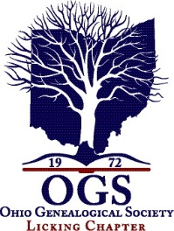
Licking County Genealogical Society
Volunteer Information Sheet
Please print information clearly
Date form was completed:_______________________________________________________

Name:___________________________________________________________________________

Address:_________________________________________________________________________

City: ___________________________________State: OHIO Zip: ______________________

Phone# Home:_________________________ Cell: ____________________________________

Email:___________________________________________________________
I wish to volunteer for the LCGS Society and Library. I have marked areas where I could help. I know that all of the projects, including indexing and transcribing data, will be done in the LCGS library and only on LCGS computers or flash drives. No information can be saved or copied for personal use.

I know Word and Excel ______________ or willing to learn how ________________

Please circle what days you would like to volunteer – you can change days whenever you want!

Monday Tuesday Wednesday Thursday Saturday (not currently available)

Please mark any of the following you would like to help with or learn to do.
____ Help researchers with looking in books, paper materials, microfilm, websites for information
____ Work the library desk during research hours directing visitors to the location of research materials
____ Help transcribe data from records, books
____ Help index booklets and ledgers
____ Help with Obituary cards: ______ typing new cards _____filing into drawers
____ Assist the Librarian to sort or process materials that are donated to the library
____ Serve on a Committee: newsletter (Lantern), Website, Membership/Recruiting, Program meetings
____ Other talents I have ___________________________________________________________________
____ Other things I am willing to do for the society________________________________________________

Librarian talked to volunteer on date: ________________ Current LCGS Member #____________
Date started to volunteer: _________________________

Licking County Genealogical Society 101 West Main Street, Newark, Ohio 43055-5054 740-349-5510
www.rootsweb.ancestry.com/~ohlcgs2 and LickingCountyOhioGenealogySociety.org Email: lcgs@lickingcountylibrary.org

