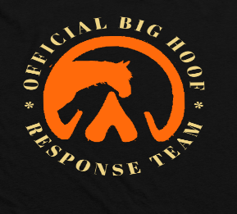 Adoption Application
Name of Horse Applying for (If Applicable)

Big Hoof Horse Rescue & Sanctuary Inc.
Po Box 1106
Nunda, NY 14517
585-404-8403
bighoofhorserescueandsanctuary@outlook.com

Please Complete in entirety:
Contact Information
Full Legal Name:
Date of Birth:
License Number
Address:
Phone Number:
Email Address:
Personal Background
Occupation:
Family members who will interact with the horse:

Previous experience with horses:

Horse Care Plan (Where will the horse live?)
Boarding: Describe the location and facilities in detail.

Acreage of Pasture:

Type of Fencing: (Board, tensile, barbed wire, t-post etc...)

Shelter:

Daily Care: Describe a typical day caring for the horse.

Veterinary Care: (Please tell us what you know in your words about proper veterinary care for horses)
Vaccination schedules:

Farrier:

Dentist:

Regular vet check-ups:

Financial Plan
Estimated monthly expenses:
Budget allocation for horse care:
Insurance details (if applicable):
Do you have an emergency vet care fund already in place
Do you understand that owning an equine can be expensive and should be considered a long-term financial commitment?
Previous Ownership and Animal Custody
Have you ever had any animals removed from your custody, either by court order or due to an owner’s surrender situation?

Include details of any animals taken to shelters, auctioned, or sold to a third party. Provide explanations for each instance.
Additional Information
Why do you want to adopt this horse?
How do you plan to handle emergencies?

References (provide full name, relationship, how long known and good phone number to reach them)
Personal references:
1.

2.

3.

Veterinary references: Large and Small Animal
If Applicable, please provide information to all veterinary services you have used that can attest to your animal care abilities.
1.

2.

3.

