**Dynapath – Program sending and drip feeding using DNC4U**

After posting code, and generating a .TXT file, you are now ready to drip feed to the machine.

**\*Preparatory notes\***

1. The Dynapath post from fusion is formatted to select the “event” in the same manner you would use to conversationally program the machine.
2. The tree / Dynapath utilizes the machines tool library when referencing tool lengths
3. Your zero reference (Z0 A.K.A G54-Z0) in the “jog” menu of the dynapath control is set using the tool that you used to set all of your other tool lengths in reference to.
4. As soon as a M code event is programed calling out a tool number, that tool length is referenced.

**Configuring the DNC4U code**

1. Open DNC4U.
2. Using the DNC4U “DNC Wizard” in the tool bar menu, you will send a program from the Dynapath to the computer which will automatically configure DNC4U to the machines flavor of code.

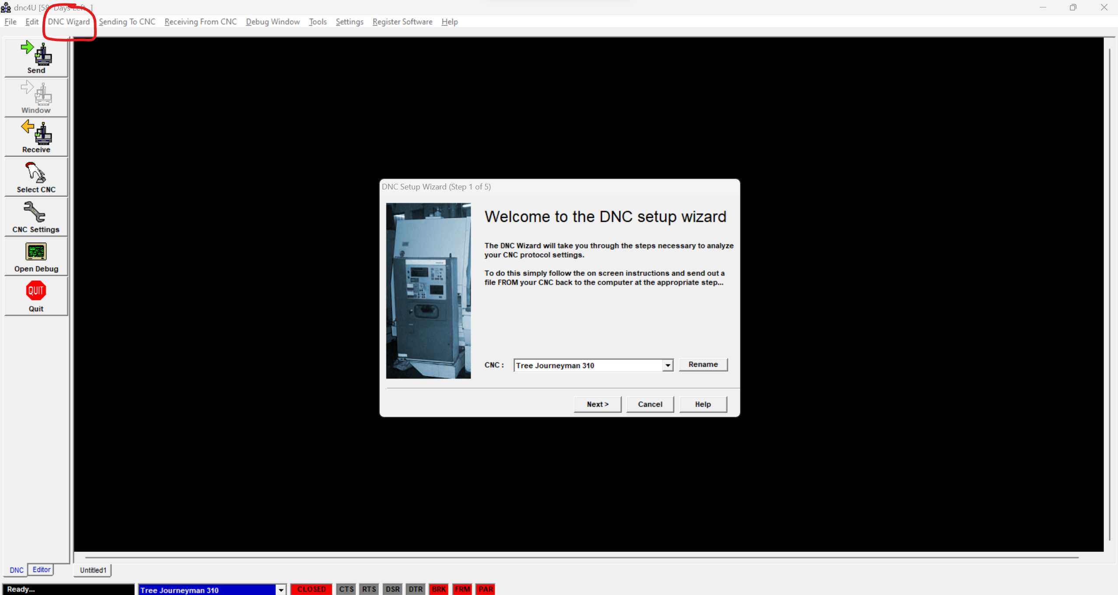

1. In the Dynapath menu, select “Load” and select the following parameters in the screen
   * R6-RS232 9600 BD
   * P1 Parity - ON
   * X0-CTL CHR -ON
   * E1 – ECHO – ON

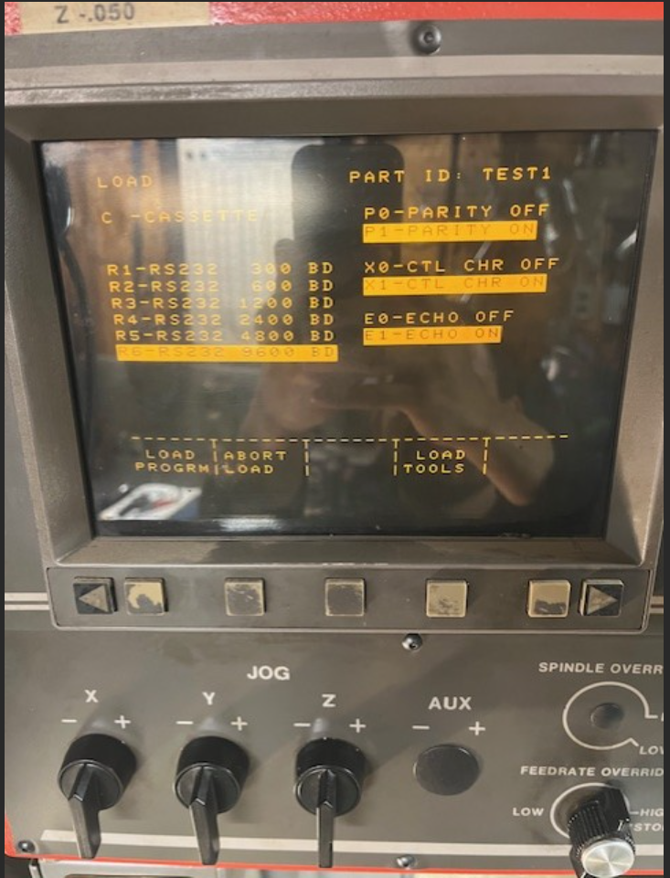

1. With a program already written and selected from the CATALOG menu in the Dynapath control, and the DNC4U wizard ready to receive a program, select the LOAD PROGRAM option in the Dynapath interface. Finish the DNC4U setup.

**Sending a Part Program**

1. If the program is under 40KB, it can be loaded in its entirety to the machine (no drip feed required)
2. To load a program – select “CNC Settings” in DNC4U and select the following

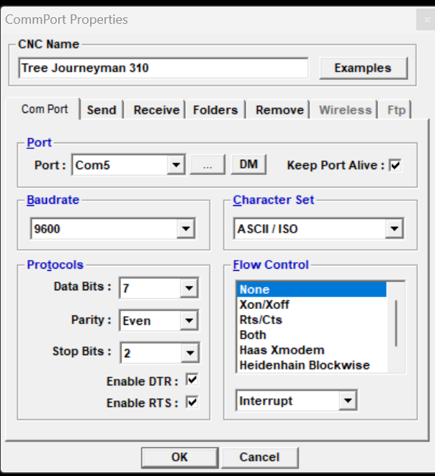

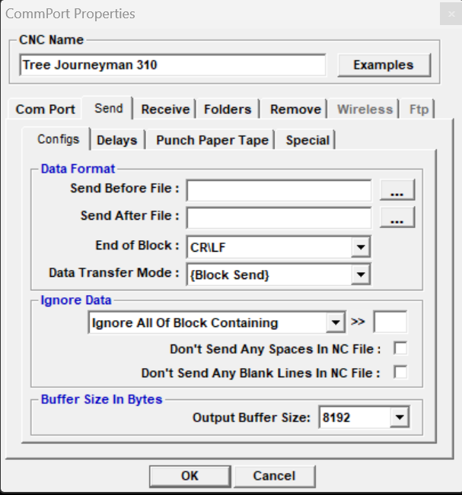

1. In the Dynapath interface, select “Record” with the following parameters
   * R6-RS232 9600 BD
   * P1 Parity - ON
   * X0-CTL CHR -ON

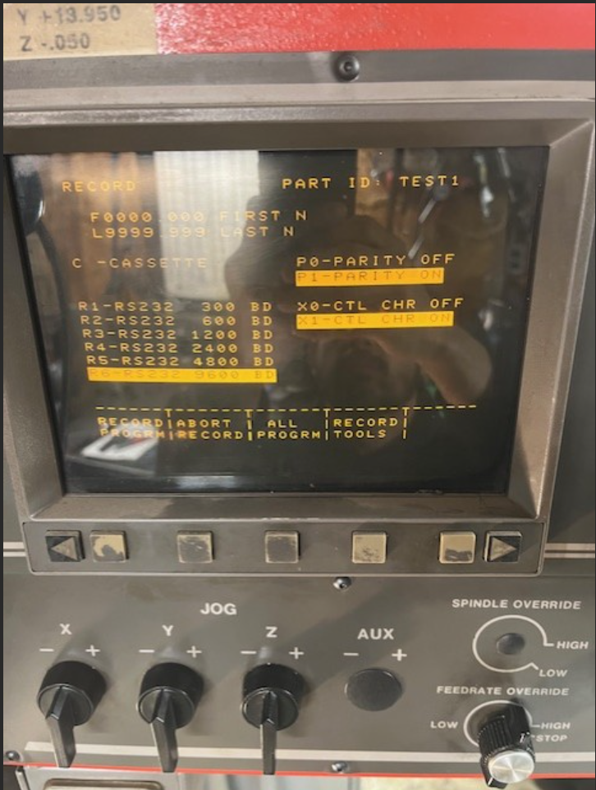

1. Select the “record program” button on the Dynapath control, then, in the DNC4U interface, select the “send” button. The program will now transfer. To declare the transfer finished. Hit the “Abort Record” button. The part program will now show up in the Catalog

**Receiving a Part Program**

1. To send a program (or tool list) from the Tree to your computer – select “CNC Settings” in DNC4U and select the following





1. In the Dynapath interface, select “Record” with the following parameters
   * R6-RS232 9600 BD
   * P1 Parity - ON
   * X0-CTL CHR -ON



1. Select the “record program” button on the Dynapath control, then, in the DNC4U interface, select the “receive” button. The program will now transfer. To declare the transfer finished. Hit the “Abort Record” button. The part program will now show up as the new file name you created with DNC4U

**Drip Feeding a Part Program**

1. To Drip Feed a program – select “CNC Settings” in DNC4U and select the following

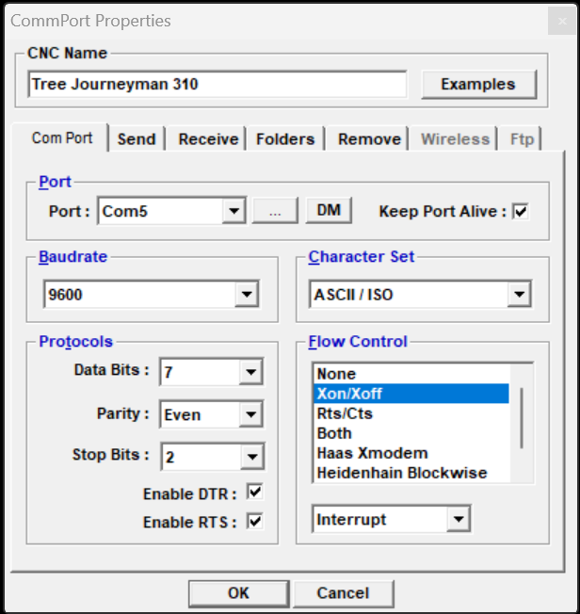

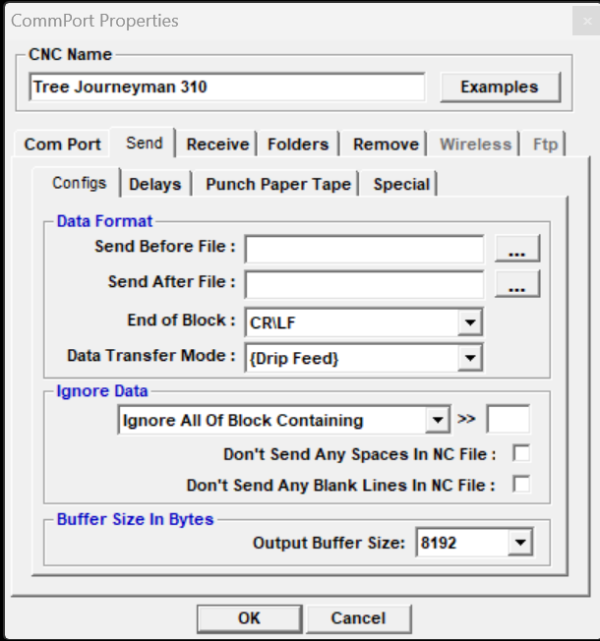

1. In the Dynapath interface, set both “record” and “load” screens to the settings listed in the above sections.
2. Select “Catalog” in the Dynapath control. Key in “RS232C” and hit enter. You are now in drip feed mode. Head back to the main menu and select “Auto”. Hit the cycle start button. The machine is now opened to receiving Drip Fed Code.
3. Head back over to the DNC4U interface and “SEND” your .TXT file. This will begin the buffered drip feed process. As soon as your ready, you can hit “Cycle Start” on the machine to begin machining.