Speeds and Feeds

Variables / Abbreviations
- Speed – Surface Feet per Minute (SFM)
- Feed – Inches per Minute (IPM)
- Feed per Tooth (FPT)
- Adjusted Feed per Tooth – Chip Thinning (AFPT)
- Feed per Revolution (FPR)
- Depth of Cut (DOC)
- Width of Cut (WOC)
- Tool Diameter (D)
- # of Teeth in Cutter (Z)
- Metal Removal Rate – Cubic Inches per Minute (MRR)

Milling Formulas
- Speed (RPM) = (SFM x 3.82) / D
- Feed (IPM) = RPM x IPT x Z
- SFM (Surface Feet per Minute) = (RPM x D) / 3.82
- IPT (Inches per Tooth) = (IPM / RPM) / Z
- MRR (Cubic Inches per Minute) = IPM * WOC * DOC
- AFPT (@ less than 1/2 dia. WOC) = IPM x sqroot of (D / WOC)
- HP (Horsepower Consumption) = MRR x mf
  - mf - steel = 1
  - mf - gray iron = .65
  - mf - aluminum = .3
  - * - 1.5% from total for every degree positive

High Speed Steel Endmill Speed and Feed’s
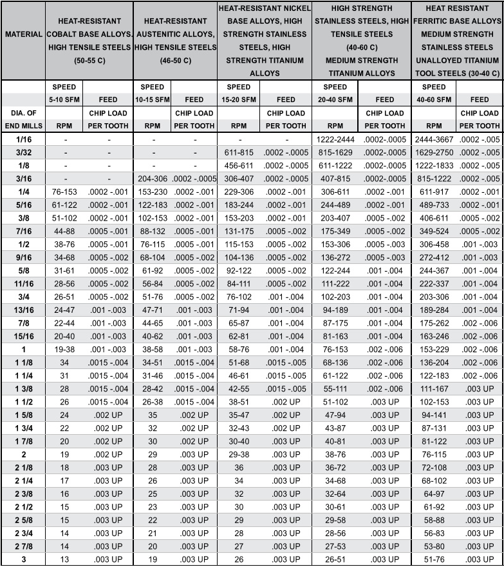
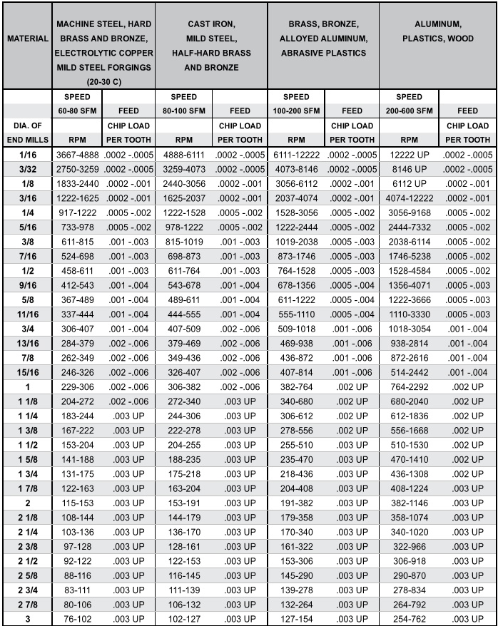

Carbide Endmill Speed and Feed’s
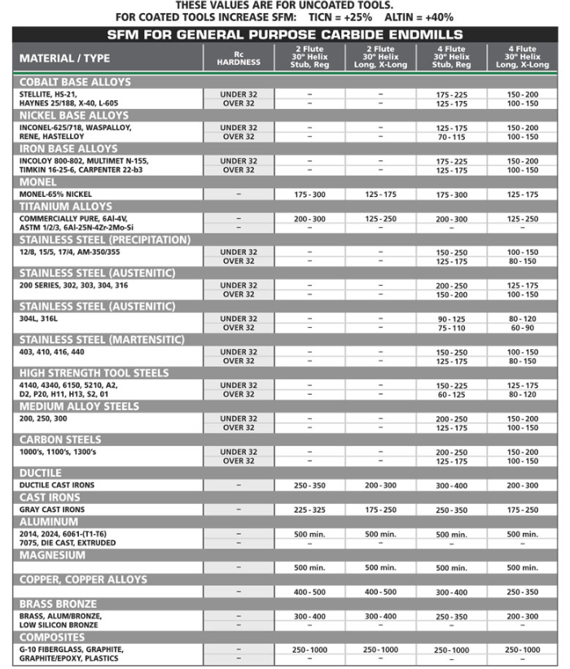

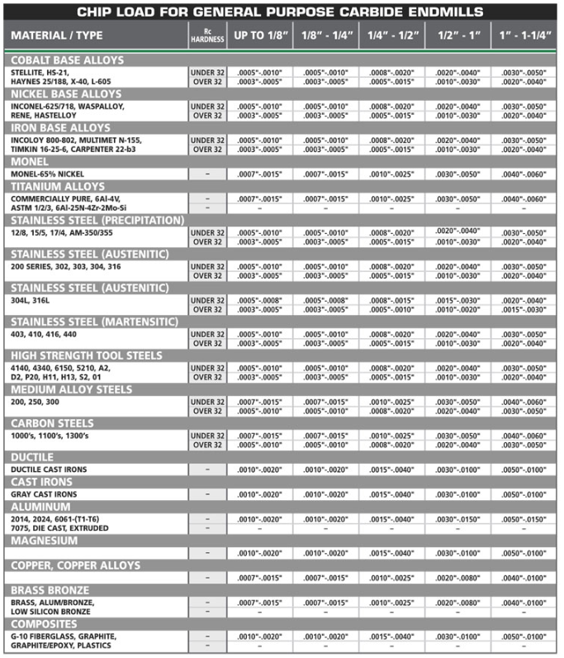

Ballmill Speed and Feed’s
