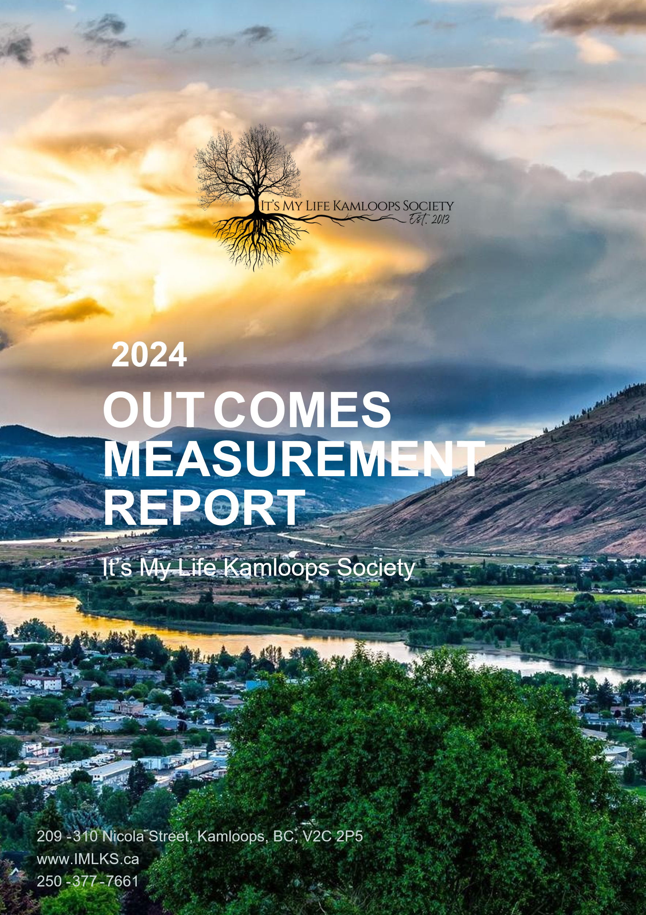

Our Mission
That the highest-quality support is provided to the individuals supported by It’s My Life Kamloops Society. By honoring each unique personality, we will create environments that ensure full involvement in all of their life choices and decisions.

Our Vision
Our vision is to thrive in a community without barriers where everyone is recognized as valued and equal!

Our Values
Integrity, Flexibility, Community, Respect for Individuals, Discovery, Uniqueness, Determination, Communication, Resourcefulness, Freedom, Optimism, Devotion, Insightfulness
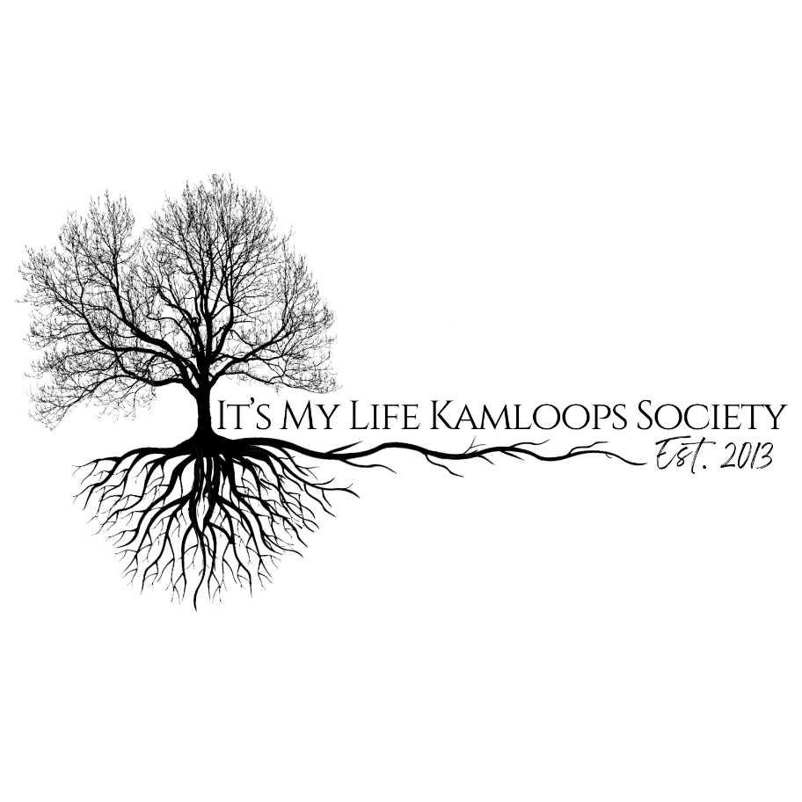

Table of contents

Who We Are 5
Overview 7
Areas We Measure 8
What For? 9
Things to Consider While Reading this Report 10
Stakeholder Feedback 11
Family Member Feedback 20
Team Member Feedback 30
Member Feedback 46
Human Resources Report 63
Employee Compliment 63
Recruitment and Retention 65
Job Satisfaction 67
Employee Turnover 68
Policies and Procedures 71
Benefits 71
Orientation and Training 71
Community Partnerships 73
Health and Safety 74
Employee Injuries 74
Health and Safety Committee 74
On going workforce challenges 75
DEMOGRAPHICS OF PERSONS SERVED 76
REPORTING SERVICE 76
Community Support/ Inclusion (Community Integration) 76
Live-In Support (Supported Living) 77
Domains 77
SECTION 1: SERVICE DELIVERY SPECIFIC OUTCOMES 78
SECTION 2: ANALYSIS OF PERSON SPECIFIC EXTENUATING AND INFLUENCING FACTORS 81
RESULTS FROM DATA 82
Interpretation of Data 83
Effectiveness 83
Efficiency 84
Service Access 85
Feedback/Stakeholder 86
Barriers and Extenuating or Influencing Severity Factors 87
Critical Incident Reports 90
Internal Incident Reports 91
Medication Errors 92
RECOMMENDATIONS FROM THE 2024 OUTCOMES REPORT 94
Goal #1: Reduce Medication Errors and Improve Documentation Practices 94
Goal #2: Increase Community Participation and Socially Valued Roles 95
Goal #3: Strengthen Onboarding and Training for Casual Staff 95
Goal #4: Improve Stakeholder Feedback and Communication 96
Goal #5: Reduce Incident Rates and Promote Safety 96
Goal #6: Enhance Employee Retention and Job Satisfaction 97
Goal #7: Maintain High Standards in Service Delivery 97
CONCLUSION 98

Who We Are
It’s My Life Kamloops Society (IMLKS) was established in the fall of 2013. It was a group of people with similar values, ethics and principals coming together to create an organization that could provide person driven quality support services to adults with diverse abilities.

At the end of 2024, IMLKS was providing support in the form of Supported Living to 12 persons, in the form of Community Inclusion to 4 individuals and, Outreach Support to 1 individual.

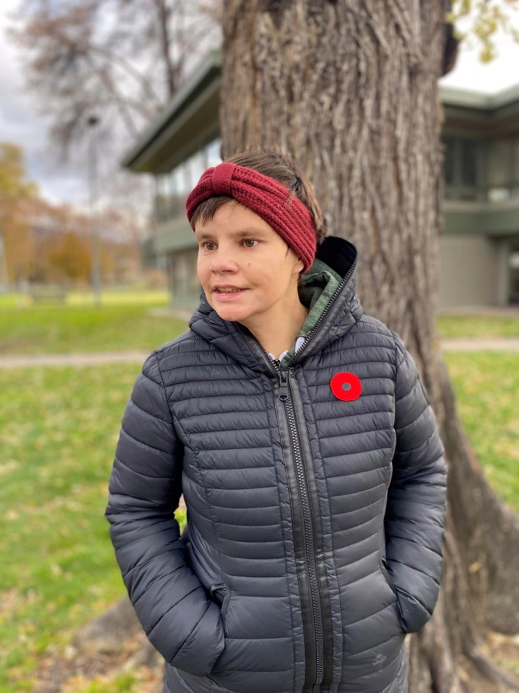
Formerly part of BC Community Services Cooperative, IMLKS found it was no longer effective or efficient to contract its administrative staff and thus decided to separate itself from the Cooperative in November of 2019. At this point, IMLKS decided to hire a part-time Bookkeeper and full-time Human Resources Manager. Throughout the summer, as part of the Canada Summer Jobs Program, IMLKS employs a temporary Human Resources Assistant.

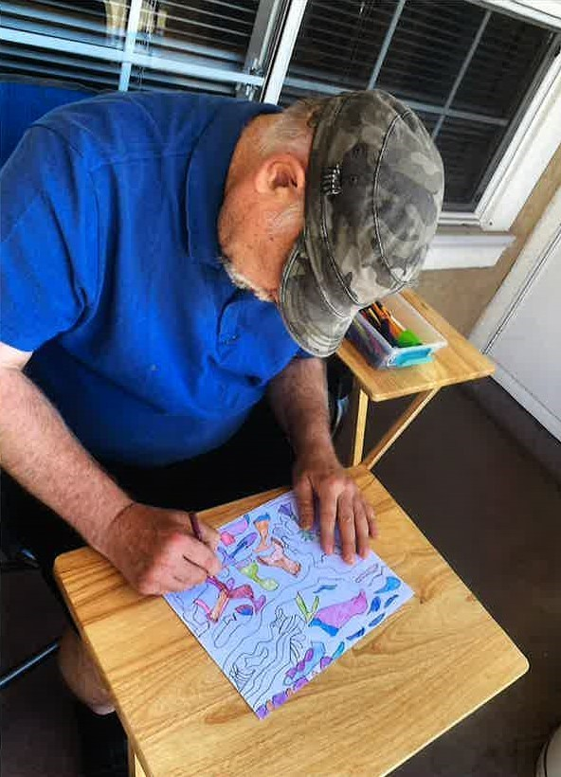
At the end of December 2024, IMLKS consisted of 52 team members including management. IMLKS’s mission is “to provide the highest quality of support to the members of IMLKS by honoring each unique personality”. For that reason, IMLKS has continued to employ the HR Manager that was hired internally, who worked frontline while completing a BBA in Human Resources before moving into the HR position in January of 2019. Because the HR manager has known the individuals supported by IMLKS since 2019 this allows our employee selection process to be centered around the individual’s personal characteristics and support needs.

Our team follows the values and philosophies of leaders in the Human Services field. We understand that “one shoe does not fit all.” We are constantly looking at creative and thoughtful ways to support persons served, to help them achieve the life they want to live.
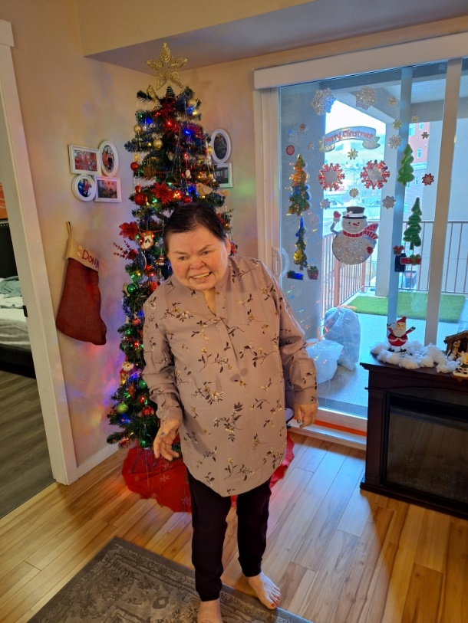
By providing person driven support, people are honored for their uniqueness and are given the opportunity to be involved in everything that occurs in their life. From choosing a home, to involvement in their community, the person is able to choose what they want their life to look like. The support provided by IMLKS enables persons served to excel, become more independent, less aggressive in some incidents (because they are provided choice, given rights and listened to) and most importantly allows their life to stay authentically centered around them!

Overview
Through this outcomes report, IMLKS uses data and feedback gathered from its stakeholders to measure goal achievement, strategize and, set new goals. The methods of collecting the feedback/information reported this year include:
- Surveys
- Health and safety records
- Human resources records and reports
- Formal complaints
- Personal communications
- Payroll records and reports
- HR Spreadsheets
- Training records
- Incident tracking records

We feel it is important to recognize that formal feedback tools like satisfaction surveys cannot – and will not – replace the impact and importance of our daily conversations and the feedback we receive from persons served, families, employees and other stakeholders on an ongoing basis. Relationships are a key foundation of our agency, and building trust with our stakeholders through day-to-day conversations and interactions will only make IMLKS stronger.

Each section of the report has a data analysis section – a description of the information from its source, and any trends or key findings on which we think we should focus. The data analysis is the basis for recommendations made by the management team, which are then approved by IMLKS’s Board of Directors.

Other important parts of this report are included in the section on human resources and health and safety. This information is included in the report because both areas affect the quality of services provided by the organization. IMLKS’s personnel are essential to the quality of services we provide to the adults and their families that we support. Therefore, it’s important to know the training, turn-over rates, accident rates, employee satisfaction and other related workforce indicators (information that tells us how our employees are doing) so that IMLKS can support the link between human resources (the department that takes care of employees) and the quality of services.

Areas We Measure
This Report compares information for this year to last year in the following areas:

EFFECTIVENESS – the service is doing what it is supposed to do (e.g. support personal growth, obtain employment, make friends, etc.).

EFFICIENCY – using resources (e.g. money, staff, equipment, etc.) in the best possible way.

SATISFACTION – stakeholders are happy with the services provided by IMLKS.

ACCESS – identifies the availability of a service based on enrolment and capacity (measured alongside efficiency).



What For?
IMLKS demonstrates how it meets the expectations of the adults receiving services and remains accountable to other stakeholders (like funders), through an Outcomes Measurement Report. An “outcome” is an end result. IMLKS wants to know what goals the organization is meeting, and how it is accomplishing those goals. The Outcomes Report helps the Board of Directors see what’s working and what needs to change in order to improve.

The information collected is both qualitative and quantitative. Qualitative information can be: written comments, opinions, and feedback that cannot be measured with a number or rating. Quantitative information is numbers or percentages (%). This information is directly taken from the surveys or reports. IMLKS must report on at least one outcome in each program area.

An outcomes measurement report is also a requirement of an accredited organization

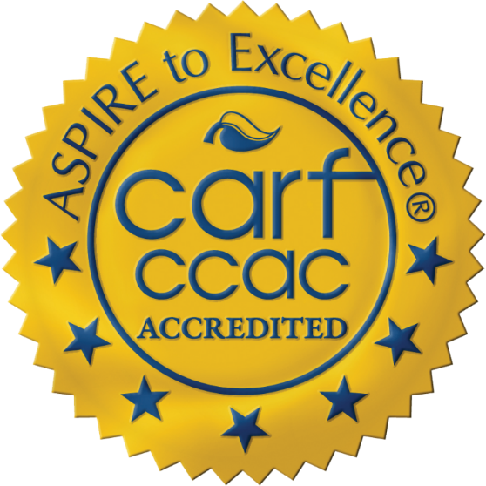

Things to Consider While Reading this Report
This report is not in plain language. It is our hope that people will get help from their families, friends or staff to read the report. IMLKS is a growing organization and there is a lot of interesting information to report on. If you would like to meet in person to further discuss the report, please contact us!

Dawn Khadikin,  Executive Director  Phone: 250.377.7661  Email: Dkhadikin@itsmylife.ca | Natalie Clos,  Human Resources Manager  Phone: 250.377.7661  Email: NClos@itsmylife.ca



Stakeholder Feedback
30 anonymous survey invitations were sent to IMLKS Stakeholders via Survey Monkey and 9 were completed. 11 of those invitations were opened and 10 were not.

Our Stakeholders include community members; other service providers such as HSCL, Occupational Therapists, Pharmacists and, funders. Persons served and family members are our most important stakeholders so they are surveyed separately.

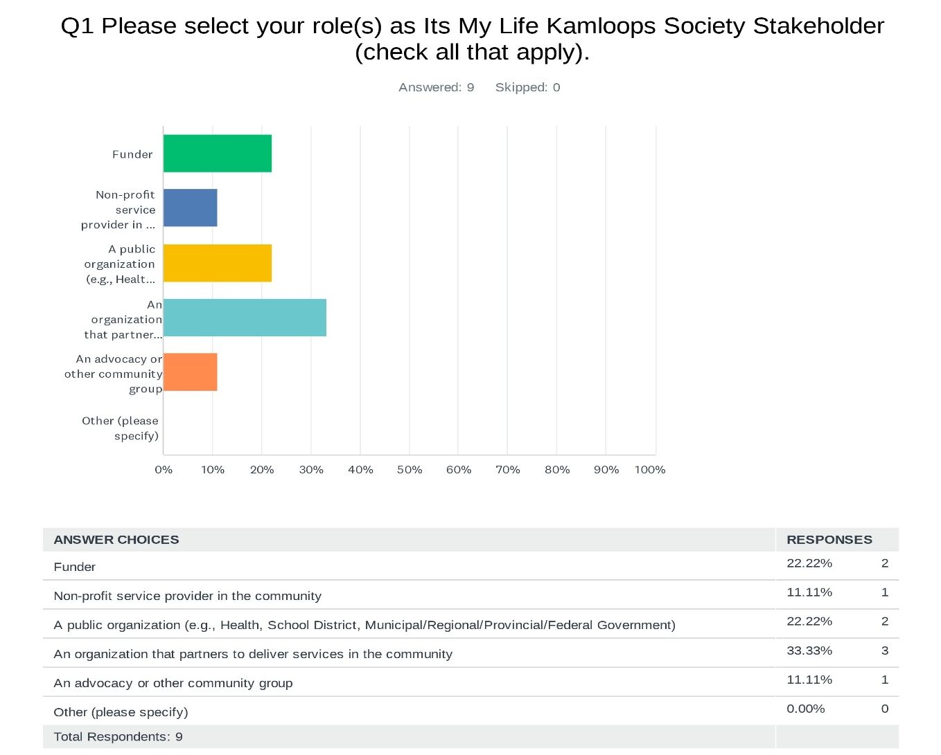
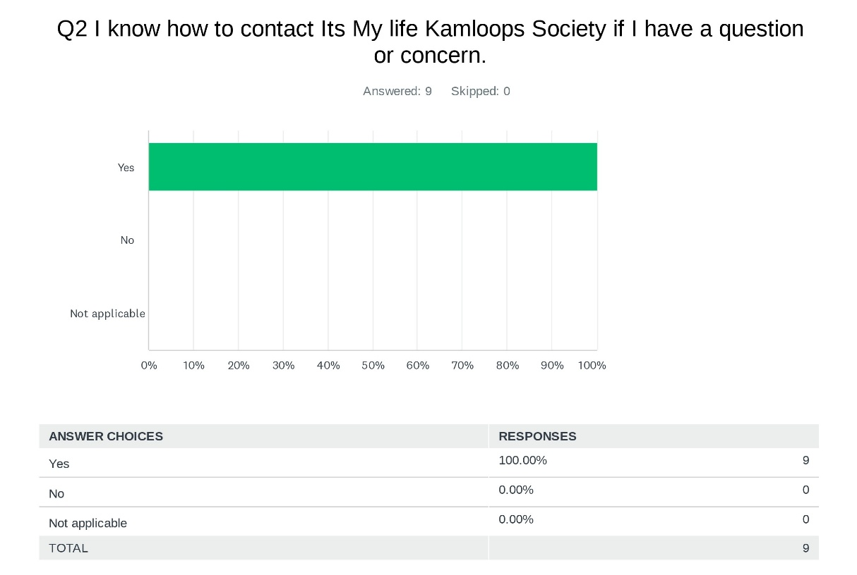
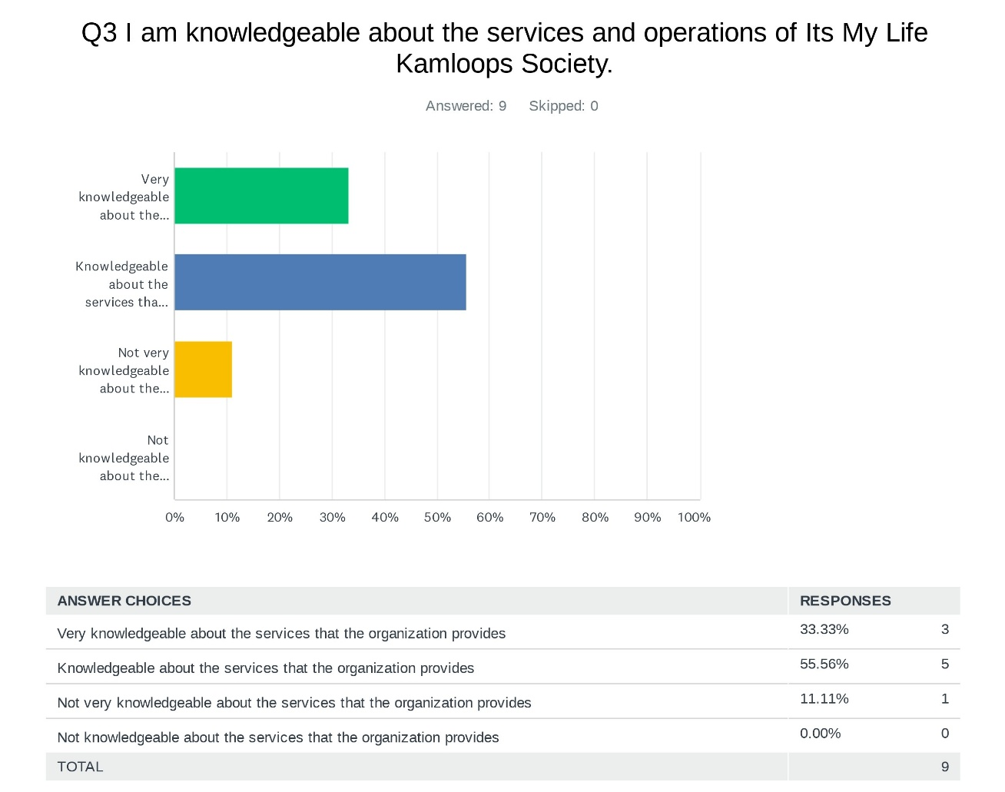
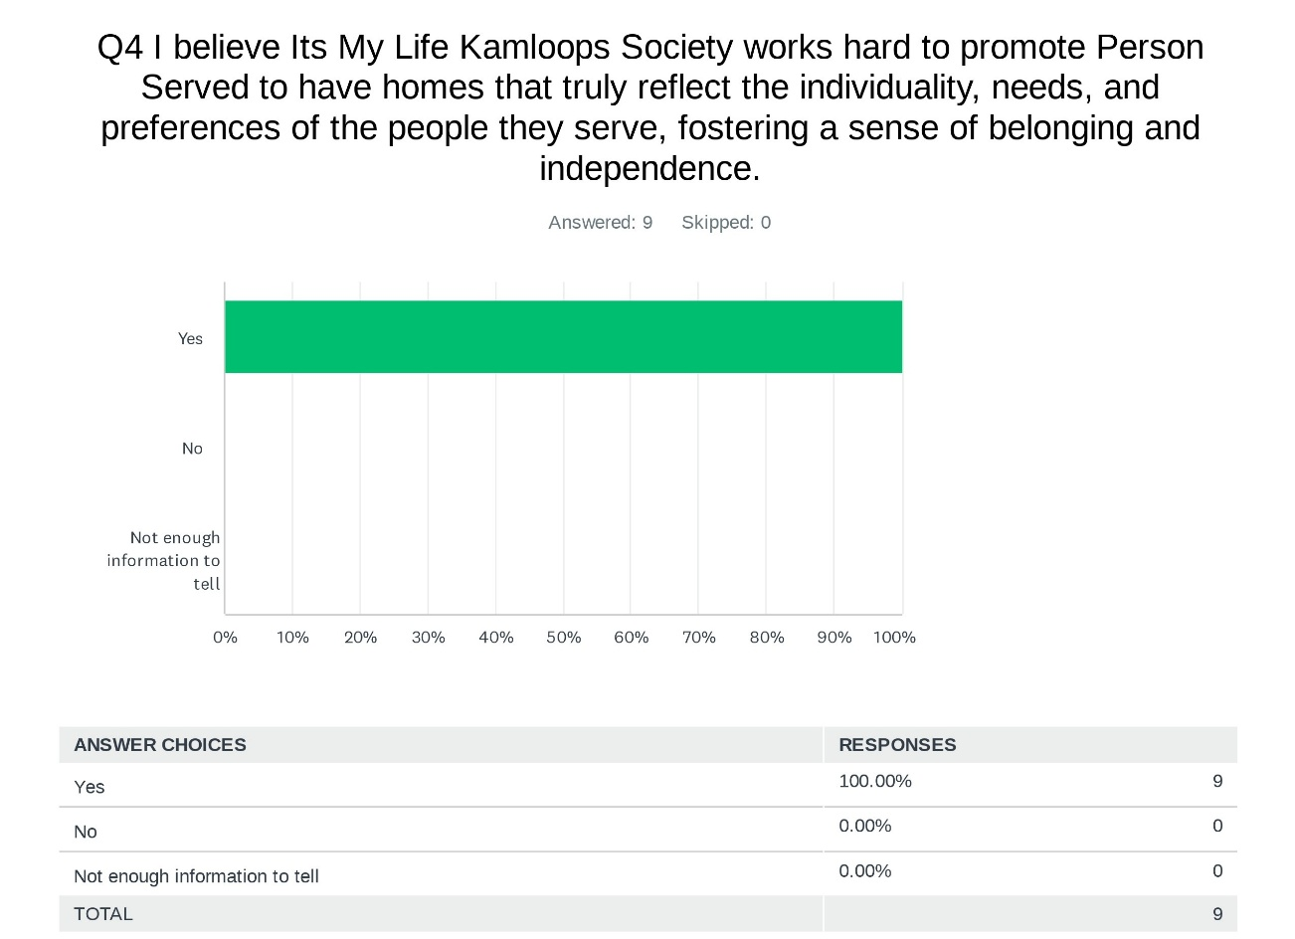
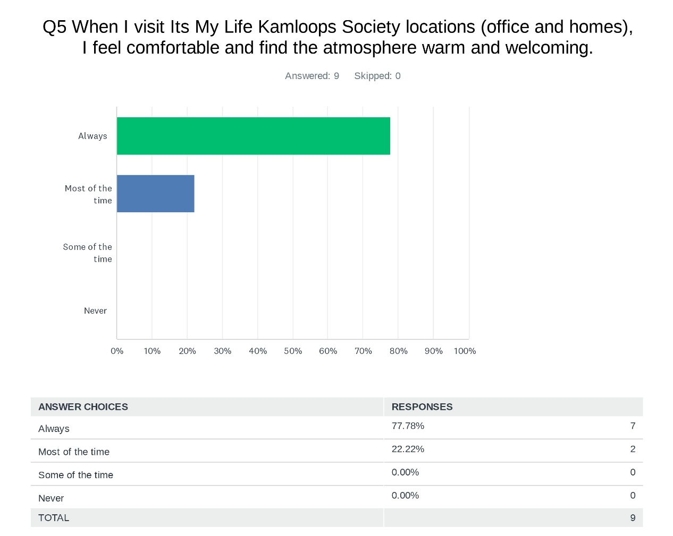

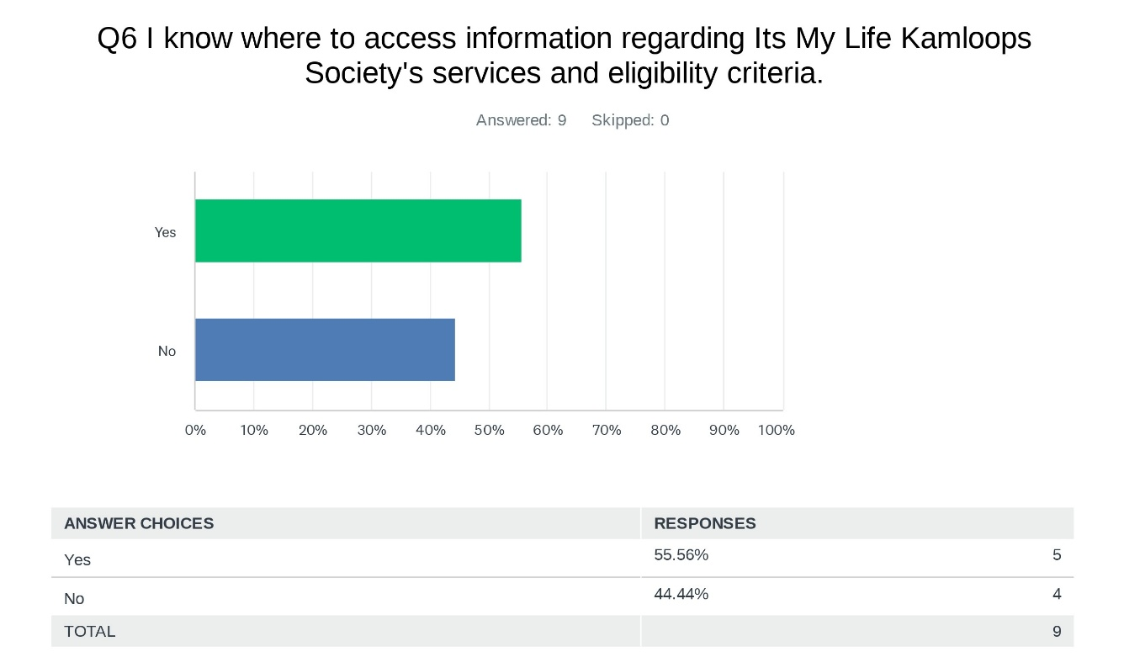
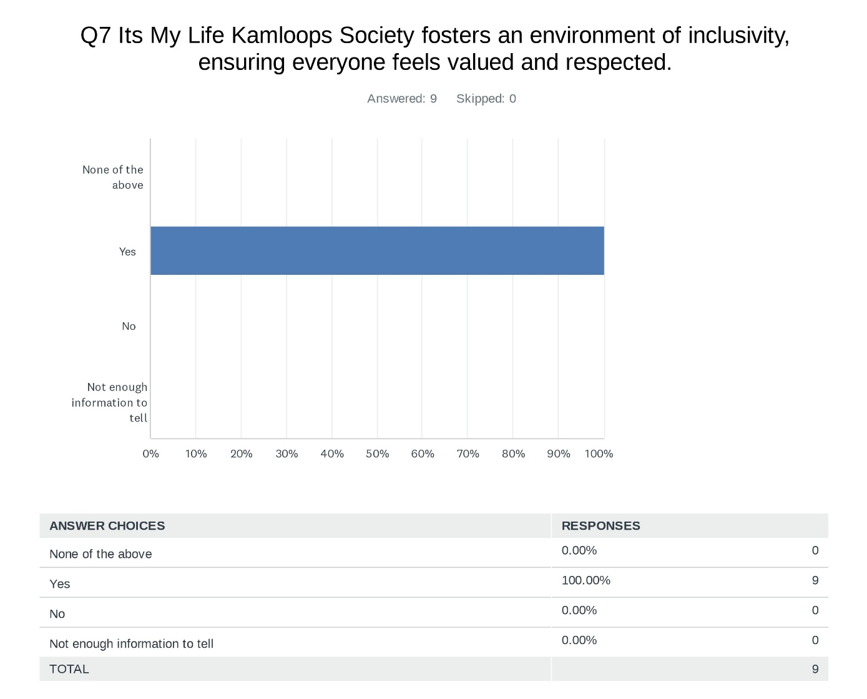

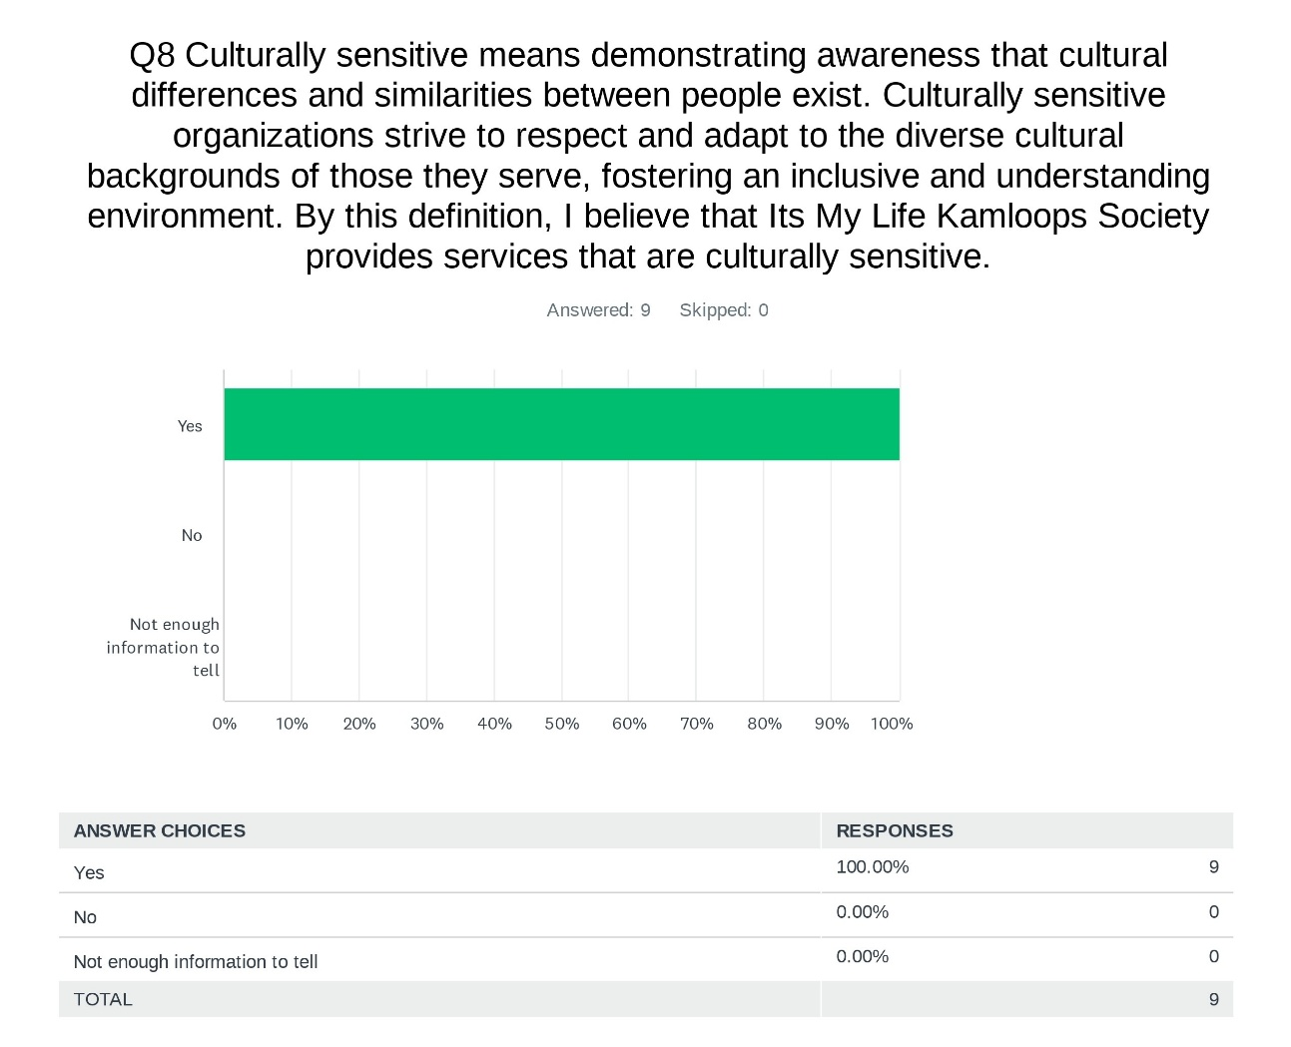
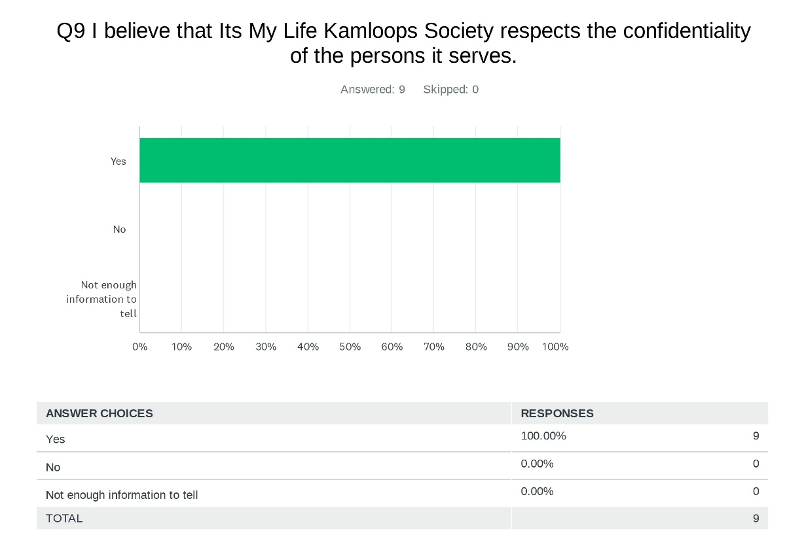

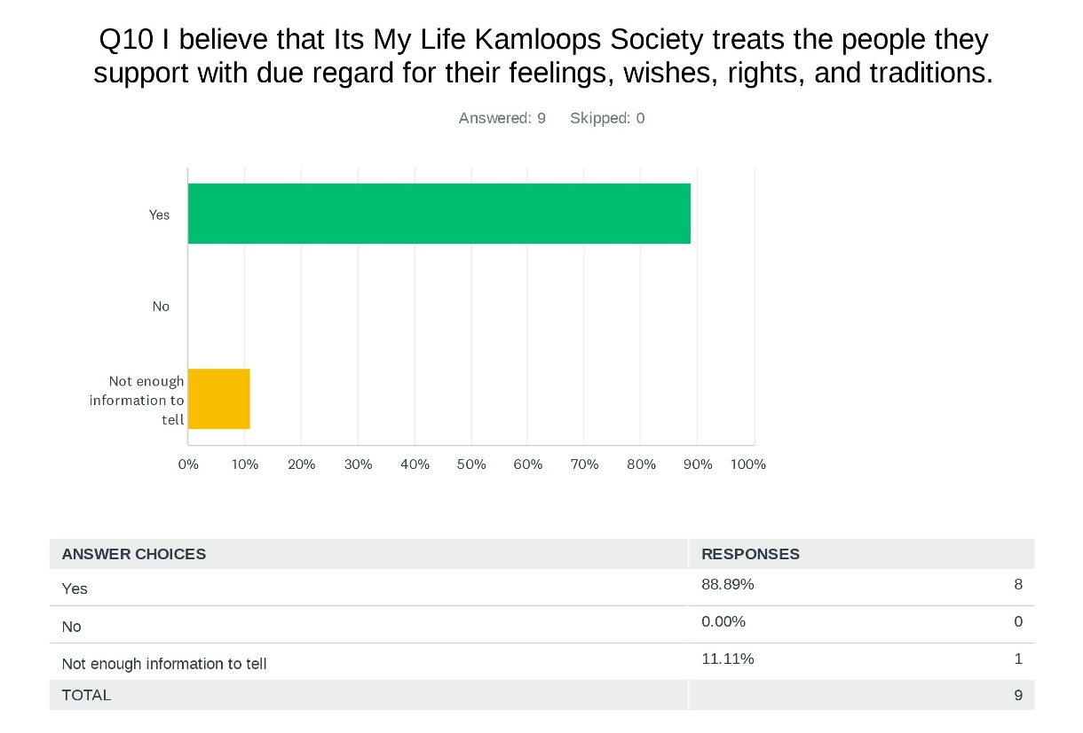
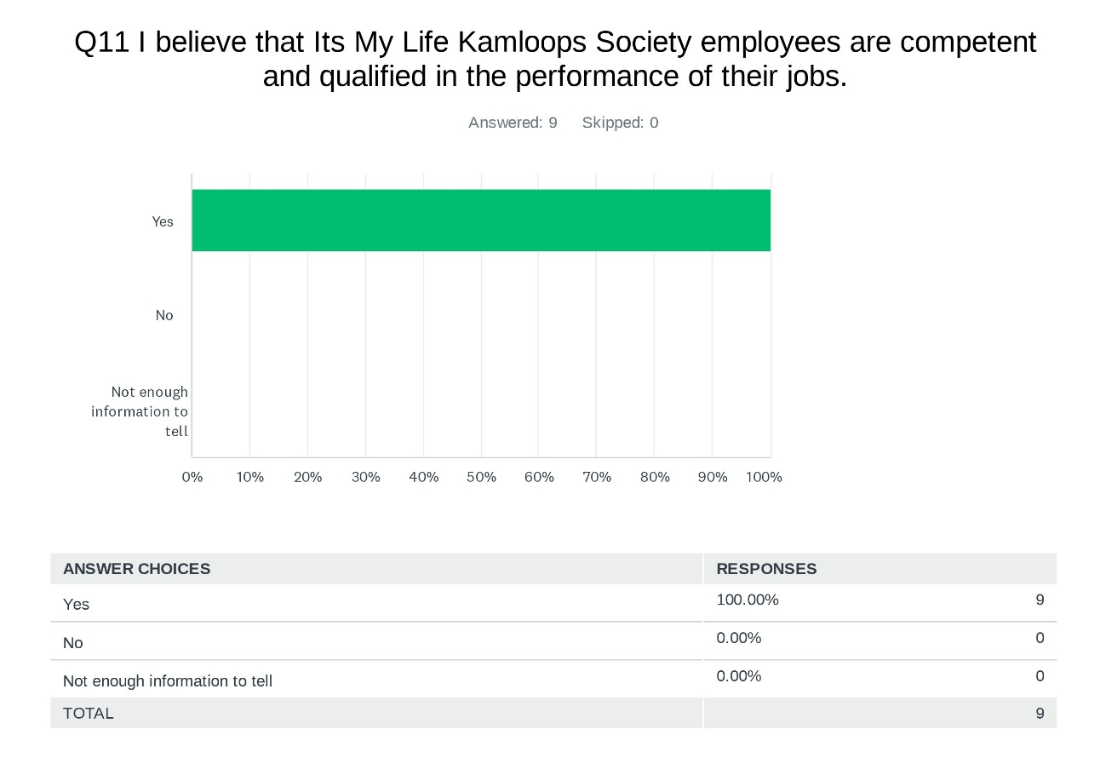

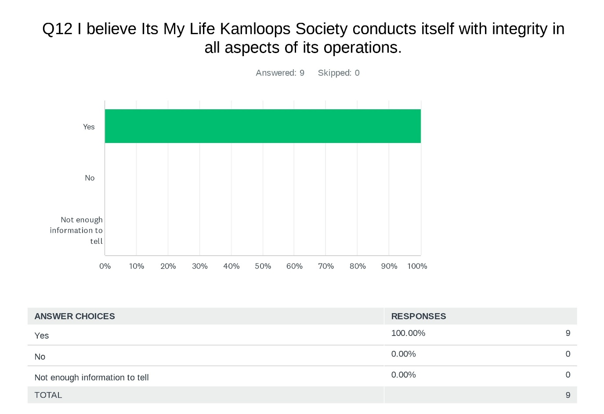
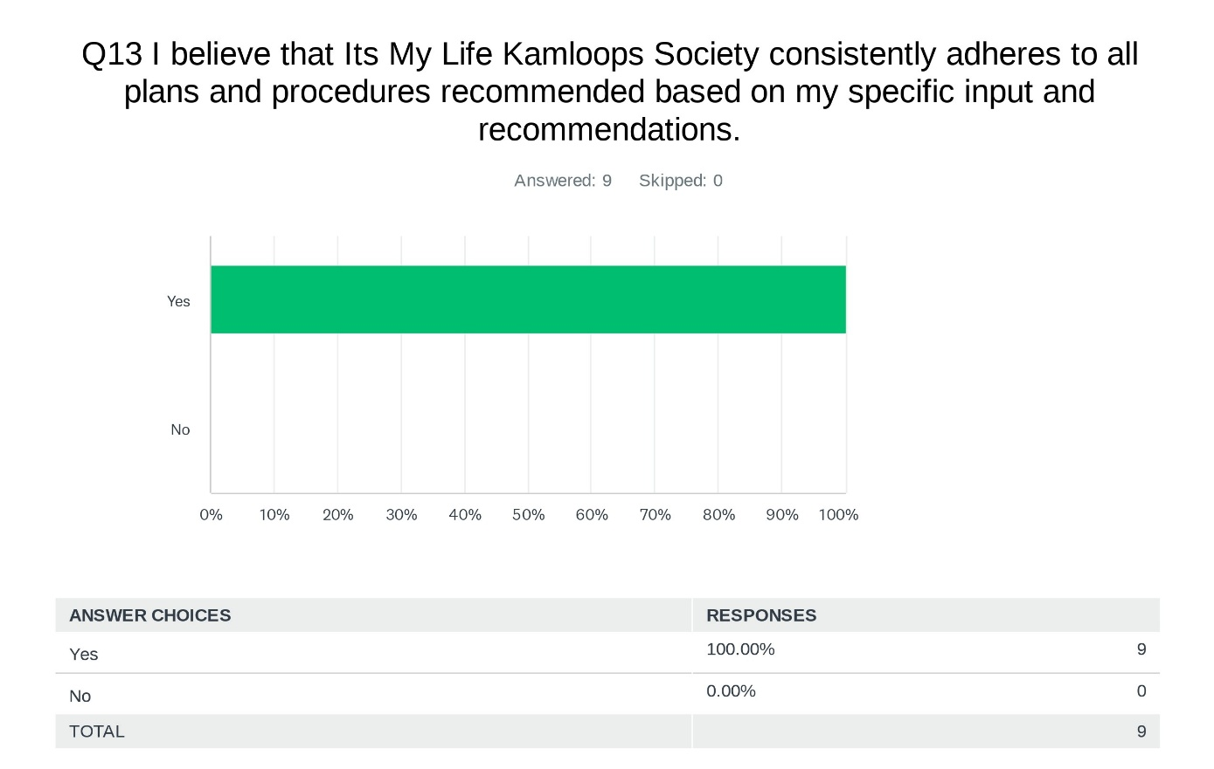

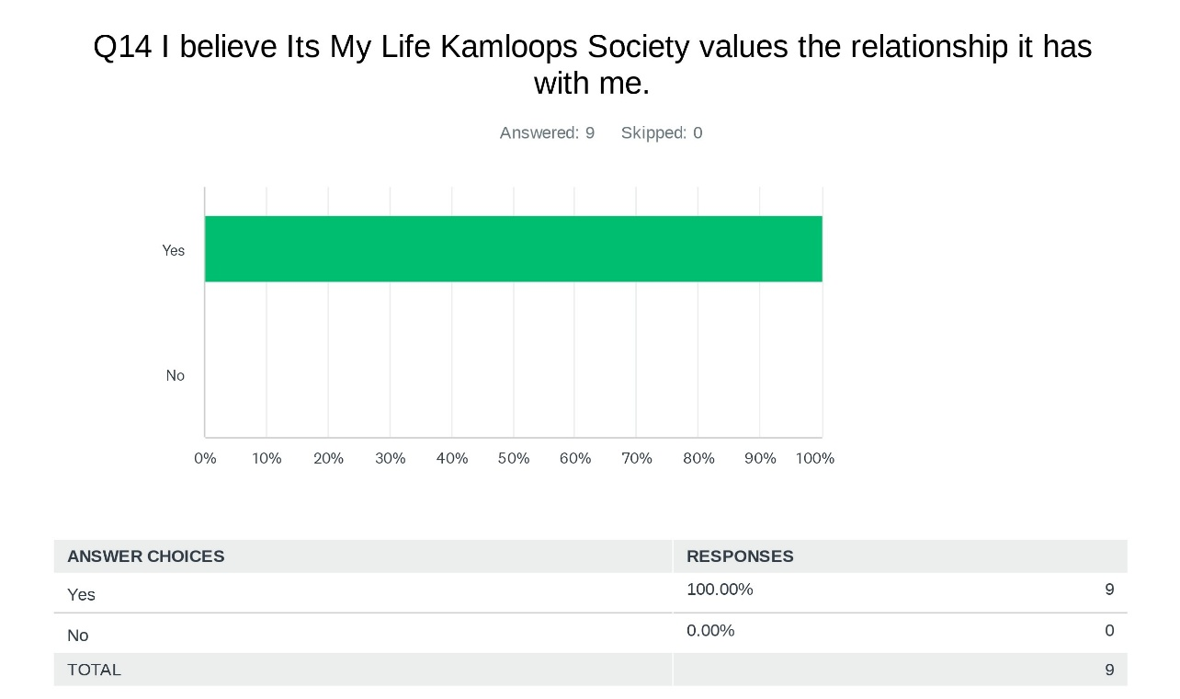
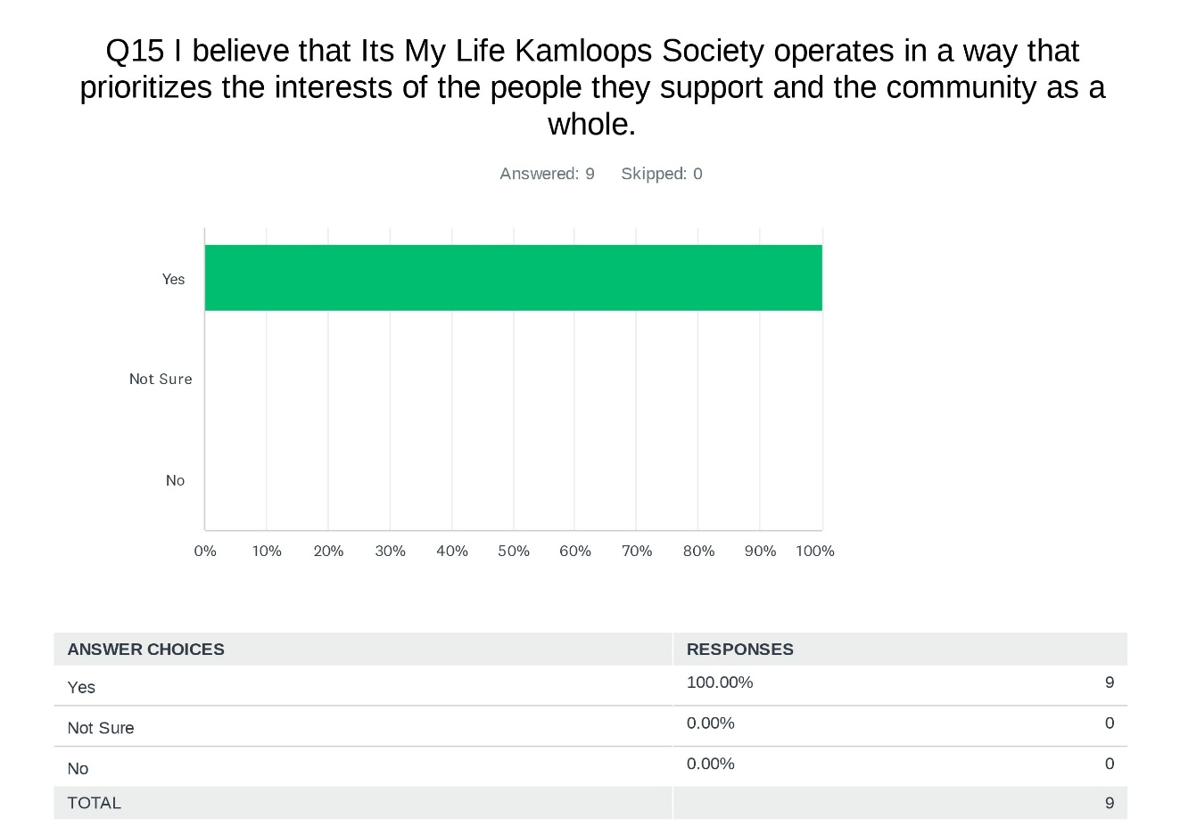

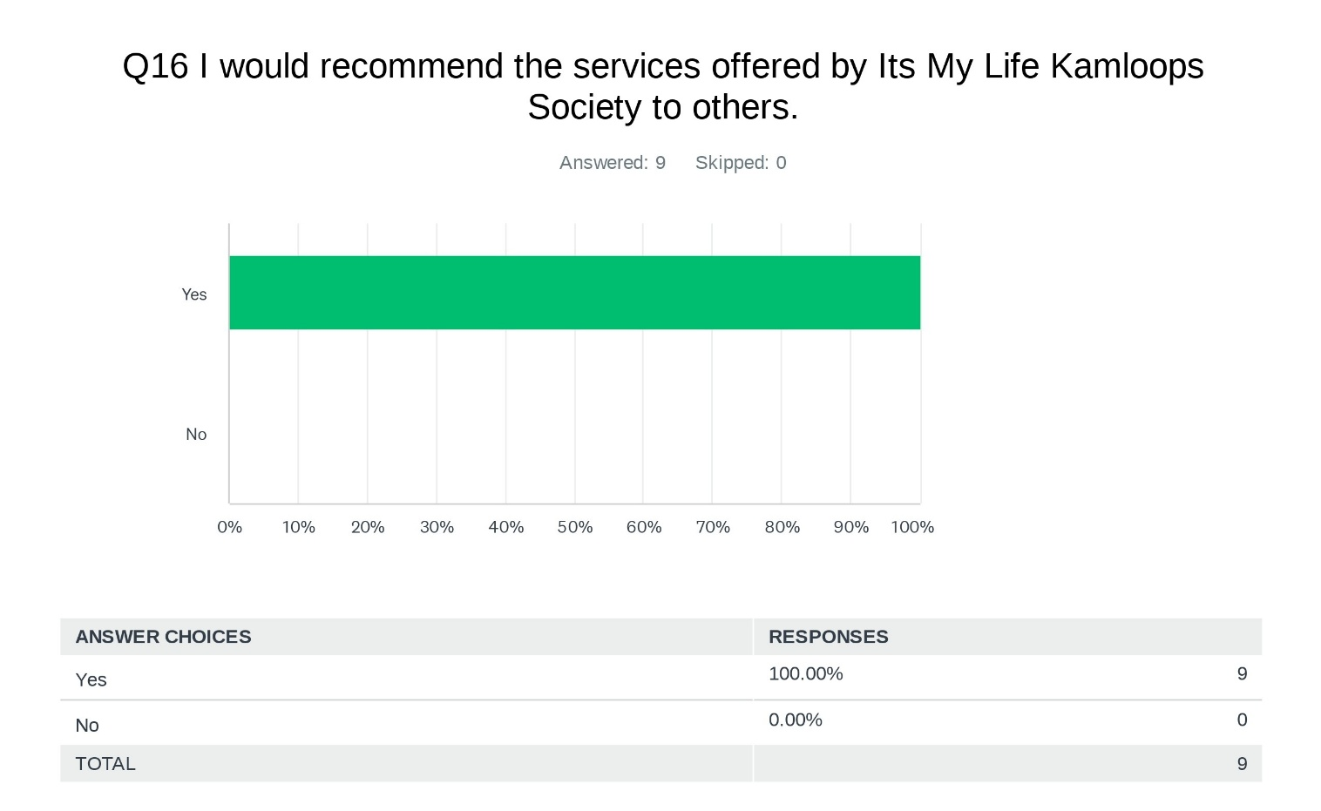


Family Member Feedback
Family members play a vital role as advocates for the individuals we serve and offer valuable insights to us as service providers. A total of 19 family members were invited to participate in our 'Family Member Survey' via SurveyMonkey. Of those invited, 18 opened the survey, and 7 took the time to share their feedback, providing us with meaningful input to help enhance our services.

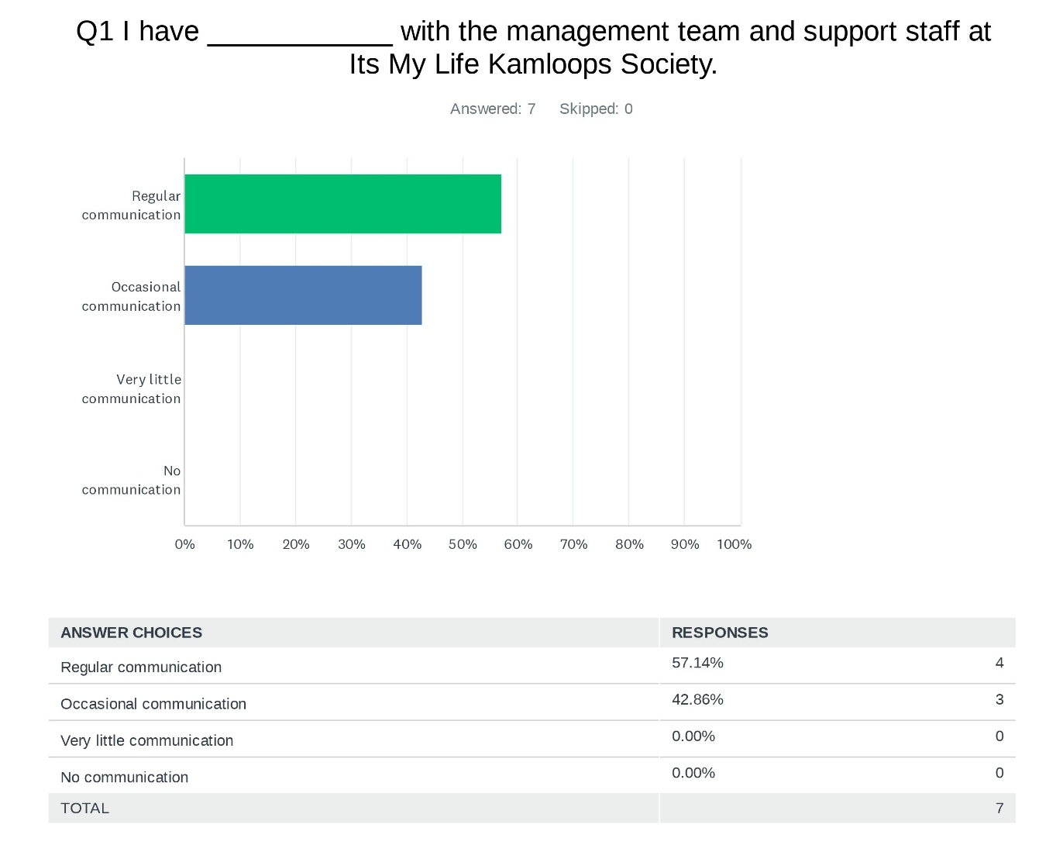

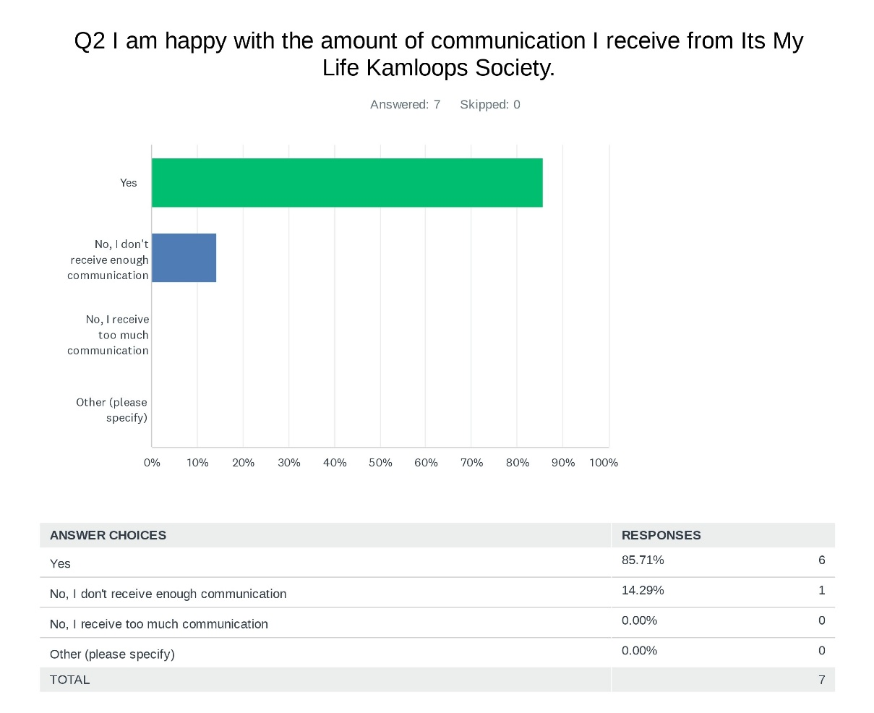
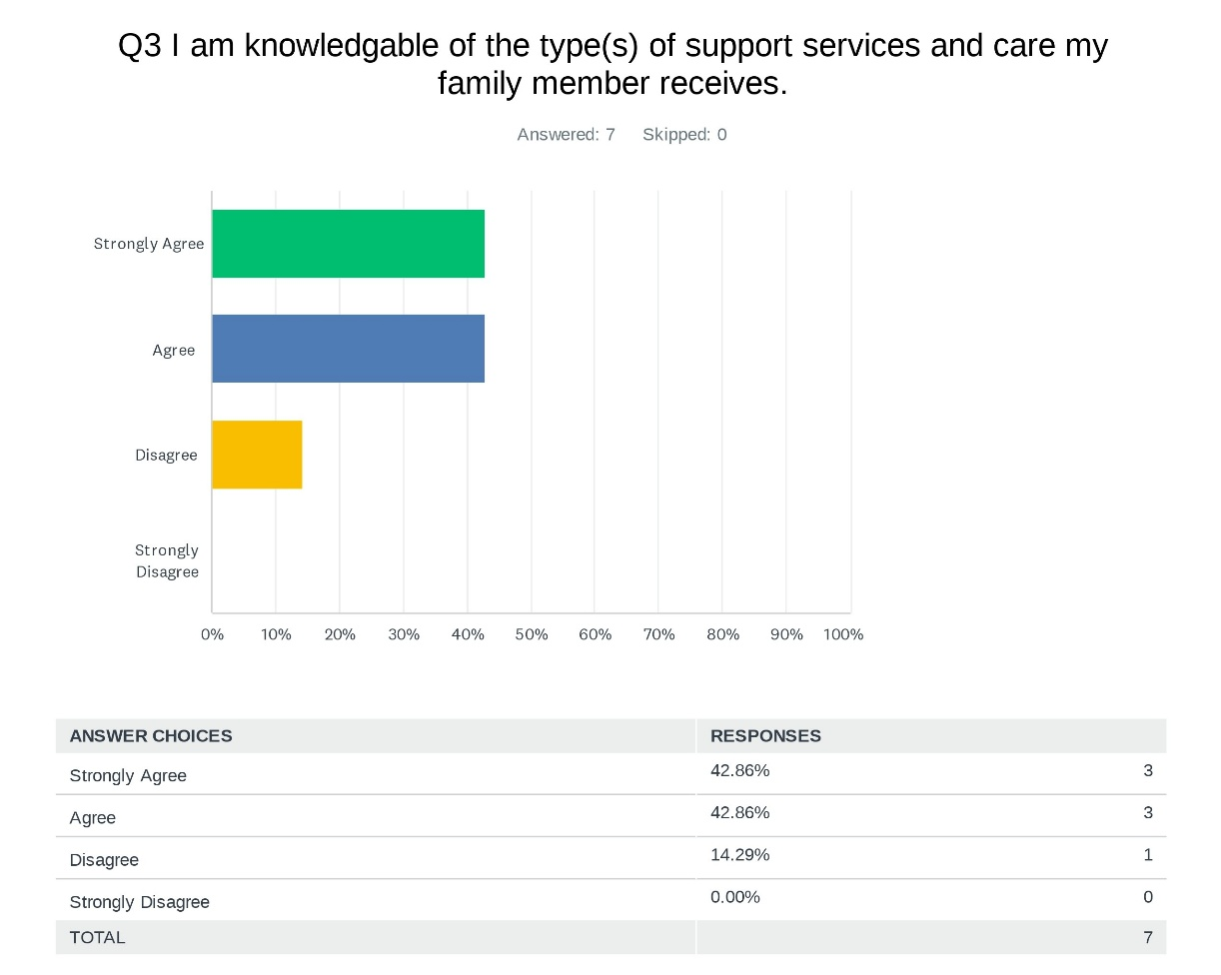
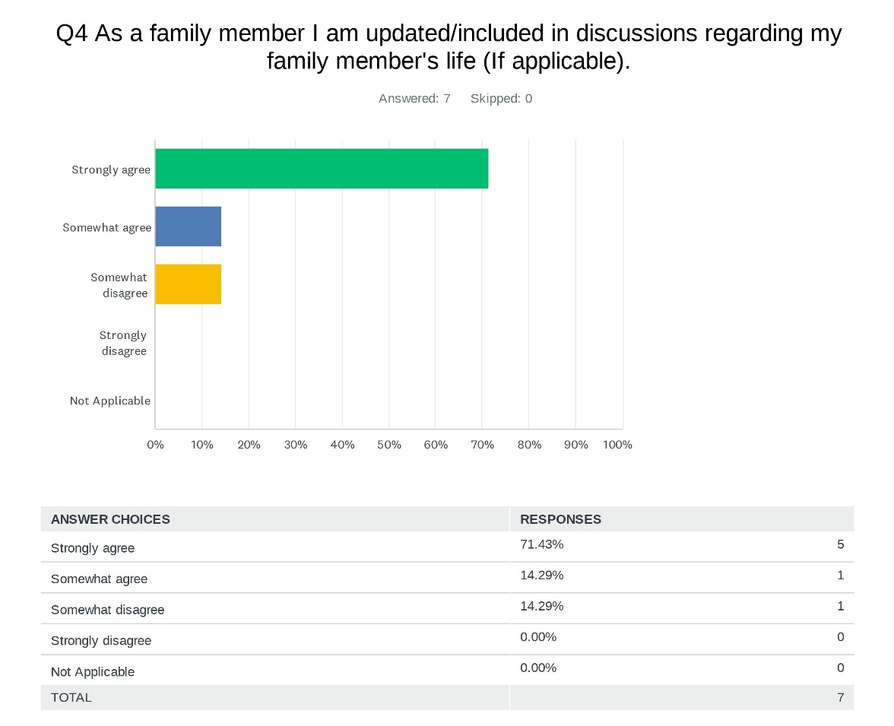
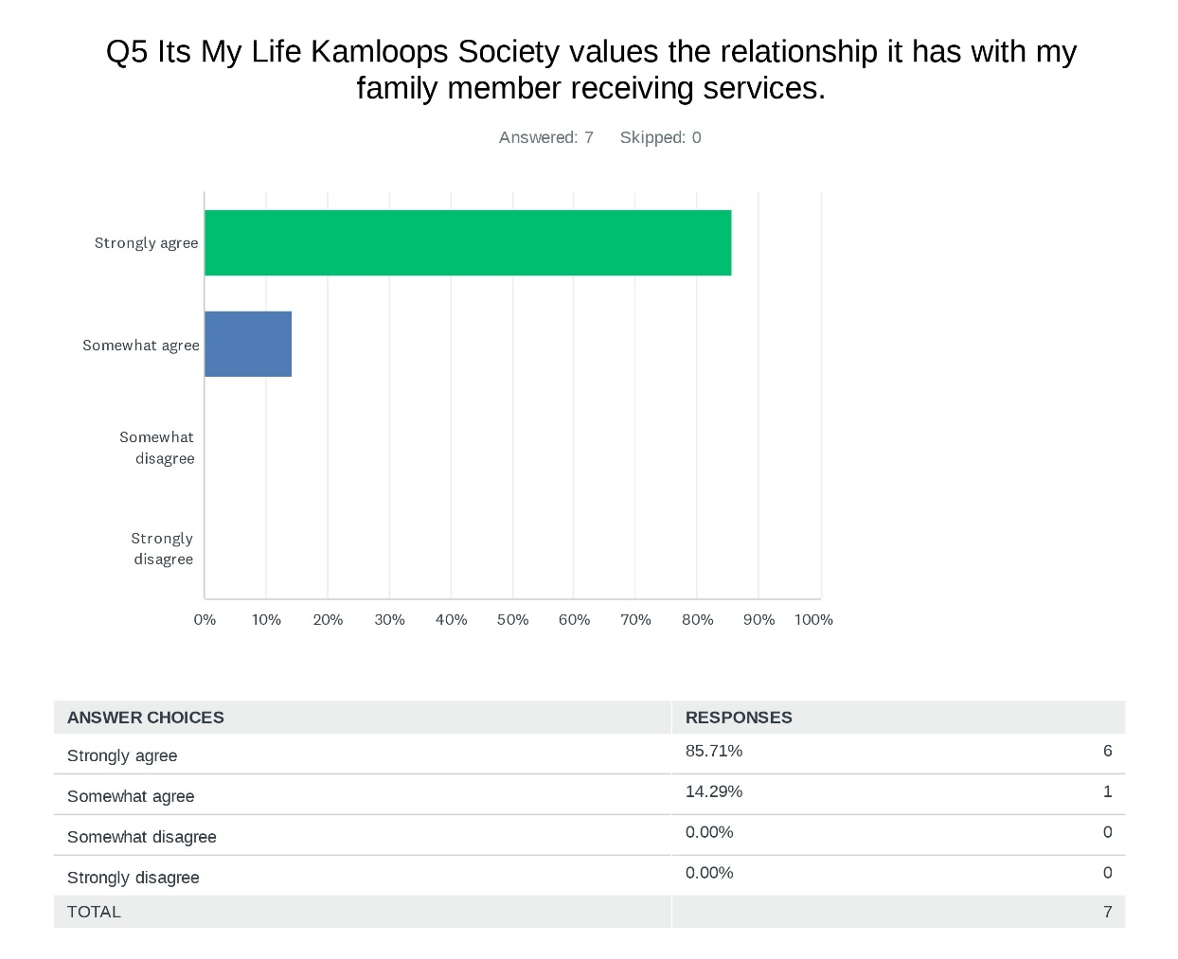

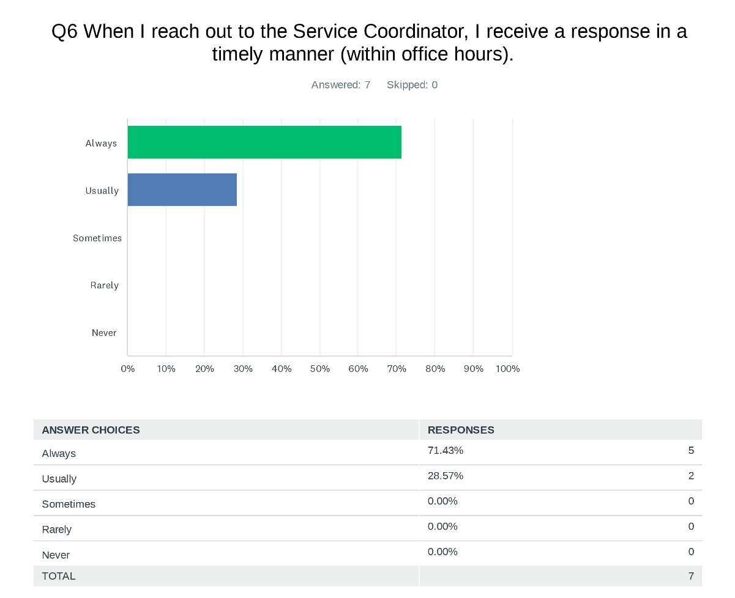
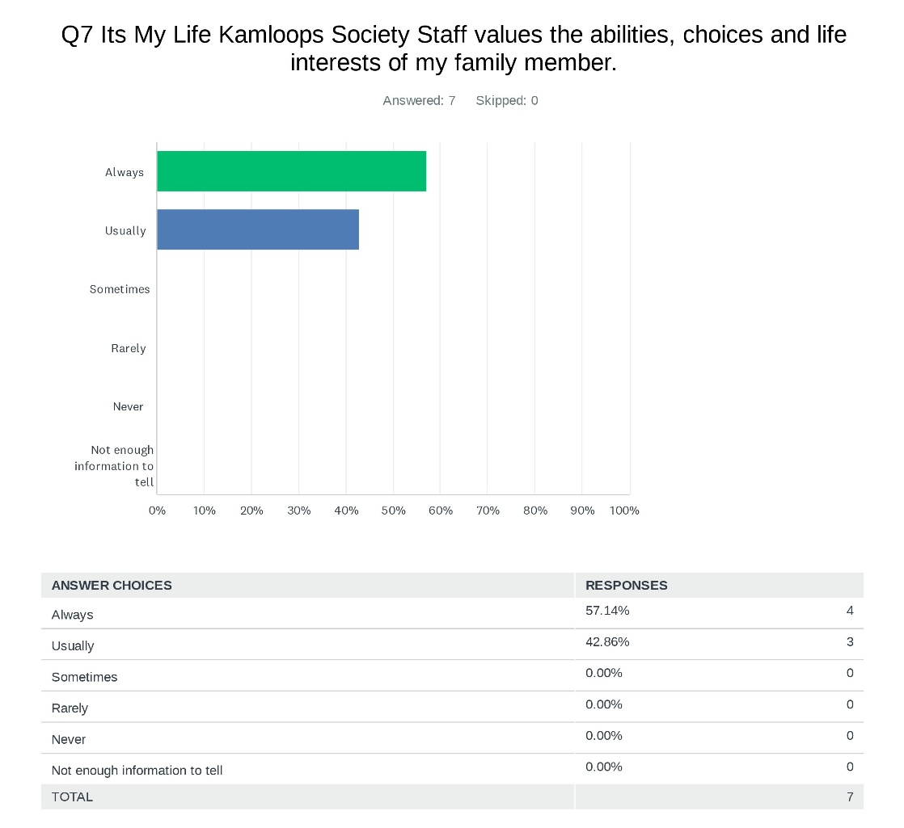
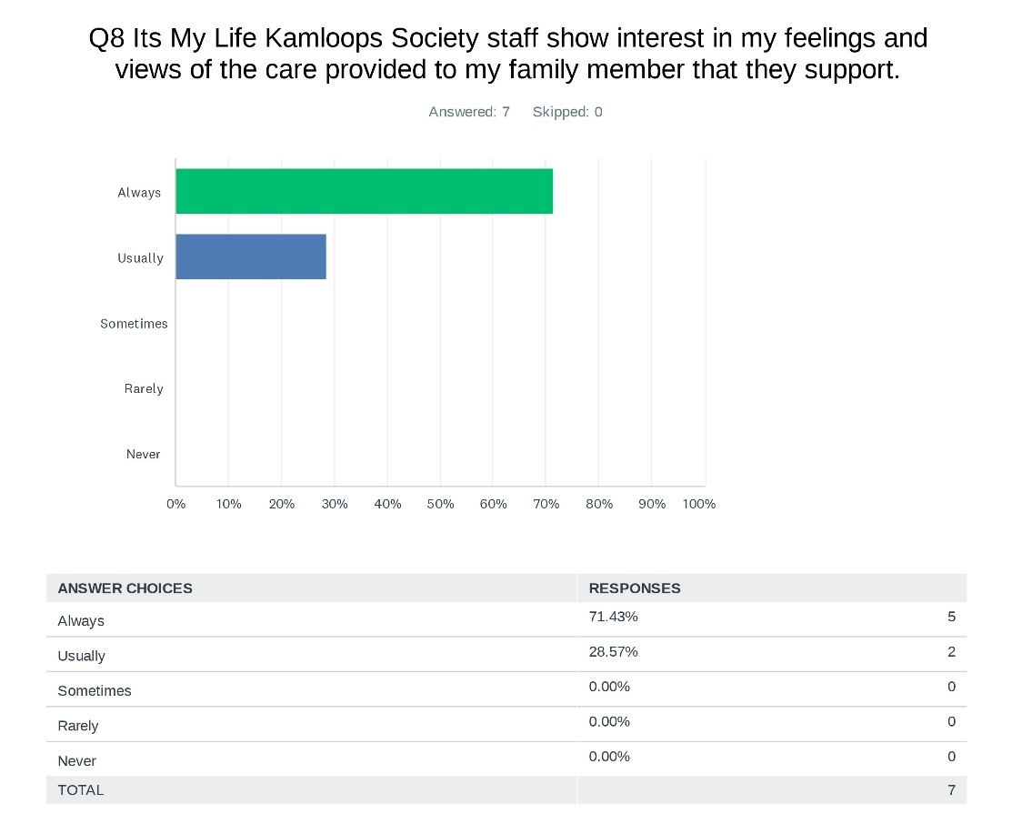
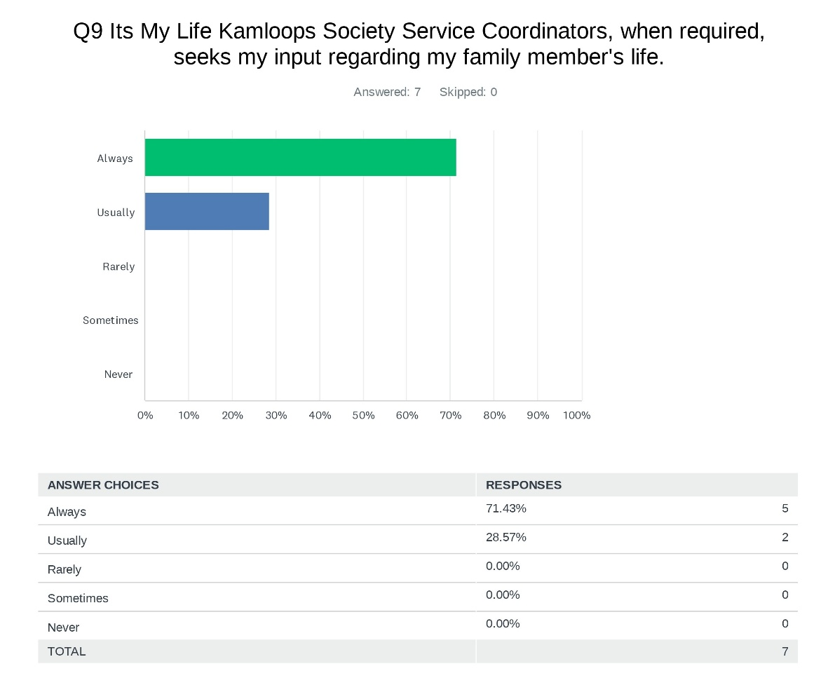

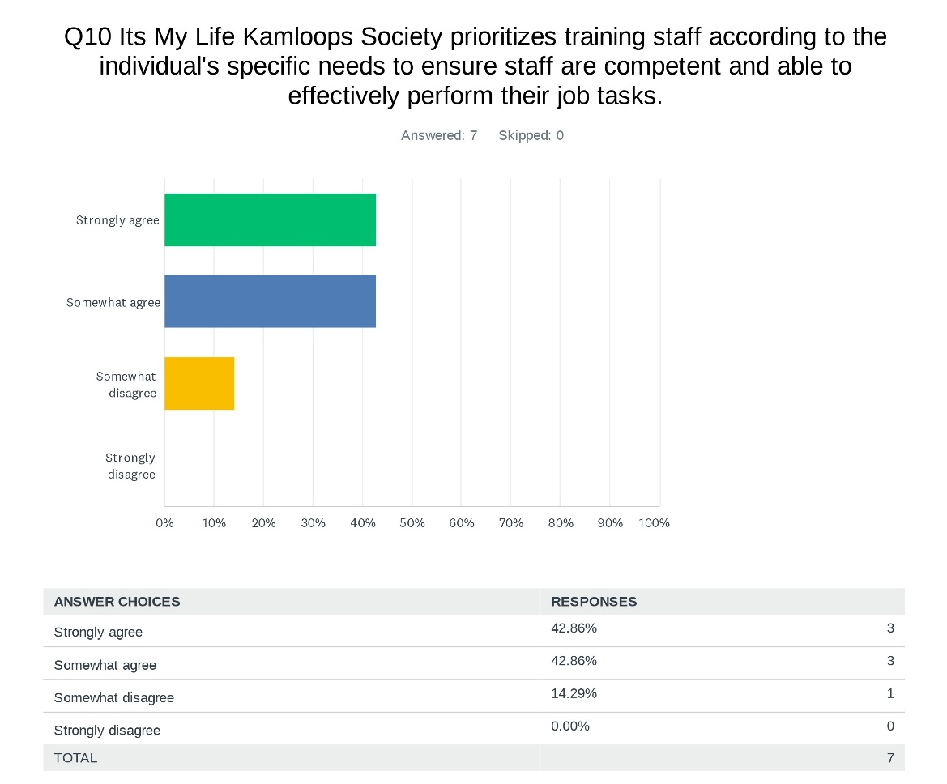
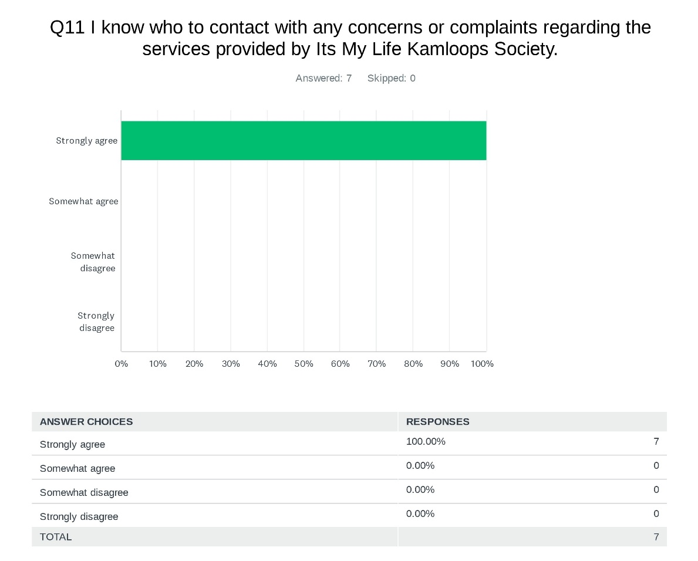

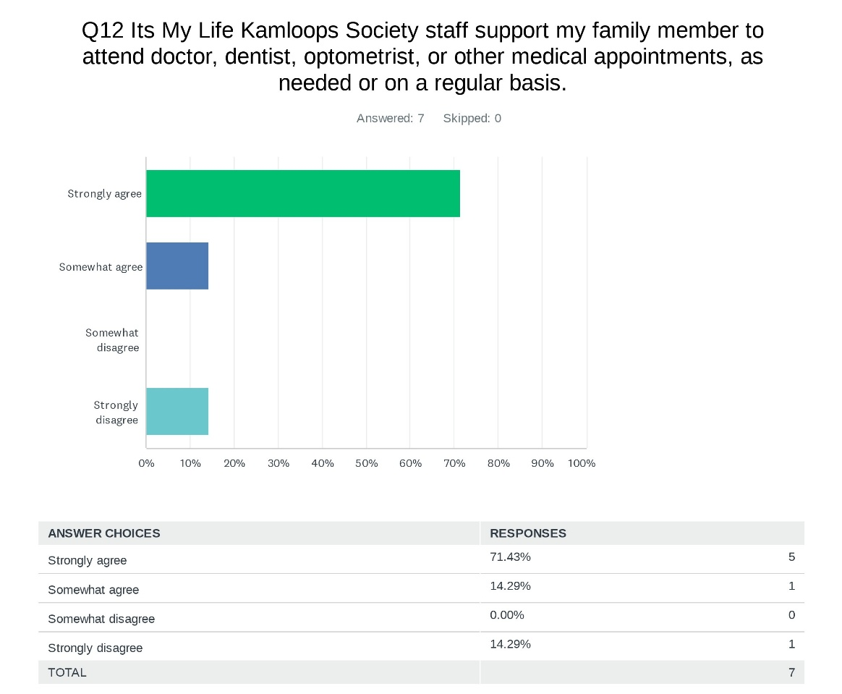
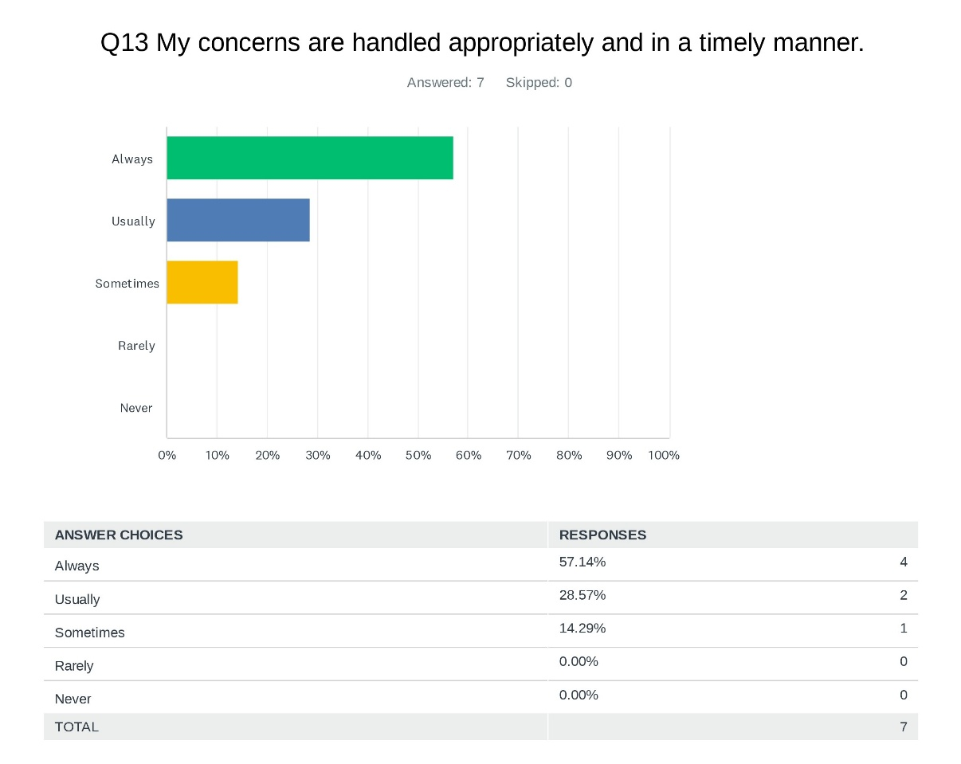
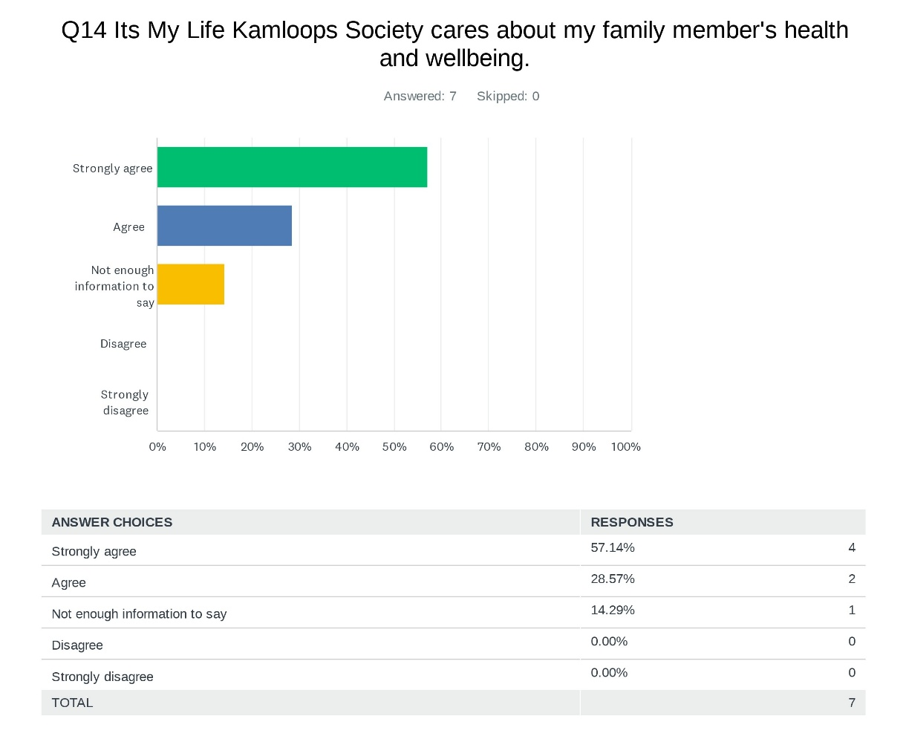
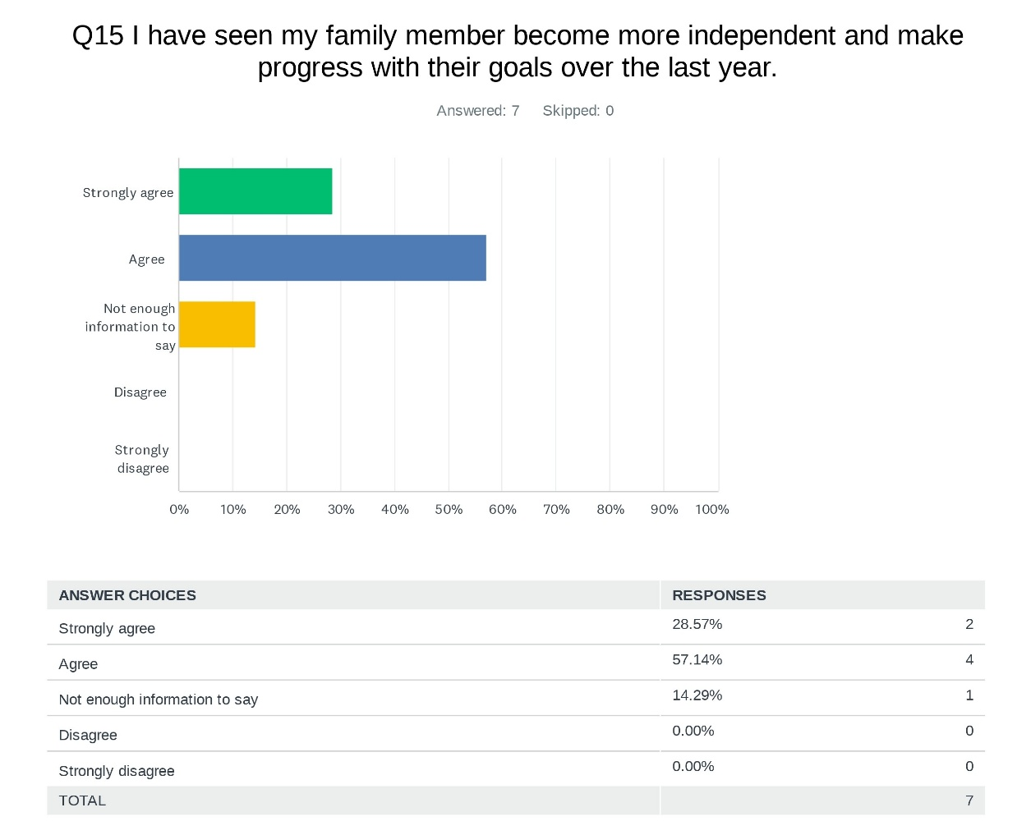
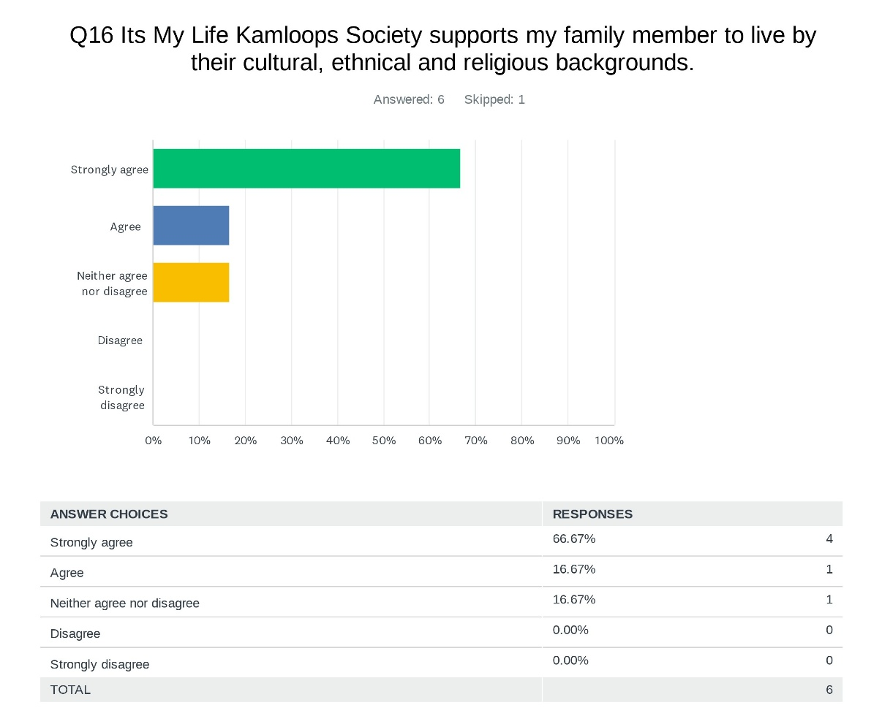

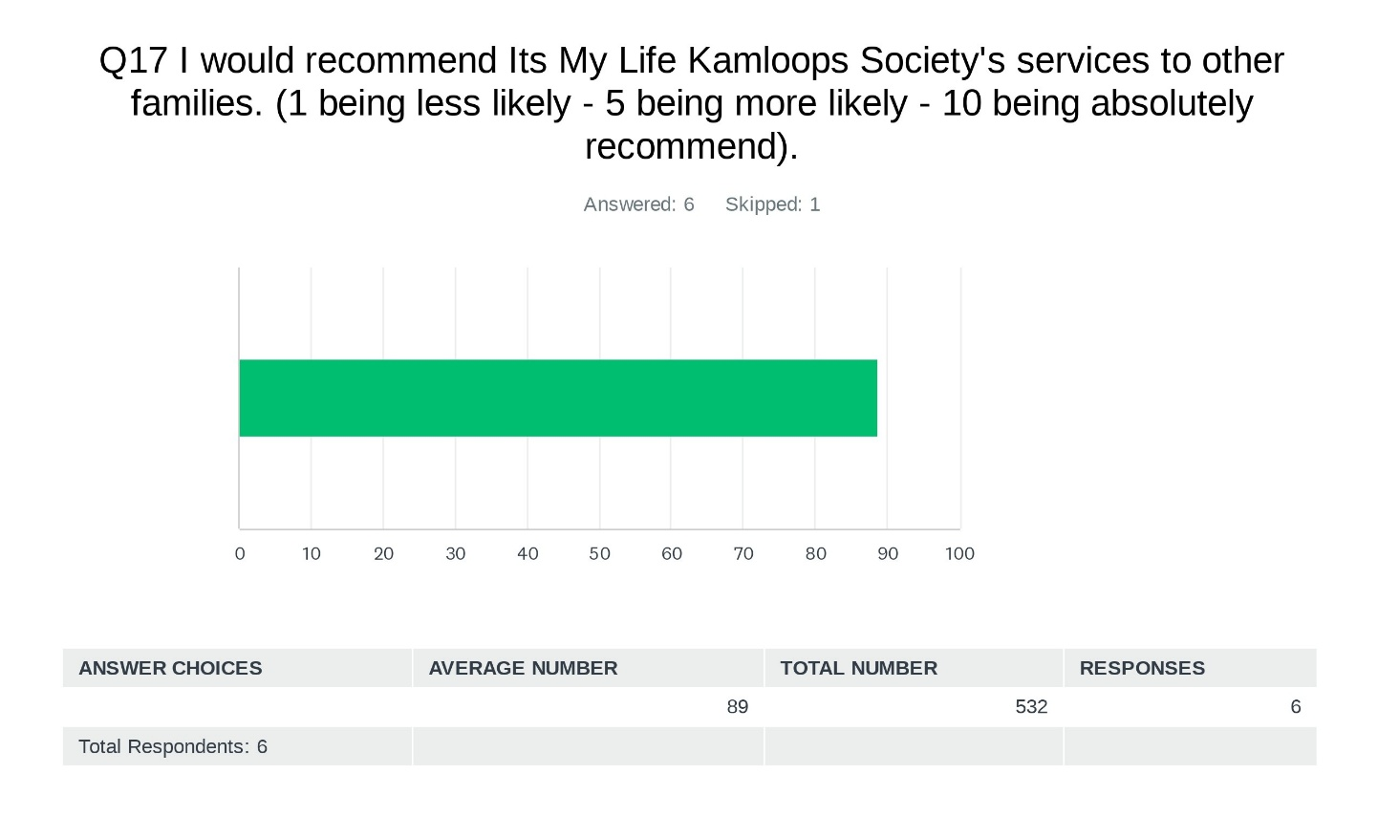

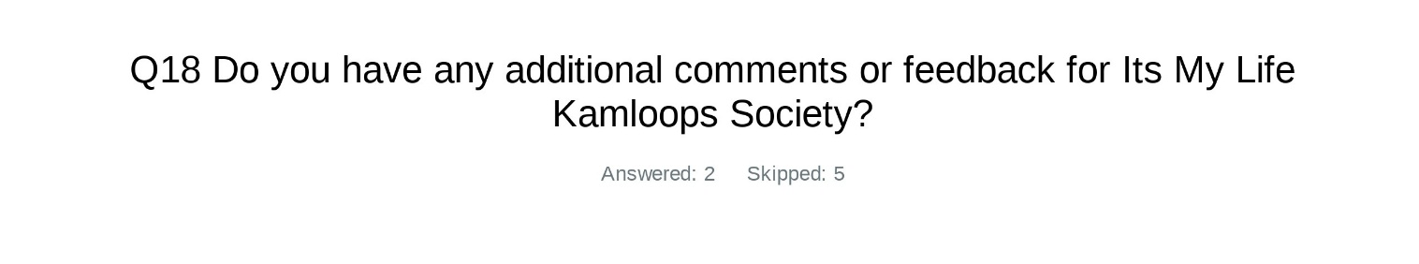
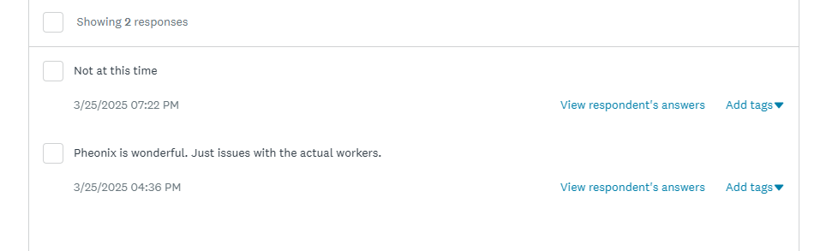


Team Member Feedback
IMLKS values the input that we receive from surveys and exit interviews as a tool to help us improve our organization. Our team members are the largest influence on the services we are able to provide for persons served so hearing what they have to say is crucial in order to maintain a positive and productive workforce.

48 Survey Invitations were sent via anonymous email link. 29 of those 48 employees chose to complete the survey that was emailed out.

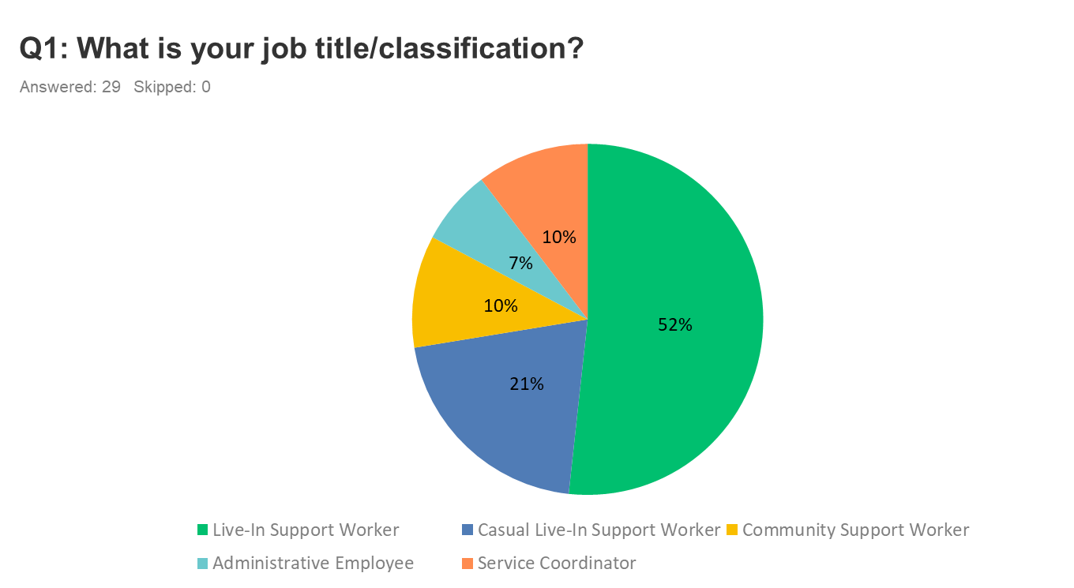
The participants responded as follows:
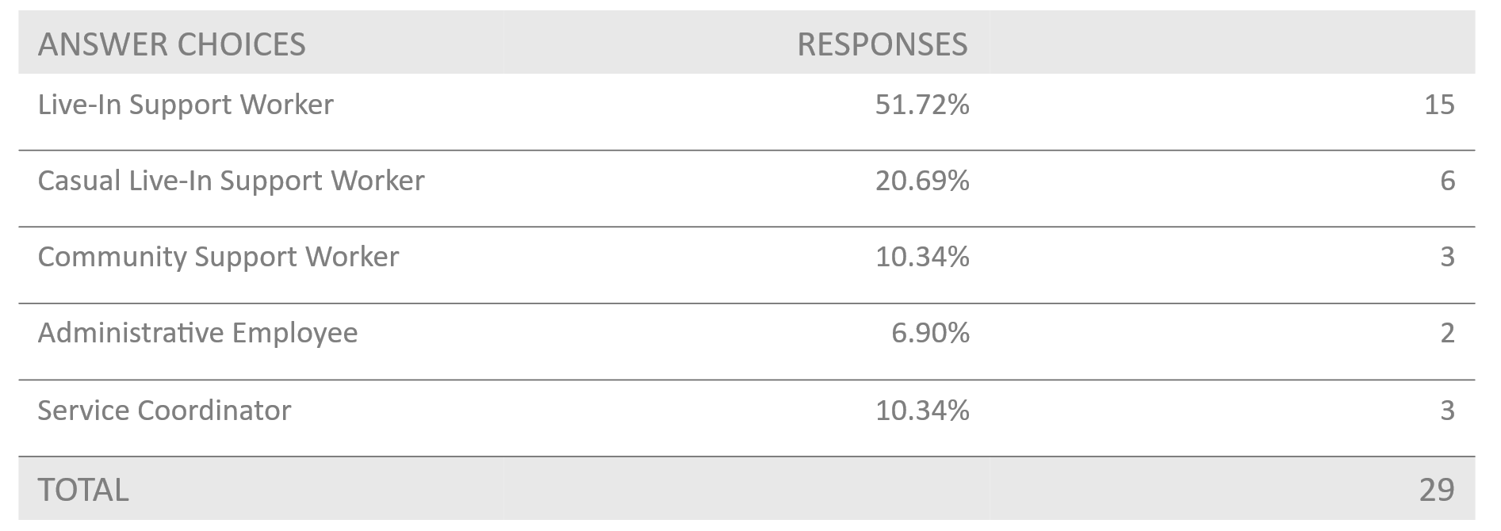
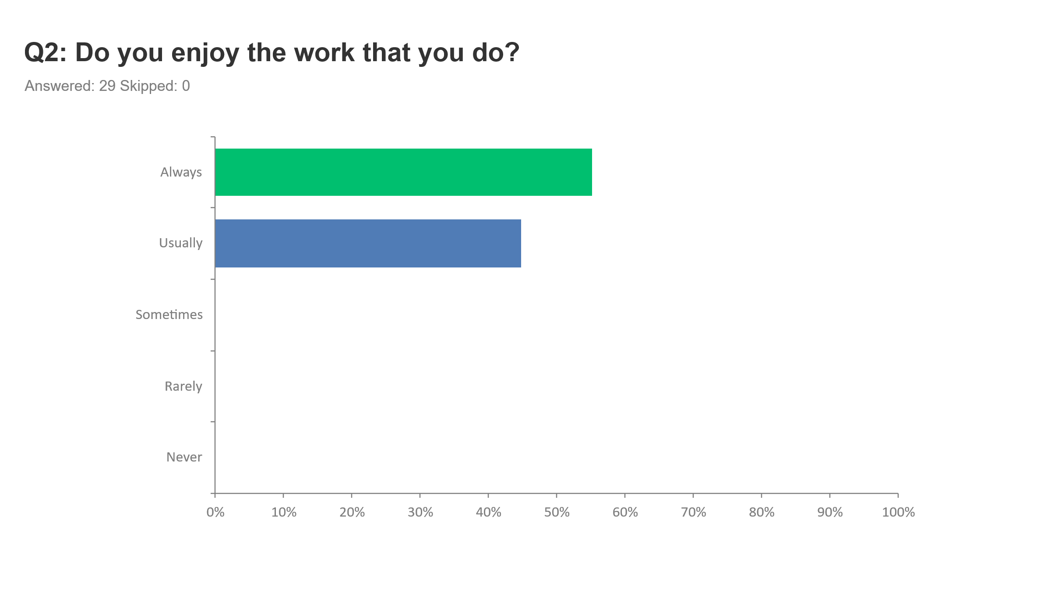
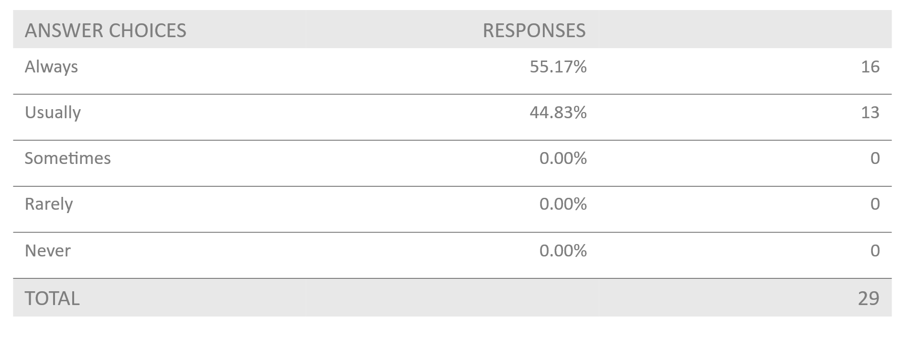

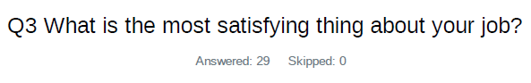

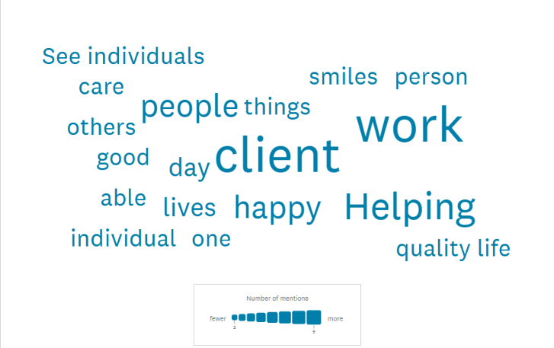
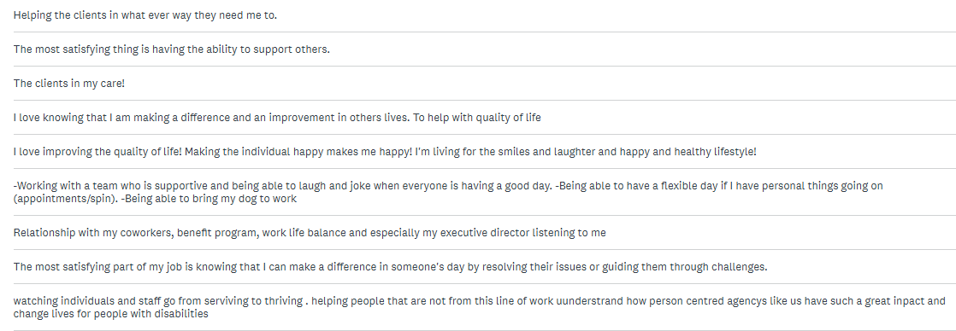
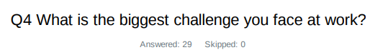
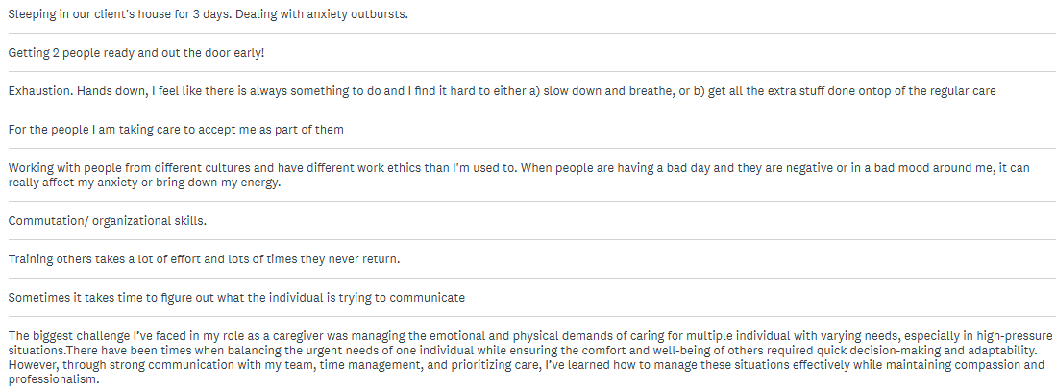

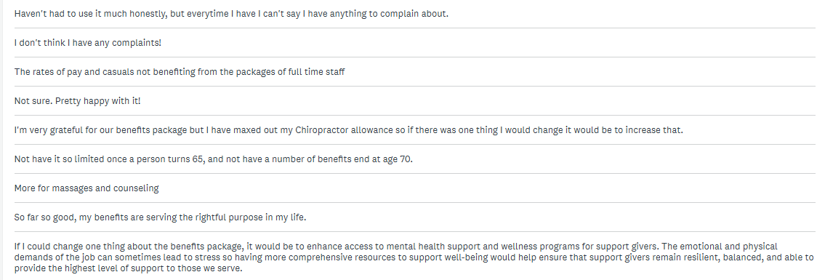
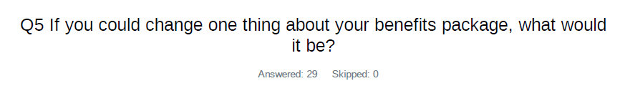
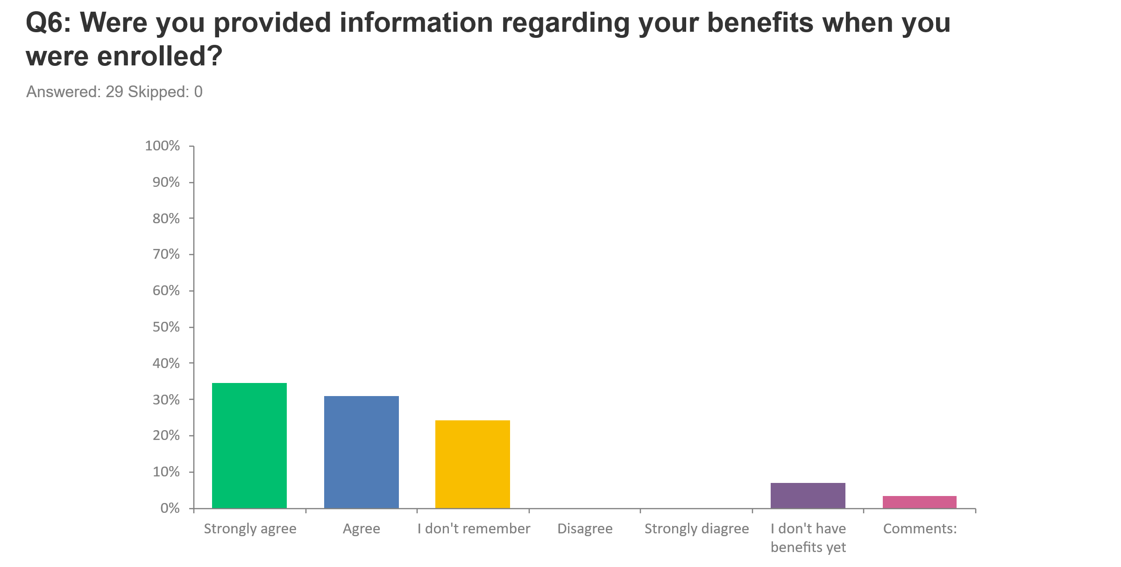
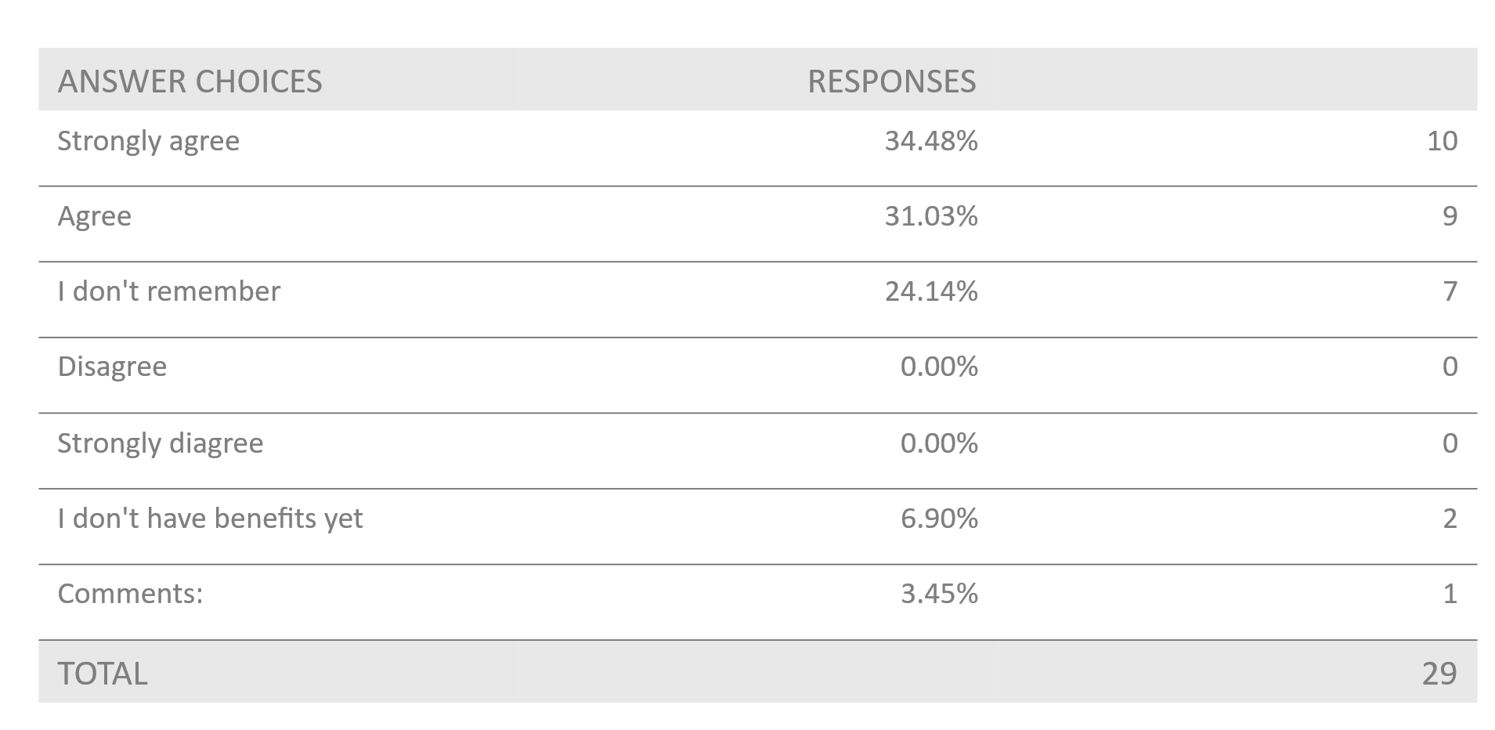
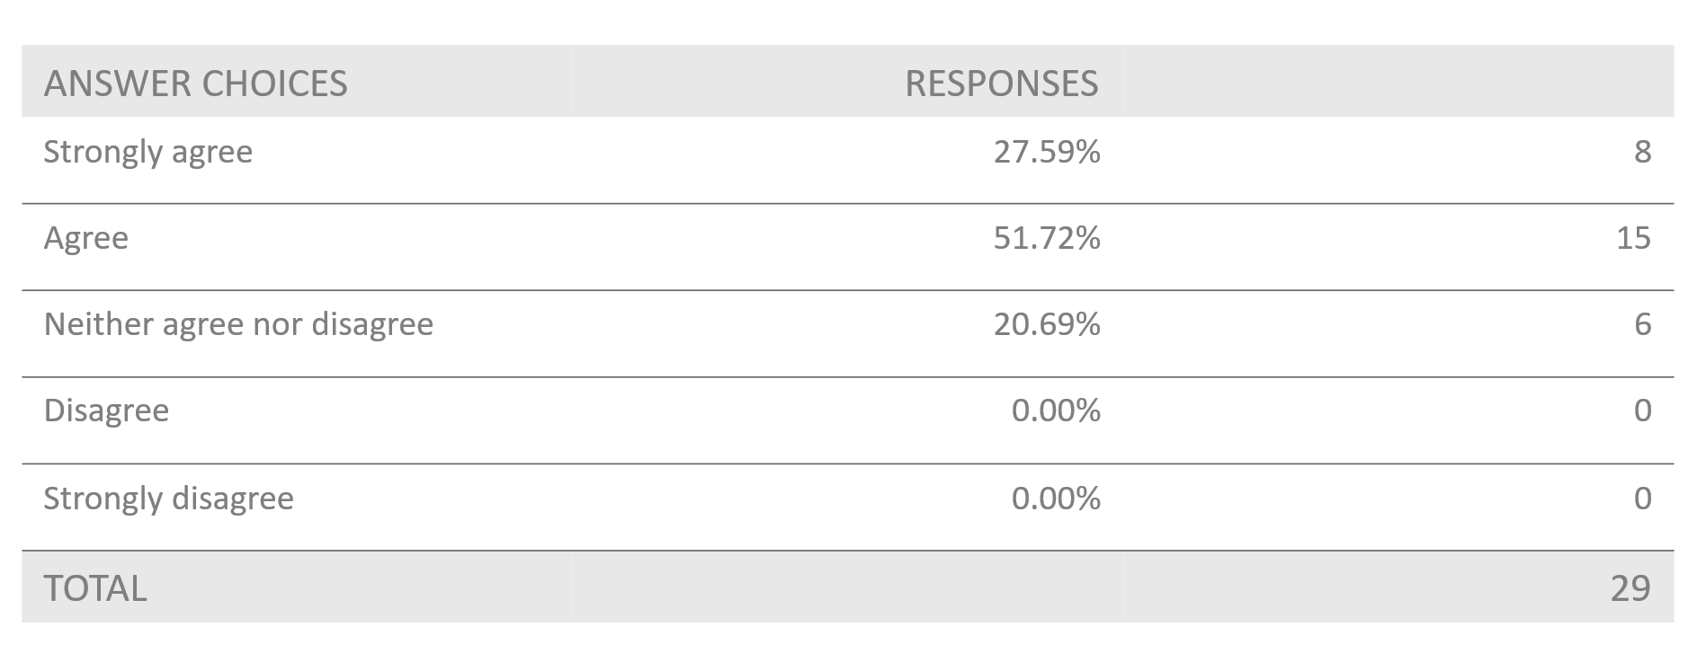
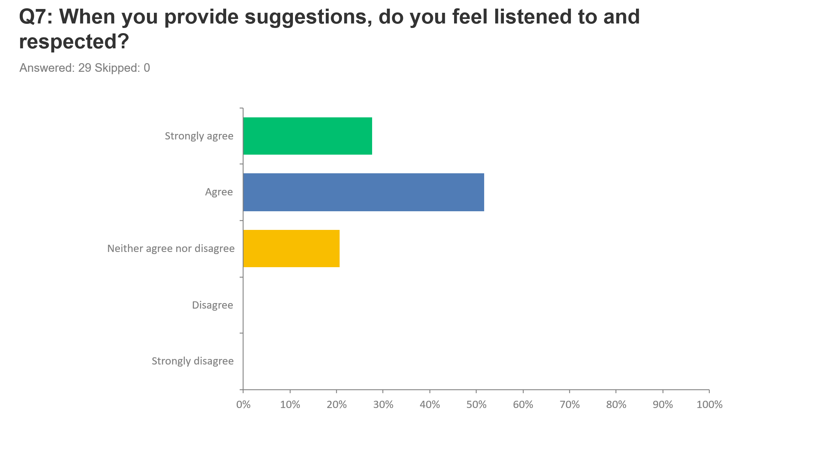

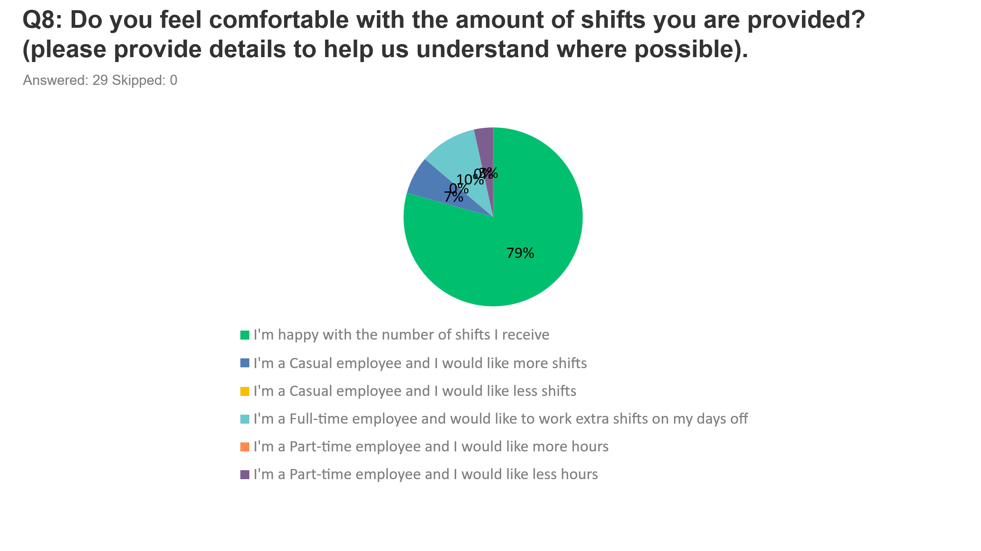
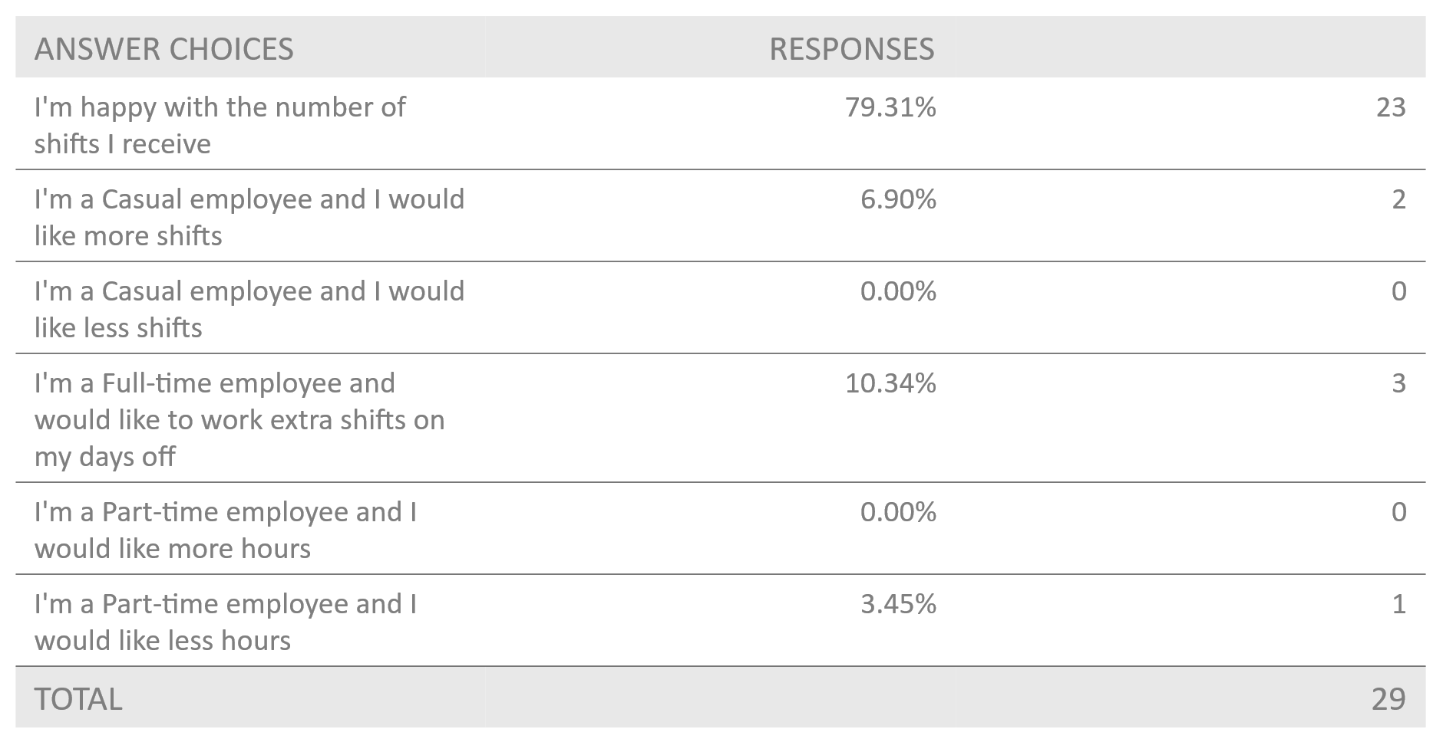

37

37
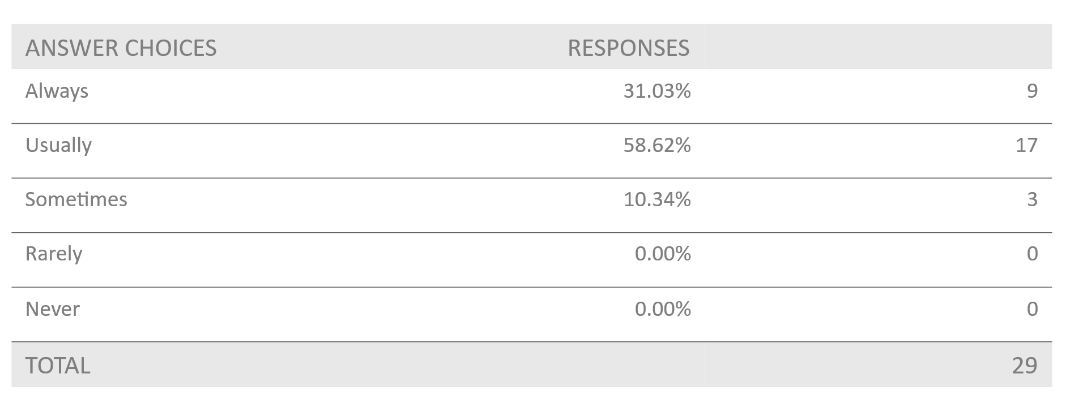
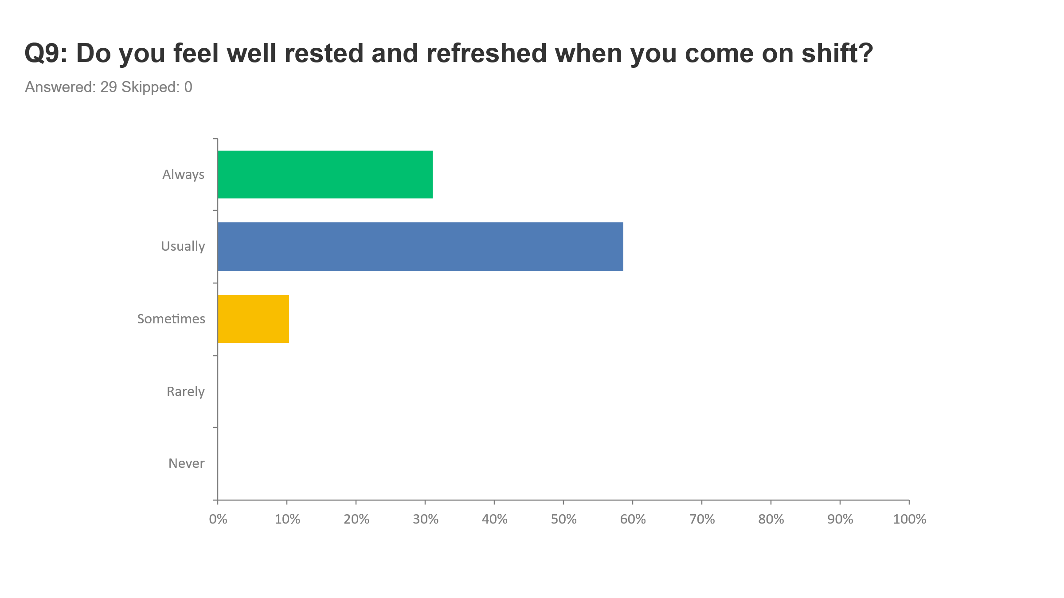
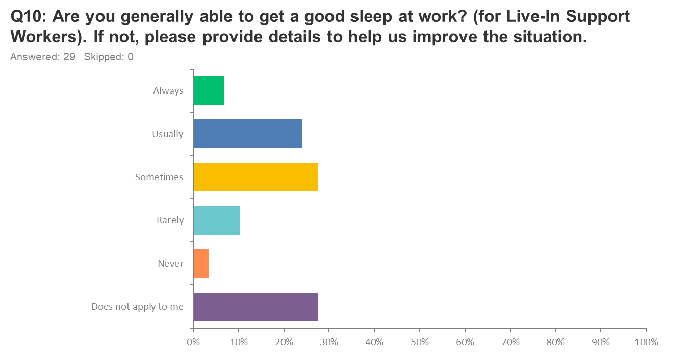
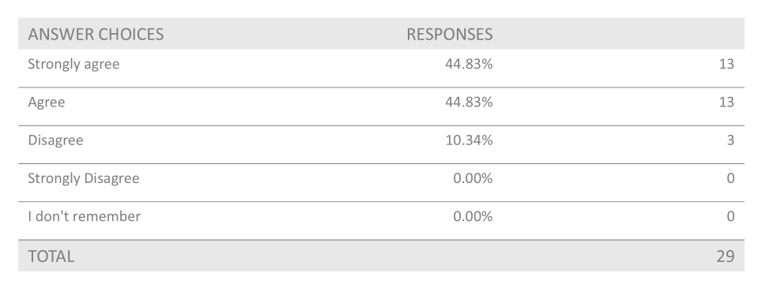
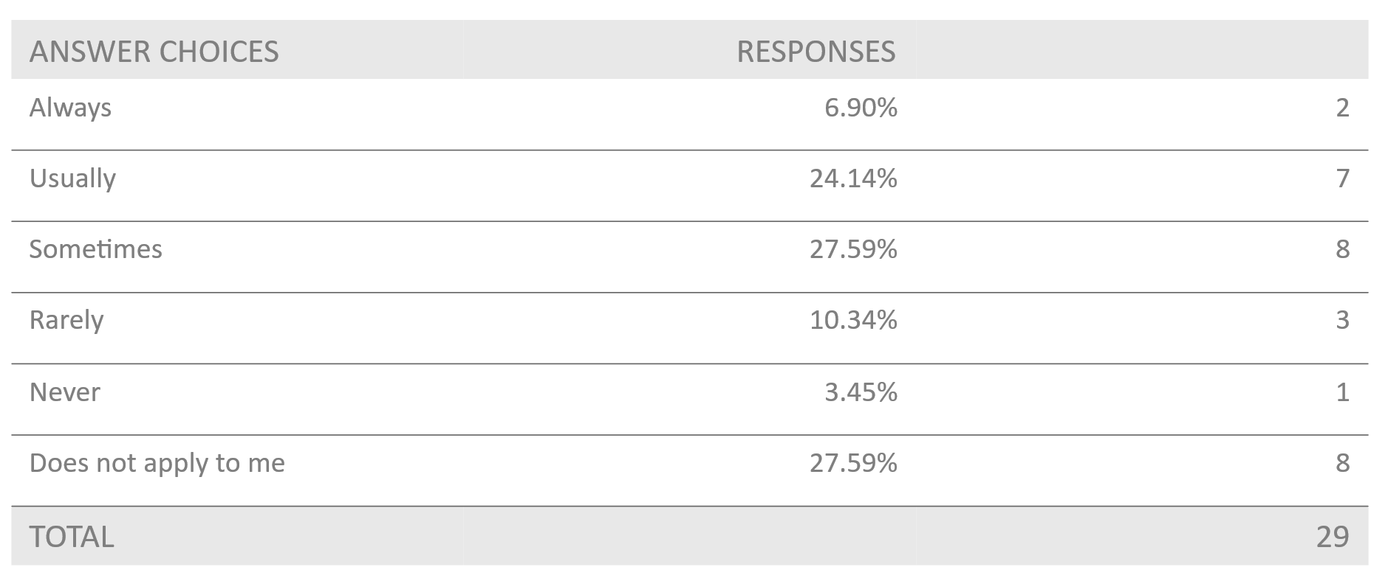
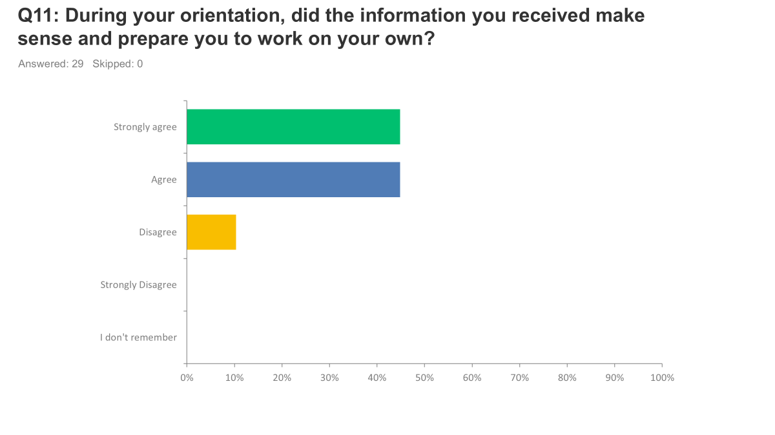
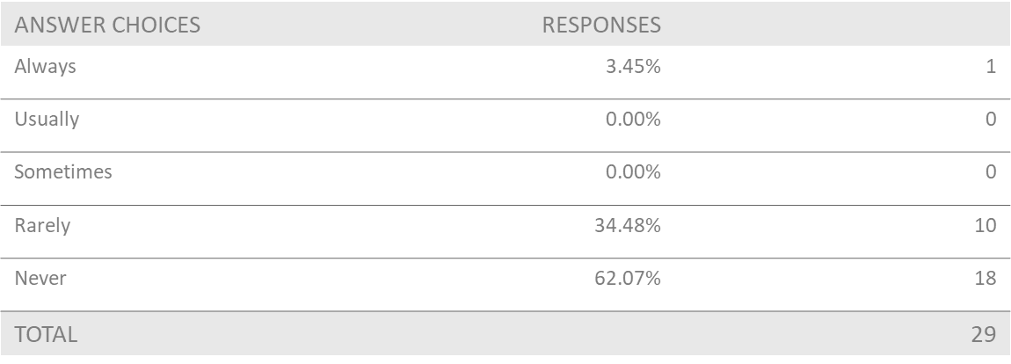
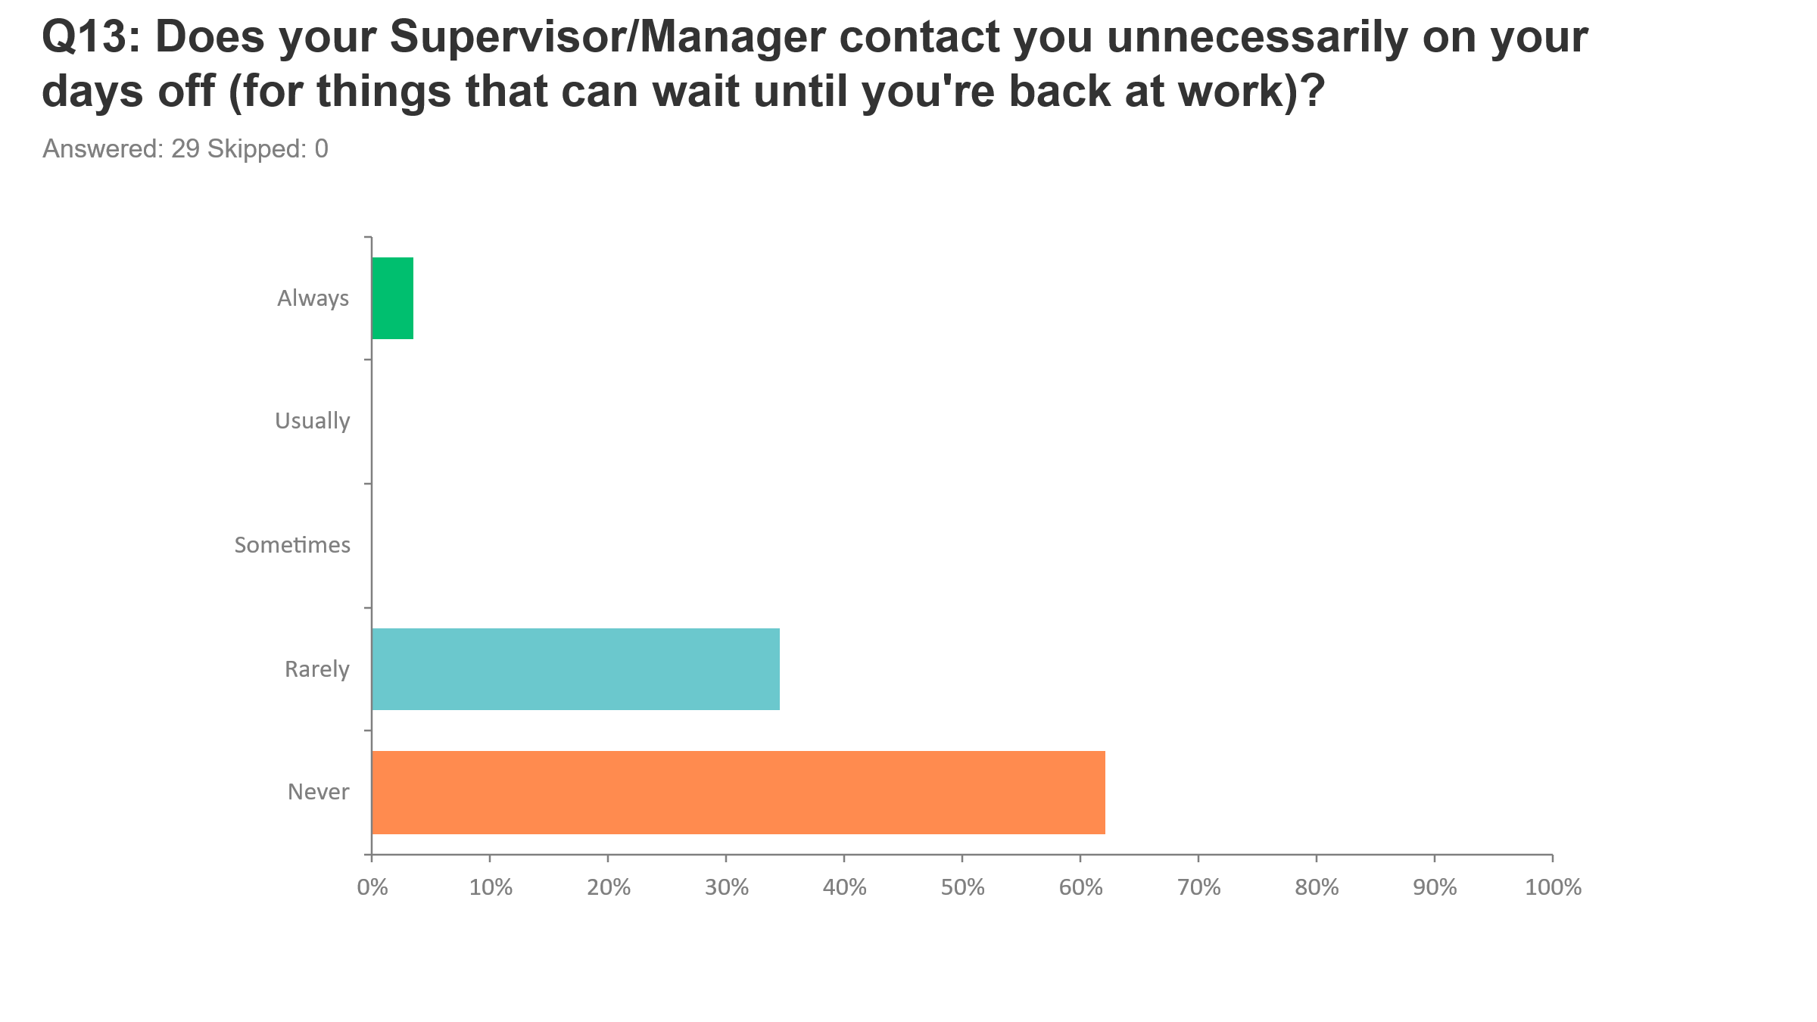
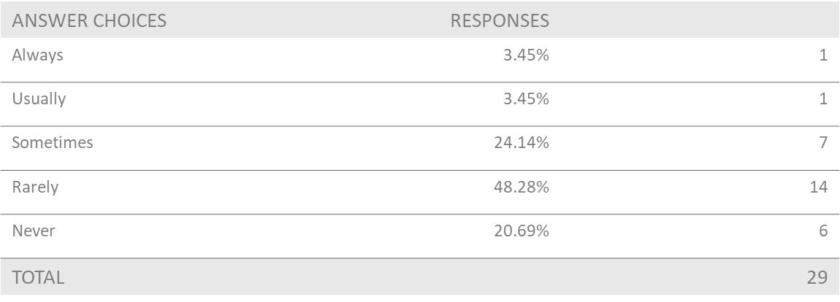
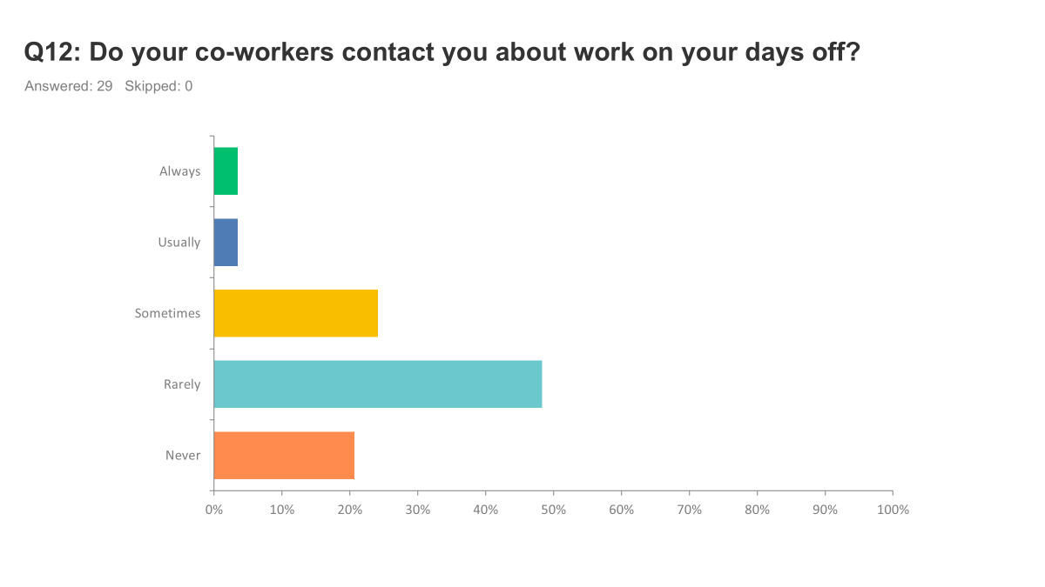
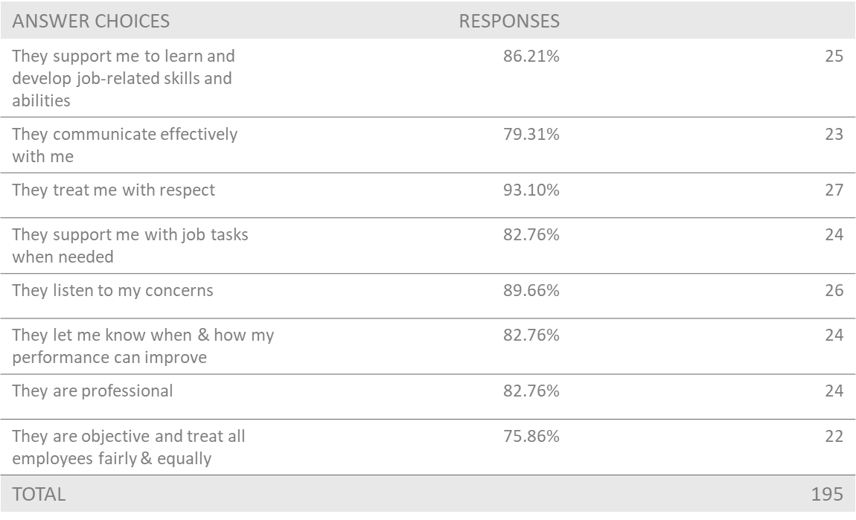
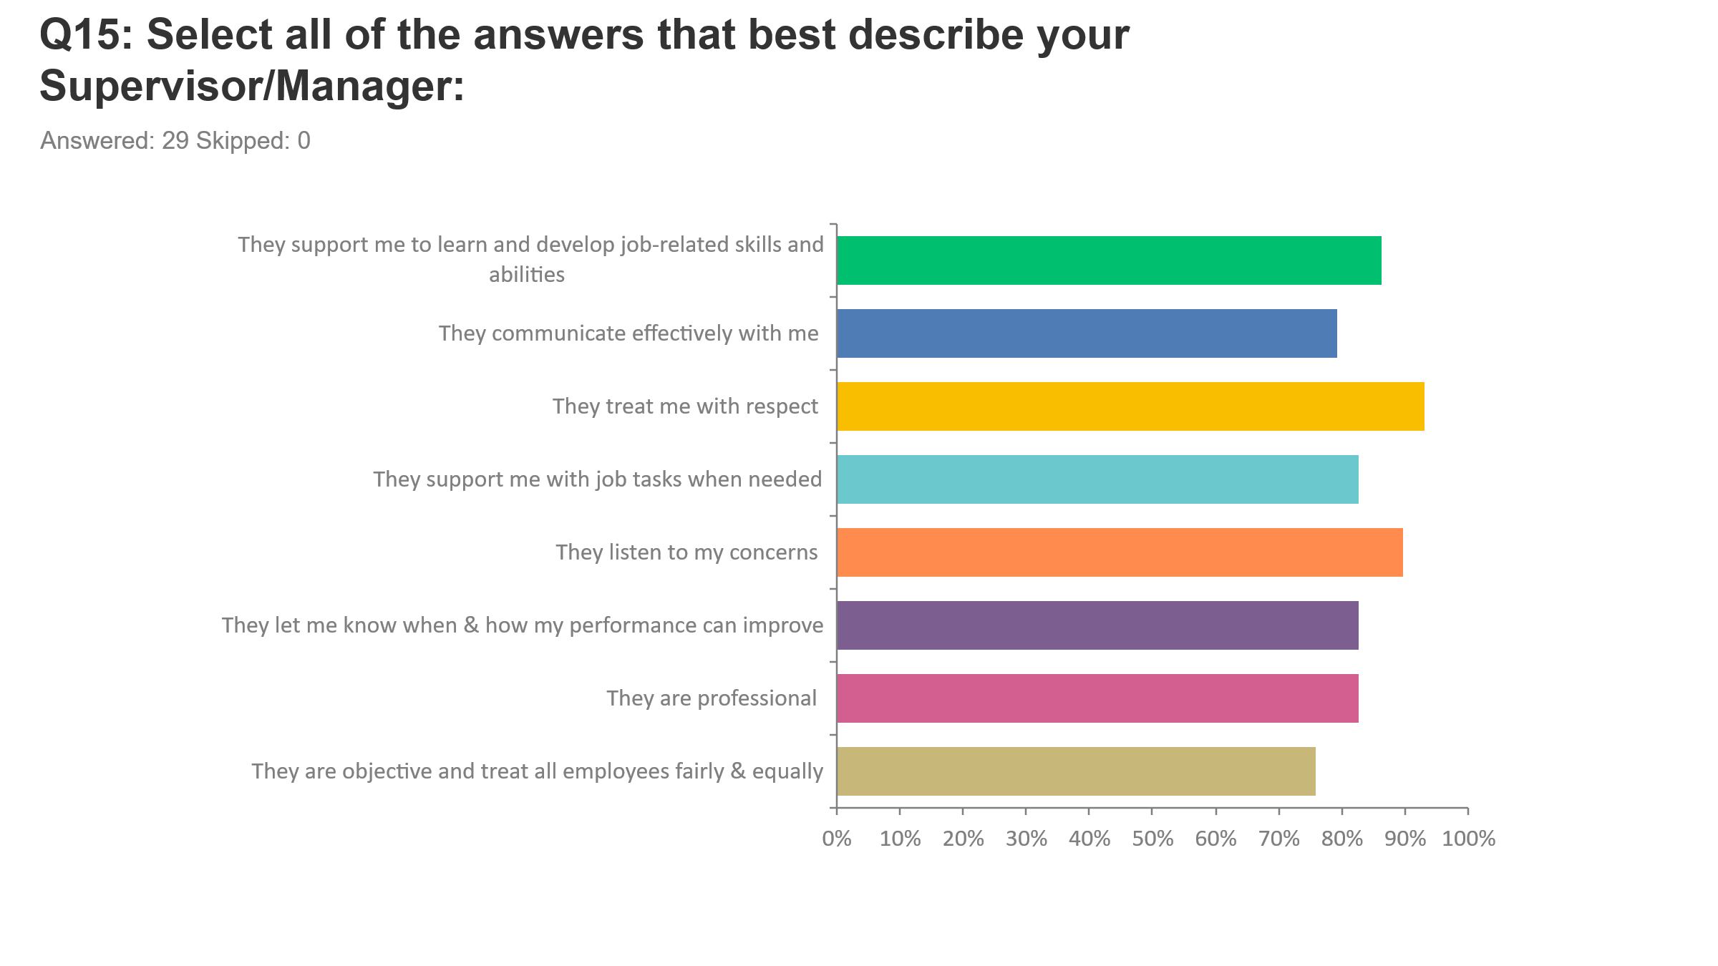
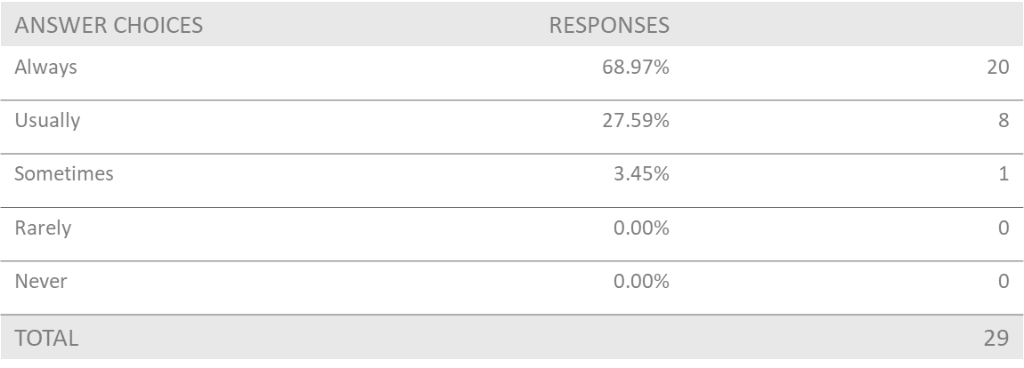
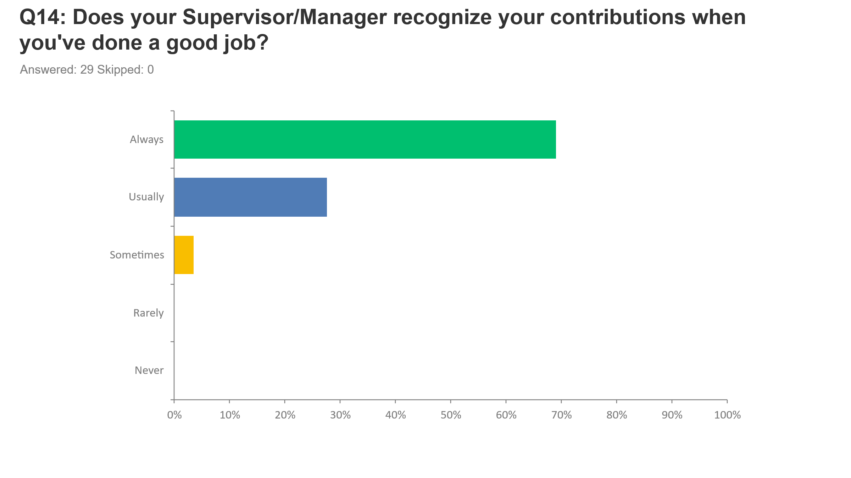
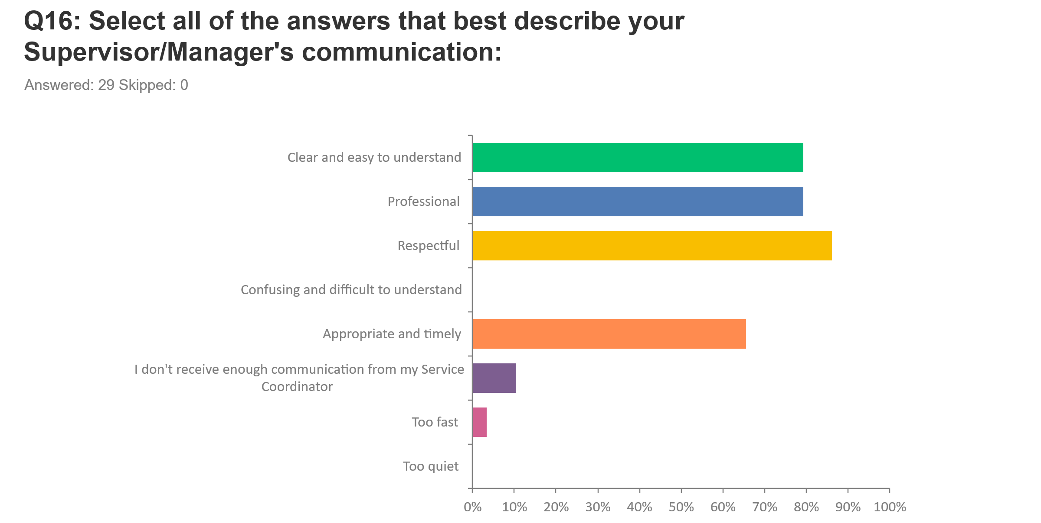
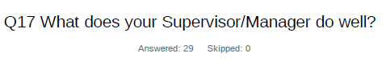
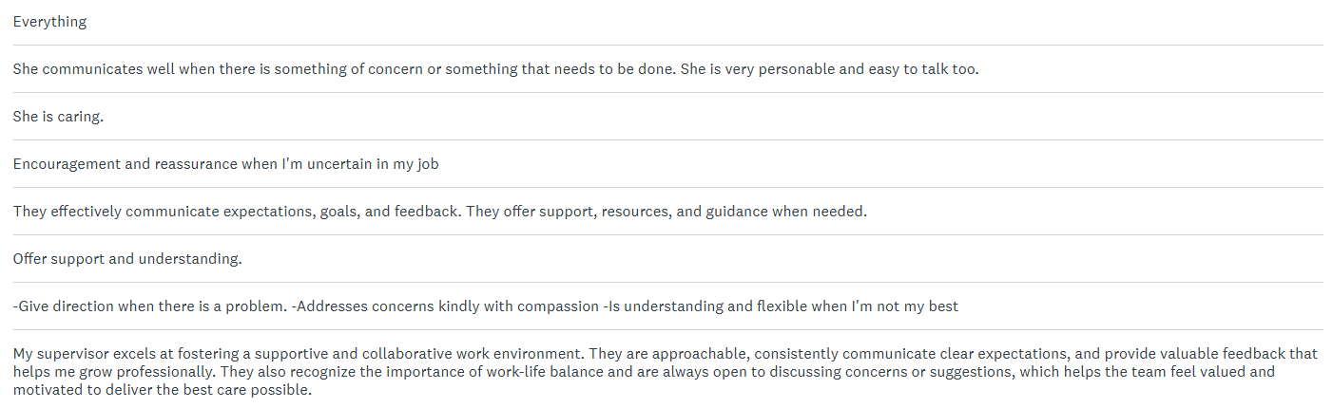
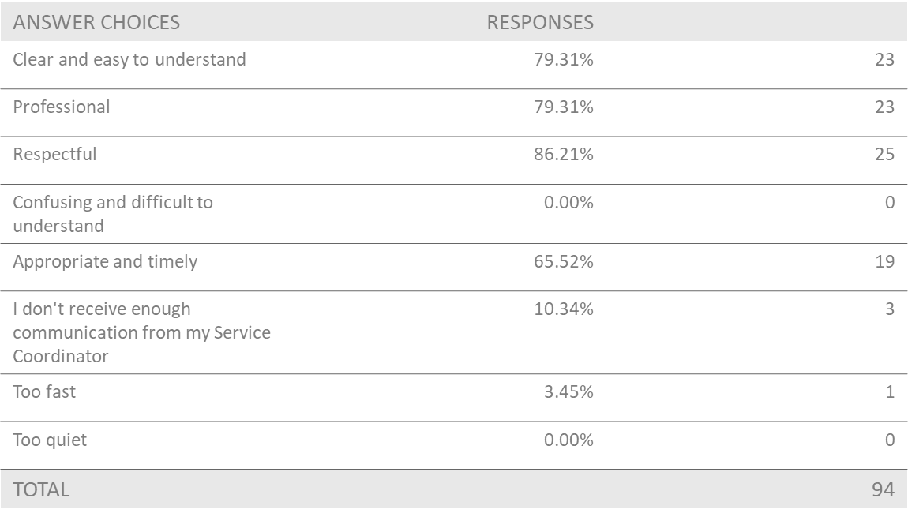
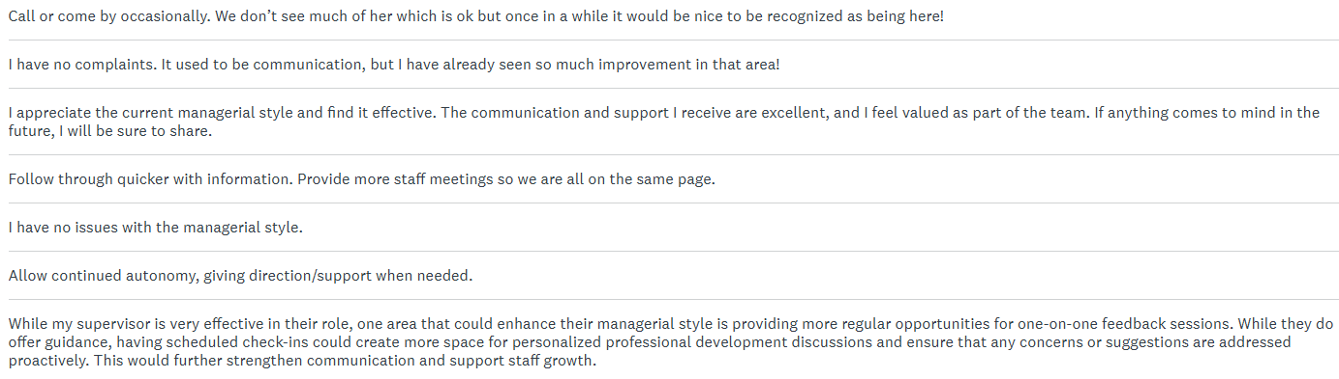
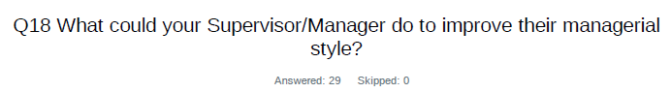
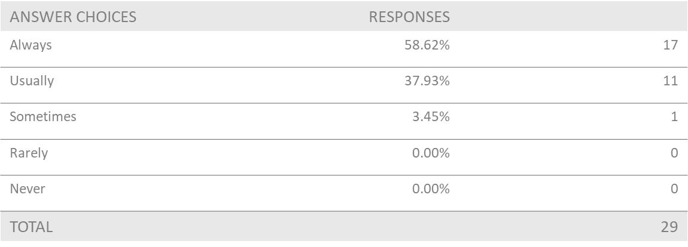
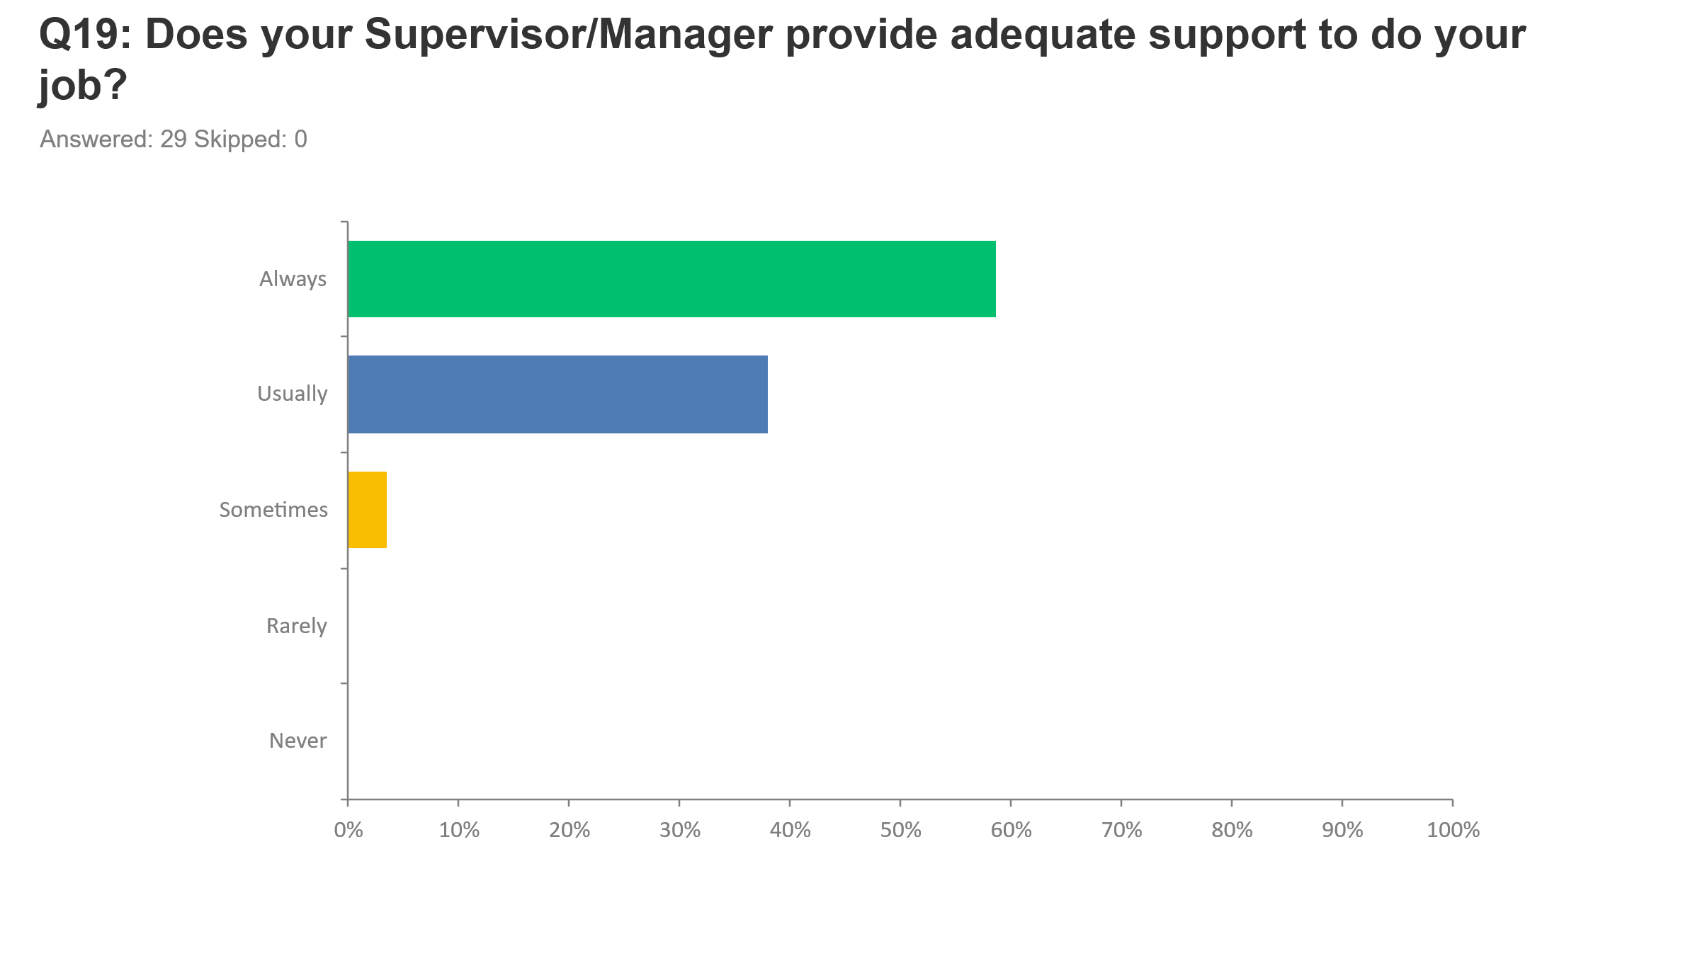
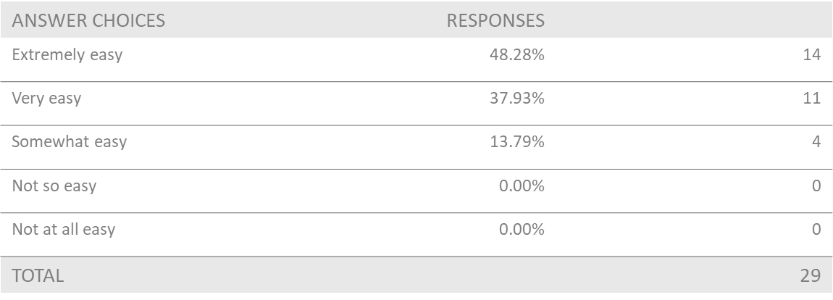
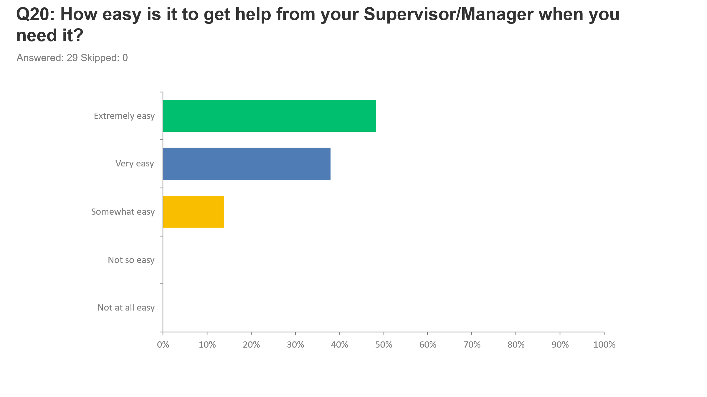
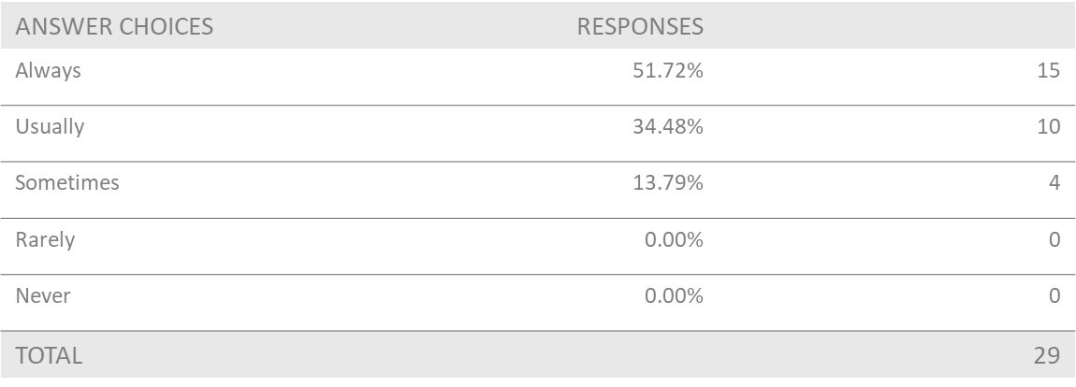
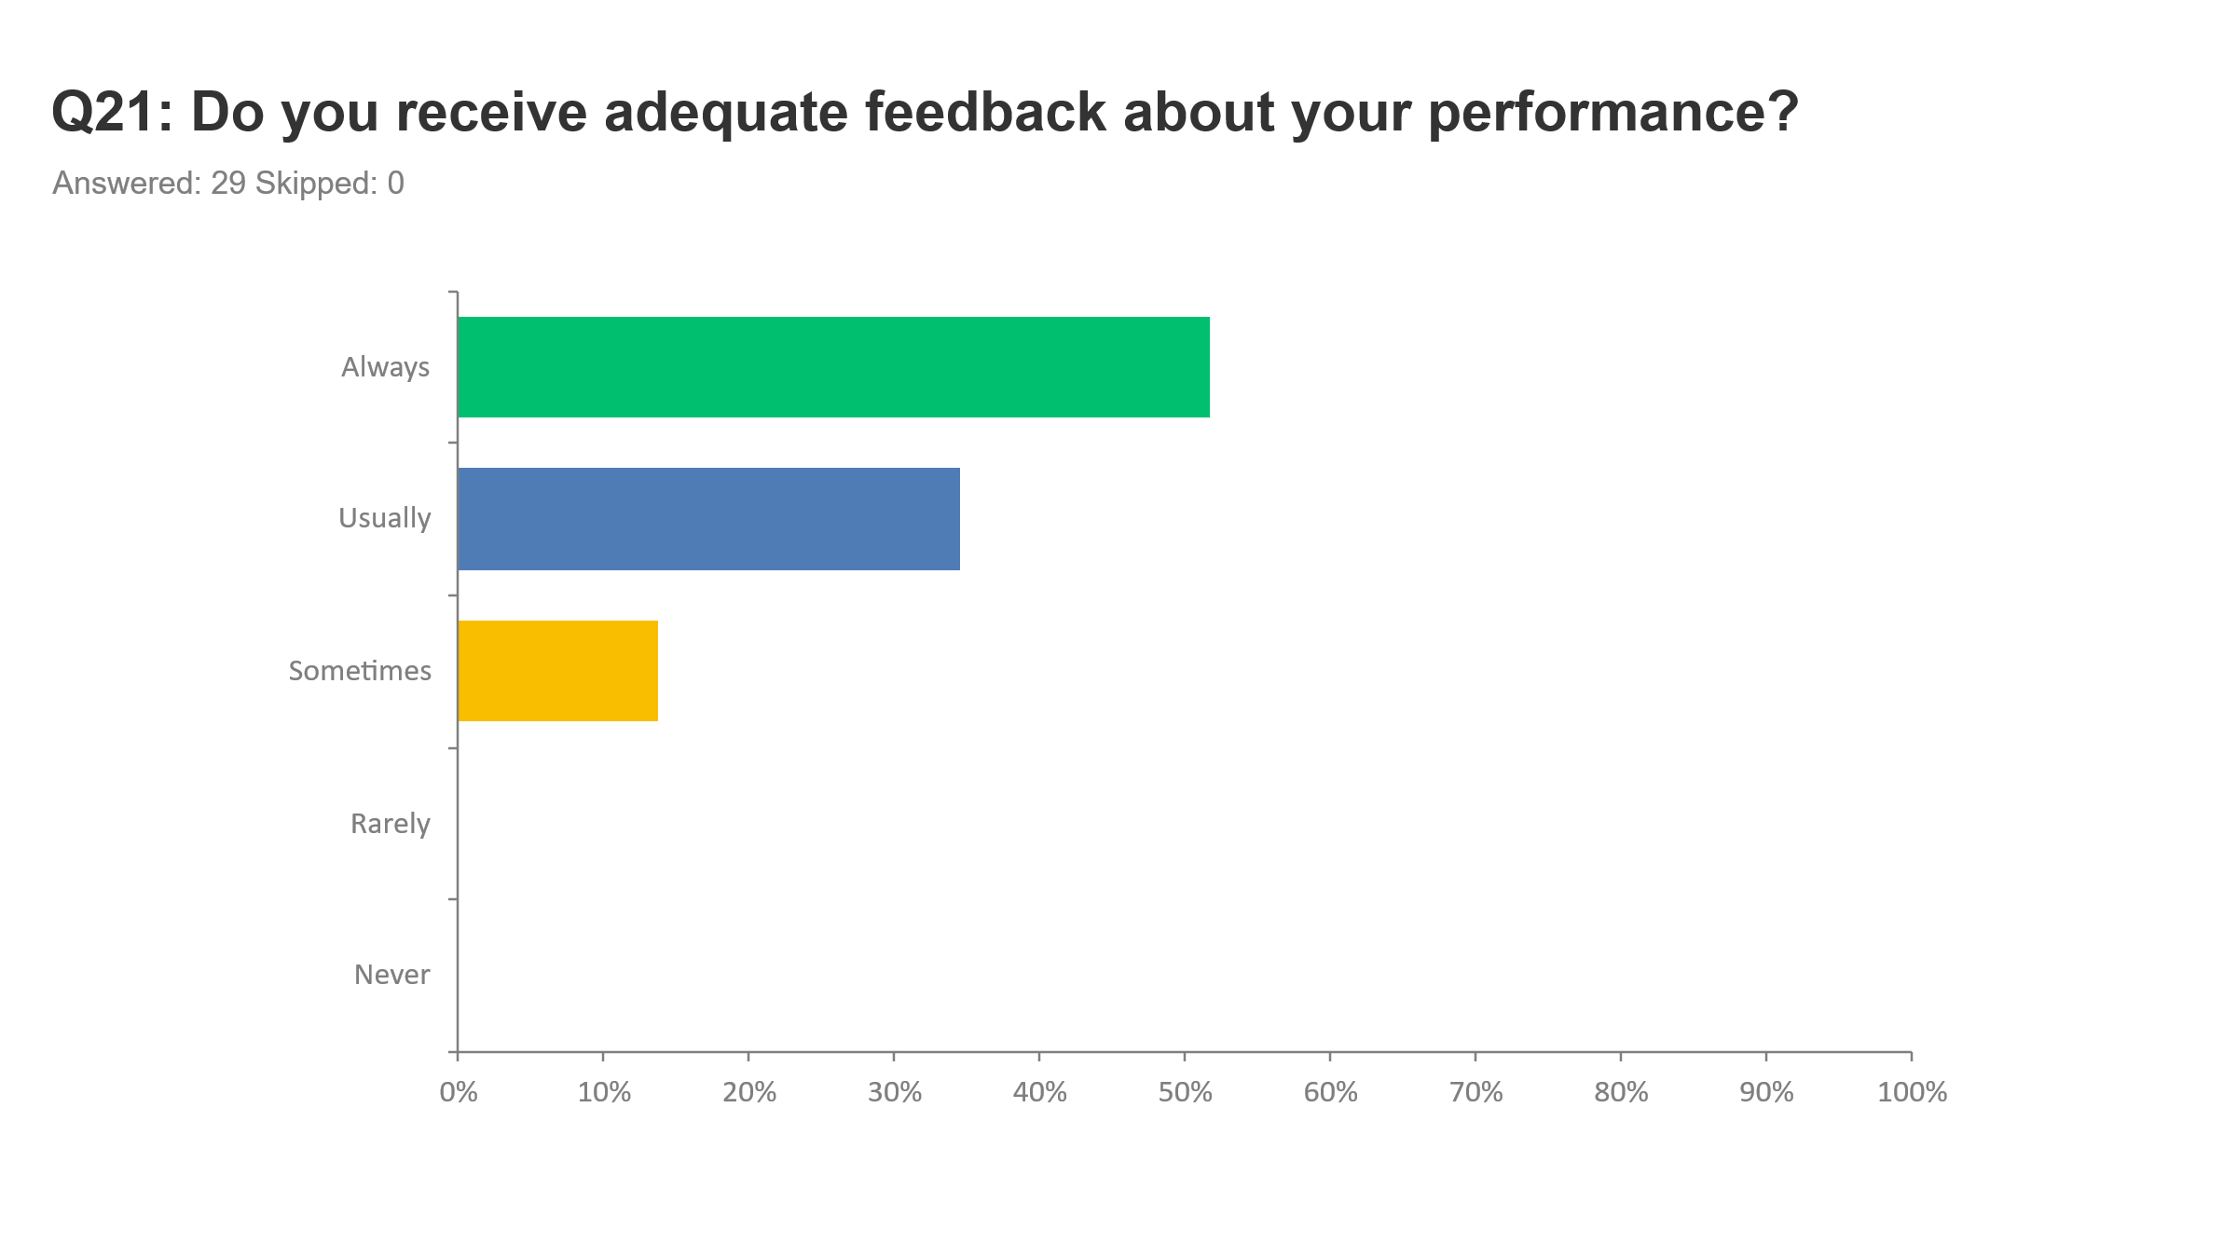
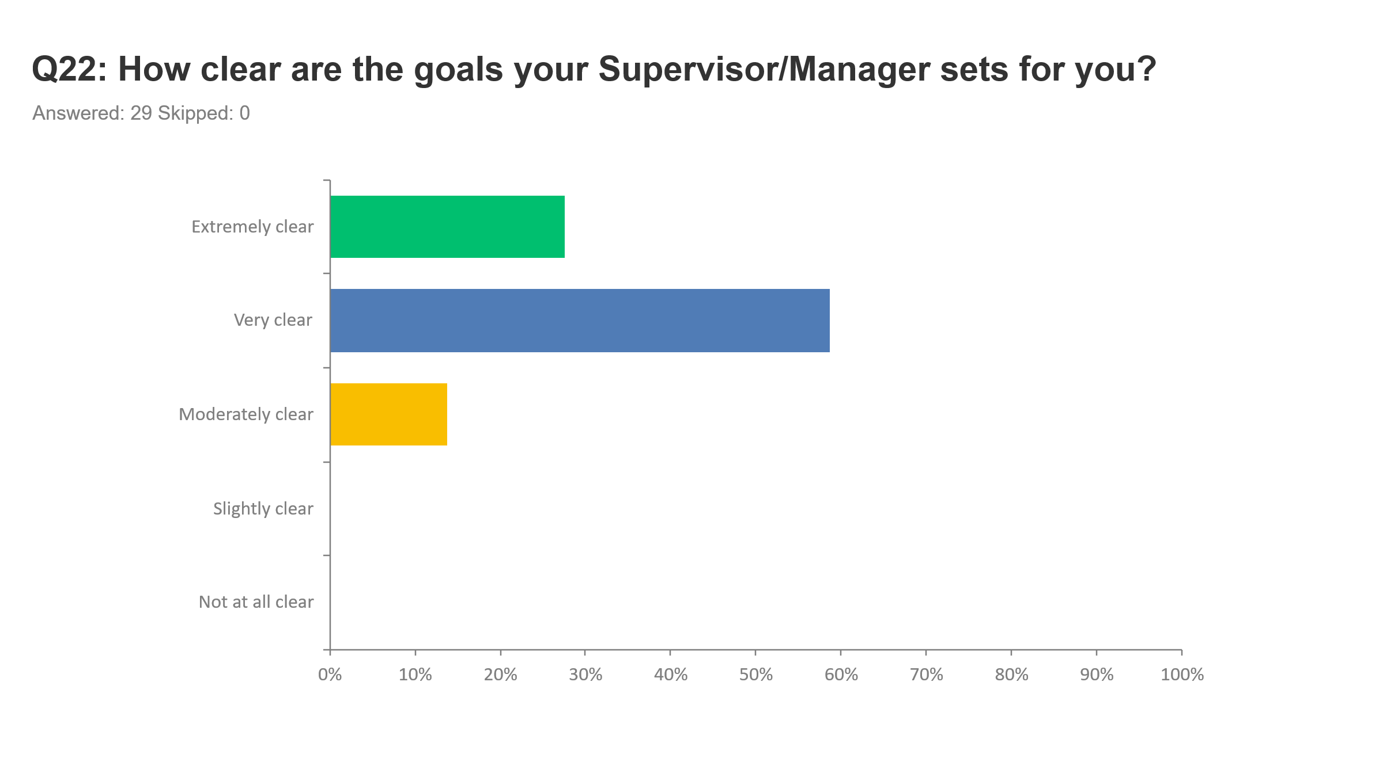
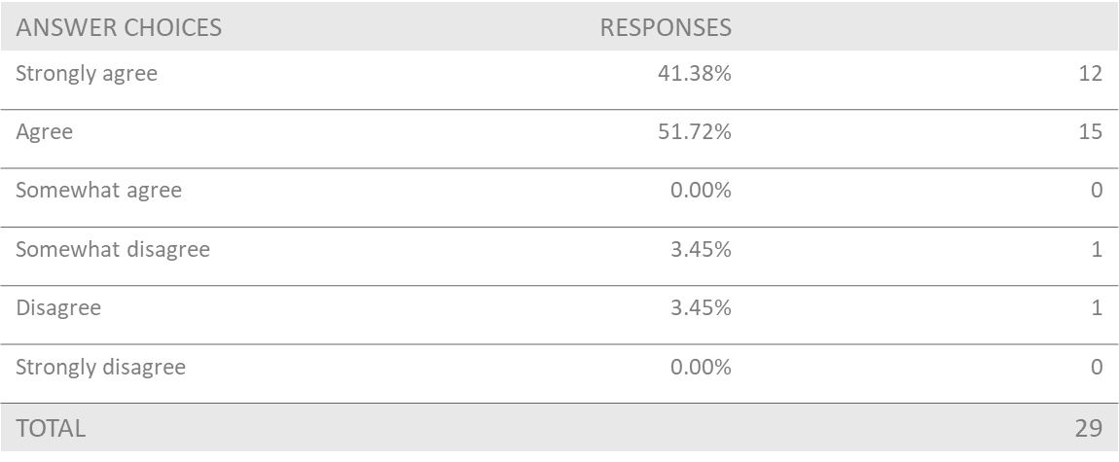
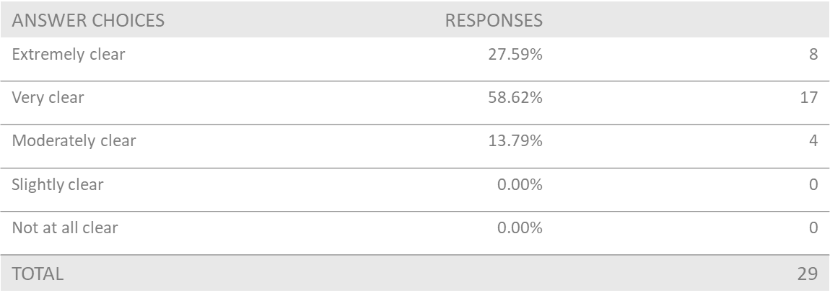
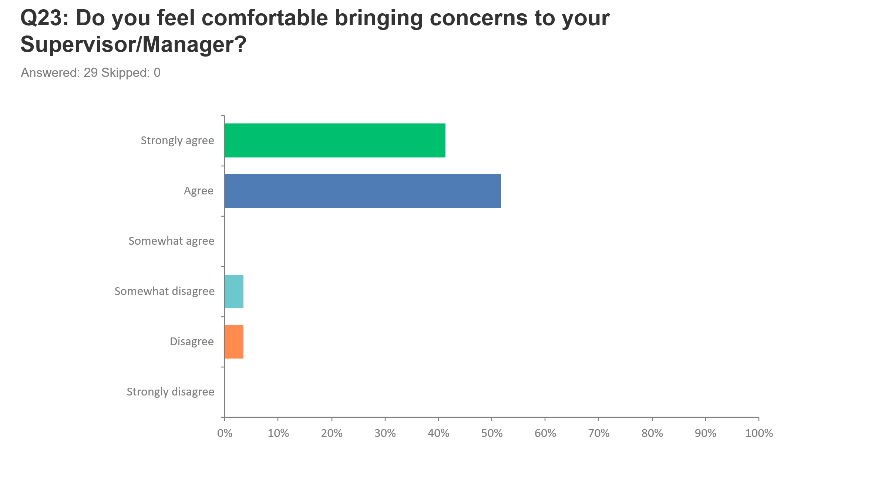
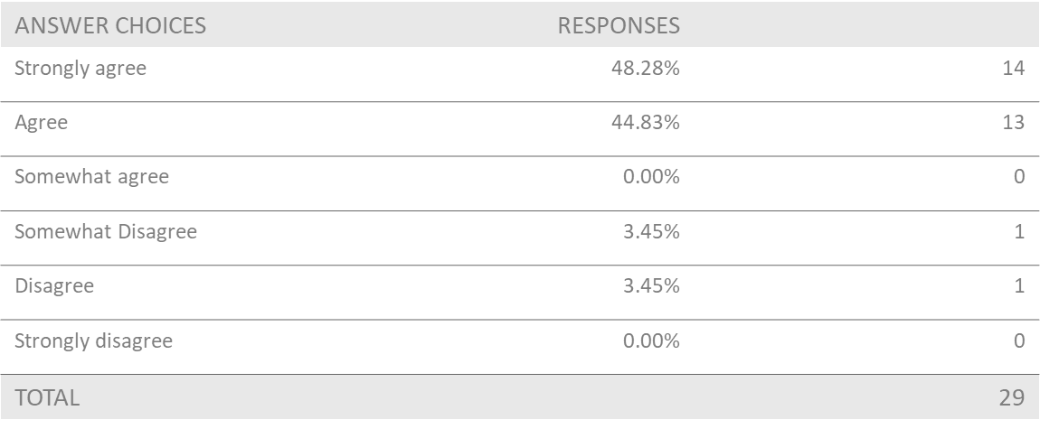
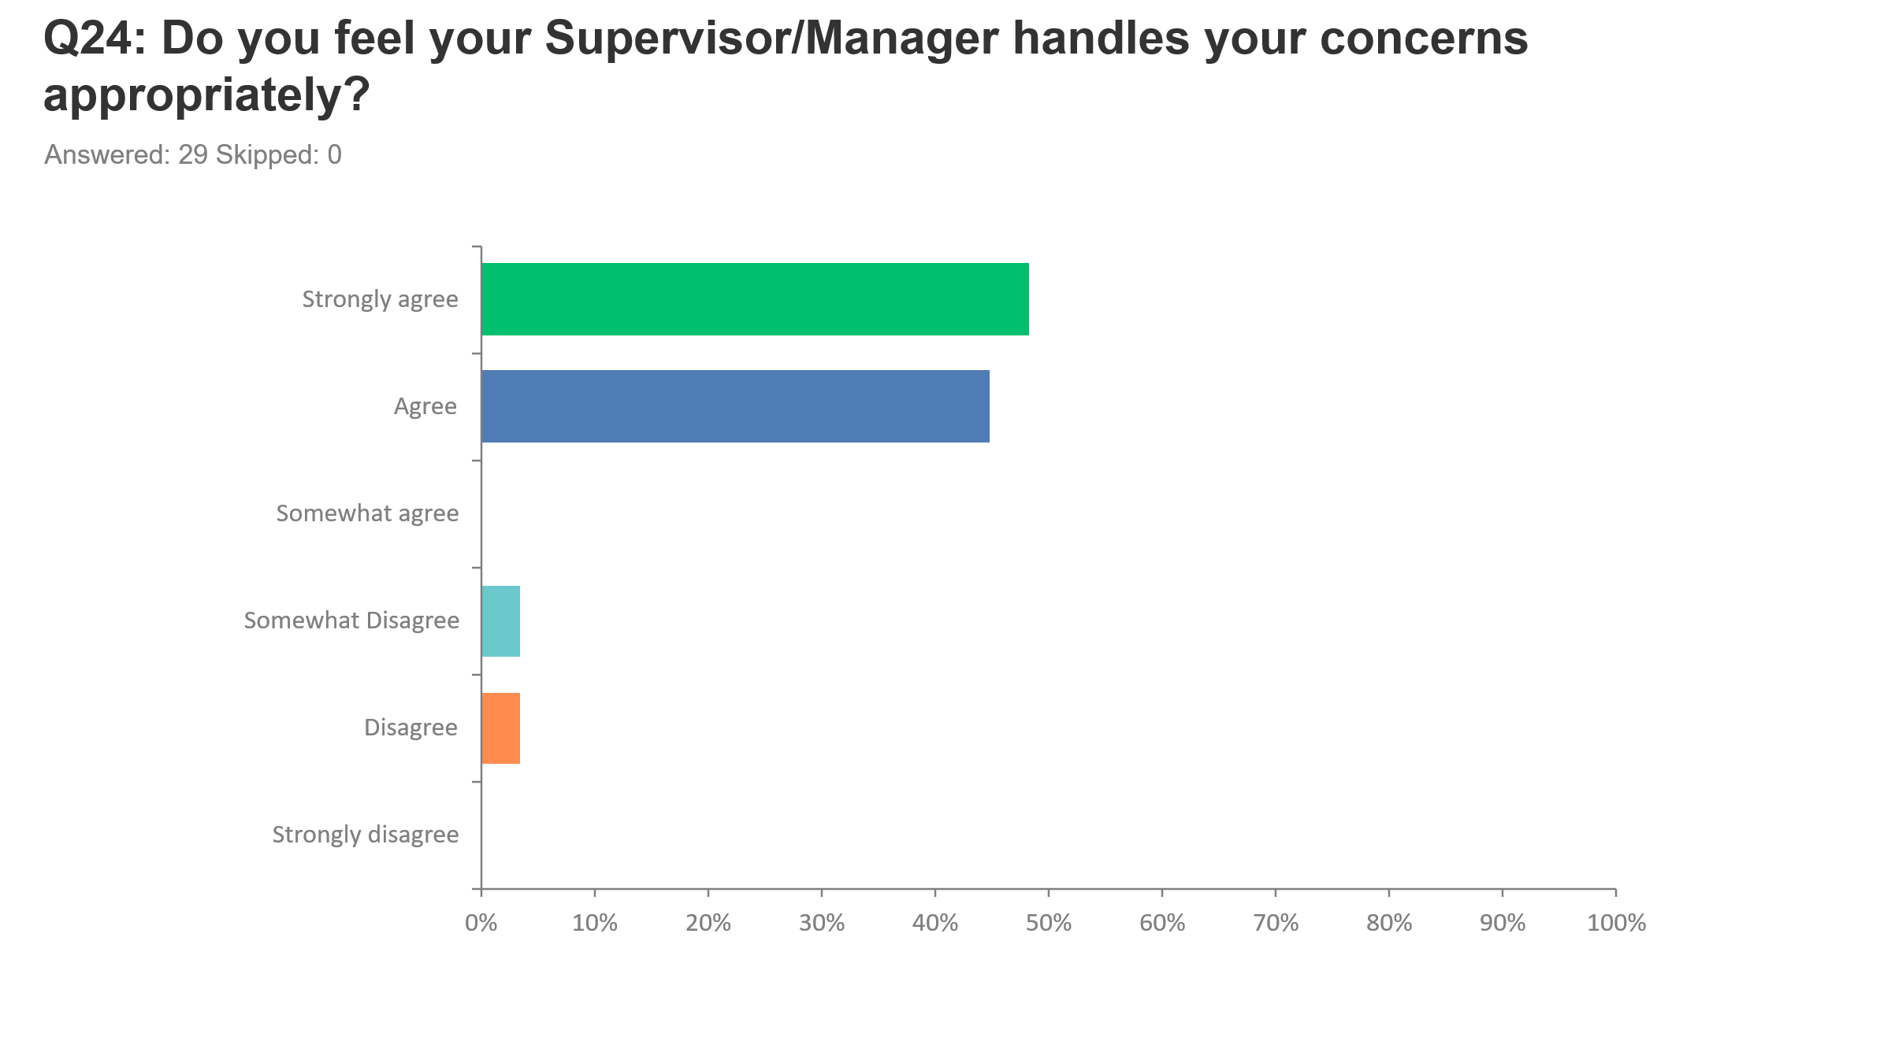
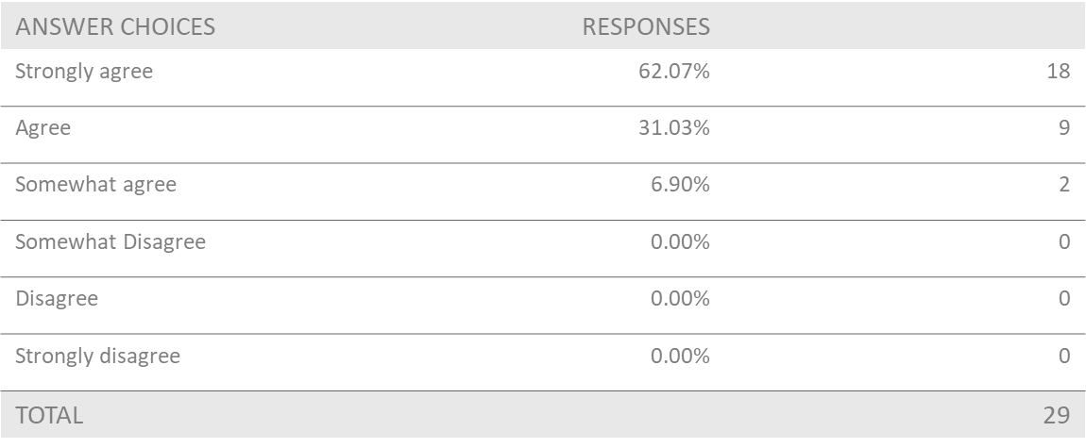
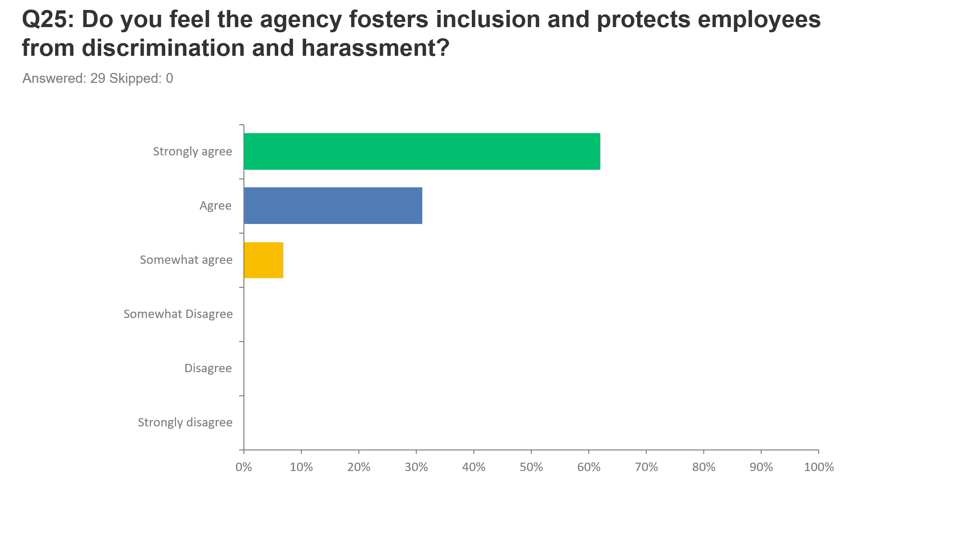
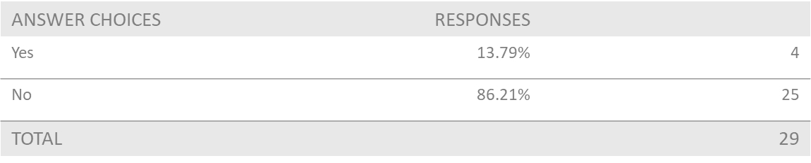
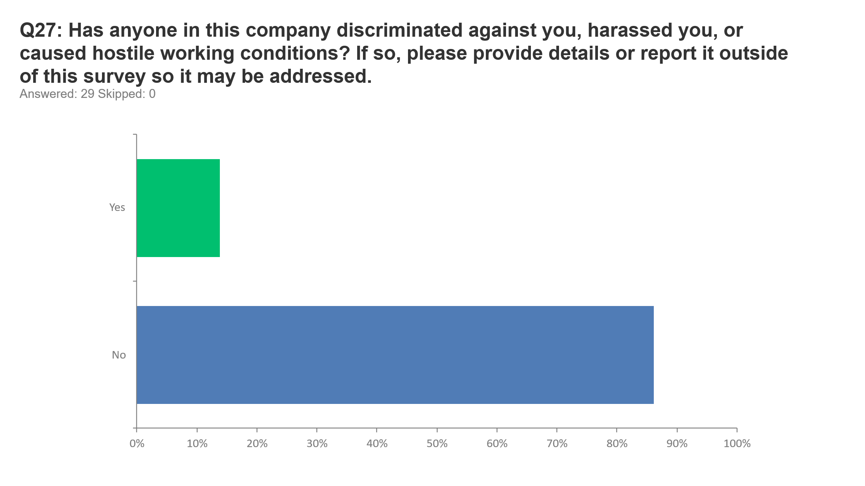
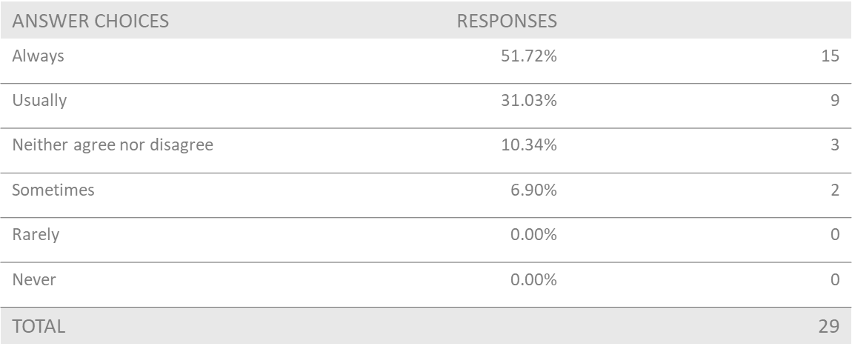
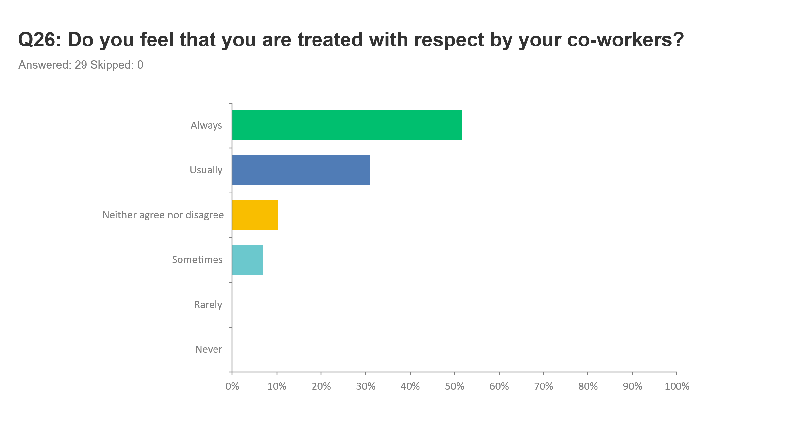
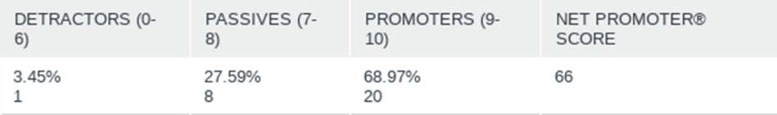
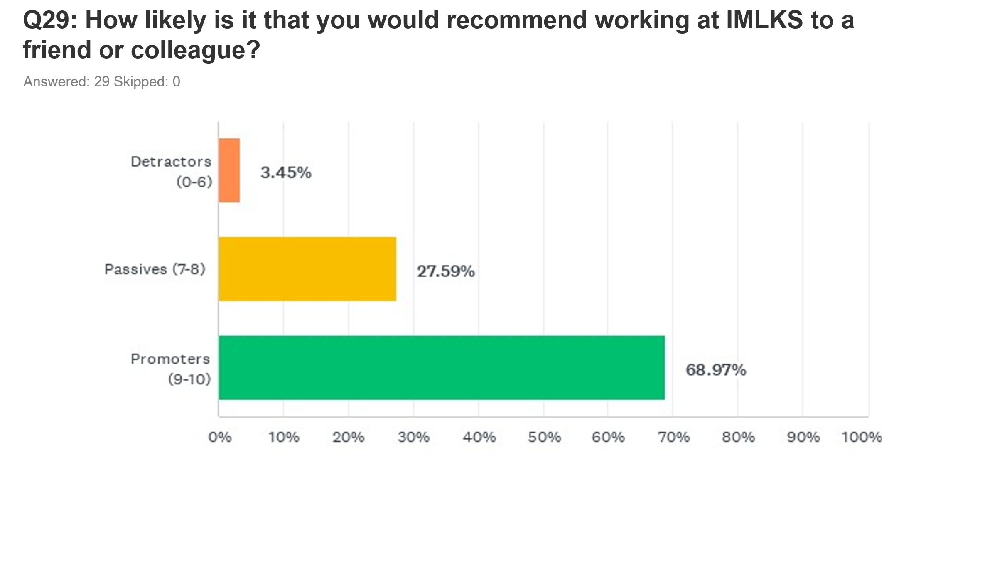
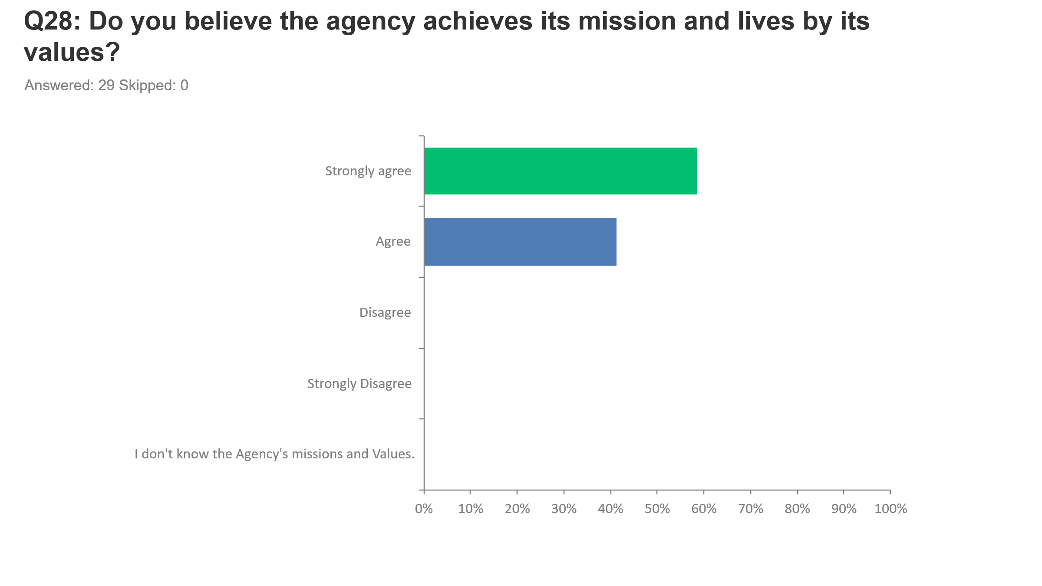
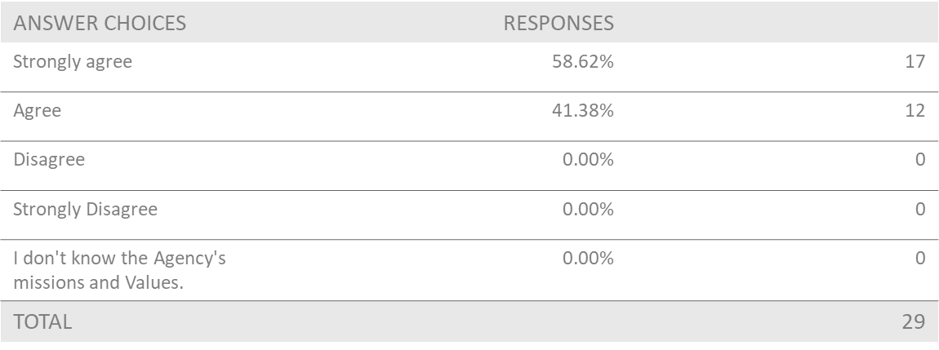
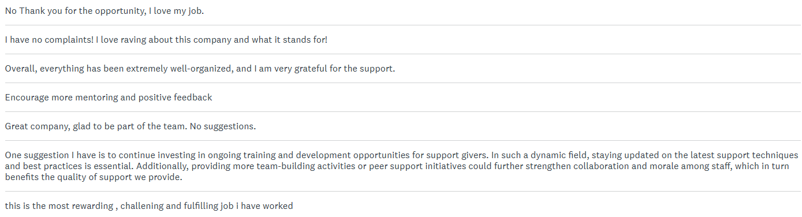
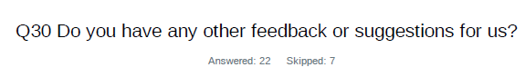

The employee survey provided valuable insights into organizational strengths and areas for improvement. The feedback collected has highlighted key priorities that will serve as a foundation for future developments. IMLKS remains committed to leveraging this input to foster growth and implement meaningful changes.



Member Feedback
Our Mission is to provide the highest quality of support to our members by honoring each unique personality and creating environments that ensure full involvement in their life choices and decisions. As such, our members’ feedback is of highest value in determining how well we carry out our mission.

Our members are very diverse. The services they need or wish to receive range significantly and are dynamic by their very nature. As are their ways of communicating and providing feedback.

We obtain informal feedback from persons served on a daily basis by having informal conversation and interactions; by observing their physical cues, emotions and behaviors; tracking their goal progress and; by looking for patterns.

Annually, we obtain formal feedback by conducting a Persons Served Survey. Surveys are conducted by paper with assistance from Support Workers or Service Coordinators where needed. Non-verbal individuals respond using their unique ways of communicating such as by body language, nods and expressions.

Out of 16 individuals served, all those receiving 24-hour support participated in our annual Persons Served Survey, resulting in 13 completed responses. Here's what we learned:

Identify as

Person serves are referred to IMLKS or requests Services

Person serves receives written information during initial meeting with staff

Person serves reflects on experiences with the agency so far

This question allowed comments around what difference those services have made and two of our individuals answered the following:
- “Monthly Rights reviews”
- “Keeping me connected in the community”

Person serves goals in the Community

Human Resources Report
The annual Human Resources (HR) Report for It’s My Life Kamloops Society (IMLKS) describes the human resources component of the work that we do and how it impacts our ability to achieve our mission. The report outlines trends and changes made to HR practices and sets goals for improvement for the year to come.

This report covers the period from January 1, 2024 – December 31, 2024.

Employee Compliment
The employee compliment can vary throughout a year based on the number of persons served, their support needs and seasonal requirements for backfill staff (for example during cold and flu season and summer holidays).

Our goal for our employees is for them to assist the persons served to achieve the highest level of independence as possible, while developing natural supports within their communities. Due to extenuating factors, many times support will still be required in some shape or form for the persons, but our goal is to help the person live a self-driven independent life, by building on the person’s social networks, life skills and community involvement.

Sourced from payroll records, on January 1st, 2024, IMLKS had 28 regular (non-casual) employees including 4 management staff and 1 Executive Director, plus 12 casual employees and 1 volunteer-admin. On December 31st, 2024, IMLKS had 30 regular (non-casual) employees including 4 management staff and 1 Executive Director, plus 24 casual employees. This gives an average workforce of 47.5 employees. If casual employees and the volunteer-admin are excluded, IMLKS has an average workforce of 29 persons.

Some employees supported more than one person at IMLKS, so the number of employees does not directly reflect the number of positions within the organization.

IMLKS had the following employee compliment in 2024:
Jan 1, 2024 | Dec 31, 2024 | Average
5 Administrative Employees | 5 Administrative Employees | 5
4 Community Support Workers | 4 Community Support Workers | 4
19 Regular Live-In Support Workers | 21 Regular Live-In Support Workers | 20
12 Casual Live-In Support Workers | 24 Casual Live-In Support Workers | 18
1 Volunteer | 0 Volunteers | 0.5
Employees total 41 | Employees total 54 | 47.5

IMLKS has grown in comparison to the previous year. The total workforce increased from an average of 46 employees in 2023 to 47.5 employees in 2024, with a notable rise in regular staff from 27 to 29 and casual staff from 16 to 18 on average. There has been a noticeable increase in time-off requests and sick days during 2024, resulting in a greater need for casual staffing. Additionally, an effort was made to secure a larger team of casual workers in response to the continued turnover that became prominent in 2022.

Another contributing factor to the increased need for casual employees is the demographic of applicants, predominantly students, who typically have limited availability. Expanding the casual pool has improved IMLKS’s ability to backfill shifts when employees are absent.

Jan 1, 2023 | Dec 31, 2023 | Average
4 Administrative Employees | 6 Administrative Employees | 5
3 Community Support Workers | 3 Community Support Workers | 3
20 Regular Live-In Support Workers | 20 Regular Live-In Support Workers | 20
13 Casual Live-In Support Workers | 19 Casual Live-In Support Workers | 16
0 Volunteers | 1 Volunteer | 0.5
43 Employees total | 49 Employees total | 46

Due to increased turnover, the HR Manager has had to dedicate more time to recruitment, hiring, onboarding, benefits administration, performance management, and offboarding. As a result, It’s My Life Kamloops Society established a permanent Administrative Assistant position to help manage this growing workload. However, the Administrative Assistant left at the end of the year.

A TRU Law student initially connected with IMLKS to explore volunteer opportunities. Throughout her time with the organization, she made valuable contributions by assisting with regular administrative functions, such as journal entries, and taking on additional tasks, including supporting persons served with grocery shopping when needed. While her volunteer commitment has now concluded, her efforts were greatly appreciated and made a meaningful impact.

Recruitment and Retention
IMLKS is committed to employing and retaining the most qualified candidates that suit the needs of the persons served and their families. We aim to select applicants who share the same values, vision, philosophy and practices of our organization.

IMLKS actively recruits through job fairs, social media, community events, referral programs, word of mouth and job search websites.

During 2024, IMLKS conducted in-person interviews in compliance with the latest health and safety regulations, ensuring workplace safety standards were met. Additionally, virtual interviews via Zoom remained available to accommodate those who preferred remote participation.

WHO WAS HIRED IN 2024?
33 EMPLOYEES
7 FULL TIME EMPLOYEES
3 PART TIME EMPLOYEE
22 CASUAL EMPLOYEES
1 ADMINISTRATIVE ASSSITANT

Approximately 47% of the applicants interviewed became successfully employed with IMLKS. In 2024, the Human Resources ‘Record of Interviewed Candidates Spreadsheet’ documented approximately 70 scheduled interviews. Of these, 62 applicants attended their interviews, resulting in 33 successful hires at IMLKS. All individuals who received an employment offer accepted their positions.

However, not all of the 33 hires remained employed through the end of the year, due to factors such as voluntary resignations, short-term contracts, and transitional roles, the net increase in staff was lower than the initial hiring figure

Comparison to previous years
Year | Interviews Booked | No Shows | Declined Positions | Successful Applicants
2019 | 77 | 5 (6.5%) | 4 of 23 offers (5%) | 19 (17%)
2020 | 59 | 2 (3.4%) | 7 of 27 offers (26%) | 20 (34%)
2021 | 76 | 9 (12%) | 6 of 39 offers (15.4) | 33 (43%)
2022 | 132 | 20 (15%) | 12 of 66 offers (18%) | 52 (39%)
2023 | 151 | 18 (12%) | 5 of 51 offers (9.8 %) | 46 (30%)
2024 | 70 | 8 (5.6%) | 0 of 33 offers (0.0%) | 33 (100%)

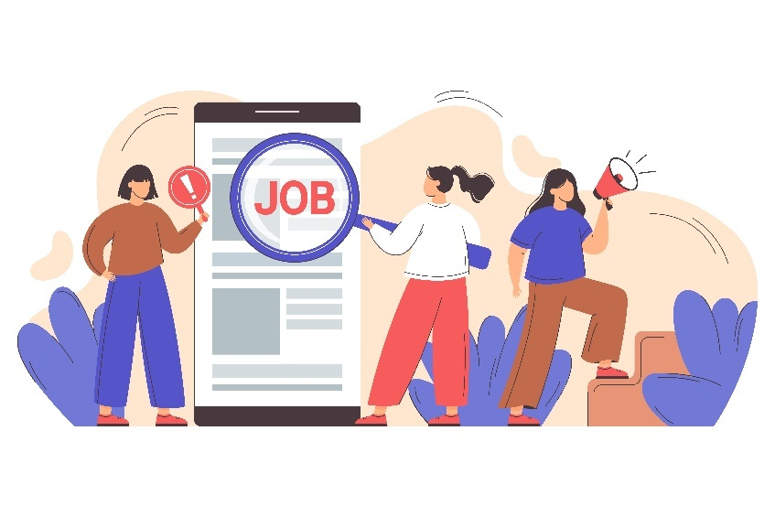
There has been a noticeable decrease in the number of interviews conducted, largely due to a more refined screening process that ensures only the most qualified candidates move forward. This strategic approach has led to a significant improvement in applicant quality, resulting in fewer interview no-shows and a higher success rate in hiring. Notably, all applicants who received job offers accepted their positions, demonstrating strong alignment between candidate expectations and the roles offered. These positive outcomes reflect the effectiveness of our targeted recruitment efforts and the overall efficiency of our selection process.

The refined screening process has resulted in a more selective approach, ensuring that only the most qualified candidates progress, significantly improving applicant quality. While this has led to fewer interview no-shows and a higher success rate in hiring, it also highlights the ongoing challenge of maintaining a steady flow of experienced and highly qualified applicants. As a result, additional focus has been placed on comprehensive onboarding, training, and support for new employees, particularly those entering the workforce for the first time, transitioning into the Social Services sector, or adapting to a new country. This strategic emphasis ensures that all hires, regardless of prior experience, are well-equipped to succeed in their roles, reinforcing the overall efficiency and effectiveness of our recruitment efforts.

Job Satisfaction
In 2024, IMLKS advocated for increased funding to support wage adjustments, ensuring competitive salaries to attract and retain qualified employees. Towards the end of the year, all positions were starting at higher rates, reflecting the agency’s commitment to addressing the rising cost of living in Canada. These adjustments also aimed to improve employee retention and job satisfaction, ensuring that dedicated professionals feel valued and motivated in their roles. Furthermore, the wage increases served as a recognition of the essential work performed by IMLKS employees, reinforcing their contributions to the well-being of the community and the success of the agency.

IMLKS Had the following hires in 2024:
Regular Live-In Support Worker | 7
Casual Live-In Support Worker | 21
Regular Community Support Worker | 3
Casual Community Support Worker | 1
Administrative Assistant | 1

Recruitment and retention of qualified employees remain significant challenges, particularly in the Health Care and Social Services sector. As demand for services in health care and community support continues to grow, the workforce has struggled to keep pace. Additionally, the ongoing mental health crisis has heightened the need for social services, further intensifying workforce pressures.

Like many other organizations, including hospitals, long-term care facilities, shelters, and community service providers, IMLKS faces strong competition for skilled professionals, making retention particularly challenging in a labor market where opportunities elsewhere remain abundant. To enhance stability and attract top talent, IMLKS has strengthened its commitment to employee well-being by expanding its Health and Wellness program, offering more competitive wages, and increasing flexibility for employees, ensuring a supportive and sustainable workplace environment.

Employee Turnover
Staff turnover has been an ongoing risk for IMLKS. Every time an employee leaves our organization, the persons served has to tell their story to someone new entering their life as a support worker. IMLKS is continually looking at ways to reduce turnover and improve staff retention. To better target where we can focus our attention in regards to reducing turnover, IMLKS has analyzed turnover in the following areas for 2024:
Area of Interest | Respective terminations/average population | Turnover Rate
Total turnover across the workforce (using an average workforce of 47.5 employees) | 24 / 54 | 44.40 %
Turnover among Regular employees (including management) across the entire workforce | 7 / 30 | 23.30%
Turnover among Regular Full Time and Part Time employees (including management) as a percentage of regular staff | 7 / 30 | 23.30%
Percentage of annual Turnover for Casual Employees | 16 / 24 | 66.70%
Percentage of annual Turnover for Regular Live-In Support Workers | 44 / 21 | 19.00 %
Percentage of annual Turnover for Community Support Workers | 3 / 4 | 75.00%
Percentage of annual Turnover for Administrative Employees | 0 / 5 | 0.00 %
Volunteer | 1/0.5 | 200.00%
Casual Administrative Employees | 1/0.5 | 200.00%

Previous Year’s results for comparison
Area of Interest | Respective terminations/average population | Turnover Rate
Total turnover across the workforce (using an average workforce of 46 employees) | 53/46 | 115%
Turnover among Regular employees (including management) across the entire workforce | 16/46 | 35%
Turnover among Regular Full Time and Part Time employees (including management) as a percentage of regular staff | 19/28 | 68%
Percentage of annual Turnover for Casual Employees | 30/16 | 186%
Percentage of annual Turnover for Regular Live-In Support Workers | 15/20 | 75%
Percentage of annual Turnover for Community Support Workers | 4/2.5 | 160%
Percentage of annual Turnover for Administrative Employees | 1/5 | 20%

As shown in the chart above, casual employees continue to account for the highest turnover at IMLKS, although the rate has decreased compared to the previous year. In the latest period, casual employees had a turnover rate of 66.70%, down from 186% last year. This significant reduction suggests a degree of stabilization in casual staffing, though turnover remains high due to the nature of the role, characterized by inconsistent shifts.

These positions have been largely filled by students or individuals seeking short-term employment, many of whom leave to secure full-time roles. Exit interviews indicate that departing casual employees most commonly cite reasons such as obtaining a more stable job or adjusting their schedules due to academic commitments.

Despite improvements, addressing retention strategies for casual employees remains crucial for reducing turnover further and maintaining workforce stability.

Comparison of overall annual turnover rates (excluding casual staff) as a percentage of the average total workforce:
Year | Turnover Rate
2019 | 38%
2020 | 40.7 %
2021 | 29%
2022 | 64%
2023 | 35%
2024 | 23.30%

The 2024 results illustrate a dynamic trend in employee retention over the past several years, with overall annual turnover rates (excluding casual staff) showing notable fluctuations: 38% in 2019, rising to 40.7% in 2020, dipping to 29% in 2021, peaking at 64% in 2022, then declining to 35% in 2023, and reaching a new low of 23.30% in 2024. This downward trend reflects positive progress in workforce stability and retention efforts.

The systematic collection of exit survey feedback has been central to these improvements by offering actionable insights that not only diagnose immediate issues but also help shape long-term retention strategies, ensuring that the enhancements implemented continue to foster a stable and resilient workforce in the face of evolving market conditions.

Policies and Procedures

Policies and procedures are in place to guide the actions of employees and to determine fair approaches in the treatment of employees. All IMLKS policies go to the Board of Directors for approval. Policies and procedures are reviewed annually and changes are tracked in our operations manual record of revisions. Our policies and procedures meet Work Safe BC policies and regulations, Community Living BC (CLBC) standards, BC employment standards and Commission on Accreditation of Rehabilitation Facilities (CARF) requirements.
This Photo by Unknown Author is licensed under CC BY-ND

Benefits
IMLKS cares about the wellbeing of its team members. In 2023 IMLKS provided eligible full-time employees with a Full benefits package (including extended health, dental, vision, LTD, Life Insurance and ASI), Municipal Pension Plan, Employee and Family Assistance Plan as well as a Health and Wellness fund.

Orientation and Training
Training and orientation of new personnel is the responsibility of the Human Resources Manager, Service Coordinators and direct support employees. Employees receive an initial orientation and on-the-job training, competency based and persons specific training prior to commencing work. This includes a review of the Health and Safety policies, Code of Ethics Policy, Confidentiality Policy, Employee Handbook (implemented in 2017) and other pertinent policies and procedures. Training requests are submitted to the HR Manager and Service Coordinators by employees.


During 2023, employees communicated that orientation day was overwhelming due to the amount of information that is reviewed on the first day. In response, the HR manager developed an “At-Home” Orientation package that employees are paid to review and complete from home prior to orientation. This has been an effective solution that has reduced the time the HR Manager spends orientating new hires in the office and has resulted in better retention of information.

Training and development opportunities are posted on ShareVision, emailed to employees and/or posted to bulletin boards. All employees are encouraged to request to attend training or educational courses they feel will assist them to be more proficient in their work. Sometimes training is required to meet a specific person’s support needs and at other times it is to gain knowledge in an area of interest. Employee participation in training is tracked by the HR Manager and Service Coordinators. There may be omissions to the number of training events if the information was not passed on.

In 2016, IMLKS started to offer diversity training to its employees. Diversity in the workplace is increasingly significant and we want staff to learn to embrace and understand the benefits of working with and supporting persons of diverse backgrounds, races, ethnicities, cognitive styles and ages.

Community Partnerships

IMLKS works collaboratively with the following community organizations:
- TOCSC  - HSCL  - TRU  - Indeed  - People in Motion  - Brock Senior’s Centre  - Kamloops Home and Community Care  - DDMHS  - Caya | - Kamloops Society for Community Inclusion  - Simple The Best Thrift Store  - Alzheimer’s Society  - BC CEO Network  - Canada Summer Grant Program  - Handy Dart

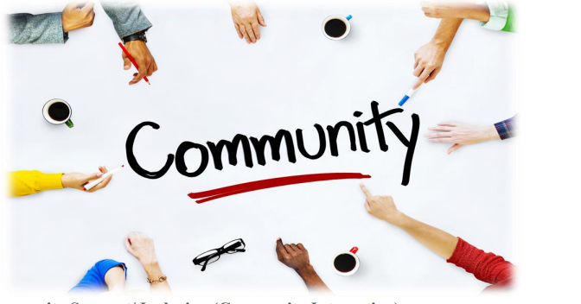

Health and Safety
Health and Safety is a priority to IMLKS and the organization aims to go above and beyond in providing a safe work environment.

Employee Injuries
During this reporting period there has been 0 WCB claims. We continue to emphasize safety in the workplace and do all we can to keep our employees safe. All incidents that cause an employee to seek medical attention or loss of time from work are investigated by members of the Health and Safety Committee.
Near misses are reported by employees so we can investigate and the Health and Safety Committee and ensure measures are in place to prevent similar instances from occurring.

Health and Safety Committee
The Health and Safety Committee is committed to doing everything they can to promote safety, monitor incidents and make suggestions for implementing improvements

Because IMLKS does not have 20 workers at any of our worksites, we are not required by WorkSafe BC to have an Occupational Health and Safety (OHS) Committee. However, IMLKS does have five Health and Safety appointed officers (2 employer representatives plus one alternate and 1 employee representative plus one alternate) that meet monthly to discuss health and safety concerns, best practices and ongoing methods for creating a safer workplace. Monthly meeting minutes are posted in a binder at the IMLKS office and uploaded to ShareVision for all employees to access. New employees are provided information about our health and safety contacts and committee during orientation.

On going workforce challenges

In 2024, IMLKS continued to navigate the evolving labor market while addressing key workforce challenges. As our sector becomes more specialized, securing skilled professionals remains a priority. The increasing demand for employees with expertise in supporting individuals with diverse abilities underscores the need for strategic recruitment and continuous workforce development. By proactively investing in training and talent acquisition, IMLKS remains committed to maintaining excellence.

Given our 24-hour shift structure, effective communication and teamwork are essential. With a diverse workforce, IMLKS recognizes the importance of cross-cultural understanding, inclusive policies, and bilingual support to enhance collaboration. By fostering a supportive work environment, we ensure employees can seamlessly coordinate to provide consistent, high-quality care at all hours.

Generational diversity also plays a role in shaping the workplace, as professionals from different age groups bring unique perspectives and expectations. While younger employees often prioritize career growth and innovation, experienced professionals contribute stability and depth of expertise. IMLKS embraces these differences by encouraging mentorship, adaptive leadership, and a work culture that values continuous learning and development.

Employee retention remains a focal point, as IMLKS understands that job satisfaction, career progression, and workplace culture significantly influence employee engagement. High turnover can disrupt operations, increase costs, and affect continuity of care. To mitigate these challenges, IMLKS prioritizes an inclusive and supportive workplace where employees feel valued and empowered to grow within the organization.

Through proactive workforce strategies, adaptability, and a commitment to employee development, IMLKS continues to strengthen its position as a leading organization in the field of supporting individuals with diverse abilities. By addressing these challenges head-on, we remain resilient and prepared to thrive in an ever-changing employment landscape.

DEMOGRAPHICS OF PERSONS SERVED
IMLKS provided service to 16 diverse individuals in 2024
Religion | Number of Person Served
Baptist | 2
Lutheran | 1
Unidentified | 12
Catholic | 1

Age | Number of Persons Served Receiving Service
19 – 29 | 3
30 – 39 | 2
40 – 49 | 4
50 – 59 | 2
60 – 69 | 4
70 – 79 | 0
80 – 89 | 1
Ethnicity | Number of Person Served
Irish | 1
Caucasian | 11
First Nations | 1
South African | 1
European | 1
French Canadian | 1

First Language | Number of Person Served
English | 16
French | 2
Other | 0

Gender | Number of Person Served
Male | 8
Female | 8
Gender Diverse | 0






REPORTING SERVICE

Community Support/ Inclusion (Community Integration)

Through supported living, we provide community inclusion support to persons served that is tailored on an individual basis to meet their needs. Support is flexible and can be provided at varied times to meet the supported individual’s lifestyle, unique goals and needs. Individuals are supported to learn new and relevant life skills, gain greater independence and autonomy. With this service we are able to take an active role in assisting the persons served, their families and personal networks to inspire and encourage the development and delivery of services and plans that enable the realization and accomplishment of each person’s potential and choices. Based on the person’s needs, support is provided to carry out:
Art on showcase in the office, created by one of our own persons served

• Day-to-day activities
• Roles
• Personal care
• Relationship building
• Assistance with financial decisions
• Working towards achievement of meaningful goals

The strength of this service is that persons served are provided flexible one on one support to effectively manage their homes, health, medications, social relationships and working lives.

Live-In Support (Supported Living)
Persons served live in their own home and have one on one support available to them 24/7. Individuals are supported to learn new and relevant life skills, gain greater independence and autonomy. With this service we are able to take an active role in assisting the persons served, their families and personal networks to inspire and encourage the development and delivery of services and plans that work towards the realization and accomplishment of each person’s potential and choices within a home and inclusive community.
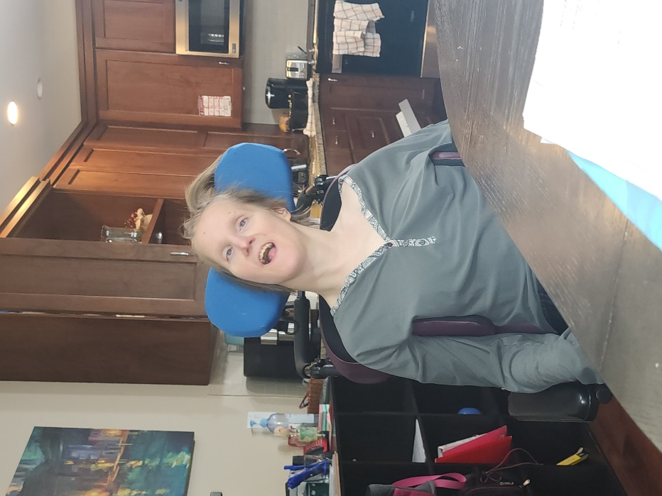
Based on the person’s needs, support is provided to carry out
• Day-to-day activities
• Roles
• Personal care
• Relationships building
• Assistance with financial decisions
• Working towards achievement of meaningful goals.

The strength of this service is that persons served are able to own or rent their own residence and have flexible one on one support available to effectively.

Domains
The Domains to be reported on include: Home, Financial Rights, Safeguards, Vulnerabilities, Relationships, Leisure, Autonomy, Nutrition, Growth, Life Meaning, Communication, Mobility, Transportation, Identity, Inclusion, Roles, Value/Respect, Adaptive Tools, and Work.
Training
In all of the services we provide, IMLKS measures satisfaction, effectiveness, efficiency and access through the Domains of Need (the areas we support people in to have good lives).

SECTION 1: SERVICE DELIVERY SPECIFIC OUTCOMES
SUPPORTED LIVING/ COMMUNITY INTEGRATION
EFFECTIVENESSS | Objective | Indicator | Who Applied To | Performance Goals for 2024 | Actual Results for 2024 | Goal for 2025
 | Persons served have meaningful roles in community | % of persons served that maintain employment for 6 months or more.  % of persons served that obtained new employment positions within the year.  % of persons served that maintain volunteer positions for 6 months or more  % of persons served that obtained new volunteer positions within the year.  % of persons served that were part of a club, team or group of interest for 6 months or more  % of persons served that joined a new club, team or group of interest within the year. | All persons served who indicated they wanted paid employment.  All persons served who indicated they would like to obtain new employment.  All persons served who indicated they wanted to volunteer.  All persons served who indicated they wanted to find new volunteer positions in 2023.  All persons served who indicated they wanted to be part of a club, team or group of interest.  All persons served who indicated they wanted to join a new club, team or group of interest. | 50% or more  20% or more  70% or more  50% or more  90% or more  20% or more | 15.38%  7.69%  38.46%  15.38%  23.08%  15.38% | 30% or more  10% or more  50% or more  30% or more  30% or more  20% or more
EFFICIENCY | Objective | Indicator | Who/What Applied To | Performance Goals for 2024 | Actual Results for 2024 | Goal for 2025
 | Minimize the need of Service Coordinator direct support fill in/ coverage  Maximize the amount of individual planning meetings | The % of funded Supported Living and CI hours that were worked by management due to staffing shortages  % of persons served that had an annual planning meeting within the calendar year | All funded hours less any refused or declined hours of support  All persons served | Less than .10% of Supported Living Hours and less than 2% of CI Hours  95% | .5% of Supported Living Hours and 1% of CI Hours  100% | Less than .10% of Supported Living Hours and less than 2% of CI Hours  95%
ACCESS | Objective | Indicator | Who Applied To | Performance Goals for 2024 | Actual Results for 2024 | Goal for 2025
 | All persons served understand their rights and responsibilities | % of person served that receive internal rights training | All persons served who have been in service for 6 months | 100% | 92.31% | 100%
SATISFACTION | Objective | Indicator | Who Applied To | Performance Goals for 2024 | Actual Results for 2024 | Goal for 2025
 | Persons Served cultural and spiritual beliefs are respected  All stakeholders feel that supported individual’s is treated with respect  Persons Served are given opportunity for choice.  Persons Served feel listened to. | % of persons served that indicate they feel staff ‘All the time’ respect their cultural and spiritual beliefs  % of stakeholders who indicate that they agree or strongly agree that their family member is treated with respect.  % of persons served that indicate they are given the opportunity to make their own choices ‘All the time’ and ‘Most of the time’  % of persons served that indicate they ‘All the time’ or ‘Most of the time’ feel listened to | All persons served who completed the survey  All stakeholders who completed the stakeholder survey  All persons served who completed the survey  All persons served who completed the survey | 80%  90%  80%  80% | 84.62%  100%  100.00%  100.00% | 90%  95%  90%  90%
BUSINESS FUNCTION | Objective | Indicator | Who/What Applied To | Performance Goals for 2024 | Actual Results for 2024 | Goal for 2025
 | All Employees participate in an Opportunity for Growth & Development  Reduce turnover  Utilize all funded hours | % of Employees that have participated in an opportunity for growth and development.  % of regular staff that leave the organization in this reporting period  % of Persons Served whose funded hours are fully utilized (excluding unused hours due to persons served unavailability) | All employees  All non-casual employees  All funded hours for all persons served less any hour’s persons served declined support | 75%  25% or less  97% or more  100% Supported Living Hours | 80%  23.30%  95 % Community Support  Hours  98% Supported Living Hours | 85%  20% or less  97% or more  97% or more

SECTION 2: ANALYSIS OF PERSON SPECIFIC EXTENUATING AND INFLUENCING FACTORS
A. DEMOGRAPHIC FACTORS | Categories |  | Results
 | AGE | 19- 29 YEARS  30- 39 YEARS  40- 49 YEARS  50-59 YEARS  60- 69 YEARS  70-79 YEARS  OVER 80 YEARS | 18.75%  12.50%  25.00%  12.50%  25.00%  00.00%  06.25%
 | FIRST LANGUAGE | ENGLISH  FRENCH  OTHER | 87.50%  12.50%  0%
 | GENDER | FEMALE  MALE  DIVERSE | 50.00%  50.00%  0%
 | COMMUNICATION | VERBAL  NON-VERBAL/OTHER  VERBAL AND NON/VERBAL | 81.25%  12.50%  06.25%
 | ETHNICTY | IRISH  CAUCASIAN  ABORIGINAL  SOUTH AFRICAN  FRENCH CANADIAN  EUROPEAN | 06.25%  68.75%  06.25%  06.25%  06.25%  06.25%
 | RELIGION | BAPTIST  LUTHERAN  CATHOLIC  NOT IDENTIFIED | 12.50%  06.25%  06.25%  75.00%
B. BARRIERS TO OUTCOMES | MOBILITY | USES A MOBILITY DEVICE  DOES NOT USE MOBILITY DEVICE | 50.00%  50.00%
 | TRANSPORTATION | OWN VEHICLE  RELIES ON SUPPORT WORKER VEHICLE  RELIES ON PUBLIC TRANSPORTATION DUE TO MOBILITY DEVICE | 18%  70%  12%
C. SEVERITY FACTORS |  | DEVELOPMENTAL DISABILITY  DUAL DIAGNOSIS | 100%  70%

RESULTS FROM DATA
 | 2023 | 2024
EFFECTIVENESS  % of persons that held paid employment position for at least 6 months within the year  % of persons that held volunteer positions for at least 6 months within the year  % of persons served that were part of a club or membership within a year for at least 6 months within the year | 33%  71%  53% | 15.38%  38.46%  23.08%
EFFICIENCY  % of funded Direct Support Hours provided by Management due to Staffing  % of persons served that had an annual planning meeting within the calendar year | .9% of Supported Living  1% of CI Hours and  100% | .5% of Supported Living Hours and 1% of CI Hours  100%
ACCESS  % of person served that received internal rights training | 100% | 92.31%
STAKEHOLDER AND PERSON SERVED FEEDBACK  % of persons served that feel their staff always treated them with respect.  % of stakeholders who indicate that they agree or strongly agree that their family member is treated with respect. | 81%  100% | 84.62%  100%
BUSINESS FUNCTION  All Employees participate in an Opportunity for Growth & Development  Reduce turnover  Utilize all funded hours | 80%  35%  96.40 % Community Support Hours  97.10% Supported Living Hours | 80%  23.30%  95% Community Support Hours  98% Supported Living Hours

Interpretation of Data

Effectiveness
In 2024, IMLKS continued to foster meaningful community engagement for persons served. While interest in employment, volunteering, and group membership remained strong, the actual participation rates revealed ongoing challenges that require thoughtful attention and strategic support.

A total of 13 individuals expressed interest in paid employment, 11 in volunteering, and 11 in joining a club, team, or community group. These numbers reflect a steady enthusiasm for socially valued roles, even as barriers persist. Compared to 2023, interest in employment rose by 44%, and interest in volunteering increased by 57%, indicating a growing desire among persons served to contribute and connect.

Despite this increased interest, only 2 individuals maintained paid employment for six months or more, representing 15.38% of those served. This marks a decrease from 2023, where 3 individuals met this benchmark. Similarly, 5 individuals maintained volunteer roles for six months (38.46%), and 3 individuals sustained club or group membership for the same duration (23.08%).

These figures suggest that while enthusiasm is high, translating interest into sustained participation remains a challenge. Barriers such as communication differences, mobility limitations, transportation access, and dual diagnoses continue to impact outcomes. Additionally, social stigma and limited employer understanding of diverse abilities further complicate the path to inclusion.

Other contributing factors include:
- Varying levels of comprehension around what employment or volunteering entails
- The need for more inclusive and flexible community opportunities
- Staff capacity to recognize and nurture the unique talents of persons served

While the percentage of individuals achieving long-term roles declined, the upward trend in interest is a powerful indicator of readiness and aspiration. Our goal for the future is to bridge the gap between interest and sustained participation by enhancing mentorship, increasing community outreach, and strengthening individualized support plans.

We believe that every person served has gifts worth sharing and a story worth telling. By continuing to dream big and invest in person-centered strategies, we aim to help more individuals find their place in the community, not just as participants, but as valued contributors.

Efficiency
In 2024, IMLKS continued to prioritize operational efficiency by minimizing the need for Service Coordinators to provide direct support coverage. This strategic focus allowed Coordinators to remain dedicated to their supervisory responsibilities, ensuring consistent oversight and quality assurance across service delivery.

The percentage of funded Supported Living hours covered by management decreased to 0.5%, while Community Inclusion hours remained steady at 1%, both well within our performance targets. This improvement in Supported Living coverage is largely attributed to the expansion of our casual support team, which provided greater flexibility in backfilling shifts during periods of staff absence. Additionally, the reduction in regular staff turnover from 35% in 2023 to 23.3% in 2024 played a significant role in stabilizing staffing patterns and reducing the reliance on management for direct support.

IMLKS also maintained its commitment to person-centered planning. Every individual supported through our services received an annual planning meeting, achieving a 100% completion rate for the second consecutive year. These meetings remain a cornerstone of our service model, offering a structured opportunity to set personalized goals, review progress, and celebrate achievements alongside families and stakeholders.

Looking ahead, IMLKS will continue to invest in workforce development and retention strategies to further reduce management coverage needs. By strengthening natural support networks, enhancing onboarding processes, and maintaining a robust casual pool, we aim to sustain and build upon the efficiency gains realized in 2024.

Service Access
IMLKS remains deeply committed to ensuring that every person served has meaningful access to their rights, resources, and supports. In 2024, we continued to prioritize individualized rights training, recognizing that accessibility is not one-size-fits-all, it must be flexible, responsive, and person-centered.


This year, 92.31% of persons served who had been in service for at least six months received internal rights training. While slightly below our 100% target, this result still reflects strong progress and a sustained commitment to accessibility. The small gap was due to scheduling conflicts and transitions in support staff, which are being addressed through improved tracking and follow-up protocols.

IMLKS has refined its approach to rights education by offering materials in multiple formats and settings. Whether through one-on-one conversations, visual aids, or informal check-ins, Service Coordinators and Support Workers tailor the experience to each individual’s communication style and comfort level. This flexibility ensures that persons served are not only informed but empowered to advocate for themselves and make informed choices.

The success of this approach is evident in the feedback received from persons served, many of whom expressed feeling listened to, respected, and supported in making their own decisions. These outcomes affirm that rights training is more than a procedural requirement, it’s a foundational element of dignity, autonomy, and inclusion.

Looking ahead, IMLKS will continue to strengthen its service access strategies by:
- Enhancing visual and plain-language resources
- Increasing staff training on inclusive communication
- Implementing quarterly check-ins to reinforce rights awareness

By embedding rights education into everyday interactions and support plans, IMLKS ensures that access is not just available, it’s meaningful, consistent, and empowering.

Feedback/Stakeholder
In 2024, IMLKS continued to honor the diverse ways in which persons served express themselves. Many individuals communicate non-traditionally, through gestures, expressions, behaviors, or assistive tools, rather than spoken or written language. Our team remains committed to interpreting these unique communication styles with care and respect, ensuring that every voice is heard, even when it isn’t verbal.

Feedback is gathered not only through formal surveys but also through daily interactions, observations, and trusted relationships. Staff rely on their deep understanding of each individual to interpret cues and behaviors that reflect satisfaction, discomfort, or unmet needs. This relational approach is central to our philosophy and reinforces the importance of knowing the person beyond the paperwork.

IMLKS continues to reject the traditional “client” model. Instead, we view the person served as the “employer,” with support staff acting as “employees.” This shift in perspective empowers individuals with greater control, choice, and dignity. It reminds us that our role is to support, not direct, the lives of those we serve.

While formal surveys remain a valuable tool, they must be interpreted with nuance. Communication barriers, comprehension differences, and emotional states can influence responses. For example, in 2024, one individual responded to survey questions with humor, not fully grasping the intent behind the feedback process. These moments highlight the need for flexible, person-centered methods of gathering input.

IMLKS will continue to mentor and train staff in active listening, cultural humility, and adaptive communication strategies. Our goal is for every person served to feel genuinely heard, respected, and supported in shaping their own life journey.

We’re not just in their lives, we’re walking beside them, because at IMLKS, it’s not just support, it’s their journey, their voice, their choice. That’s why it’s called It’s My Life Kamloops Society.

Barriers and Extenuating or Influencing Severity Factors
IMLKS recognizes that achieving socially valued roles, such as employment, volunteering, or community membership, is not equally accessible to all. In 2024, barriers such as limited mobility, communication challenges, and dual diagnoses continued to impact participation outcomes. These factors, combined with societal stigma and a lack of inclusive opportunities, make it more difficult for persons served to engage fully in community life.

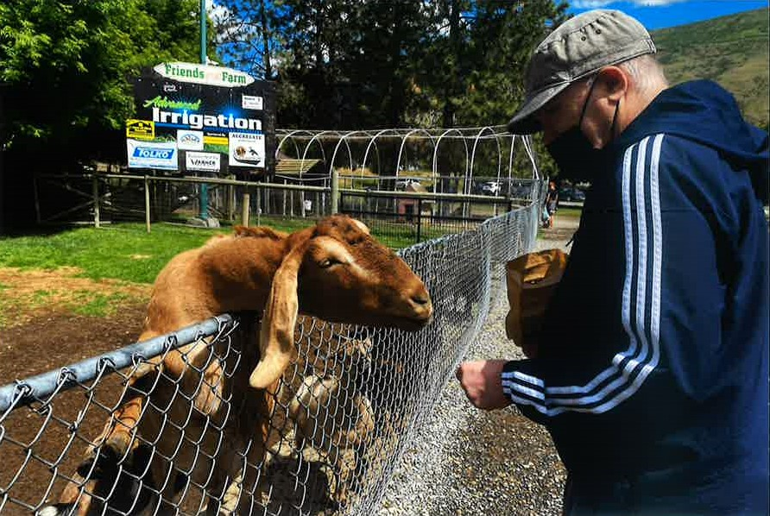
Transportation remains a significant hurdle, with 70% of individuals relying on support worker vehicles and 12% dependent on public transit options that may not accommodate mobility devices. Additionally, the complexity of medical needs and behavioral health challenges can limit access to consistent opportunities.

IMLKS remains committed to dismantling these barriers through advocacy, education, and creative problem-solving. We continue to promote the value of inclusion, challenge outdated perceptions, and support staff in recognizing the untapped potential of every person served. By investing in training, partnerships, and individualized planning, we aim to create pathways for all individuals to pursue meaningful roles and relationships in their communities.

Business Function
As discussed throughout this report, we understand the importance of educating our employees on person centered support, our philosophies and providing person specific training.
In 2024:

  - 16 employees participated in Seizure Training
  - 8 employees participated in Ostomy Training

  - 16 employees participated in Catheter Training
  - 3 employees participated in Manual Dis-impaction Training
  - 14 employees participated in G-Tube Training
  - 11 employees recertified First Aid Training through IMLKS
  - 6 employees participated in EAO webinars
  - 1 employee participated in CPHR Webinars
  - 45 employees participated in Medication Training (new staff and annual re-testing)
  - 16 employees participated in stoma digitization and catherization training
  - 12 employees participated in Wound Care Training
  - 14 employees participated in Roho-Cushion Training
  - 29 employees participated in Dementia Training and Workshop
  - 19 employees participated in MANDT Training
  - 6 employees participated in diversity Workshop.
  - 6 employees participated in Neuro Diversity Workshop
  - 28 employees participated in CLBC Privacy and Information Management Training
  - 28 employees participated in Food safety Training
  - 28 employees participated in Home Hazards Training
  - 28 employees participated in Gender Diversity and Diversity Training

(Please note: some of these employees attended more than one educational opportunity)

Because a lot of the positions at IMLKS are one on one 24-hour shifts, it can make it difficult for all employees to attend the training events. IMLKS has explored creative ways to provide flexible and accessible training such as by webinar and online resources.

IMLKS has also tried to offer the same training events semi-annually or annually to ensure all employees are provided the opportunity to attend.

Incident Reports


Incidents
Incident Reports, Medication Errors, Workplace Injuries and Critical Incident Reports are tracked for follow-up. In 2024, the following incidents occurred:
- 14 Critical Incident Reports (CIR) completed (compared to 17 in 2023)
The majority of the IIRs are related to fall, aggression or self-harm
- 66 Internal Incident Reports (IIR) completed (compared to 58 in 2023)
- 29 medication errors (compared to 37 in 2023)
- 0 Workplace Injuries (compared to 3 in 2023)

Critical Incident Reports

There were 14 critical incident reports in 2024, marking a continued decline from 17 in 2023 and 19 in 2022, a 26% decrease over two years. Of these, 8 were related to unexpected illness, 4 were due to falls, 1 involved the use of seclusion, and 1 was categorized as other injury. All incidents received appropriate follow-up and were reported to CLBC in accordance with policy.
This steady reduction in CIRs reflects IMLKS’s ongoing commitment to proactive care and risk mitigation. The majority of incidents were health-related and largely unpreventable. The single use of seclusion was carried out by a medical professional in a hospital setting, not by IMLKS staff, and was thoroughly reviewed. While some falls were unavoidable due to medical conditions, IMLKS continues to implement preventative strategies and staff training to reduce future risks.
Through strong collaboration with HSCL and medical teams, IMLKS has supported individuals with complex care needs while successfully decreasing the number of critical incidents. This progress underscores the effectiveness of our person-centered approach and our dedication to continuous improvement in service delivery.

Internal Incident Reports
In 2024, IMLKS recorded 66 Internal Incident Reports, a 14% increase from the 58 reports filed in 2023. While the overall number rose slightly, the nature of incidents shifted in meaningful ways, reflecting both emerging challenges and areas of improvement.

Falls accounted for 14 incidents in 2024, up from just 2 in 2023. This increase is largely due to a broader range of individuals experiencing mobility-related challenges, including new health complications and age-related factors. In response, IMLKS has prioritized fall prevention strategies, including mobility assessments, equipment upgrades, and staff training in safe transfer techniques.

Self-Injurious Behavior was reported in 9 incidents in 2024, down from 11 in 2023. This modest improvement is attributed to consistent staffing and strong rapport between individuals and their support workers. One individual, in particular, showed reduced self-injury when supported by familiar staff who respected his need for space and routine, highlighting the importance of continuity in care.

Aggression-related incidents rose from 8 in 2023 to 11 in 2024. These incidents were concentrated around one individual and occurred primarily during staff transitions or training periods. Casual staffing and unfamiliarity with the person served were common factors. IMLKS is actively addressing this by enhancing onboarding protocols and increasing mentorship for new staff to ensure smoother transitions and better behavioral outcomes.

To mitigate these risks, Service Coordinators have reviewed behavior support plans and reinforced the importance of recognizing early signs of escalation. All staff supporting individuals with a history of aggressive or complex behaviors are required to complete Non-Violent Crisis Intervention (CPI) or MANDT training. These tools equip employees with the skills to respond safely, respectfully, and effectively.

Medication Errors
In 2024, IMLKS reported 57 medication errors, up from 37 in 2023 and significantly higher than the 6 errors recorded in 2018. This steady increase over the years reflects a concerning trend in medication safety and is largely attributed to major workforce changes following the COVID-19 pandemic. Since the pandemic, IMLKS has experienced high staff turnover and a growing reliance on casual employees, many of whom are international students. Although casual staff receive the same orientation and annual training as permanent employees, including reviewing the medication policy, observing and practicing routines, and being tested before administering medications, they often face additional challenges. Language barriers, cultural differences, limited healthcare experience, and inconsistent work schedules across multiple homes all contribute to difficulties in learning and retaining medication procedures. These factors make it harder for casual staff to become proficient in individual residents’ routines, increasing the likelihood of errors. The most common issue in 2024 was failure to document administered medications, with 46% of errors categorized as “Drug not signed for.” While the medication may have been given, the absence of documentation poses serious risks, including potential duplication, missed doses, and confusion for future caregivers. A small number of errors were also linked to pharmacists, indicating that the issue spans multiple roles within the medication process. To address these concerns, IMLKS is exploring targeted interventions such as enhanced supervision for casual staff,
digital documentation tools, and focused audits to identify recurring patterns. These efforts reflect IMLKS’s ongoing commitment to improving medication safety and ensuring the highest standard of care for all individuals.

RECOMMENDATIONS FROM THE 2024 OUTCOMES REPORT

Goal #1: Reduce Medication Errors and Improve Documentation Practices
WHY
In 2024, IMLKS recorded 57 medication errors—a 54% increase from 2023. Nearly half (46%) were due to undocumented administration, primarily during casual staff shifts. Many casual staff are international students who face language barriers, irregular schedules, and limited healthcare experience, making documentation especially vulnerable. These errors, though often administrative, can lead to serious consequences such as double dosing or missed medications, directly impacting the health and safety of persons served.

ACTION PLAN
To address this, IMLKS will take a multi-pronged approach focused on prevention, education, and accountability:
- Root Cause Analysis
  - Review incident logs and interview staff to identify patterns (e.g., time of day, staff type, location)
  - Track repeat errors and correlate with training gaps
- Training & Support Enhancements
  - Develop visual guides for medication routines and MAR documentation
  - Assign mentors to new staff for hands-on support
- Monitoring & Accountability
  - Conduct random MAR audits and provide feedback
  - Staff who fail to document will receive one verbal warning, followed by progressive discipline
- Tools & Resources
  - Encourage cross-referencing blister packs and MARs before administration

Goal #2: Increase Community Participation and Socially Valued Roles
WHY
Only 15.38% of persons served maintained employment for 6+ months, and just 23.08% participated in clubs or groups. Barriers include mobility limitations, communication challenges, and social stigma. Despite this, interest in community involvement is growing, and meaningful roles can significantly improve self-esteem and quality of life.

ACTION PLAN
- Barrier Identification
  - Interview persons served and staff to understand challenges
  - Assess transportation and accessibility gaps
- Solution Development
  - Offer transportation support through handyDART, bus passes, organization van (hope to be purchase in the year 2026), etc.
  - Partner with inclusive organizations that offer flexible participation options

Goal #3: Strengthen Onboarding and Training for Casual Staff
WHY
Casual staff turnover remains high (66.7%), and many incidents occur during their shifts. Feedback shows that orientation is overwhelming and not retained well. Strengthening onboarding is essential to reduce errors and improve staff confidence

ACTION PLAN
- Feedback Review
  - Analyze exit interviews and training evaluations for common themes.
- Training Improvements
  - Maintaining the at home pre-orientation to avoid to many information in office.
  - Maintaining shadow shifts with experienced staff
  - Maintaining mentorship program

Goal #4: Improve Stakeholder Feedback and Communication
WHY
Formal surveys are limited by communication barriers. Some persons served respond with humor or confusion, and non-verbal individuals require alternative feedback methods. Without accurate feedback, service improvements are difficult to target.

ACTION PLAN
- Gap Identification
  - Review past survey responses and staff observations
  - Consult with families and coordinators for additional insights
- Tool Development
  - Maintaining visual and pictorial survey tools
  - Train staff to interpret non-verbal cues and use informal check-ins
- Testing & Refinement
  - Adjust based on clarity, usability, and staff input

Goal #5: Reduce Incident Rates and Promote Safety
WHY
While Critical Incident Reports (CIRs) decreased, Internal Incident Reports (IIRs) related to aggression doubled. Many incidents occurred during casual shifts or training periods, indicating a need for stronger preventative measures and staff preparedness

ACTION PLAN
- Data Analysis
  - Categorize incidents by type, time, and staff involved
Identify high-risk environments and individuals
- Prevention Strategies
  - Increase MANDT/CPI and crisis intervention training
  - Assign consistent staff to high-risk individuals
  - Use behavior tracking tools to anticipate escalation
- Feasibility & Monitoring
  - Budget for training and staffing adjustments
  - Consult with HSCL and mental health professionals
  - Track incident rates and staff feedback monthly

Goal #6: Enhance Employee Retention and Job Satisfaction
WHY
Regular staff turnover dropped to 23.3% in 2024, a major win. However, casual turnover remains high. Exit interviews cite inconsistent schedules and lack of benefits as key reasons for leaving. Improving retention will reduce training costs and improve service continuity.

ACTION PLAN
- Cause Investigation
  - Review exit interviews and survey data
  - Identify patterns in resignation timing and job dissatisfaction
- Retention Strategies
  - Maintaining the Health and Wellness program
  - Create predictable shift schedules
  - Develop internal career pathways and promote from within (Casual to PT or FT)

Goal #7: Maintain High Standards in Service Delivery
WHY
IMLKS met its goals for planning meetings and rights training. However, satisfaction indicators like “feeling listened to” and “having choice” scored below target (38.46%). These indicators are essential to person-centered care and dignity.

ACTION PLAN
- Gap Identification
  - Review survey responses and staff notes
  - Interview persons served about unmet needs and preferences
- Service Enhancements
  - Train staff in active listening and choice facilitation
  - Create personalized support plans with input from persons served
- Monitoring & Adjustment
  - Pilot training modules and gather feedback
  - Roll out improvements and track satisfaction scores quarterly

CONCLUSION

The Outcome Management Report provides an overview of the types of services we offer, compares goal progress from 2018 to 2024, and describes the steps that we take to ensure that these services are beneficial and rewarding to the people we serve.

In line with our commitment to continuous quality improvement, the results and recommendations throughout this report will be reviewed by the leadership team and the Board of Directors.

The information presented in this report will help us:
Focus our efforts to provide optimal services for the persons served
Provide ongoing information about the organization’s performance
Continually enhance service delivery and the organization
Provide proof of continuous service improvement
Improve health and safety, physically & emotionally

