**Global International Reading Literacy Instute** , **G.I.R.L.**

Phone numbers: ***(857) 615-2007 / (774) 719-2218***

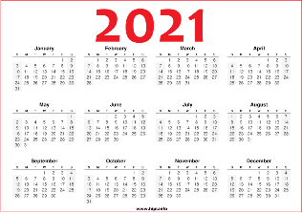 Email address: girl@globalinternationalliteracy.com

Learning is Freedom

**Registration Form**

|  |
| --- |
| First Name |
| Last Name |
| Date of Birth __________ / ___________ /__________ |
| Lagagues: First language Second language  _____________ ______________ |
| Phone number: |
| Mailing address: |
| City |
| State |
| Zip Code |
| Education level: |
| Class desire: |
| E-mail: |
| ***Student will be contacted via email address, please list clearly your primary*** ***email address.***  __________________________________________________________ |
| ***I am a\an***: |
| Parent |
| Caregiver |
| Adult |
| ***Please Choose which date you will be starting*** |
| Right Now Afert 1 week After 2 weeks After 1 month |
| Do you agree to post your picture or video’s class on GIRL website? Yes No |