**Lenny and the DreamMakers**

**Annual Report -2020**

In the wake of the pandemic and racial injustice, we have survived the broken heartedness, the chaos and the confusion that was 2020. In fact, we have not only survived, we have learned, listened and changed. We have moved toward working together for what is good and right. Here is what we experienced and learned in 2020.

January started out as any other year. We were sorting and prepping for our fist of the year Caper. On February 1st we delivered what we thought was the first Caper of the year. It was wonderful in that we had lots of volunteers helping, lots of people receiving and clear weather as well. Instead of being just the first Caper though, it was also the last one for 2020.

In February we continued collecting and readying for our next Caper. However, in March we got the news that large gatherings of people were no longer allowed because of the pandemic. The filled bins in the garage were ready to go, but there was no place where we could safely deliver them. Late in March, after discussion with Board Members, we decided we could move the stuff from bins to boxes (that didn’t need to be returned) and just drop off the sorted clothing and other items to the Stability Site instead of staying and helping people decide what they needed. Also, in March we were able to give eight boxes of our stockpile of non-perishable food (and toilet paper!) to the Family Housing Network.

April found us listening and learning and trying to figure out how we could fulfill our mission while staying within the Covid guidelines. In May we dropped off a Chicken Teriyaki dinner to the 60 residents at the Stability Site along with a few personal needs items and bus passes.

Since the dinner was well received in May, we decided to do another in June. The various sites were not getting their expected food donations due to the closure of schools and businesses. So, in May, we delivered meals to Altheimers Family Shelter, Adam’s Street Women’s shelter, Nativity House and the Stabilization Site.

June became the month where we became sure that we would not be able to have a Garage Sale this year although our sheds were overflowing with sale items. Further, we started to figure out how we could do our distribution of items a bit differently and still keep everyone safe. We began to let agencies know that we could still do Welcome Boxes with a no-contact porch pickup. That has worked so well, we will probably continue to do the pickups that way, even when the pandemic has abated. We also clarified how we could do our Capers differently, calling it Meals and More. Once a month we would deliver a meal and whatever items had been donated during that month. This may continue to be our new plan for life beyond the pandemic.

Since we had some backlog of children’s items, we worked out a drop off at the TRM’s Women’s Shelter in July. They set up a time for their residents to look through our items. Once again, we packaged our items in boxes that did not need to be returned. We carried a whole pick up truck full of boxes and dropped them off at their donation site for them to distribute.

Knowing that the good weather would soon be at an end and thus our ability to sort clothing outside in a safer environment, we contacted shelters in August to let them know this might be our last chance to deliver in 2020. With the help of many volunteers, we sorted all the donations for four different shelter sites. Once again, we delivered food, clothing, blankets and bus passes in September.

October, November, and December found us on the schedule of delivering a one time a month meal and some donated items to the 65 residents at the Stabilization Site. October was also a winning month where we finished in 5th place in the Million Pillowcase Challenge and won 2 bolts of fabric and $100. November was the month where we finally got to do our Fundrive with Value Village even though we had to drive to Lacey to deliver our items. It was worth it because we earned over $600 for recycling all the stuff we had been saving for months.

Thanksgiving dinner of turkey sandwiches, potato salad, cranberries, and pumpkin pie was brought to the site on Thanksgiving Day. We served sparkling cider to all. Christmas dinner was much the same with ham sandwiches, chips and Christmas cookies. Because of a generous donation we were able to wrap a gift for each resident of a backpack, socks, and some sweet treats. The residents were happily excited to have a gift to open.

Despite the pandemic, and in some cases because of it, our financial picture stayed healthy this year. Several people gave unexpected donations using their stimulus checks to support Lenny and the DreamMakers. This is what our finances looked like for 2020:

*Pies courtesy of Cameron Quinsey*

**Accomplishments for 2020**

* Won two bolts of cloth and $100 from the million Pillowcase Challenge
* Garage Sale proceeds of $787 even though we were unable to have a sale.
* Made and delivered a total of over 600 greeting cards to people in Hospice
* Made and delivered over 300 pillowcases and 200 blankets
* 25 dedicated workers logged 1324 volunteer hours
* Individual donations were up over last year to $7329.00
* Participated in the free bus pass distribution with 800 passes
* Filled requests for 46 Welcome Boxes which is $16,100 worth of goods
* Delivered 585 meals to shelter sites
* Made 145 masks and 20 gowns for Chi Franciscan nursing staff

**Thank you to all our donors. This year you helped provide:**

 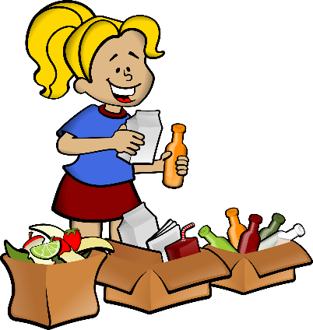

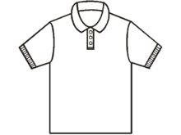

585 Meals 7300 pounds of clothing 46 Welcome Box Families

***Everyone deserves food, shelter, and clothing.***

***We at Lenny and the DreamMakers will continue to do our part***

***in moving toward that goal.***

***2021 is ready and waiting for us to deliver.***

**Lenny and the DreamMakers - Budget to Actual**

**Budget Period January 1, 2020 to December 31, 2020**

**Bank Balance as of December 31, 2020- $4441.63**

**REVENUE**

Projected Actual

Fundraising

Garage Sale $ 1500.00 $787.00

Potluck Donations 150.00 40.00

Holiday Party 200.00 0

School Supplies 250.00 0

Hats and Gloves Drive 250.00 0

Welcome Box 500.00 0

Fred Meyer Rewards 200.00 237.87

Amazon Rewards 150.00 153.63

Value Village FunDrive 700.00 943.79

Individual's Donations 3000.00 7329.00

Gift Cards 150.00 50.00

Other 800.00 0

**Total Income** **$ 7850.00** **$9541.29**

**EXPENDITURES**

License fees, etc 50.00 50.00

Storage Bins/infrastructure 100.00 3.14

School Supplies 250.00 0

Hats and Gloves 250.00 0

Transportation Vouchers 1000.00 750.00

Office Supplies 150.00 37.00

Capers 2000.00 4212.26

Holiday Party 150.00 0

Welcome Box 3000.00 2338.61

Garage Sale 100.00 74.36

Gift Cards 150.00 50.00

Other/Miscellaneous 500.00 708.61

**Total Expenses** **$7700.00** **$8223.98**