Bramhall Queensgate Sports Club

Hall and Clubhouse Room Dimensions

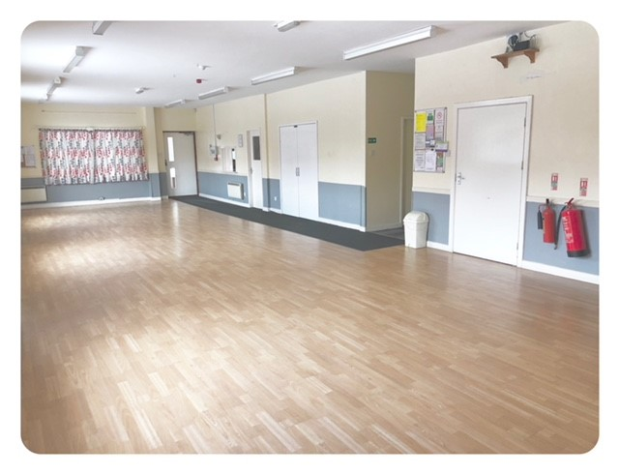
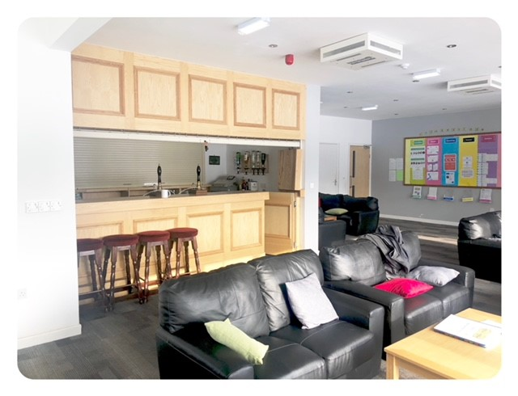
Main Hall Tennis Clubhouse
7.2 metres

5 metres

12.5 metres

7.5 metres
Bar & Kitchen

4 metres

15.1 metres

Bar Hatch

Height 2.75m metres
Kitchen
5.5 metres

