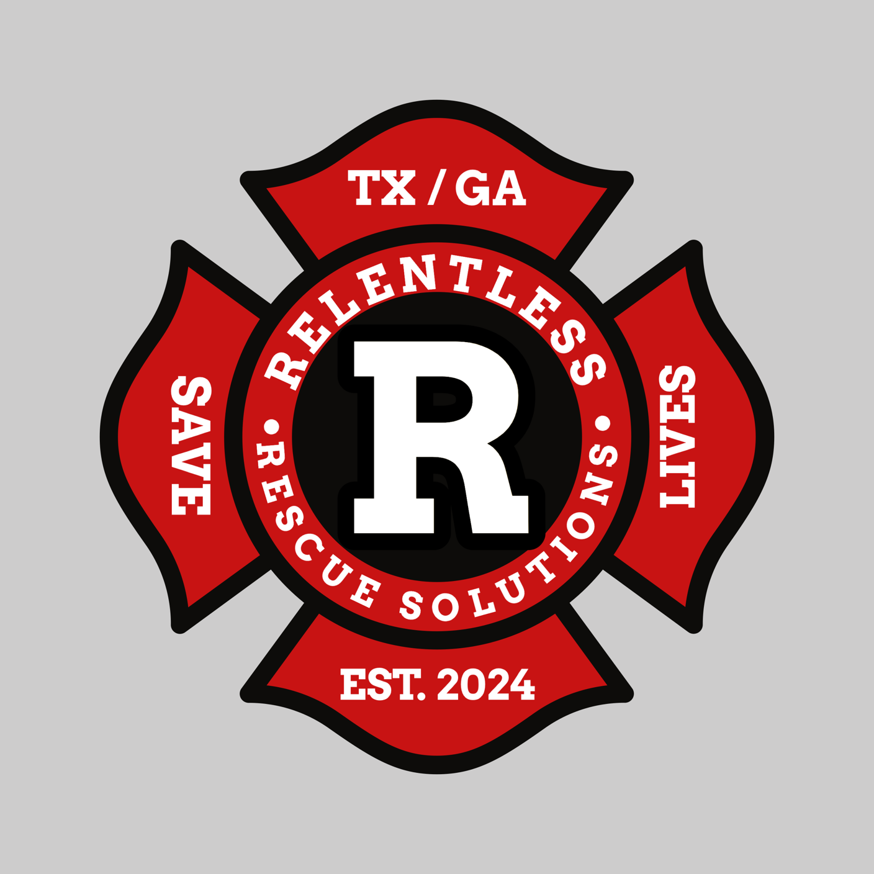

Thank you for your time and investment in training for the future. After completion of this time-to-task training, RRS will have a good base for an expected amount of time to compare with the new product. You and your Company will be playing a vital role in the growth of the Product moving forward and we expect and hope that you and your Company will help us in providing similar tests once the product is ready to go. Unfortunately, at this point we are unable to give further details on what the product will be; but we will be sure to keep you up to speed on all the details as soon as possible. Stay safe and Train Hard!

* Kurt and Ryan Thomas

***DESCRIPTION OF THE TRIALS***

* The goal of this Time-to-Task is to figure out how long it takes different variations of removal to be completed.
* We anticipate that these trials will take place in the Apparatus Bay; but feel free to do them any location that works best for your crew. Please be sure to document what kind of flooring the tasks were completed on.
* Feel free to use a FF or dummy in turnout gear or normal clothes as simulated victim. Please document this using the following: ***D****-Dummy,* ***FFD****-Dummy in turnouts,* ***L****-Live Person in normal clothes,* ***FFL****-Live in turnouts*. Then simply write weight of victim after letter (Ex. FFD185 for a 185-pound dummy in turnouts)
* The number of Firefighters must be *at least two* for any single trial; feel free to use more if your crews are bigger – be sure to document on the table.
* The *drag length must be 50’ in a straight line* to simulate a hallway approximately 4’ wide and then a *left- or right-hand corner* and *another 30’ straight line* with the same 4’ width.
* Feel free to use any means, techniques, or accessories that you have; again, please document what was used (ex. Webbing harness, low-leg drag, extremity push, etc.).
* Time should start on finding downed victim. Record time for packaging (this is the amount of time from victim location to first movement on 50’ straightaway). Then record removal time (all 50’, turn and all 30’).
* We ask that each firefighter run the trial at least twice, one in each position. We ask that each firefighter be in full turnout gear, with SCBA; on-air is up to you.
* We are hoping to get at least 10 trials out of each Company that agrees to test.
* The Table will have extra space, if you are running more trials, let us know and we will get you more tables to fill out.
* If you would like to try and practice/time any other removal situations, for example removal including up or down a flight of stairs, please be sure to follow the rest of the requirements listed above including lengths, etc. only changing one variable at a time; please don’t try any other variations if you cannot provide at least 10 trials. (Provide a brief written description of what was altered separately).
* We will gladly accept pictures and video clips of your crew training. Please focus on removal techniques used for victim packaging specifically and victim drags, etc.

*FD, Station, Shift: _________________________________**Date:__________*

|  |  |  |  |  |  |  |
| --- | --- | --- | --- | --- | --- | --- |
| *Trial* | *# FF’s* | *Flooring* | *Victim* | *Victim Packaged* | *Packaging Time* | *Removal Time* |
| *1* |  |  |  |  |  |  |
| *2* |  |  |  |  |  |  |
| *3* |  |  |  |  |  |  |
| *4* |  |  |  |  |  |  |
| *5* |  |  |  |  |  |  |
| *6* |  |  |  |  |  |  |
| *7* |  |  |  |  |  |  |
| *8* |  |  |  |  |  |  |
| *9* |  |  |  |  |  |  |
| *10* |  |  |  |  |  |  |
| *11* |  |  |  |  |  |  |
| *12* |  |  |  |  |  |  |
| *13* |  |  |  |  |  |  |
| *14* |  |  |  |  |  |  |
| *15* |  |  |  |  |  |  |
| *16* |  |  |  |  |  |  |
| *17* |  |  |  |  |  |  |
| *18* |  |  |  |  |  |  |
| *19* |  |  |  |  |  |  |
| *20* |  |  |  |  |  |  |
| *21* |  |  |  |  |  |  |
| *22* |  |  |  |  |  |  |
| *23* |  |  |  |  |  |  |
| *24* |  |  |  |  |  |  |
| *25* |  |  |  |  |  |  |

*Comments:*