**GREATER LAS VEGAS ORCHID SOCIETY**

**ORCHID COLUMN**

**CAROL SIEGEL, EDITOR**

**SUNDAY, March 10, 2024 1 PM**

**Bridget Uzar “Tropical Slipper Orchids”**

the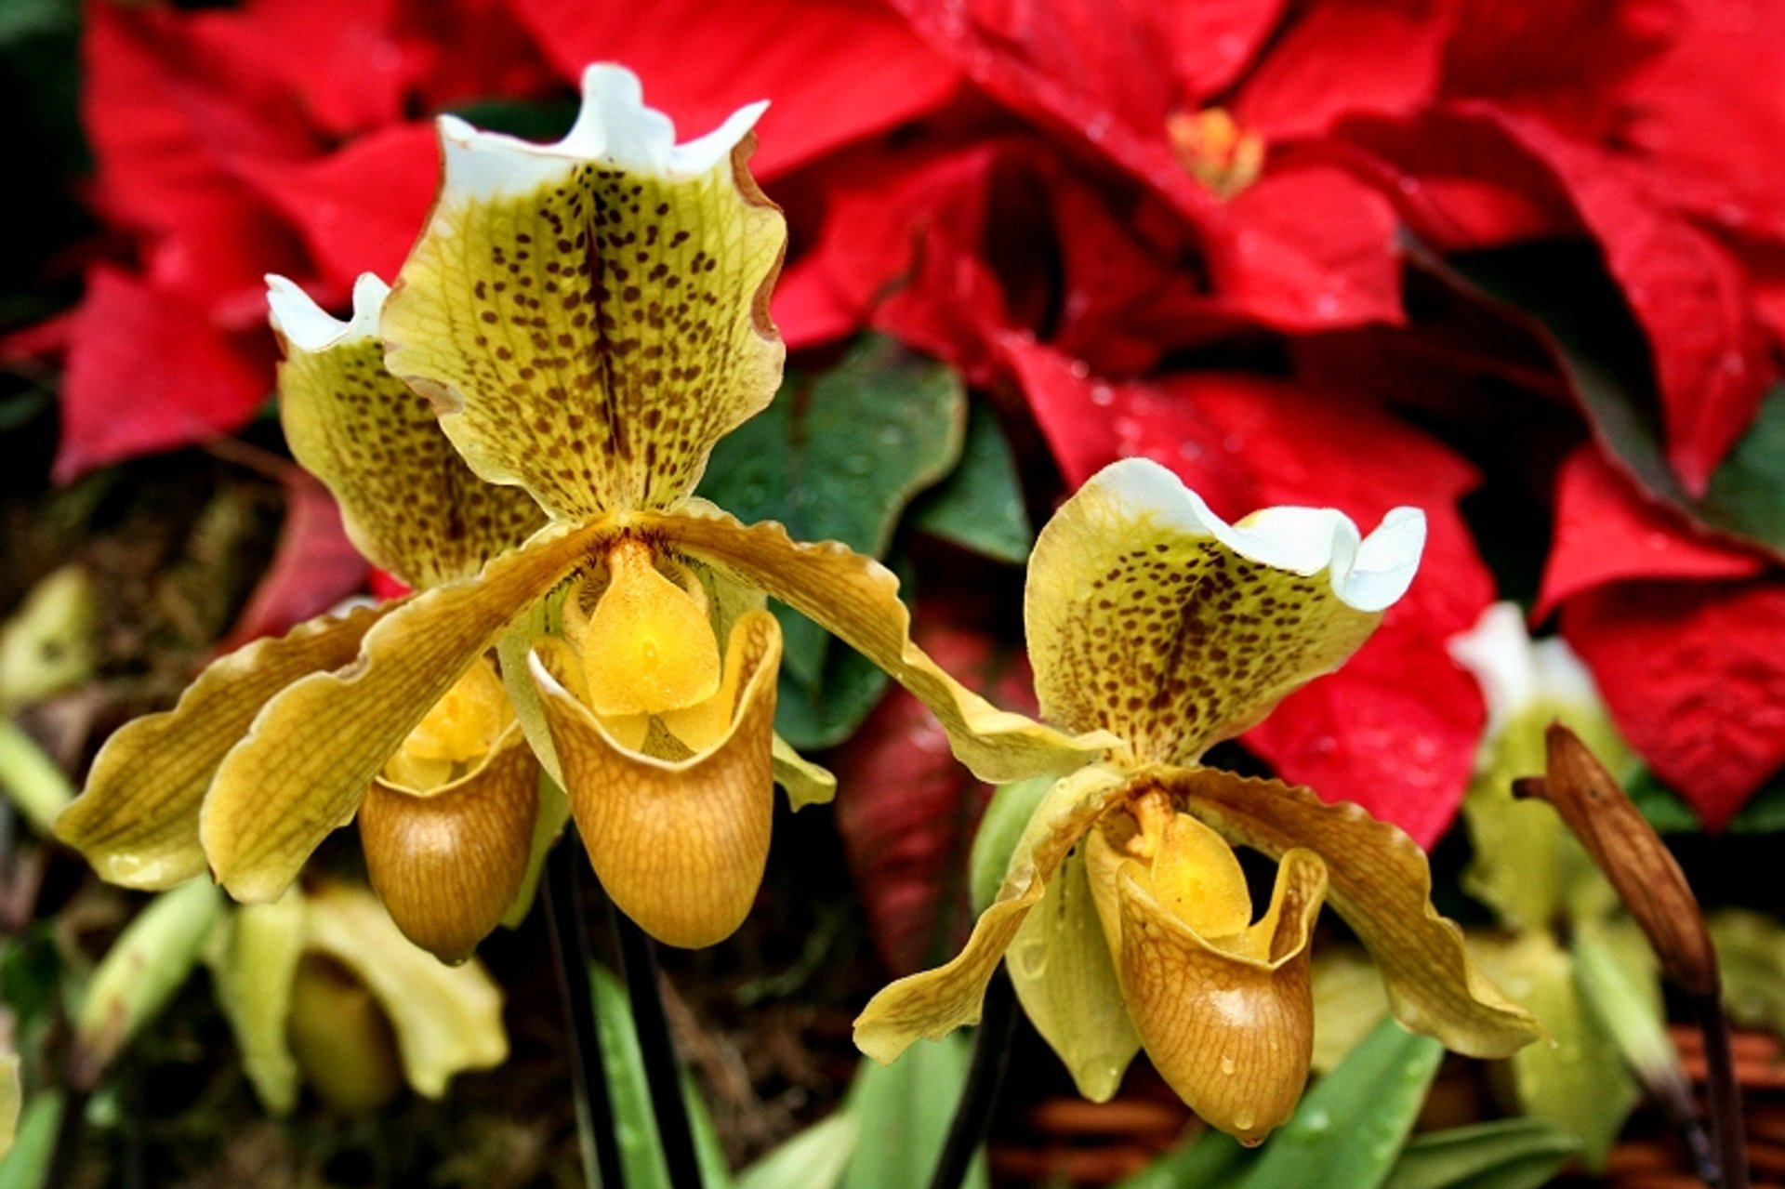

**In March, it is our pleasure to present Bridget Uzar from Carter Holmes Orchids who will be doing a Zoom presentation on slipper orchids from the tropics. We loved her presentation earlier this year on troubleshooting your orchids. Hilo Orchid Farms promises to provide slipper orchids in bud for us to sell. They are one of the few nurseries that will sell us orchids in bud at a very reasonable price.**

**Bridget Uzar is a fourth-generation green thumb and a second-generation orchid grower. Following in her father’s footsteps, she has been at Carter and Holmes Orchids for over twenty years but has been around orchids her whole life, essentially growing up under the benches. Bridget began working at Carter and Holmes in2002 in an everyday potting and watering capacity, eventually**

**being given charge of the collection and breeding houses. She made her first Cattleya cross in 2008 and hasn’t stopped since. Starting in 2009, she began working on the digital photography, catalog publications and other marketing work for Carter and Holmes Orchids. Today, Bridget has been the chief grower and hybridizer for over a decade overseeing greenhouse management and production. She also handles the company marketing emails as well as promotional material and social media.**

***Introduction to Tropical Ladyslippers.* Discussion of the Ladyslipper alliance in general and then we switch our focus to Paphiopedilums and Phragmipediums. Discussion will include history of the genera, types of species & hybrids on the market, basic care and culture.**

**POTLUCK**



**We are having a potluck in March. I will provide St. Patrick Day themed paper goods and decorations. Jen and Isabel Toma will provide drinks. We ask each of you to bring something, main dish, dessert, side dish for 10-12 people with serving utensils. It will be as good as we make it. Doesn’t have to be St. Patrick theme- just tasty. In April, we are looking for five volunteers to provide food and drink for the meeting. Can you help? Email me** [**growlove@cox.net**](mailto:growlove@cox.net)



**Our website is down for some unknown reason. It appears to show information from 2017- OY. Diana has created other websites, and she (and I will try to help but who knows…) will create a new website. We will keep you posted. Sorry for the inconvenience, but that’s life….**



**BRING YOUR BLOOMING BEAUTIES TO THE LIBRARY FOR SHOW AND TELL. YOU CAN EVEN BRING PLANTS THAT YOU JUST BOUGHT OR THAT ARE NOT IN BLOOM BUT HAVE AN INTERESTING STORY .**

**. DUES REMAIN $35 FOR A SINGLE AND $50 FOR A COUPLE. DONATIONS, OF COURSE, ARE ALWAYS APPRECIATED.**

**Last year, members gave donations of $1500, and it made all the difference.**

**If you haven’t paid your 2024 dues, please….We now have the ability for you to pay your dues online! Dues are still $35 for an individual and $50 for a couple.   Just click on the link, and the rest is quite clear. The form will ask for your credit card information which is secure through the Square application. I tried it, and it worked great. If you want to add a little extra for a donation, just add it on to your membership. It says “donation” instead of “dues” due to a technicality because we are a non-profit. You will receive a receipt immediately.. You can also pay at the meeting, but it makes the treasurer’s job much easy if someof you do this online.**

**Here is the link-**

https://square.link/u/NDRpbeQq

**UPCOMING EVENTS**

**March 10, 2024 Bridget Uzar “Introduction to Tropical Ladyslippers”**

**April 14 Ron Kaufman “1001 Ways to Kill an Orchid”**

**May 5, 2024 Ron Parsons (First Sunday) “Orchids of Madagascar”**

**Saturday June 8, 2024 2:30Carol Siegel “How to Build an Orchid Collection” (THIS IS A SATURDAY AT 2:30 BECAUSE EVERYTHING ELSE WAS TAKEN BY THE LIBRARY…)**

**July 14, 2024 Alan Koch “Growing in the Home”**

**August 11, 2024 Mary Gerritsen**

**September 8, 2024 Fred Clarke**

**October 13, 2024 Peter Lin**

**November 10, 2024 Cathy Loftfield “Orchids of the Old World”**

**Great fun at our February meeting with our Italian feast from Siena Italian Trattoria and entertainment from Russine Zellner and John Anthony 617-834-1286. Thank you for all your kind and loving words on my very big birthday. So nice.**

**In April, Ron Kaufmann will speak on 1001 ways to kill your orchids. I did a talk on ten ways to do that thing, but Ron is a more experienced and knowledgeable grower than I and knows lots more ways to do that! Should be fun.**

**Below is a culture sheet and information on slipper orchid Paphiopedilum from the American Orchid Society.**

# Paphiopedilum Culture Sheet

### **paff-ee-oh-PED-ih-lum**

Paphiopedilums, the lady's-slipper orchids, originate in the jungles of the Far East including Indonesia. They are semiterrestrial, growing in humus and other material on the forest floor, on cliffs in pockets of humus and occasionally in trees. They are easy to grow in the home, under lights or in the greenhouse.  
  
**Light** is easier to provide for paphiopedilums than many other types of orchids. They require shady conditions, as in the home in an east or west window, or near a shaded south window. In the greenhouse, shade must be provided. Give about 1,000 to 1,500 foot-candles. In the home, fluorescent lighting is excellent; suspend two or four tubes 6 to 12 inches above the leaves.  
  
**Temperatures** for paphiopedilums cover a considerable range. Paphiopedilums are traditionally separated into two groups: the warm-growing mottled-leaved types and the cool-growing green-leaved types. A third, increasingly popular group is the warmer-growing strap-leaved multifloral paphiopedilums. Warm-growing types should be kept at 60 to 65 F during the night, and 75 to 85 F or more during the day. Cool-growing types should be kept at 50 to 60 F during the night and 75 to 80 F during the day. However, many growers raise all plants in the same temperature range with excellent results. The plants can stand night temperatures in the 40s if necessary (as when grown outside in mild climates), as well as temperatures to 95 F. Care must be taken to protect the plants from rot when cold (keep humidity low, and avoid moisture on leaves or in the crowns of the plants), and also to protect from burning when hot (shade more heavily and increase humidity and air movement around the plants).  
  
**Water** must be available at the roots constantly, because all plants in this genus have no pseudobulbs. All of these plants need a moist medium - never soggy, but never dry. Water once or twice a week.  
  
**Humidity** for paphiopedilums should be moderate, between 40 and 50 percent, which can be maintained in the home by setting the plants on trays of gravel, partially filled with water, so that the plants never sit in water. In a greenhouse, average humidity is sufficient. Using an evaporative cooling system in warm climates can increase the humidity. Air movement is essential, especially when humidity is high.  
  
**Fertilize** on a regular schedule, but care must be taken to avoid burning of the fleshy, hairy roots. High-nitrogen fertilizers (such as 30-10-10) are recommended when potted in any fir-bark mix. In warm weather, some growers use half-strength applications every two weeks; others use one-quarter strength at every watering. It's important to flush with clear water monthly to leach excess fertilizer, which can burn roots. In cool weather, fertilizer applications once a month are sufficient.  
  
**Potting** should be done about every two years, or as the medium decomposes. Seedlings and smaller plants are often repotted annually. Mixes vary tremendously; most are fine- or medium-grade fir bark, with varying additives, such as perlite (sponge rock), coarse sand and sphagnum moss. Moisture retention with excellent drainage is needed. Large plants can be divided by pulling or cutting the fans of the leaves apart, into clumps of three to five growths. Smaller divisions will grow, but may not flower. Spread the roots over a small amount of medium in the bottom of the pot and fill with medium, so that the junction of roots and stem is buried 1D 2 inch deep in the center of the pot. Do not overpot; an average plant should have a 4- to 6-inch pot.