**+P**

**GREATER LAS VEGAS ORCHID SOCIETY**

**ORCHID COLUMN**

**CAROL SIEGEL, EDITOR**

**“THE ORCHIDS OF HAWAII” CAROL SIEGEL, PRESENTER**

**THE GREATER LAS VEGAS ORCHID SOCIETY**

**THE ORCHID COLUMN**

**CAROL SIEGEL, EDITOR**

**SUNDAY NOVEMBER 12, 2023 1 PM**

**TROUBLESHOOTING YOUR ORCHIDS**

**Bridget Uzar of Carter and Holmes**

**\**

**PETER LIN**



**Growing orchids is one of the great pleasures of life, but sometimes we don’t exactly know what to do when one (or more) of our orchids looks like it is ready to take the one-way trip to the garbage. This month, we have snared Bridget Uzar of Carter and Holmes Nursery to give us tips and tricks to bring our sickly or sad orchids back from the brink. Bridget Uzar is a fourth-generation green thumb, and a second-generation orchid grower. Following in her father’s footsteps, she has been at Carter and Holmes Orchids for over twenty years but has been**

**around orchids her whole life, essentially growing up under the benches.**

**Bridget began working at C&H in2002 in an everyday potting and watering capacity, eventually being given charge of the collection and breeding houses. She made her first Cattleya cross in 2008 and**

**hasn’t stopped since. Starting in 2009, she began working on the digital photography, catalog publications and other marketing work for Carter and Holmes Orchids. Today, Bridget has been the chief grower and hybridizer for over a decade overseeing greenhouse**

**management and production. She also handles the company marketing emails as well as promotional material and social media.**

**Her talk on troubleshooting your orchids is a Zoom Power Point presentation on spotting signs of stress, pests or disease in your favorite plants. Learn about watering difficulties, identifying virus, treating for various insects and more. This is surely a welcome and timely subject.**

**She will be sending a box of plants for us to sell as well. YAY! Our favorite thing…. Ole Borresen has also gotten us hotel plants to sell!**

**BEST WISHES TO MYRA GLASSMAN FOR GOOD LUCK ON HER UPCOMING SURGERY. OUR PRAYERS ARE WITH YOU.**

**ANNUAL ELECTIONS**



**At our November meeting, we will have our annual elections. The proposed slate:**

**Carol Siegel President**

**Cathy Loftfield Vice-President**

**Christine Delacruz Secretary**

**Jackie Bravermann Treasurer**

**Since our dear Election Chairlady Myra will be recovering from surgery, if you have other nominations for officers, email Diana Smith, our Interim Election Chairlady, at** [**n2orchids@hotmail.com**](mailto:n2orchids@hotmail.com)

**OLE BORRESEN’S ANNUAL PLANT SALE**

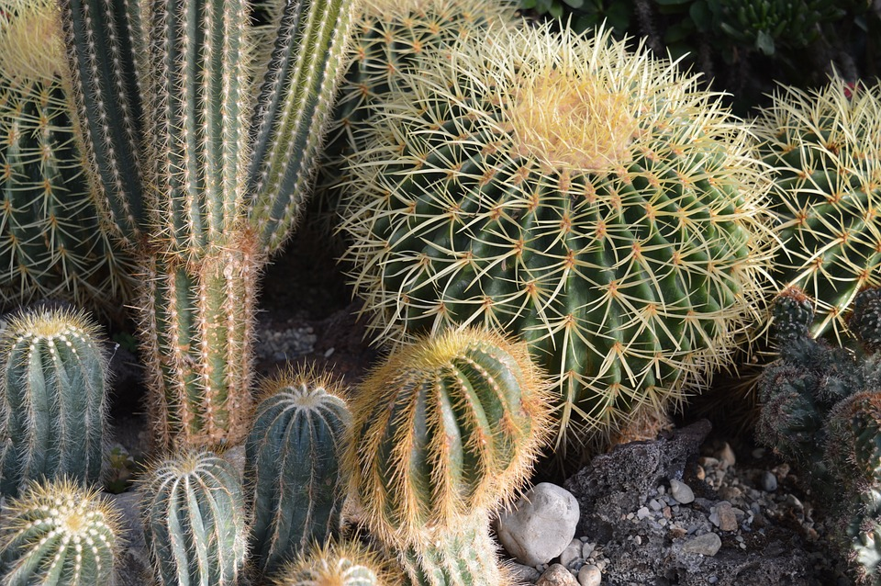

**Our dear Ole Borresen is having his annual plant sale including all kinds of cactus, orchids and plants at his home at 1248 S. 8th Street on Friday and Saturday November 10 and 11th from 9-3. No need to call him. Just come on over.**

**Ole also has gotten hotel orchids for us to sell at our meeting. Such a dear man.**

**NOVEMBER BAGEL EXTRAVAGANZA**



**In Nov, we will have our annual Bagel Extravaganza.**

**Diana and I will bring bagels from Bagel Café and a cookie tray. Ole will provide cream cheese. Jackie will pick up the bagels. Cathy will provide all the drinks and paper goods, dear girl.**

**We ask you to bring things to put on the bagels, cheese, cold cuts, cole slaw, tuna or chicken salad, smoked salmon and the like or a dessert or side dish.**

**It will be as tasy as we make it. Our piano player will delight us at the keyboard. Thanks, Dennis.**

**COMING ATTRACTIONS**

**November 12 Bridget Uzar Carter and Holmes “Troubleshooting Your Orchids”**

**She will provide orchids to sell**

**December 10, 2023 Holiday party Art Chadwick “Cattleya” In person talk WITH ORCHIDS TO SELL**

**January 14 White Elephant Sale Orchid Limited Zoom Nursery Tour and Growing Phals Jason Fischer**

**Feb 11, 1024 Diana Smith “Mounted Orchids”**

**March 10, 2024 Bridget Uzar “Introduction to Tropical Ladyslippers”**

**April 14 Ron Kaufman “1001 Ways to Kill an Orchid”**

**May 5, 2024 Ron Parsons (First Sunday)**

**June 9, 2024 Carol Siegel “How to Build an Orchid Collection”**

**July 14, 2024 Alan Koch**

**August 11, 2024 Mary Gerritsen**

**September 8, 2024 Fred Clarke**

**October 13, 2024 Peter Lin**

**November 10, 2024 Cathy Loftfield “Orchids of the Old World”**

**IT’S PHALAENOPSIS TIME…**

**Remember that the hotels give us lots of phalaenopsis to sell so you probably have several. In order to bloom in the spring, these orchids need about three weeks of cooler temperatures (like 60 or a little below) right now. You can accomplish that by putting them in an unheated guest room or the garage or the like for a few weeks, not super-cold but cooler. If you don’t give a little chill to your phalphalaenopsis now, they may be healthy but skip a blooming season. Just saying…**

**GOOD VIDEOS**

**On You Tube. There is a terrific series on orchid care called “Orchid Girl.” She has now stopped making these videos, but there are lots of them, and they are just terrific.**

**There are two good You Tube videos from the Orchid Girl series (which are excellent) on troubleshooting problems with your orchids.**

**Below are the links. Opposite click the addresses below and then press “Open the Hyperlink” and the video will play. If that is too hard, you can type “Troubleshooting Your Orchid” and you will see the Orchid Girl Video link that says, “What’s Wrong with My Orchid.”**

**There is a part one and a part two.**

[**https://www.youtube.com/watch?v=-YIWfOjznmY**](https://www.youtube.com/watch?v=-YIWfOjznmY)

[**https://www.youtube.com/watch?v=HbQV1_2XFzk**](https://www.youtube.com/watch?v=HbQV1_2XFzk)