a `P
GREATER LAS VEGAS ORCHID SOCIETY
ORCHID COLUMN
CAROL SIEGEL, EDITOR
“THE ORCHIDS OF HAWAII” CAROL SIEGEL, PRESENTER

“I must have flowers-always and always”-Claude Monet”

THE GREATER LAS VEGAS ORCHID SOCIETY
THE ORCHID COLUMN
SUNDAY, JULY 12, 2026 1 pm
ORCHIDS FOR SALE HILO ORCHID FARM SHOW AND TELL
PETER LIN FAVORITE FRAGRANT ORCHIDS
THANK YOU TO MARK ROMANSKY FOR HIS WONDERFUL TALK ON BUYING ORCHIDS IN JUNE. WE LOVE YOU.
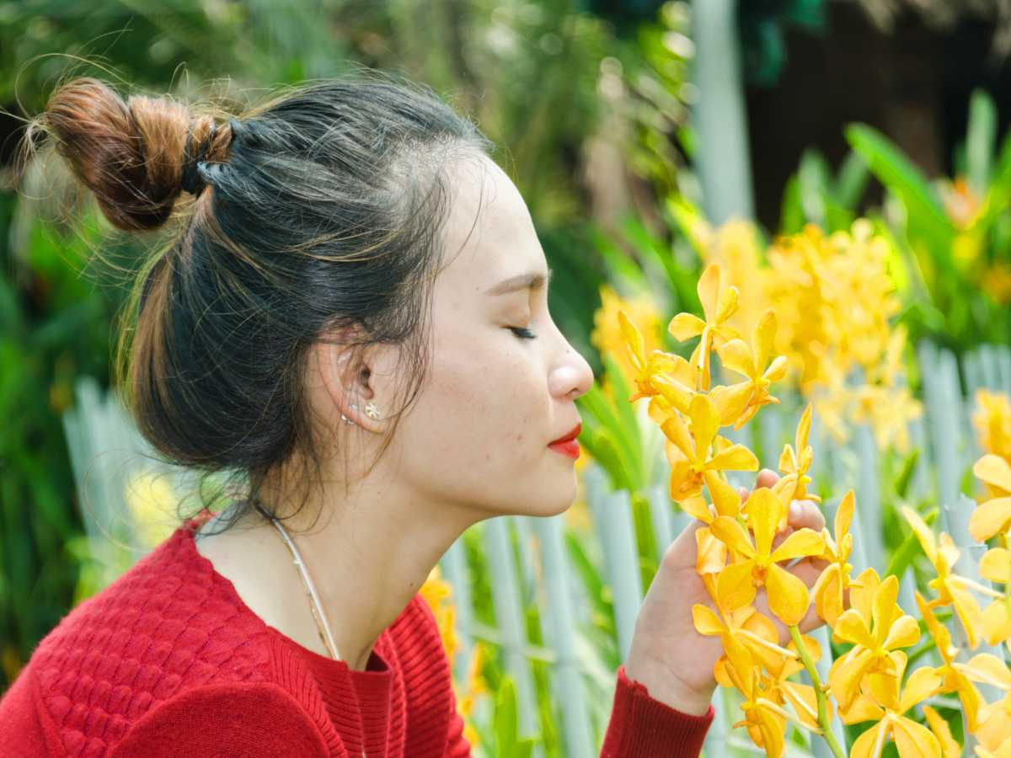

u have any favorite vendors, please share them with us.
We will also have several dozen orchids in bloom from Hilo Orchids. Their plants are reasonably priced, very well-grown and always re-bloom for most of us.

EPIPACTIS GIGANTEA

75 % OF ORCHIDS ARE FRAGRANT
DELIGHTFUL, STINKY, OR DISTINCTIVE



With our poor sense of smell, we can only smell some of them. They are not meant for us but to attract the pollinators.
Peter Lin will delight us with a talk on his favorite fragrant orchids in July.

Peter Lin will be presenting his talk on: Favorite Fragrant Orchids. Along with the beauty of the flowers, many orchids have an alluring fragrance that is hard to beat in the plant world. This fast paced PowerPoint presentation will show you some of my favorite orchids with truly fragrant flowers, and how to grow them.
Peter started growing orchids over 30 years ago, but then stopped due to school and starting a career. It wasn't until about 14 years ago that the orchid "bug" came back and he is now heavily involved once again. He is an accredited judge with the American Orchid Society and a hybridizer of mini-catts. He enjoys meeting with other orchid enthusiasts, and can often be found at various orchid shows and societies around the country. He also has hundreds of photos of his orchids that he maintains on Flickr. You can view them by typing this address into the internet: http://www.flickr.com/photos/minicatt/collections/
Due to limited growing space, Peter likes to specialize in miniature orchids, both species and hybrids, and has received numerous AOS awards. His other interests in orchids include Dendrobiums, Angraecoids, and Neofinetias. He maintains a collection of a thousand or more orchids at his home in Southern California in 3 small greenhouses, as well as an offsite greenhouse.
(optional)

We have all missed the hotel orchids that we used to get donated by the big hotels. They stopped sharing them with us and started giving/selling them to their employees. BOOHOO. Dr Joel Davidson, our long-time member, was able to convince the MGM to
(wait for it) donate orchids to us again. We hope to have some this month!! The orchids are a big money-maker for the club and a source of lots of pleasure so thank you, Joel. Hopefully, this is the start of a wonderful new chapter for us. Thanks, too, to Ole for caring and carting them. So nice of you both.
JUNE POTLUCK


Bring something yummy for our spring potluck I will have a sunflower décor.

SHOW AND TELL

We will have show and tell this meeting. You can even bring
something you just bought.


We are pleased that so many paid dues and even gave us donations to bolster our treasury. They were appreciated. DUES FOR 2026 WILL BE WILL BE $40 FOR AN INDIVIDUAL AND $60 FOR A COUPLE. DONATIONS, OF COURSE, ARE ALWAYS APPRECIATED.

We now have the ability for you to pay your dues online! Just click on the link, and the rest is quite clear. The form will ask for your credit card information which is secure through the Square application. I tried it, and it worked great. If you want to add a little extra for a donation, just add it on to your membership. It says “donation” instead of “dues” due to a technicality because we are a non-profit. You will receive a receipt immediately.. You can also pay at the meeting, but it makes the treasurer’s job much easy if someof you do this online.
Here is the link-
https://square.link/u/NDRpbeQq?src=sheet

YOUTUBE MISS ORCHID GIRL
www.missorchidgirl.com

One of the most popular orchid channels on YouTube is Miss Orchid Girl. Over ten years, the very charming Dani has produced 2583 very useful free videos on almost a daily basis. She has over 537K subscribers and has had over 84 million views. She presents hours and hours of simple, easy-to-understand and professional tutorials suited for beginners and experienced growers. Her tips and tricks cover every subject from making your orchids rebloom, building an orchid collection on a budget, caring for slipper orchids, selecting 10 mini cattleyas, figuring out if your orchid is dead and alive, and evaluating orchid myths. She has orchid care for beginners as well as an orchids in bloom spotlight. Most of her content is free, but in 2024 she will air two public videos each week but will have exclusive content for those who pay a monthly fee.
She has an excellent video on fragrant orchids. You can click on the link or copy and paste the link and watch the video. You will like it.
https://www.youtube.com/watch?v=0aMlnXNaZT8&t=3s


Diana, website genius, and I created our new website https://lasvegasorchidsociety.org/
If you don't get a newsletter or don't remember a meeting date, it is always there as well as lots of information.
Do click on it. There are 22 articles that might interest you.
There is an article I wrote for Orchid Digest “The Barnum and Bailey Freak Show of Orchids” that has a big section on stinky orchids with pictures that you might like. It is the first article and you can download it for free.

Upcoming Events:

Sunday, July 12 Peter Lin :”Discovering Fragrant Orchids”

Sunday, August 9, 2026 Fred Clarke “The 80% Grower”

Sunday, Sept 13, 2026 Bridget Uzar “The Orchid Royalty- Cattleya”

Sunday, October 11 Carol Siegel August 9, 2026
“Orchids and Hummingbirds- Sex in the Fast Lane”

Sunday, Nov 8, 2026 Diana Smith “Bugs and Diseases”

