`P
GREATER LAS VEGAS ORCHID SOCIETY
ORCHID COLUMN
CAROL SIEGEL, EDITOR
“THE ORCHIDS OF HAWAII” CAROL SIEGEL, PRESENTER

“I must have flowers-always and always”-Claude Monet”

THE GREATER LAS VEGAS ORCHID SOCIETY
THE ORCHID COLUMN
Sunday, February 8, 2026 1 pm
BETH DAVIS “ALL ABOUT CATTLEYA”
KATE SCHLATTER ON PIANO AT 1 PM
WWe



EPIPACTIS GIGANTEA

We will make every effort not to move the meeting along to get everyone out before kickoff. As such, we will not have a show and tell. We will have MANY orchids for sale from 808 Orchids that we think you will love. They will be beautiful dendrobium in bud/bloom for $20 and worth it.

Beth Davis, a wonderful speaker, of Waldor Orchids fame, will entertain and educate us in February with a talk on everyone’s favorite orchid, cattleyas, the queen of orchids.

The Cattleya Allure: Exploring The Cattleya Alliance
One Group At A Time

Beth breaks down the Cattleya Alliance into nine
groups to highlight their physical characteristics,
cultural requirements, and breeding.

Beth is a third-generation orchid grower from Waldor
Orchids located in Linwood, NJ. Waldor is a family-
owned business and has been that way since
1925. She has worked at the greenhouses for over 25
years, doing many different jobs.
She enjoys being in the greenhouses, repotting, and
taking care of the plants. Beth has a growing
collection of her own, most of which are either
species or the more unusual types of orchids. She is
an American Orchid Society-accredited judge. Along
with her love of orchids, she does freelance floral
design and loves to garden.

Waldor will offer a 30 day code for 10% off supplies,
and when we start shipping again, I will send you
another code for 10% plants. We are not shipping now
until warmer weather, and we don't hold plants, so the
second code will not be available until we start
shipping again. I will give you the code on the ZOOM.

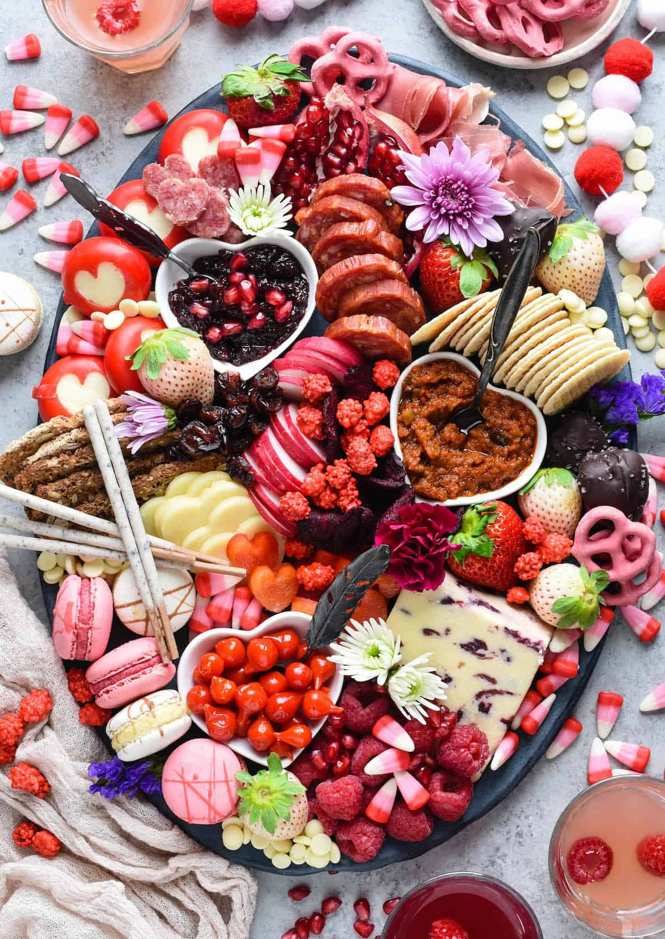

VALENTINE’S DAY BUFFET
I WILL HAVE LOVELY VALENTINE DÉCOR AND PAPER GOODS FOR OUR MEETING. WE WILL HAVE A BUFFET SO PLEASE BRING SOMETHING YUMMY TO SHARE WITH ALL OF US WITH SERVING SPOONS. IT WILL BE AS DELICIOUS AS YOU MAKE IT!

WHITE ELEPHANT SALE
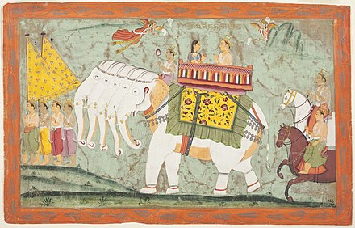

We are pleased to announce that our very fun White Elephant Sale netted $1000. Thank you all for your enthusiastic participation in this fundraiser which is a much anticipated annual tradition.



Anybody who has paid dues or who pays dues on Sunday at the meeting gets, not only the two imprinted pens but also a Valentine cup with lid and straw that I donated. What a deal!!

We are pleased that so many paid dues and even gave us donations to bolster our treasury. They were appreciated. DUES FOR 2026 WILL BE WILL BE $40 FOR AN INDIVIDUAL AND $60 FOR A COUPLE. DONATIONS, OF COURSE, ARE ALWAYS APPRECIATED. THIS YEAR WE NO LONGER GET HOTEL PLANTS AND DUE AND DONATIONS ARE SPECIALLY IMPORTANT NOW TO KEEP OUR WONDERFUL PROGRAMS GOING. I have been personally chipping in, but it would be nice to have the club more self-sufficient. In 2023, members gave donations of $1500, and it made all the difference.
If you haven’t paid your 2025 dues, PLEASE FEEL FRREE TO PAY YOUR 2026 DUES….

We now have the ability for you to pay your dues online! Just click on the link, and the rest is quite clear. The form will ask for your credit card information which is secure through the Square application. I tried it, and it worked great. If you want to add a little extra for a donation, just add it on to your membership. It says “donation” instead of “dues” due to a technicality because we are a non-profit. You will receive a receipt immediately.. You can also pay at the meeting, but it makes the treasurer’s job much easy if someof you do this online.

Here is the link-
https://square.link/u/NDRpbeQq?src=sheet


Diana, website genius, and I created our new website https://lasvegasorchidsociety.org/
If you don't get a newsletter or don't remember a meeting date, it is always there as well as lots of information.
Do click on it. There are 22 articles that might interest you.

Upcoming Events:
SOME DATES ARE DIFFERENT (not the second Sunday) BECAUSE OF LIBRARY
AVAILABILITY

Sunday, February 8, 2026 Beth Davis “All About Cattleyas”

Sunday, March 22, 2026 Fred Clarke “The Fabulous Flower Fields” (every other Saturday and Sunday in March was taken- really) Note this is the third Sunday.

Saturday,April 18, 2026 Cathy Loftfield “The Santa Barbara Orchid Show” All Sundays taken and most Saturdays, too

Somewhere between the end of April and the beginning of May, we will visit Calico Basin to see our native orchid Epipactis gigantea in bloom (depending on Mother Nature…) Our orchid guru, Mark Romansky, will lead us.

Sunday, May 10, 2026 Beth DaviS “All About Dendrobium”

Sunday June 14, 2026 Mark Romansky
“Where to Buy Orchids”

Sunday, July 12 Peter Lin :”Discovering Fragrant Orchids”

Sunday, Sept 13, 2026 Bridget Uzar “The Orchid Royalty- Cattleya”

