a `P
GREATER LAS VEGAS ORCHID SOCIETY
ORCHID COLUMN
CAROL SIEGEL, EDITOR
“THE ORCHIDS OF HAWAII” CAROL SIEGEL, PRESENTER

“I must have flowers-always and always”-Claude Monet”

THE GREATER LAS VEGAS ORCHID SOCIETY
THE ORCHID COLUMN
SUNDAY, MAY 10, 2026 1 pm
ORCHIDS FOR SALE SHOW AND TELL

THANK YOU TO JOEL DAVIDSON, JUDITH ORR AND NOREEN ITO FOR YOU GENEROUS DONATIONS TO PAY OUR INSURANCE. IT WAS SO KIND!
THANK YOU TO WONDERFUL CATHY LOFTFIELD FOR A TERRIFIC TALK ON THE SANTA BARBARA ORCHID SHOW. WE LOVED IT!

BETH DAVIS presents-
“Dendrobiums:
Graceful Beauties, Tiny Treasures, Unforgettable Wonders

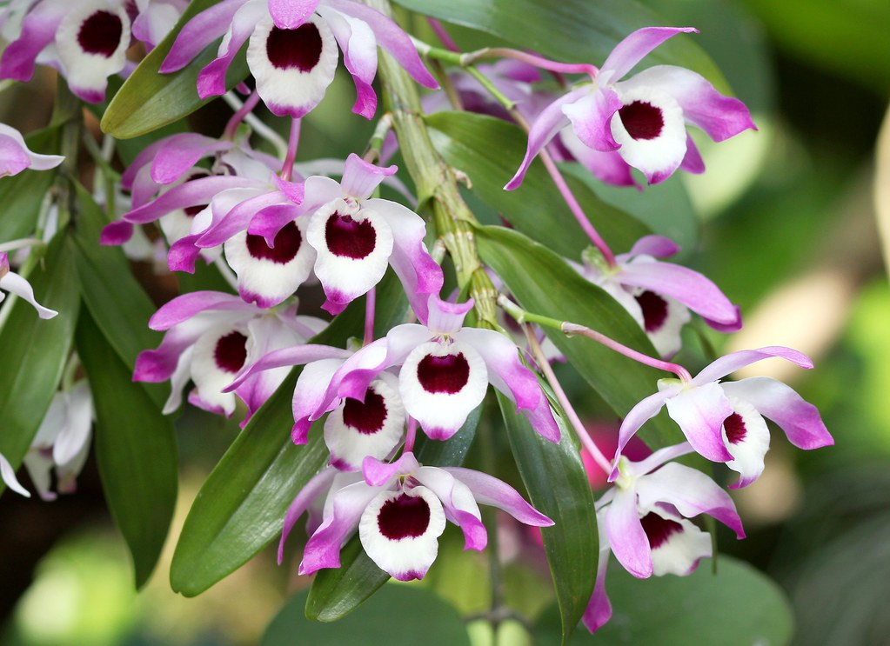

EPIPACTIS GIGANTEA

Explore one of the largest genera of orchids. We will discuss the characteristics, culture, and care of 10 of the 30 dendrobium groups.
Biography
We just love Beth Davis whose talks on her family nursery as well as on cattleyas were a big hit with our club.Beth is a third-generation orchid grower from Waldor Orchids located in Linwood, NJ. Waldor is a family-owned business and has been that way since 1925. She has worked at the greenhouses for over 25 years, doing many different jobs. She enjoys being in the greenhouses, repotting, and taking care of the plants. Beth has a growing collection of her own, most are either species or the more unusual types of orchids. She is an American Orchid Society-accredited judge. Along with her love of orchids, she does freelance floral design and loves to garden.
WE WILL HAVE SOME DENDROBIUM FOR SALE FROM 808 ORCHIDS. BETH WILL ALSO HAVE A SPECIAL LIST OF DENDROBIUM FOR US TO BUY AT A DISCOUNT. SHE WILL GIVE US THE INFORMATION DURING HER ZOOM TALK.

Plant Talk
Inside The New York Botanical Garden
Dendrobiums
Posted in Gardening Tips, The Orchid Show on March 20 2012, by Sonia Uyterhoeven
Sonia Uyterhoeven is the NYBG‘s Gardener for Public Education.

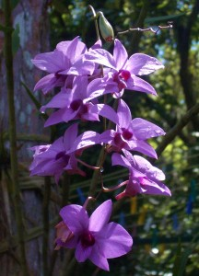Dendrobium phalaenopsis hybrid
To the chagrin of my more tropically-inclined colleagues, I have been resisting the temptation to sing the praise of dendrobiums for years. “Give me an oncidium any day,” I used to exclaim. “They are easier to grow and I will not kill them!”
Initially, it was true… I had issues with dendrobiums. If the vegetative growth (foliage and pseudobulbs) in many orchids is fairly unattractive when they are out of bloom, the cane dendrobiums are positively ugly.
I do not like them in bloom; I do not like them out of bloom; I do not like them Sam-I-am with green eggs and ham! I was adamant. They looked like mutant orchids, outcasts in an otherwise pulchritudinous family–the Orchidaceae.
Time (and experience) is a great healer, and I have slowly come around to appreciate this genus. The other day I was in the Nolen Glasshouses drooling over some colorful evergreen Den-Phal dendrobiums–Dendrobium phalaenopsis hybrids. While you generally see the flowers in white, pink, and lavender, the ones that caught my eye were chartreuse with reddish-purple highlights–a color combination that I find divine if the tones are right.
Dendrobiums are no more complicated than other orchid genera, it is just important to understand who they are and what they need. Some dendrobiums such as the popular Dendrobium nobile hybrids are deciduous. They are not for the faint-hearted; they require a dormancy period in the fall when their growth comes to a screeching halt. They defoliate and you turn your back on them and walk away, leaving them alone in a bright, cool spot–neglected–for several months. This is not entirely true–in our arid home environments where orchids are starved for humidity, you will have to occasionally mist them so the canes do not shrivel and dry.
Dendrobium nobileis from the Himalayan foothills, where it encounters wet summers and cool, dry winters. These orchids like to grow like gangbusters in the summer and have their cool rest in the fall to winter, before they flower and start up again. Research has shown that they are more likely to flower if the night time temperature in the fall and winter drops to around 55 F. If that is impossible, try to keep it under 65 degrees Fahrenheit, otherwise there is a good chance that you will get keikis (a baby orchid) instead of flowers. Water them every two to three days in the summer and fertilize them once a week. Discontinue this regime in the fall. They grow best in bright, indirect light in a southern window and may need a sheer curtain for protection from the intense heat of the summer sun.
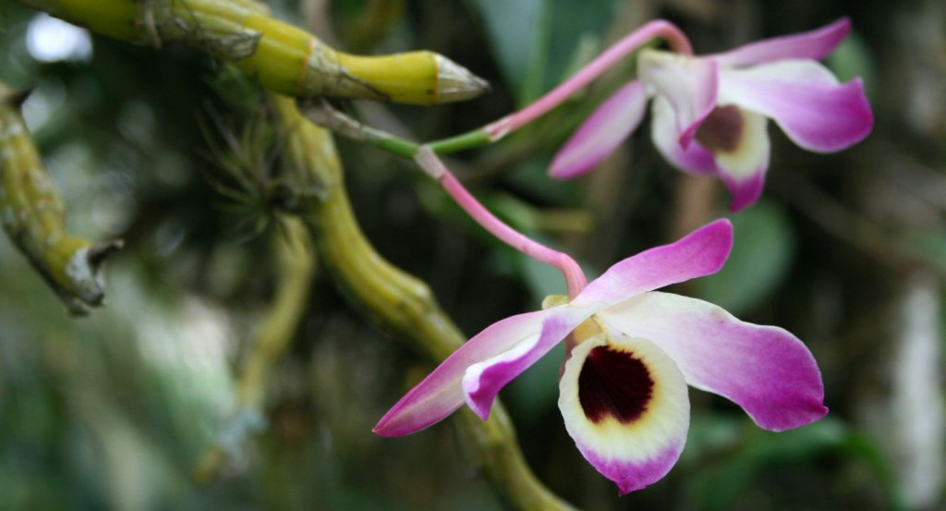Dendrobium nobile
Equally popular evergreen dendrobiums are the Den-Phal type whose flowers look like small moth orchids, or the antelope dendrobiums with their twisted hornlike petals. These dendrobiums require more consistency in their lives–a sunny southern or western window with bright, indirect light and warm temperatures. Since many of them herald from Malaysia, New Guinea and Australia, they are ideal for homeowners living in Hawaii and Florida. For those of us who live in the northeast, it simply gives us an idea of what we are trying to create.
In terms of watering, these evergreen dendrobiums like moisture when they are growing and prefer things a little more dry in the winter months once they have reached mature growth. Fertilize weekly during the growing season. Restricting water and fertilizer in the winter months (reduce by about 20 to 30%) will help trigger flowering.
Dendrobiums like good drainage and will not tolerate wet roots, so provide them with a free-draining orchid mix. They also have a small root system and love to be pot-bound, so grow them in a small clay pot and place them in a large cache pot for stability. Increasing the humidity around the orchid by placing pots on trays full of pebbles and water (drywell) will be appreciated by this exotic orchid.
Dendrobiums come in a vast array of shades, including red, orange, yellow, white, pink, lavender, chartreuse and many elaborate permutations within that color spectrum. Like many other orchids, they are a joy to grow once you get the swing of it. My rejoinder has since changed from my initial mantra of “I will not grow them here, I will not grow them there; I will not grow them anywhere.” With a little hand holding, I managed to pass under the lintel and move into a more complete realm that includes dendrobiums as part of my repertoire.

EPIPACTIS GIGANTEA

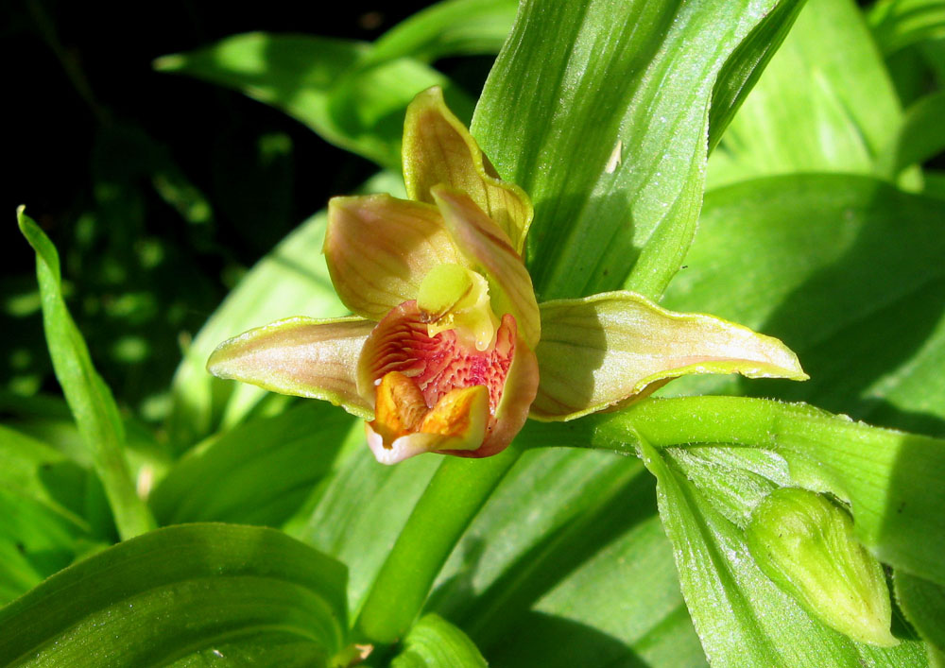

DUE TO UNSEASONABLY WARM MARCH TEMPS IN THE 90S FOLLOWED BY WEEKS OF COLD WEATHER, OUR NATIVE ORCHID WAS BLASTED BY THE END OF APRIL AND WE MISSED THEM. THANK YOU, MARK, FOR YOUR WILLINGNESS TO LEAD US. IT WAS ONLY THE SECOND TIME IN 20 YEARS THAT THIS HAPPENED.

I DID GO UP TO CALICO BASIN LAST WEEKEND AND WALKED THE PLATFORM THERE. (If you don’t know about the platform, it is a flat boardwalk with a half-mile easy walk suitable for seniors and walkers with a gorgeous view of the red rock, native plants, and even has some of our orchids under the boardwalk)There are some still in bloom although not the display we usually see further up the mountain. I took a few pictures. You turn off the road to the exit before Red Rock State Park at a sign that says Red Spring and go all the way down the road. On the left is a sign, parking lot and turn off for Red Spring. The Boardwalk with good signage is there. There orchids are hidden under the beginning of the Boardwalk where you start the climb up.

The orchids are very showy with a beautiful erect stem with lots of burgundy and apricot flowers up and down the stem. They love water and grow against the gorgeous red sandstone rocks, moistened by springs that wet the base of the rock. They are deciduous and disappear in winter, but reappear every spring by the thousands. They are found all over- western North America, western Canada, central Mexico and are the most abundant orchid of the Pacific coast of North America. They are called the “Chatterbox Orchid” because there lips wave in the breeze, attracting their syrphid fly pollinator which we actually saw carrying pollinia. A terrestrial orchid (growing in the ground), it forms big clumps, making a gorgeous display. 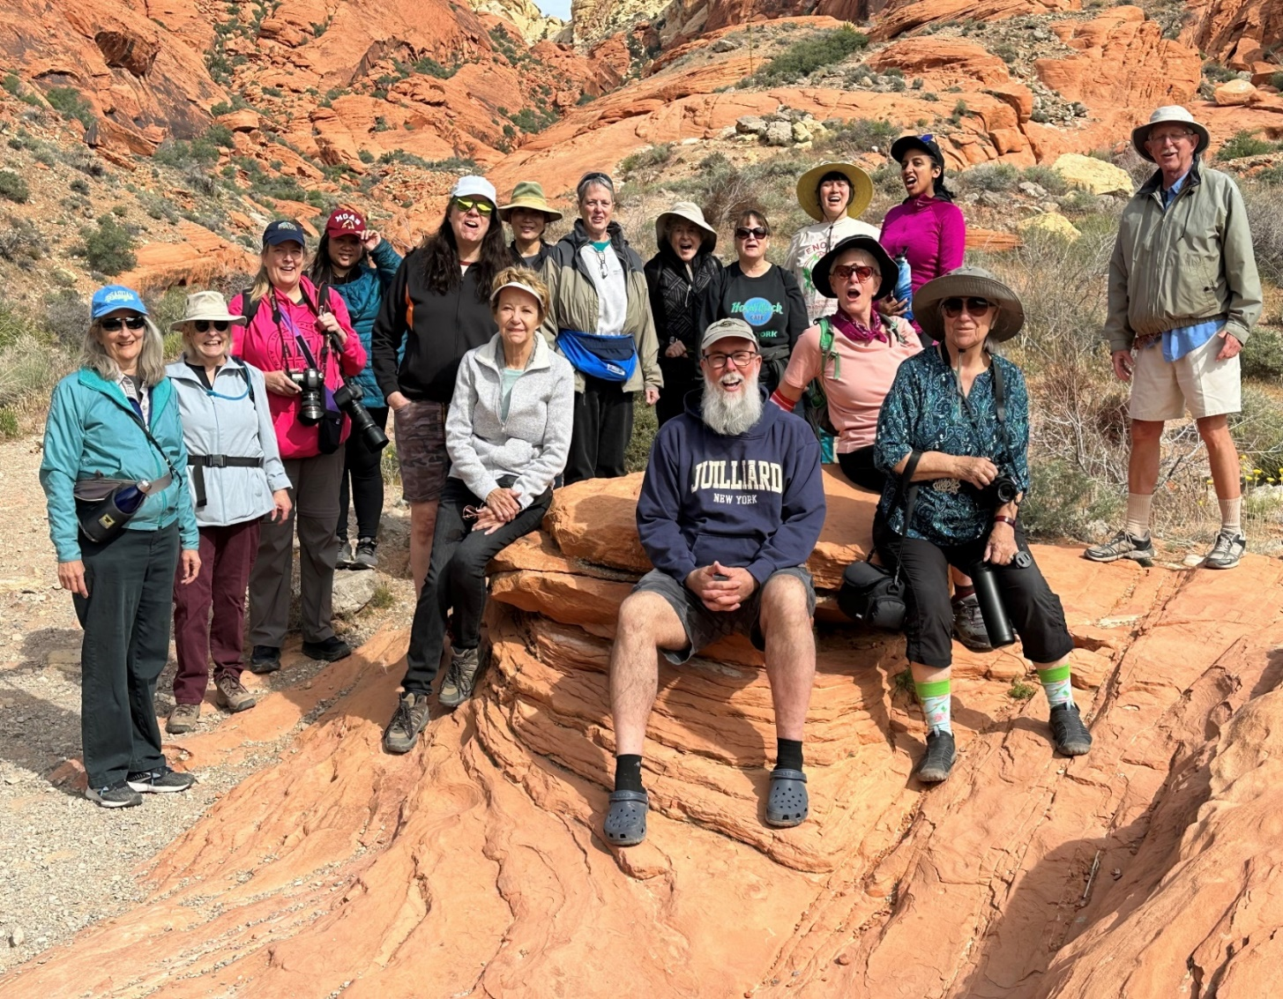

MAY POTLUCK
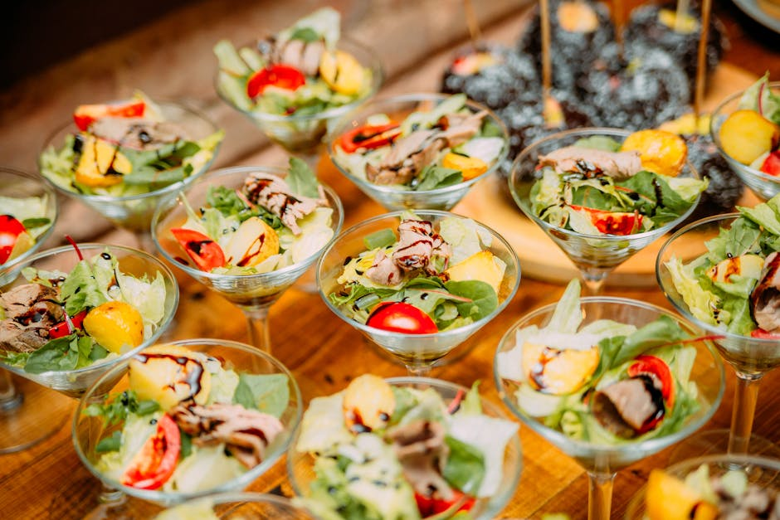

Bring something yummy for our spring potluck I will have a sunflower décor.

SHOW AND TELL

We will have show and tell this meeting. You can even bring
something you just bought.


I have attached a list of members to the email. Check your name. IF THERE IS NOT A 26 AFTER YOUR NAME, YOU STILL NEED TO PAY YOUR INDIVIDUAL $40 DUES OR $60 COUPLE DUES. IT MAKES SUCH A DIFFERENCE IN PROVIDING FUN AND INTERESTING PROGRAM. IF YOU NO LONGER CAN BE PART OF OUR CLUB- BOO HOO- PLEASE REPLY TO THIS EMAIL.
We are pleased that so many paid dues and even gave us donations to bolster our treasury. They were appreciated. DUES FOR 2026 WILL BE WILL BE $40 FOR AN INDIVIDUAL AND $60 FOR A COUPLE. DONATIONS, OF COURSE, ARE ALWAYS APPRECIATED. THIS YEAR WE NO LONGER GET HOTEL PLANTS AND DUE AND DONATIONS ARE SPECIALLY IMPORTANT NOW TO KEEP OUR WONDERFUL PROGRAMS GOING. I have been personally chipping in, but it would be nice to have the club more self-sufficient. In 2023, members gave donations of $1500, and it made all the difference.
If you haven’t paid your 2025 dues, PLEASE FEEL FRREE TO PAY YOUR 2026 DUES….

We now have the ability for you to pay your dues online! Just click on the link, and the rest is quite clear. The form will ask for your credit card information which is secure through the Square application. I tried it, and it worked great. If you want to add a little extra for a donation, just add it on to your membership. It says “donation” instead of “dues” due to a technicality because we are a non-profit. You will receive a receipt immediately.. You can also pay at the meeting, but it makes the treasurer’s job much easy if someof you do this online.
Here is the link-
https://square.link/u/NDRpbeQq?src=sheet

YOUTUBE MISS ORCHID GIRL
www.missorchidgirl.com

One of the most popular orchid channels on YouTube is Miss Orchid Girl. Over ten years, the very charming Dani has produced 2583 very useful free videos on almost a daily basis. She has over 537K subscribers and has had over 84 million views. She presents hours and hours of simple, easy-to-understand and professional tutorials suited for beginners and experienced growers. Her tips and tricks cover every subject from making your orchids rebloom, building an orchid collection on a budget, caring for slipper orchids, selecting 10 mini cattleyas, figuring out if your orchid is dead and alive, and evaluating orchid myths. She has orchid care for beginners as well as an orchids in bloom spotlight. Most of her content is free, but in 2024 she will air two public videos each week but will have exclusive content for those who pay a monthly fee.


Diana, website genius, and I created our new website https://lasvegasorchidsociety.org/
If you don't get a newsletter or don't remember a meeting date, it is always there as well as lots of information.
Do click on it. There are 22 articles that might interest you.

Upcoming Events:
SOME DATES ARE DIFFERENT (not the second Sunday) BECAUSE OF LIBRARY
AVAILABILITY

Sunday, May 10, 2026 Beth DaviS “All About Dendrobium”

Sunday June 14, 2026 Mark Romansky
“Where to Buy Orchids”

Sunday, July 12 Peter Lin :”Discovering Fragrant Orchids”

Sunday, August 9, 2026 Carol Siegel August 9, 2026
“Orchids and Hummingbirds- Sex in the Fast Lane”

Sunday, Sept 13, 2026 Bridget Uzar “The Orchid Royalty- Cattleya”

Sunday, October 11 Fred Clarke “The 80% Grower”

