**P**

**GREATER LAS VEGAS ORCHID SOCIETY**

**ORCHID COLUMN**

**CAROL SIEGEL, EDITOR**

**“THE ORCHIDS OF HAWAII” CAROL SIEGEL, PRESENTER**

**“I must have flowers-always and always”-Claude Monet”**

**THE GREATER LAS VEGAS ORCHID SOCIETY**

**THE ORCHID COLUMN**

**SUNDAY JULY 13, 2025**

**Peter Lin “12 Months of Orchids”**

**1 pm**

**Kate Schlatter will delight on the piano at 1**

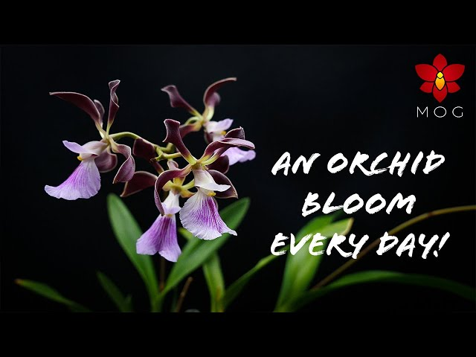

**12 Months of Orchids  
This fast paced PowerPoint  presentation discusses how to build an orchid collection to have blooms for every month of the year.  There are many orchids that bloom at different times of the year, so instead of concentrating on one season, now you can have a collection of orchids in bloom for each month of the year!**

**EPIPACTIS GIGANTEA**

**Peter started growing orchids over 30 years ago, but then stopped due to school and starting a career. It wasn't until about 11 years ago that the orchid "bug" came back and he is now heavily involved once again. He is an accredited judge with the American Orchid Society and a hybridizer of mini-catts. He enjoys meeting with other orchid enthusiasts, and can often be found at various orchid shows and societies around the country. He also has hundreds of photos of his orchids that he maintains on Flickr. You can view them by typing this address into the internet:** [**http://www.flickr.com/photos/minicatt/collections/**](http://www.flickr.com/photos/minicatt/collections/)

**Due to limited growing space, Peter likes to specialize in miniature orchids, both species and hybrids, and has received numerous AOS awards. His other interests in orchids include Dendrobiums, Angraecoids, and Neofinetias. He maintains a collection of a thousand or more orchids at his home in Southern California in 3 small greenhouses, as well as an offsite greenhouse.**

**We will have a few dozen blooming plants for sale from Hilo Ochids in addition to some Grammatophyllum.**

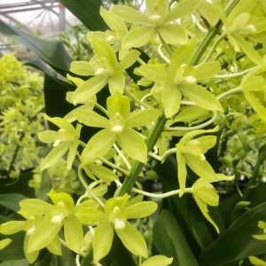**Gram. scriptum var. Citrinum**

I have purchased a dozen ***Grammatophyllum scriptum*** from 808 Orchids in Hilo, Hawaii. We still have four out of bloom specimens for $20.

Grammatophyllum orchids are renowned for their impressive size, robust pseudobulbs, and elongated, leathery leaves. Their striking inflorescences bear multiple vibrant blooms in colors ranging from green and yellow to brown and maroon, emitting a pleasant fragrance.

To care for Grammatophyllum orchids, provide them with bright, indirect light and maintain temperatures between 70-85°F (21-29°C). Ensure good airflow to prevent fungal issues. Water these orchids generously when the potting mix feels almost dry, but avoid overwatering to prevent root rot. Fertilize regularly during the growing season using a balanced orchid fertilizer. Repot the orchids every few years, using a well-draining medium suitable for epiphytic orchids.

***FOURTH OF JULY POTLUCK***



I will provide PATRIOTICdécor and paper goods. Cathy will graciously provide drinks. We ask all of you to bring something yummy to eat- main dish, side, salad or dessert for 10-12 peole with serving spoons. Just lovely! I will provide coffee this month. If there is a kind soul who could provide coffee going forward, I would be grateful. I have the pot, but I have a lot to do setting up so if someone could volunteer, it would be a help.

**July 13 Peter Lin “12 Months of Orchid Growing”**

**August 10 Ron Kaufmann "Canoeing through the Canopy: Orchid Exploration in the Flooded Forest of the Rio Negro."**

**Sept 14 Jason Fischer “Vanilla”**

**Oct 12 Cathy Loftfield “Lycaste”**

**Nov 9 Art Chadwick in person “The Chelsea Flower Show”**

**December 14 Holiday party Carol Siegel “How to Build an Orchid Collection” John Anthony and Russine Zellner persorm**

**January 11, 2026 Mark Romansky “Secrets to Potting an Orchid”**

**February 8, 2026 Beth Davis “All About Cattleyas”**

**March 9, 2026 Fred Clarke “The Fabulous Flower Fields”**